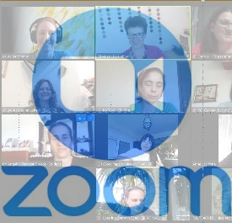
Dear students,
You have signed up for our GOAL Heroes project. Here is the latest information:
On Wednesday, we will meet on Zoom. Use this link to join our meeting.
https://us02web.zoom.us/j/84910599698?pwd=SmdjUTdZdVVWM0dGU0d5Q2ozc2czdz09
Meeting ID: 849 1059 9698
Passcode: 496642

For our Heroes books we will us the app BOOK CREATOR.
Please go to https://bookcreator.com/online/
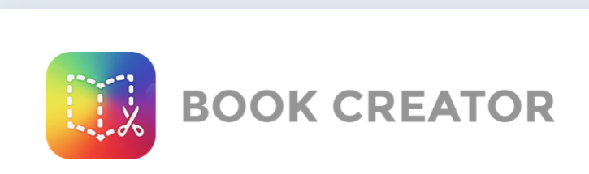 and create a free account.
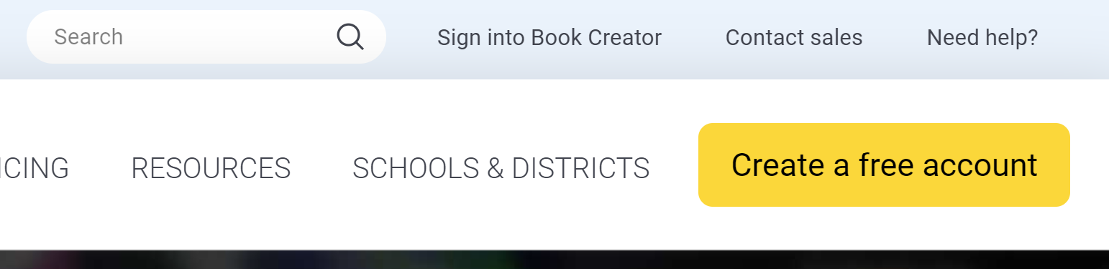
You will need your gmail address or your school email to sign in as a student.
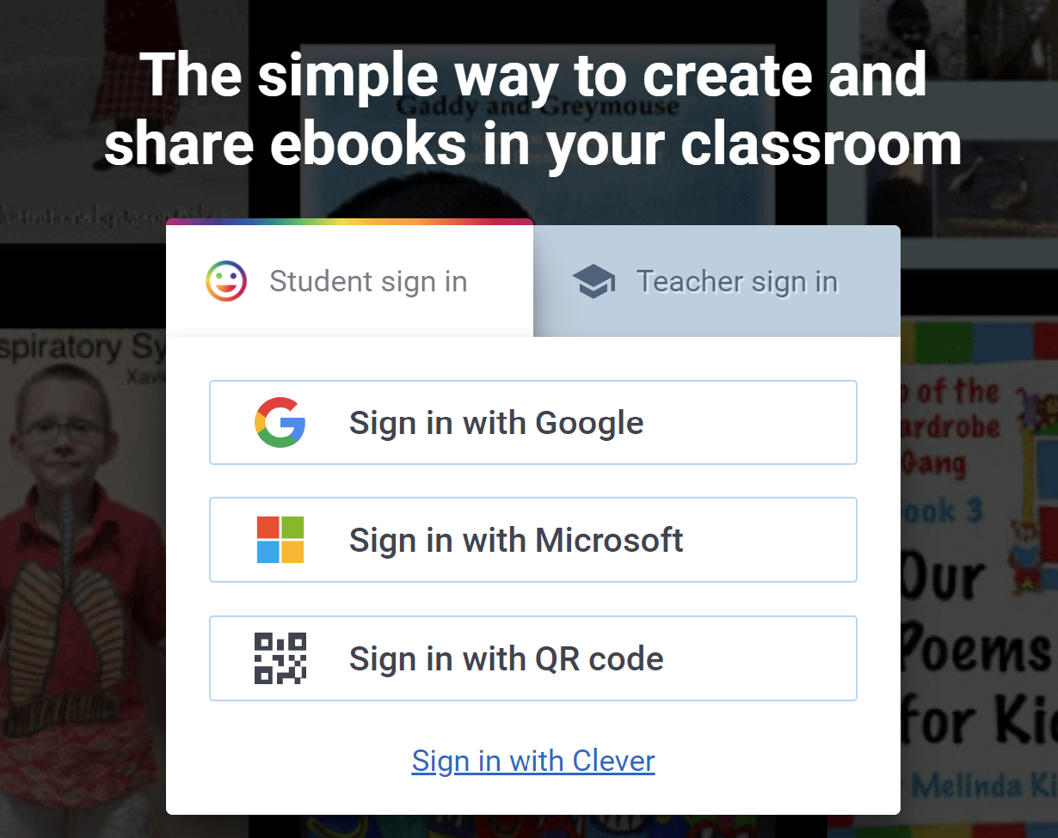
If you do not have a g-mail address or a Microsoft address, send an e-mail to: lis@polzleitner.net.
Tell me your name and country and I will then send you a code to sign up.
Sign in to book creator and use the following invite code to join our group:
MM7NPQL
There you will find my book of instructions and a “TESTBOOK for teachers and students”. You can try out the tool and play around with it.
WARNING: You need the latest version of CHROME or SAFARI or EDGE browsers. Update your browser if necessary.
As soon as you have joined our group, I will put you into your team. Please join as soon as possible. This will help me get everything ready for our meeting on Wednesday.

All the best,
Elisabeth Pölzleitner (Teacher from Austria)

