GOAL – Online Workshop: Superheroes of our World


Day 1  Time: 8.00 – 13.00 (Austria, Italy)  9.00 – 14.00 (Cyprus, Greece, Romania) |  |  |  |  |  |  |  |  |  |  | approx. time
Project kickoff on Zoom:  - What is this project about?  - Superheroes? Where can we find them?  - Tips for Writers  - Tips for Illustrators |  |  |  |  |  |  |  |  |  |  | 8.00-8.30  9.00-9.30  main room
Getting to know your team members: Warm-up activity in your team  https://www.polzleitner.com/epep/0-NMS/ErasmusGOALproject/Superheroes/Ice-breaker-in-common.docx |  |  |  |  |  |  |  |  |  |  | 15’ in
Team 1 | Team 2 | Team 3 | Team 4 | Team 5 |  | Team 6 | Team 7 | Team 8 | Team 9 | Team  10 | breakout-rooms
11 | 12 | 13 | 14 | 15 |  | 16 | 17 | 18 | 19 | 20
21 | 22 | 23 | 24 | 25
Come back to the main room: Join your workshop for writers or illustrators. |  |  |  |  |  |  |  |  |  |  | 8.45-9.30  9.45-10.30  2 breakout  rooms
Workshop 2: More tips for writers Who is your hero?  - What superpowers does he/she have?  - Where does your story play?  - What is the problem?  - How will your hero solve it?  Meet the writers in |  |  |  |  | Workshop 2: Tips for Illustrators (all teams)  - Let’s look at some picturebooks and collect ideas  - How to paint story backgrounds  - How to draw or paint the characters / parts of characters / accessories  - Trying out the features of book-creator online |  |  |  |  |  | 8.45-9.30  9.45-10.30  2 breakout  rooms
Break |  |  |  |  |  |  |  |  |  |  | 30’
Let’s meet in the main room again to discuss the next steps |  |  |  |  |  |  |  |  |  |  | 5’
Book Teams (writers and illustrators) meet to discuss first plans and ideas for their book. |  |  |  |  |  |  |  |  |  |  | 10.00 – 10.30  11.00 – 11.30
Team  1  Illustators work offline but keep in touch with their team.  Writing teams: Write your story | Team 2 | Team 3 | Team 4 | Team 5 |  | Team 6 | Team 7 | Team 8 | Team 9 | Team10 | 10.30 – 12.45  11.30 – 13.45  Students from Cyprus will leave at 13.00)
Short plenary: 12.45 – 13.00
13.45 – 14.00
Time for questions and good-bye

Day 2  Time: 8.00 – 13.00 (Austria, Italy)  9.00 – 14.00 (Cyprus, Greece, Romania) |  |  |  |  |  |  |  |  |  | 8.00-13.00  9.00-14.00
Welcome back  - Highlights and good examples  - Some more tips from your teachers  - Plan for the day  - Time for questions |  |  |  |  |  |  |  |  |  | 8.00 – 8.30  9.00 – 9.30
Back to your team  See how far you are?  What needs to be done next?  Back to work… |  |  |  |  |  |  |  |  |  | 8.30-10.00  9.30-11.00
Team1 | Team 2 | Team 3 | Team 4  Writers work in your teams. Get feedback from your teachers. Then polish the text.  Practice recording the text. Read it to a teacher, then record the text in the app. | Team 5 | Team 6 | Team 7 | Team 8  Illustrators add backgrounds and characters to the books. Design all the pages carefully. Then design a cover page.  Delete all the instructions and organize your pages. | Team 9 | Team 10
Break |  |  |  |  |  |  |  |  |  | 10.00-10.30  11.00-11.30
 |  |  |  | Meet in your teams and polish and finalize your books. |  |  |  |  |  | 10.30–11.45  11.30-12.45
  Plenary:  Let’s celebrate:  Read all the books and find out about the superheroes.  Rounding-off the project |  |  |  |  |  |  |  |  |  | 11.45-13.00  12.45-14.00  Cyprus will leave at 13.00

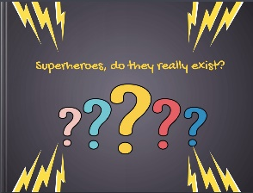
Day 3:
Let’s celebrate our superhero books
Step 1
Let’s recap and look at some of the amazing superheroes that you have created in this project (teacher’s presentation)
Step 2
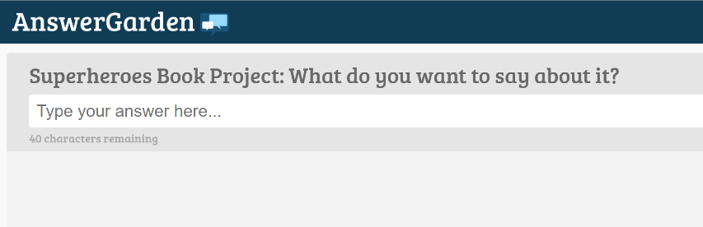
Answer the question in our ANSWERGARDEN

Step 3
Read the books and write short feedback comments for the other teams.
- What do you like about their books?
- What did they do exceptionally well?
- Do you have any tips for them?
- You can also add some to the books that you like a lot.
You will find all the books on this padlet:https://padlet.com/lispolzleitner/w9mboe0h6spz
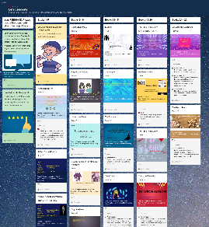

Step 4
Explore the books in detail and answer the quiz. You can win a little prize if you get lots of answers right. You can do this on paper or online.
https://forms.gle/ksHj9H2Es1p2p1fN6
