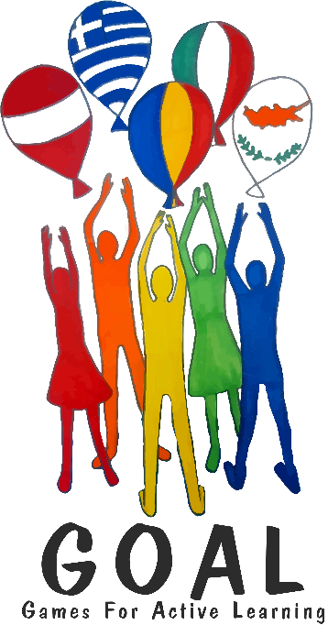
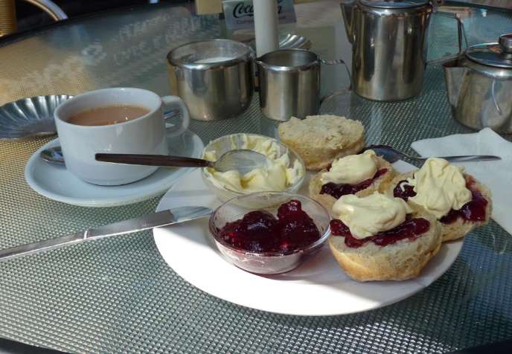
Tea and Talk

GOAL Meeting online: Friday, December 11th, 15:30 (Vienna time), 16.30 (Romania, Cyrus, Greece)
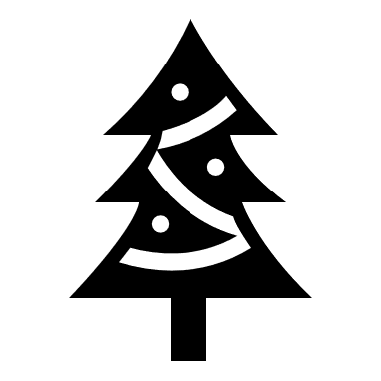
In order to participate in the meeting AND the group-chats, please download the Zoom desktop app (Zoom client for meetings) – or the Zoom app on your mobile device. You do NOT need your own Zoom account. https://zoom.us/download
To join the meeting, use the following link:
https://us02web.zoom.us/j/87862896042?pwd=Wkxsd1ZYMXhmaFFsek1VNTcrcXl2Zz09
When you join the meeting, please write your COURNTRY and then your FIRSTNAME: example: Austria Lis

Dear friends,
Everything is closed, and we cannot even meet our friends in our own countries. BUT, we can still look outside and travel in our minds. We can travel by reading books, AND, we can meet friends – even new friends online. This is what we are going to do in our TEA and TALK meeting on Zoom.
Part 1: Welcome chat
We will all meet on Zoom and start our discussion in a big group. Maybe you can bring your favorite drink (tea, hot chocolate, fruit juice….) and a typical sweet from your country to the meeting and share it with us (at least show it to us – unfortunately, we cannot taste and smell it.)
Part 2: Group discussions: Finding out about our everyday lives right now
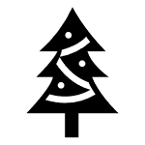
In this part we will be put into mixed groups, with students from all the different countries. The teachers of all the countries will also join the different groups. In your groups, find out as much as possible about the following things. Take notes on your sheet, so you can later discuss the answers with your teachers at home.
Look at the questions on the next page

Questions for your group chats
 | Austria | Cyprus | Greece | Italy | Romania
What are your schooldays like at the moment? Do you have distance learning or are you at school?
What tools and platforms do you use for distance learning? How do you talk to your teachers?
What are the things that bother you most (that you do not like at all) at the moment?
Do you see any advantages (good things) now during lockdown times? What are the good things?
Tell us about one highlight of the last few days or weeks. A nice surprise, something that you did well, a nice moment…
How do you spend your free time during lockdown and Corona times? What fun things can you do?
  Can you share a crafts tip for a nice self-made Christmas present? | https://padlet.com/lispolzleitner/1uub1mqikqxf |  | Scan the QR code with your phone. Then take a photo of your present and upload it to the padlet. The best ideas will win a prize. |  | Win a prize
Your choice: Any other questions?

How are you going to celebrate Christmas, or spend the Christmas holidays this year?
Will it be different from other years?

What else would you like to find out about your new friends?
Keep talking about anything that interests you personally.


After the meeting

What do we all have in common? What are the differences?
Usually, we….
but this year…
Write keywords and short sentences into the Venn diagram.
We must (not)…

Discuss these results with your teachers at home.
Greece
We are (not) allowed to…

We would like to….

Italy
Cyprus
We miss…

Romania
Austria

