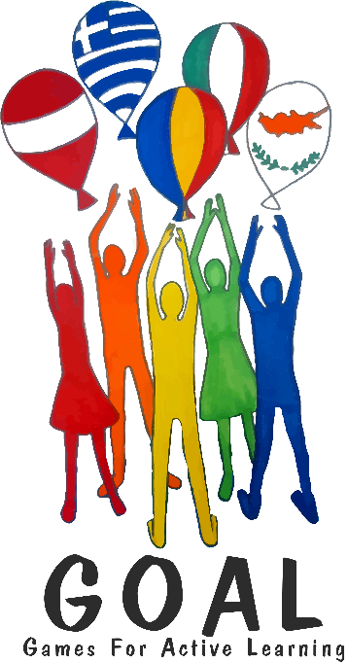
Everyday Life in Corona-times (2nd online meeting)

GOAL Meeting online: Friday, June 5th, 12.00 (Vienna time), 13.00 (Romania, Cyrus, Greece)
In order to participate in the meeting AND the group-chats, please download the Zoom desktop app (Zoom client for meetings) – or the Zoom app on your mobile device. You do NOT need your own Zoom account. https://zoom.us/download
To join the meeting, use the following link:
https://us02web.zoom.us/j/83484274749?pwd=Y2FBWGZoVmlXZkVKNEp6MG4rSDBGZz09
Meeting ID: 834 8427 4749
Password: 017352

When you join the meeting, please write your COUNTRY and your Firstname : example: Austria-Lis, Italy-Anna, Greece-Iannis …
We need this to form mixed groups quickly.

Dear friends,
Everything is closed, and we cannot even meet our friends in our own countries. BUT, we can still look outside and travel in our minds. We can travel by reading books, AND, we can meet friends – even new friends online. This is what we are going to do in our GOAL meeting on Zoom.
Part 1: Welcome chat
We will all meet on Zoom and start our discussion in a big group. We will welcome you and each country will briefly tell us where you are from (country, city, school). Maybe one person in each country can prepare 2-3 pictures on your computer that you can share with us in this phase. A map? A photo of your school?

Part 2: Group discussions: Finding out about our everyday lives before Corona times and now
In this part we will be put into mixed groups, with students from all the different countries. The teachers of all the countries will also join the different groups. In your groups, find out as much as possible about the following things. Take notes on your sheet, so you can later discuss the answers with your teachers at home.

Questions for your group chats
What was a normal school day like before Corona broke out?

 | Austria | Cyprus | Greece | Italy | Romania
What time does school normally start in your country, what time does it end in your country?
Do you have lunch in school?
If yes, what is it like?

What are your favorite subjects (1-2) and what subjects do you not like? Explain why you like or dislike them.
How much time do you usually spend on studying or homework every day?

How do you normally go to school? (Bus, tram, train, bike, walk, parents drive you…?)

What did you do in your free-time before the corona lockdown? How did you spend your afternoons and weekends… Tell us as many things as possible.

The Lockdown:

A: The lockdown in schools | Austria | Cyprus | Greece | Italy | Romania
Tell us about your home-schooling experience:
How do you study now?
How do your teachers contact you and teach you?
Is there anything you like BETTER about home-schooling?
What do you NOT like about home-schooling?
What do you miss most?
B: The Lockdown: Everyday life in your city

What rules do you have to follow now?
What are you allowed to do?
What are you not allowed to do?
C: Your plans for the summer holidays

What are your plans for the summer holidays? What are you going to do?
Your choice: Any other questions?

What else would you like to find out about your new friends?
Keep talking about anything that interests you personally.

After the meeting

We must (not)…
What do we all have in common? What are the differences?
Greece
Write keywords and short sentences into the Venn diagram.
We are (not) allowed to…

Discuss these results with your teachers at home.

We would like to….

We miss…

Italy
Cyprus

In the summer we are going to …

Austria
Romania

