In this project we are going to
- play lots of games
- make new games and share them with our partners
- find out lots of things about our partners in Italy, Greece, Cyprus and Romania
- make short videos to show our culture and lifestyle to our partners
- write e-mails and letters to our partners
- have competitions (online and real) with our partners
and finally
- we are going to travel to Cyprus and Greece to meet our partners

Join us!
Mach mit!
You can earn travel points for each good contribution!!!

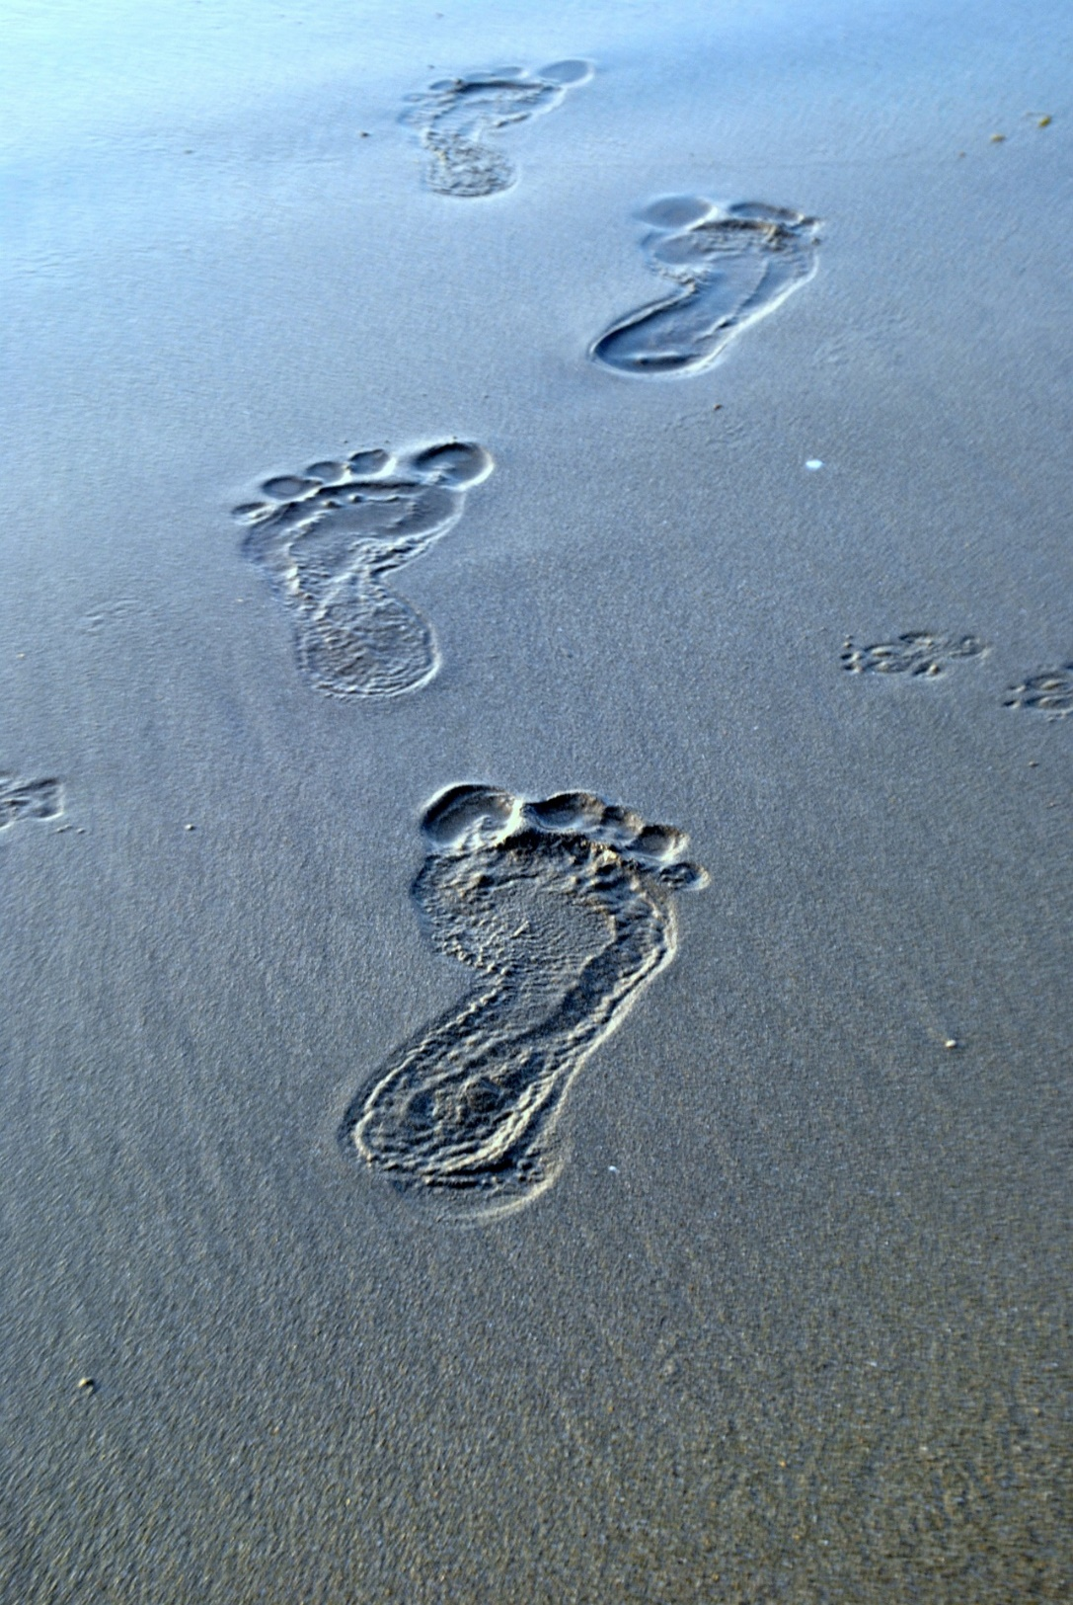
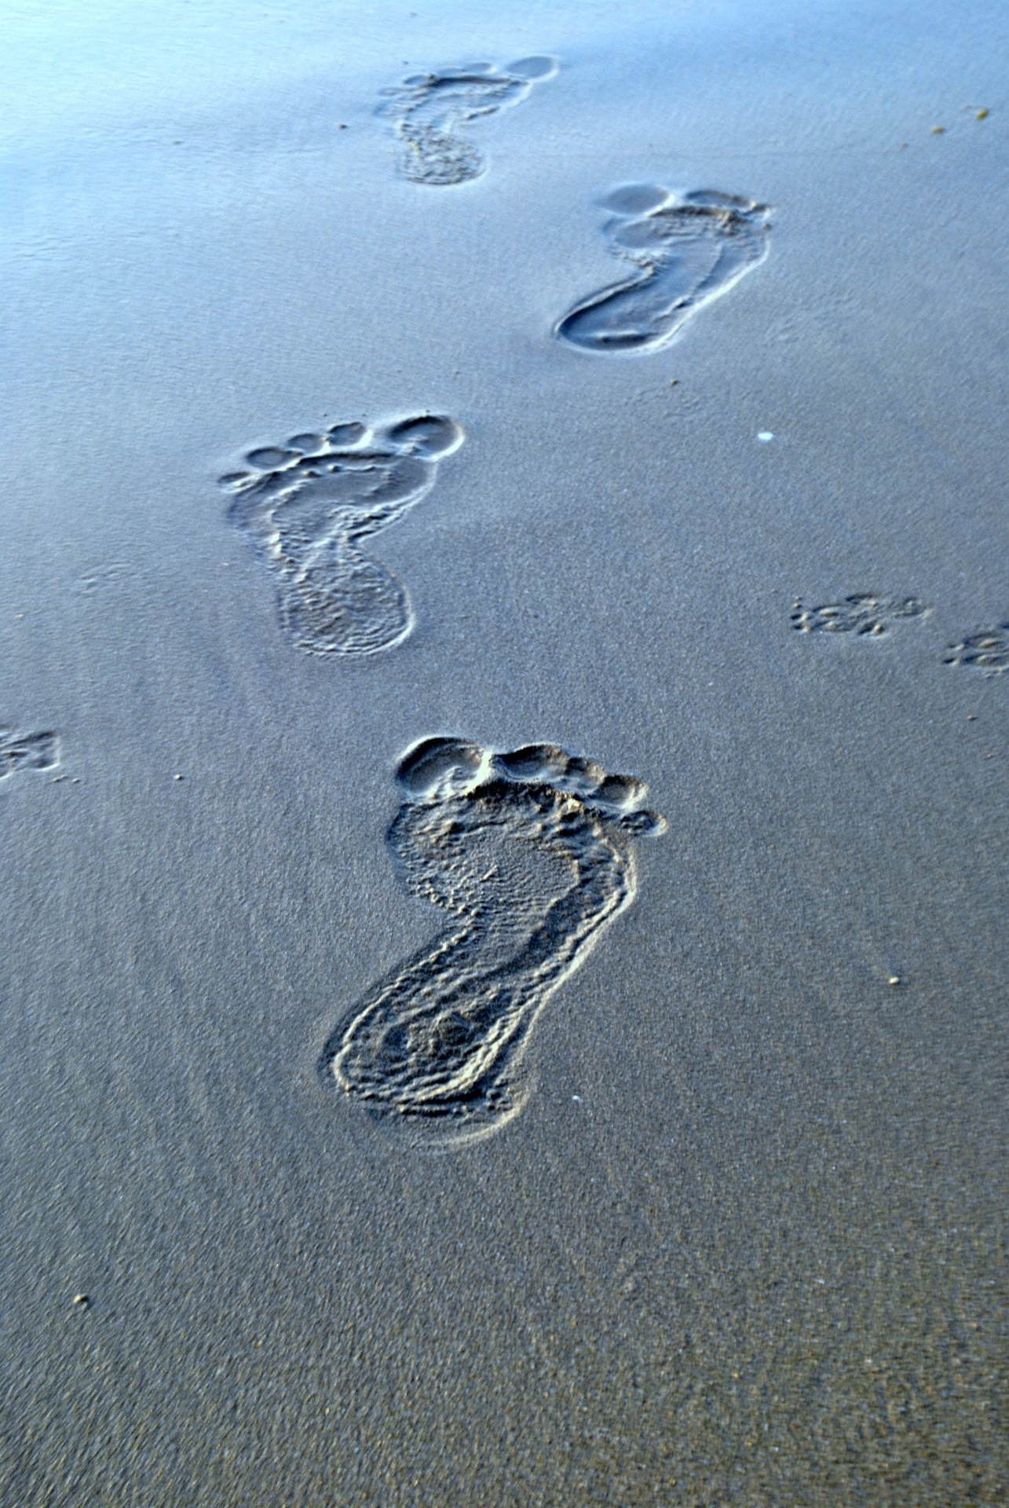
To earn travel points you can
- make a short video about our school (subjects, places, things we do…)
- make a short video about a game that you can play
- make a short video about an interesting place in Graz
- make a short video about an interesting cultural event in Graz (Krampus, Nikolaus, Eiskrippe, Christmas markets …)
Later – in our project week you can
- make your own games about Graz, Austria, our culture…
All videos should be 1-2 minutes long. use
- ComPhone (5-6 pictures) + your voice in English
- or Flipgrid
- or Powerpoint-videos (mp4)

Challenge 1
Design a LOGO for our project

