



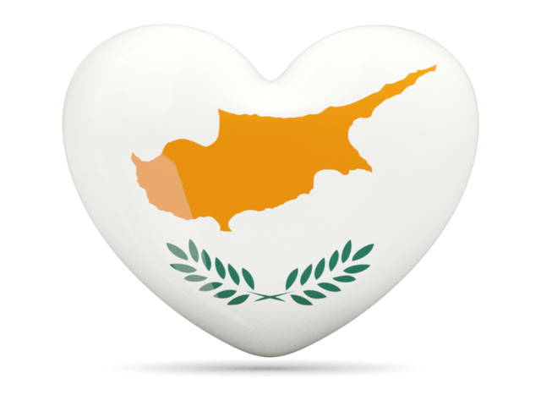
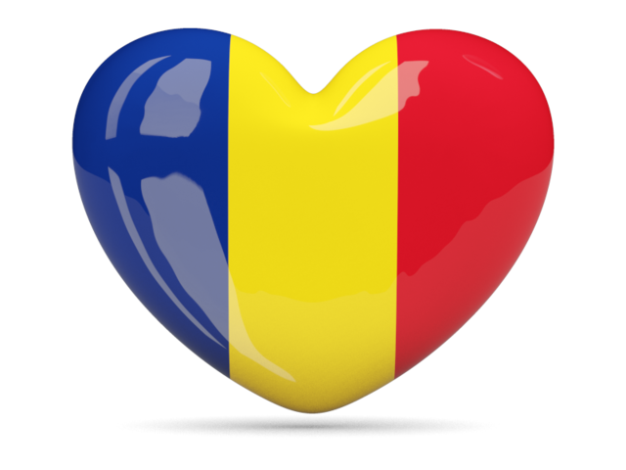

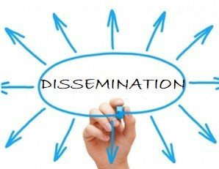

DISSEMINATION PLAN

PROJECT FULL TITLE | GAMES FOR ACTIVE LEARNING
PROJECT ACRONIM | G.0.A.L
PROJECT NUMBER | 2019-1-RO01-A229-063665
DELIVERABLE | DISSEMINATION PLAN
STATUS | VERSION 1.0
AUTHORS | Nicoleta Ciobanu (Colegiul Național Elena Cuza) Elisabeth Poelzleitner(Neue Mittelschule der Pädagogischen Hochschule Steiermark )Constantina Stefanou( Dimotiko Scholeio Defteras Pano) Pinelopi Vassiliou(39th Primary School of Patra) Anna Scarfone( Istituto Comprensivo Statale "A. Pagano" )
ABSTRACT  (FOR DISSEMINATION) | The current document is the Dissemination Plan of the G.O.A.L project. The aim of the Dissemination plan is to establish and run the visibility of the project, so that all activities that will be carried out during the project lifetime will be widely known with the highest possible visibility, in EU countries.

SUMMARY
The current document is the Dissemination Plan of the G.O.A.L project. The aim of the Dissemination plan is to establish and run the visibility of the project, so that all activities that will be carried out during the project lifetime will be widely known with the highest possible visibility, in EU countries.
This document outlines the dissemination activities carried out by project partners. It sets out what has already been achieved, and provides an outline of what is planned.
An overview is given of all dissemination opportunities identified through traditional communication channels such as event attendance (e.g. conferences, seminars, workshops, etc.), project publications (e.g. leaflets, press releases as well as conference papers, articles in professional journals etc.) and project presentations (e.g. to local stakeholders, etc.), complemented also by online activities based around the project website, and through the main social platforms (e.g. Twitter, Facebook, etc.). The dissemination activities have been designed to target the key audiences and stakeholders and to maximize awareness of GOAL objectives and training activities.
METHODOLOGY
The dissemination activities were planned in an iterative way – from an outline in the Project Description, through the transnational meeting discussions and further identification of activities, to this deliverable, and will be carried out over the full duration of the project.
The project relies upon shared Google documents and Dropbox facilities to enable collaborative input and the collection of information about G.O.A.L activities.

PARTNER CONTRIBUTIONS
All project members have contributed to the diary of dissemination activities by recording information about individual contributions to training conferences, to any other related conferences and workshops where the objectives of G.O.A.L have been (or will be) publicized and presented. All partners have also actively participated in discussion of the initial dissemination activities such as the selection of the project logo and dissemination opportunities in their countries through newsletter, institutional websites. All partners have been given the opportunity to review this document.
DISSEMINATION STRATEGY
OBJECTIVES
The overall aim of G.O.A.L’s dissemination activities is to ensure wide reaching impact, uptake and use of project deliverables among identified stakeholders from local, regional and international perspective.
The main purpose of the present dissemination plan is the identification of all dissemination and communication tools, activities, targeted groups and strategy needed for this information diffusion.
The dissemination plan defines clear and reliable rules for the dissemination activities and tools which will be implemented and used by all project partners.
The objectives, activities and results of the project will be disseminated to the relevant target groups with appropriate content and on time. The content, timing and frequency of the various dissemination activities are established.
The monitoring of the dissemination activities provides evaluation of the progress and ensures that the set out objectives will be realized. The Dissemination Plan and strategy will be reviewed every 6 months to monitor the achievements and to integrate new dissemination actions, objectives and tools, suggested by project partners and involved stakeholder
Any dissemination activities and publications in the project will acknowledge the European Erasmus Plus Programme funding. Scientific publications will mention that: “The research leading to these results has received funding from the European Community’s Erasmus Plus Programme under grant agreement from project G.O.A.L 2019-1-RO01-A229-063665”.
The GOAL project pursuits a two-stage approach.
….

The resulting dissemination strategy will therefore aim to help in spreading knowledge about the project’s aims and its initial steps to gain maximum support from community in identifying relevant content and motivating multipliers to organize and host training events. Project partners are well-embedded within their national, European and international networks, so that dissemination can help with coordinating efforts and providing promotional material to be distributed.
BENEFICIARIES
- Pupils
- Parents
- Local authorities
- Teachers in partner schools
- Teachers in other schools
- Students / future teachers

RESOURCES
Personal communication (e-mail, telephone), web-based dissemination, media communication and press releases, social media including twitter and blogs, publication and scientific activities (journal papers, workshops, presentations at external conferences.) will be the resources for implementing the dissemination plan.
DISSEMINATION TOOLS
The dissemination of the results of the G.O.A.L project will take several forms and use a variety of disseminating tools:
MEETING WITH PARENTS and LOCAL AUTHORITIES are organized in each school in order to announce the project. There will be opening ceremonies and exhibitions about the partners and the project in the partner schools. Each school throws balloons in the national flag colours to start the project. pening ceremonies, launching the project
ERASMUS BILLBOARD
Each school will set up a billboard with the inscription "Erasmus partnership program, funded by the National Agency of the European Commission - 2019-2021".Pupils in each school will decorate a MAP and will mark each partner country. Partners will share 2-3 photos of their town and school that can be printed and added to the maps. Pupils will be asked to do some basic research about their partners' countries and languages (finding greetings in the different languages and adding them to the billboard, etc).
SELECTION OF A PROJECT LOGO
The development of a visual identity and a project logo ensure that the project outputs are visibile and easily recognisable and consistent.Pupils will create a logo of the project, using different techniques. The best one wil be chosen to represent the project.
Therefore every event, presentation, newsletter, deliverable ,leaflet, sticker, etc. is making use of this visual identity together with the EU logo and disclaimer.
CREATION OF A PROJECT POST CARD
A postcard of the project will be produced in order that partners could disseminate G.O.A.L in all the training conferences, at their own institutions , among colleagues, pupils and stakeholders.
PRESS ARTICLES
Articles are written in schools’ magazines . Articles are written by each partner in order to disseminate each LLT and all the local activities in the project. The photos of the articles are uploaded on the website.
PROJECT WEBSITE
The website is especially important in promoting the project and posting results and dissemination material. It will be used as one of the main channels to promote the project . The website is constantly being updated in English, while partners could translate the information in their language ,in order to maximize the impact of information. Each partner will incorporate a link on their school website to the G.O.A.L project .
BANNER
A good practice in regard to linking to a project’s website is the creation of a banner. A banner should be interesting and pleasant in order to capture the attention of the website’s visitor.
POSTER
A poster of the project will be edited . It will be printed and it will be visible in all school partner. It will be posted on the project’s website, on partner websites and on various metworks.
G.O.A.L" METHODOLOGY- describing the steps of using games as a teaching tool will be available on the website
G.O.A.L" BOOKLET (the participants, the description of project, the objectives, the
results etc.) - "TOGETHER FOR EUROPE";
TEACHER'S GUIDE digital presentation "UNITED IN DIVERSITY";
Collection of all the games developed in the project - "G.O.A.L - GAMES FOR ACTIVE LEARNING";
CALENDAR with the games in our project will be edited and distributed in every school .
NEWSLETTERS will be sent to parents, stakeholders and local authorities to announce the project abjectives and to describe the activities of the project.
CONFERENCES, WORKSHOPS AND OPEN EVENTS
Project partners will communicate the results in WORKSHOPS, CONFERENCES AND SEMINARS in order to extend the impact of the project and to inform the stakeholders of the activities and progress of the project and get some feedback/input.
This will result in the continued use of the project results and methodologies in the future and also to develop new partnerships. AFTER the project the partners will continue further dissemination and will develop ideas for future cooperation.
AUDIOVISUAL PRODUCTS
Each partner will edit a short video after each LLT they organised, using lumen5.com / powtoon.com or other apps. A final video-clip about the project and a common digital presentation of the partner schools and countries will be created and uploaded on the project’s website and on You Tube.
PRESENCE IN THE INTERNET - SOCIAL MEDIA CAMPAIGNS
Social media marketing is the process of taking advantage of various social media networks (like Facebook, Twitter, Google+, Instagram, Tumblr etc.) to promote the activities and the objectives of the project. Because traffic from social media sites is usually highly targeted, the probability to draw attention to the project is generally higher than using a search engine query. Another important benefit of traffic from social media is that it is essentially free or relatively low cost compared to other forms of traffic generation.
E-TWINNING PLATFORM will be created to promote the GOAL project to other institutions and toallow communication among partners.
SCHOOL EDUCATION GATEWAY is best means for posting different materials made during the project.
ERASMUS + PROJECT RESULTS PLATFORM is one of the ways to share project results

Dissemination time plan
Dissemination time plan is an on-going process. It was initiated at the first transnational meeting and it will be upgraded constantly with the participation of all the project partners.

Nr | Deliverable title | Description/ link | Lead partner | Dissemination level | Delivery date / month
1. | MEETING WITH PARENTS and LOCAL AUTHORITIES |  | All partners | public | M1
2. | ERASMUS BILLBOARD |  | All partners | public | M1
3. | SELECTION OF A PROJECT LOGO |  | All partners | public | M2
4. | PROJECT WEBSITE |  | ROMANIA | public | M1
5. | PRESS ARTICLES
6. | BANNER |  | All partners | public | M1
7. | POSTER |  | ROMANIA | public | M3
8. | GOAL METHODOLOGY |  | All partners
9. | GOAL BOOKLET
10 | TEACHER’S GUIDE
11 | CALENDAR
12 | NEWSLETTERS
13 | CONFERENCES
14 | WORKSHOP
15 | AUDIOVISUAL PRODUCTS
16 | PRESENCE IN THE INTERNET
17 | E-Twinning / SEG / EPRP plaform

Dissemination Activity Report
The Dissemination Activity Report is a brief document where each dissemination activity intended as an outcome, is going to be reported in terms of its description, audience, achieved contacts. This report is intended to be a key support in the periodic reporting phases of the project.
Here follows the document each partner is requested to complete for any type of dissemination activity carried on. They are going to be summarised every six months so we have an updated list of all dissemination activities during the project.
Dissemination Activity Report (DAR)
TASK | Dissemination
PARTNER NAME
ACTIVITY TITLE
DATE
ACTIVITY TYPE | Article/conference/workshop
SHORT DESCRIPTION | Place  Audience  Link  Other

CONCLUSION
This dissemination plan is a flexible, living and light-weight plan. Based on the defined target groups and objectives described in the description of work, the strategy aims at maximizing the use of project deliverables, mainly the offering of training events and material, ensuring that key stakeholders receive the full, lasting benefits of G.O.A.L project
It also allows the project team to adapt to future developments.

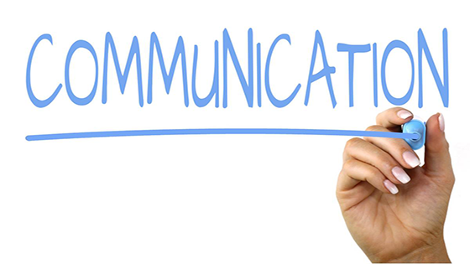
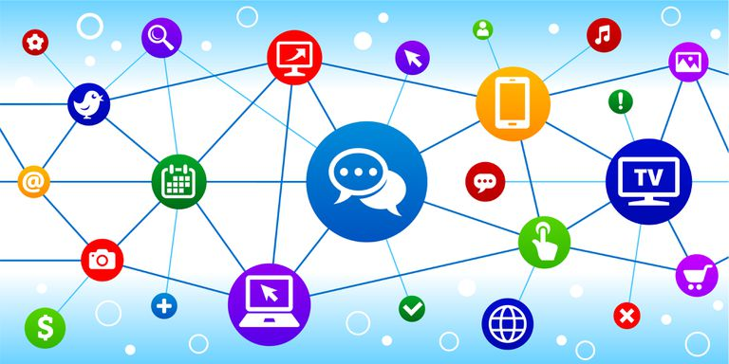

COMMUNICATION PLAN
In order to ensure constant flow of information among partnering institutions the project communication will be structured in three levels: at the project management level, at project activity level and stakeholder meetings.
Project coordinators will remain in contact throughout the project duration through:
-regular Skype conference calls
- Whatsapp: messages, calls and video calls
-text messages
- e-mail
-facebook messanger
- telephone calls
During the whole project period, the project communication will be conducted mainly among team members involved in each of the project activities. The project coordinators will monitor the implementation of each activity.
Additionally constant written and Skype communication among project team members involved in the implementation of each activity will take place. This communication will be closely monitored by the project coordinators, in case some major issues need fast resolution.
As part of the interaction process between project team members and stakeholders,
a number of communication tools are engaged:
The communication among the project members and the pupils will be conducted
in both directions:
- the pupils will be constantly briefed about specific project activities directly , by the project members
2) they will provide feedback of the successfulness of above mentioned activities, once the implementation period of each is completed (by focus groups / questionnaires)
Additionally, The E Twinning platform will provide an on-line solution for communication among stakeholders themselves, stakeholders and project team members .
This document is conceived as a ‘living’ strategy; its contents will be regularly updated during the duration of the project, with progress reviewed at each consortium management meeting.

