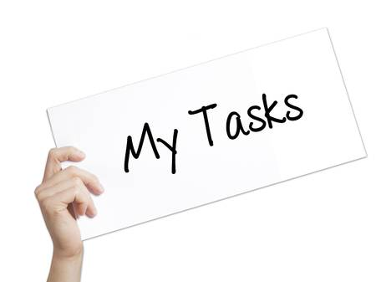

TASKS
The coordinator will manage, coordinate, monitor and evaluate all the activities developed within the
project, keep in contact with all the partner schools and contribute to the design and realization of the
final products and dissemination of the project activities and products.
We will ensure the active involvement of the partners by Skype conferences held monthly, by emails and during the project meetings.

ALL PARTNERS WILL:
- exchange ideas and cooperate in designing and trialing the learning-games as described above;
- communicate regularly with all the partners:
- present and discuss the project with colleagues in their schools and select their Erasmus+ team;
- make the Erasmus+ billboard noticeable in their school and keep it updated throughout the project;
- promote and disseminate the project within their team and keep it alive among children, parents and colleagues and local authorities
- fill in the dissemination activity report periodicaly and send it to the coordinator;
- guide and organize communication between children;
- plan and organize Learning Teaching Training activities when they are hosts;
- elaborate: a list of presence at each LLT , a minute of each LLT , a report after each mobility and a short video
- keep other partners regularly informed on the project development by uploading the results and the
videos of their activities on the project's website;
- evaluate regularly the project's progress within the school and contact coordination if necessary;
- develop and elaborate a methodology -"G.O.A.L" METHODOLOGY- describing the steps of using
games as a teaching tool.
-
-
ROMANIA
- will create the project website and will keep it updated regularly;
- will write a report by the end of the first year where all the developed activities will be described;
- will create the "G.O.A.L" booklet (the participants, the description of project, the objectives, the
results etc.) - "TOGETHER FOR EUROPE";
- will organize a GAMES AND MOVEMENT workshop to train teachers.

CYPRUS
- will create and administer an eTwinning platform for communication;
- will organize a workshop about using the eTwinning platform;
- will design questionnaires for teachers, pupils and parents in all partner schools;
- will write a final report about the pupils' engagement and learning outcomes of this project, based
on the analysis of the questionnaires and focus groups from all countries. This analysis will be
included in the Teacher's Guide.

AUSTRIA
- will collect the presentation of each country and will make a common digital presentation "UNITED
IN DIVERSITY";
- will create a TEACHER'S GUIDE for the use of digital tools for learning;
- will organize a DIGITAL GAMES workshop to train teachers.

GREECE
- will organize a SOCIAL INCLUSION GAMES WORKSHOP;
- will collect photos and videos of the games from all the participants and all the results of the project
and will produce a final video-clip about the project.

ITALY
- will create a collection of all the games developed in the project - "G.O.A.L - GAMES FOR ACTIVE
LEARNING";
- will realize a calendar with the games in our project.

