Words in context
1 | Read and complete the email with the words in the box. There are two extra words.

crop down majority Famine cheer thought intention support interfere
starving cattle independent landlords

Hi Adam,
I’m having a great time with my exchange friend Ben in Dublin!
Yesterday we visited the Dublin Memorial to the ⁽⁰⁾Famine of 1846 and I learned a lot about that period of history. In 1845 and 1846, the potato ⁽¹⁾__________________ in Ireland failed. This meant that many people were ⁽²⁾__________________ because they didn’t have enough food. The ⁽³⁾__________________ made things worse because they sold their grain and ⁽⁴⁾__________________ to England. The British government didn’t export food to Ireland because they thought that they shouldn’t ⁽⁵⁾__________________ with the economy. As a result, many people in Ireland died or left the country forever.
Ben’s family told me about recent Irish history, too. Ben’s grandfather took part in several rebellions, which were put ⁽⁶⁾__________________ by the British. But in 1998, the ⁽⁷⁾__________________ of Irish people voted for the Good Friday Agreement, which finally brought peace to the island.
Ben is taking me to watch a football match tomorrow. It wasn’t our ⁽⁸⁾__________________ to go, but Ben got free tickets from his friend! I’m not sure who I’ll ⁽⁹⁾__________________ for yet! I’ll probably just ⁽¹⁰⁾__________________ the team who are winning!
See you soon,
Matt

2 | Complete the text with the words in the box. There are three extra words.

busy critics bravery runway nearby rewarded wings controller on duty
treatment injuries immigrants

I’m from a family of ⁽¹⁾_______________ who came to the USA over 50 years ago. My family origins are in Rome, but I consider myself to be an American. When I was a kid, I always wanted to be a pilot. So I worked hard and in the end I was ⁽²⁾_______________ with a great job! I’m always very ⁽³⁾_______________ at work, but I love what I do!
I had a difficult flight last year, but luckily I was ⁽⁴⁾_______________ with an excellent co-pilot. We took off from LaGuardia and everything was fine, but then I realised that there was a problem with one of the ⁽⁵⁾_______________ of the plane. We decided to land at ⁽⁶⁾_______________ Teterboro airport so that we could check that everything was OK. It was a difficult and very bumpy landing, but we did it. Several passengers needed medical ⁽⁷⁾_______________ when we arrived, but luckily nobody was seriously injured. We were rewarded for our ⁽⁸⁾_______________ by the airline. But there were also some ⁽⁹⁾_______________ who said that we shouldn’t have taken off in the first place. I was just glad that nobody was seriously injured.

3 | Complete the dialogue with the words in the box. There are three extra words.

eye prove think escaped took up mentioned committed relatives excellent
took over consider look

Raoul | This restaurant is ⁽¹⁾_______________, isn’t it?
Harriet | Yes, it is. It reminds me of one of my ⁽²⁾_______________. My uncle Philip loved Korean food.
Raoul | You’ve never ⁽³⁾_______________ him before.
Harriet | Well, we don’t talk about him very much because he ⁽⁴⁾_______________ a crime a few years ago.
Raoul | Really? What did he do?
Harriet | He ⁽⁵⁾_______________ a company abroad and we think that he hid money there to avoid paying tax.
Raoul | That’s terrible!
Harriet | I know, he was arrested but they couldn’t ⁽⁶⁾_______________ that he’d done anything wrong so he ⁽⁷⁾_______________ going to prison. You can’t choose your family, can you? Anyway, could you keep a(n) ⁽⁸⁾_______________ on my bag while I go to the toilet? You never know what criminals might be around!
Raoul | Yes, of course. I shall look at the menu and ⁽⁹⁾_______________ what I’m going to have for dessert!

4 | Complete the text with the words from the box. There are two extra words.

job satisfaction ups and downs cash bonus salary working hours think up
pros and cons deadlines earn

There are a lot of different things to think about when it comes to looking for a new job. I always try to consider the ⁽¹⁾________________________ of a new position – you need to think about the bad things as well as the good things!
The ⁽²⁾________________________ of a new job is important – we all need to ⁽³⁾________________________ enough money to live on every month and a(n) ⁽⁴⁾________________________ at the end of the year is always helpful too!
But money isn’t everything. ⁽⁵⁾________________________ are also something to consider – I don’t want to spend every evening and weekend in the office trying to meet impossible ⁽⁶⁾________________________.
But the most important thing for me is ⁽⁷⁾________________________ – I want to enjoy my work! I’d really like a creative job where I can ⁽⁸⁾________________________ ideas for new projects!

5 | Complete the dialogue with the words from the box. There are two extra words.

witnesses suspect crime evidence hacker criminal illegal mystery
blackmail victim weapons stole

Jasmine | I’m just reading an article about a horrible ⁽¹⁾__________________ that was committed in our town.
Eliot | Really? What happened?
Jasmine | Well, a thief ⁽²⁾__________________ a woman’s laptop from her bag when she was on the train. It had all the woman’s personal information on it, so the ⁽³⁾__________________ tried to use this information to ⁽⁴⁾__________________ her. He said he’d tell everyone her personal information.
Eliot | That’s awful. What did the ⁽⁵⁾__________________ do about it?
Jasmine | She went straight to the police, but they couldn’t do anything because they didn’t have any ⁽⁶⁾__________________. A few days later, another laptop was taken on the same train. This time, there were several ⁽⁷⁾__________________ who saw exactly what happened. So the police arrested the ⁽⁸⁾__________________ and found over 25 laptops at his flat! They also found some ⁽⁹⁾__________________ including several knives.
Eliot | So what happened in the end?
Jasmine | Well, the man said that he hadn’t done anything ⁽¹⁰⁾__________________ because he was only borrowing the laptops.
Eliot | No way! Surely the police didn’t believe that.
Jasmine | Of course not, he was sent to prison yesterday.

6 | Use the pictures below to help you to complete the story.

As the storm got worse, the ⁽¹⁾___________________________ became louder and louder in Mary's ears. A ⁽²⁾___________________________ suddenly lit up the dark room.
"I hope this house isn't ⁽³⁾___________________________," she said to herself. She noticed something strange near the ⁽⁴⁾___________________________. She ⁽⁵⁾___________________________ on the floor to look for clues.
"This mark is definitely a ⁽⁶⁾___________________________," she said. "Someone has tried to clean it with ⁽⁷⁾___________________________."
Suddenly, there was a loud noise behind her. Mary turned around and was so shocked by what she saw that she immediately ⁽⁸⁾___________________________.
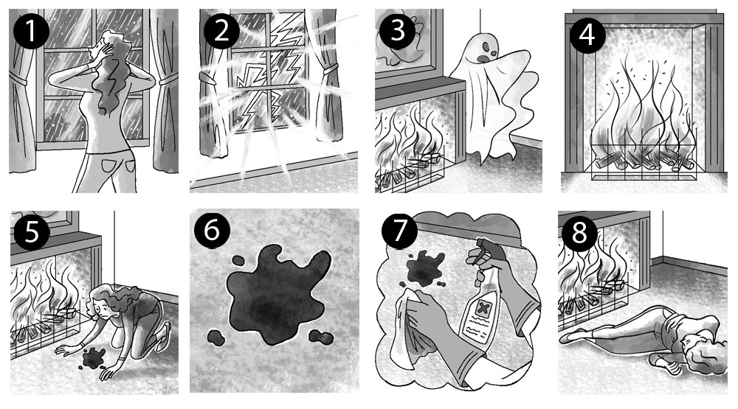

7 | Complete the text with the words in the box. There are three extra words.

majority rebellion incidents founded independent government autonomy

After Ireland became ⁽¹⁾__________________, there was a period called ‘the Troubles’. There were lots of terrible ⁽²⁾__________________ and it wasn’t until 1998 that the Irish people got a chance to vote on a peace deal. The ⁽³⁾__________________ of Irish people voted in favour of the Good Friday Agreement. After that the British ⁽⁴⁾__________________ called their soldiers home.

8 | Circle the correct option to complete the sentences.

The passengers on the boat became more ⁽¹⁾distant / destroyed / desperate as the storm got worse.
The plane had to make a(n) ⁽²⁾emergency / ambulance / pilot landing in a field.
We realised that the coach was ⁽³⁾under / on / in trouble when we got onto the motorway.
A large explosion blew ⁽⁴⁾up / on / off the whole building.
We had to ⁽⁵⁾evaluate / evacuate / even the building because of a fire.
Emergency services ⁽⁶⁾returned / rescued / regretted passengers from the sinking ship.
The bus collided ⁽⁷⁾to / on / with a lorry in the town centre.

9 | Complete the dialogue with the words in the box. There are three extra words.

proper stunning improve intention fluent cheer foreigner nonsense interfere

Rachel | I really want to be ⁽¹⁾_______________ in Spanish. I still feel like a ⁽²⁾_______________ when I visit Barcelona.
Zara | That’s ⁽³⁾_______________! You speak Spanish really well.
Rachel | I want to ⁽⁴⁾_______________ my pronunciation so that I can get a ⁽⁵⁾_______________ job on my year abroad.
Zara | Well, if that’s your ⁽⁶⁾_______________, then you should start applying for jobs now.

10 | Complete the dialogue with the words in the box. There are three extra words.

confidently deserve employer responsible for confident advice positive
unemployed ambitions smart memorise

Sam | Aunty Mary, you’re ⁽¹⁾________________________ doing interviews for new staff at your company, aren’t you?
Mary | Yes, I am.
Sam | Well, I’ve got a job interview for a position as a waiter next week. Have you got any ⁽²⁾________________________ for me?
Mary | Yes, of course. It’s important to find out as much as you can about the job and the ⁽³⁾________________________ before the interview. And make sure you can talk ⁽⁴⁾________________________ about why you want the job. Don’t ⁽⁵⁾________________________ your answer though because it’s best to sound natural.
Sam | What other questions do you think they might ask me?
Mary | They might ask why you think you ⁽⁶⁾________________________ the job. Also, they might want to know what your ⁽⁷⁾________________________ are for the future.
Sam | Well, that one is easy! I just don’t want to be ⁽⁸⁾________________________ any more!

11 | Write the correct jobs under the pictures.

1 | 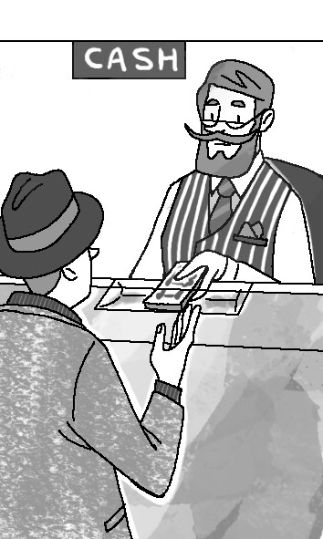  ________________________ |  | 2 | 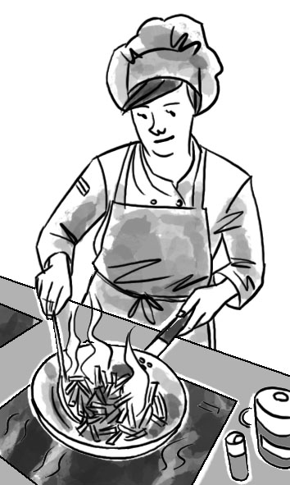  ________________________ |  | 3 | 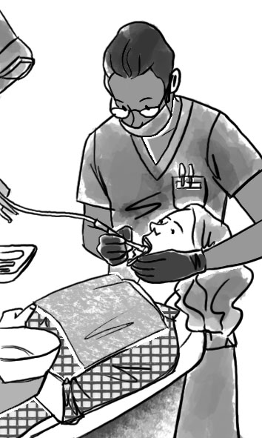  ________________________
4 | 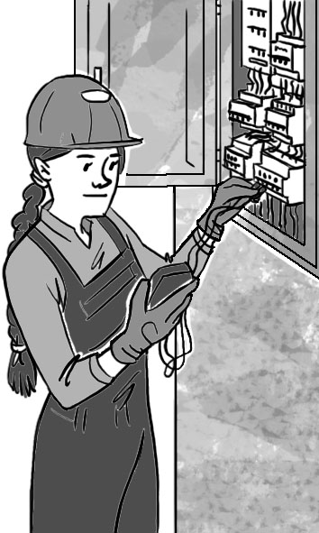  ________________________ |  | 5 | 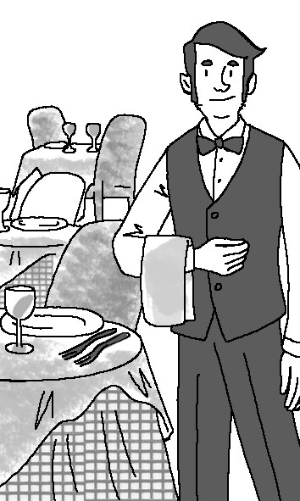  ________________________ |  | 6 | 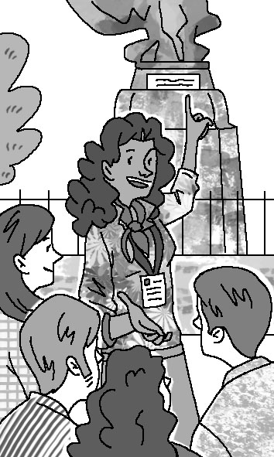  ________________________
7 | 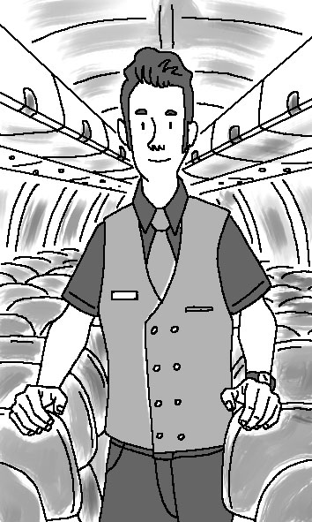  ________________________ |  | 8 | 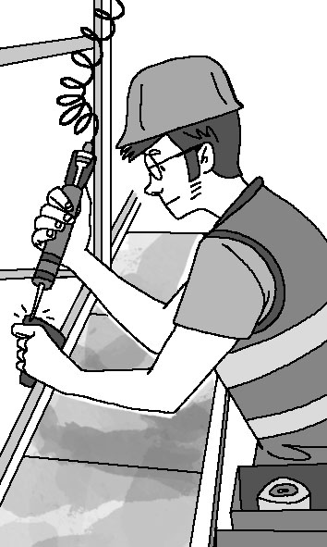  ________________________ |  | 9 | 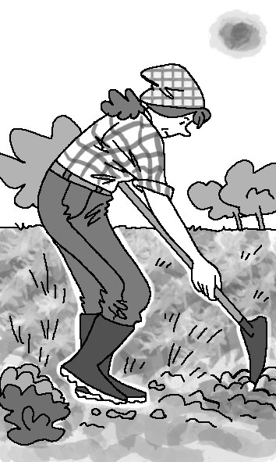  ________________________
10 | 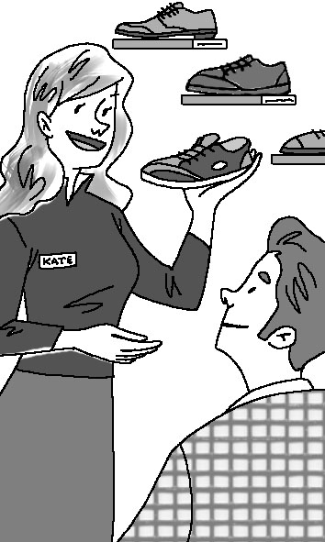  ________________________

Language in context
12 | Circle the correct form to complete the sentences.

1 | Sarah bought / had bought the detective novel because she hadn’t read it before.
2 | When the detective writer turned on his computer, he found that someone hacked / had hacked into his files.
3 | The detective was worried because the police hadn’t found / didn’t find any evidence at the crime scene.
4 | By the time the police arrived at the crime scene, the criminals had disappeared / disappeared.
5 | By the time Detective Shaw arrived / had arrived at the police station, the inspector had started the meeting.
6 | The witness had been / was sure that she had seen the suspect at the crime scene.
7 | The criminal was sent to prison because he stole / had stolen some jewellery from his neighbour.
8 | I reported the crime, but another witness had told / told the police already.

13 | Complete the text with the past simple or past continuous form of the verbs in brackets.

Hi Sara,
We’re just back from our weekend in Dublin. We had an amazing time while we ⁽¹⁾___________________________ (stay) there!
On Saturday, we ⁽²⁾___________________________ (go) to an outdoor art gallery in the National Botanic Gardens. While we ⁽³⁾___________________________ (look) at the garden paintings, it started to rain! But it ⁽⁴⁾___________________________ (not last) for long and in the evening we went to an outdoor concert at Iveagh Gardens. I really enjoyed looking up at the stars while I ⁽⁵⁾___________________________ (listen) to the music! My brother ⁽⁶⁾___________________________ (not like) it much though. He ⁽⁷⁾___________________________ (not listen) to the music, because he ⁽⁸⁾___________________________ (play) games on his phone!
Unfortunately our plane was delayed for two hours coming home. But while we ⁽⁹⁾___________________________ (wait) at the airport, I ⁽¹⁰⁾___________________________ (bump into) an old friend. While all the other passengers ⁽¹¹⁾___________________________ (complain) about the delay, I ⁽¹²⁾___________________________ (catch up) with my friend!
See you soon,
Lisa

14 | Complete the sentences with the past simple or the past perfect form of the verbs in brackets.

1 | The criminal __________________ (find) guilty and sent to prison. He __________________ (steal) some jewellery from his neighbour.
2 | The detective writer __________________ (turn on) his computer and something was wrong. Someone __________________ (hack) into his files.
3 | The witness __________________ (recognise) the suspect. She __________________ (see) him at the crime scene.
4 | Sarah __________________ (buy) the detective novel. She __________________ (not / read) it before.
5 | Detective Shaw __________________ (know) the criminal. She __________________ (meet) her before.
6 | The police __________________ (not / find) anything useful at the crime scene. So the detective __________________ (be) worried now because he didn’t have any evidence he could use.
7 | I __________________ (report) the crime, but the police already knew about it. Someone __________________ (tell) the police already.
8 | The criminals __________________ (run) away when the police __________________ (reach) the crime scene.

15 | Complete the sentences with said that or told.

1 | The editor _______________ the reporters that he was retiring.
2 | The tour guide _______________ the tourists that the park had been opened in 1963.
3 | Tom _______________ his car had collided with a lorry.
4 | Valerie _______________ her building had been evacuated the day before.
5 | The pilot _______________ the passengers that the plane was delayed.
6 | Sarah _______________ she wanted to visit the museum.
7 | The students _______________ their professor that they didn’t understand.
8 | The street vendor _______________ he sold the best hot dogs in New York.
9 | The historian _______________ his students about Frank Lloyd Wright.
10 | The architect _______________ his new designs would be ready the following day.

16 | Complete the reported questions.

1 | “Why do you want to work in a bookshop?”  She asked me _____________________________________________________________________
2 | “What have you studied at university?”  She asked me _____________________________________________________________________
3 | “Do you know Spanish?”  She asked me _____________________________________________________________________
4 | “What’s your favourite book?”  She asked me _____________________________________________________________________
5 | “Who’s your favourite author?”  She asked me _____________________________________________________________________
6 | “What do you like doing in your free time?”  She asked me _____________________________________________________________________
7 | “Do you like working in a team?”  She asked me _____________________________________________________________________
8 | “How did you find out about this job?”  She asked me _____________________________________________________________________

17 | Put the sentences into reported speech.

1 | “I want to visit this museum in two days,” said Sarah.  Sarah said that ____________________________________________________________________.
2 | “My car collided with a lorry three days ago,” Tom said.  Tom said that ______________________________________________________________________.
3 | “The park was opened in 1963,” said the tour guide.  The tour guide said that ______________________________________________________________.
4 | The architect said, “My new designs will be ready tomorrow.”  The architect said that _______________________________________________________________.
5 | “I sell the best hot dogs in New York City,” the street vendor said.  The street vendor said that ___________________________________________________________.
6 | The editor said, “I am retiring next month.”  The editor said that _________________________________________________________________.
7 | “Unfortunately the plane is delayed,” the pilot said.  The pilot said that __________________________________________________________________.
8 | “My building has been evacuated yesterday,” Valerie said.  Valerie said that ____________________________________________________________________.
9 | “We don’t understand this,” the students said.  The students said that _______________________________________________________________.

18 | Complete the text with the past continuous form of the verbs in brackets.

Hi Sara,
We’re just back from our weekend in Dublin. We had an amazing time while we ⁽¹⁾______________________________ (stay) there!
On Saturday, we went to an outdoor art gallery in the National Botanic Garden. While we ⁽²⁾______________________________ (look) at the garden paintings, it started to rain! But it didn’t last for long and in the evening we went to an outdoor concert at Iveagh Gardens. I really enjoyed looking up at the stars while I ⁽³⁾______________________________ (listen) to the music! My brother didn’t like it much though. He ⁽⁴⁾______________________________ (not / listen) to the music, because he ⁽⁵⁾______________________________ (play) on his phone!
Unfortunately our plane was delayed for two hours coming home. But while we ⁽⁶⁾______________________________ (wait) at the airport, I bumped into an old friend. While all the other passengers ⁽⁷⁾______________________________ (complain) about the delay, I ⁽⁸⁾______________________________ (catch up) with my friend!
See you soon,
Lisa

19 | Read and report the pilot’s message from the plane.

“¹ Our plane is in trouble. ² The engine is making strange noises. ³ We can’t make it to the airport. ⁴ We must make an emergency landing. ⁵ I’ll land the plane here on this river. ⁶ I landed in a field last year. ⁷ I haven’t landed on a river before. ⁸ But I know what I’m doing. ⁹ I’m sure it will be fine.”

1 | The pilot said that __________________________________________________________________.
2 | She said that ______________________________________________________________________.
3 | She said that ______________________________________________________________________.
4 | She said that ______________________________________________________________________.
5 | She said that ______________________________________________________________________.
6 | She said that ______________________________________________________________________.
7 | She said that ______________________________________________________________________.
8 | She said that ______________________________________________________________________.
9 | She said that ______________________________________________________________________.

20 | Read the pilot’s message from the plane. Then complete the reported message below.

“Our plane is in trouble. The engine is making strange noises. We can’t make it to the airport. We have to make an emergency landing. We will land the plane here on this river. I landed a plane in a field last year. I haven’t landed on a river before, but my co-pilot has done several sea landings. We know what we are doing, so I am sure that we will be fine.”

The pilot said that ⁽¹⁾________________________ plane ⁽²⁾________________________ in trouble. She said that the engine ⁽³⁾________________________ strange noises. She said that they ⁽⁴⁾________________________ it to the airport. She said that they ⁽⁵⁾________________________ make an emergency landing. She said that ⁽⁶⁾________________________ would land the plane ⁽⁷⁾________________________ on ⁽⁸⁾________________________ river. She said that she ⁽⁹⁾________________________ a plane in a field ⁽¹⁰⁾________________________. She said that she ⁽¹¹⁾________________________ on a river before, but ⁽¹²⁾________________________ co-pilot ⁽¹³⁾________________________ several sea landings. She said that they ⁽¹⁴⁾________________________ what they ⁽¹⁵⁾________________________, so ⁽¹⁶⁾________________________ was sure that they ⁽¹⁷⁾________________________ fine.

21 | Sophie interviewed Harry. Write the questions either in direct or indirect speech.

1 | direct: “What do you like doing in your free time?”  indirect: __________________________________________________________________________
2 | indirect: She asked him who his favourite author was.  direct: ___________________________________________________________________________
3 | indirect: She asked him if he knew Spanish.  direct: ___________________________________________________________________________
4 | direct: “What have you studied at university?”  indirect: __________________________________________________________________________
5 | direct: “How did you find out about this job?”  indirect: __________________________________________________________________________
6 | indirect: She asked him what his favourite book was.  direct: ___________________________________________________________________________
7 | direct: “Why do you want to work in a bookshop?”  indirect: She asked him _____________________________________________________________
8 | indirect: She asked him if he liked working in a team.  direct: ___________________________________________________________________________

