Words in context
1 | Read and complete the email with the words in the box. There are two extra words.

crop down majority Famine cheer thought intention support interfere
starving cattle independent landlords

Hi Adam,
I’m having a great time with my exchange friend Ben in Dublin!
Yesterday we visited the Dublin Memorial to the ⁽⁰⁾Famine of 1846 and I learned a lot about that period of history. In 1845 and 1846, the potato ⁽¹⁾crop in Ireland failed. This meant that many people were ⁽²⁾starving because they didn’t have enough food. The ⁽³⁾landlords made things worse because they sold their grain and ⁽⁴⁾cattle to England. The British government didn’t export food to Ireland because they thought that they shouldn’t ⁽⁵⁾interfere with the economy. As a result, many people in Ireland died or left the country forever.
Ben’s family told me about recent Irish history, too. Ben’s grandfather took part in several rebellions, which were put ⁽⁶⁾down by the British. But in 1998, the ⁽⁷⁾majority of Irish people voted for the Good Friday Agreement, which finally brought peace to the island.
Ben is taking me to watch a football match tomorrow. It wasn’t our ⁽⁸⁾intention to go, but Ben got free tickets from his friend! I’m not sure who I’ll ⁽⁹⁾cheer for yet! I’ll probably just ⁽¹⁰⁾support the team who are winning!
See you soon,
Matt

2 | Complete the text with the words in the box. There are three extra words.

busy critics bravery runway nearby rewarded wings controller on duty
treatment injuries immigrants

I’m from a family of ⁽¹⁾immigrants who came to the USA over 50 years ago. My family origins are in Rome, but I consider myself to be an American. When I was a kid, I always wanted to be a pilot. So I worked hard and in the end I was ⁽²⁾rewarded with a great job! I’m always very ⁽³⁾busy at work, but I love what I do!
I had a difficult flight last year, but luckily I was ⁽⁴⁾on duty with an excellent co-pilot. We took off from LaGuardia and everything was fine, but then I realised that there was a problem with one of the ⁽⁵⁾wings of the plane. We decided to land at ⁽⁶⁾nearby Teterboro airport so that we could check that everything was OK. It was a difficult and very bumpy landing, but we did it. Several passengers needed medical ⁽⁷⁾treatment when we arrived, but luckily nobody was seriously injured. We were rewarded for our ⁽⁸⁾bravery by the airline. But there were also some ⁽⁹⁾critics who said that we shouldn’t have taken off in the first place. I was just glad that nobody was seriously injured.

3 | Complete the dialogue with the words in the box. There are three extra words.

eye prove think escaped took up mentioned committed relatives excellent
took over consider look

Raoul | This restaurant is ⁽¹⁾excellent, isn’t it?
Harriet | Yes, it is. It reminds me of one of my ⁽²⁾relatives. My uncle Philip loved Korean food.
Raoul | You’ve never ⁽³⁾mentioned him before.
Harriet | Well, we don’t talk about him very much because he ⁽⁴⁾committed a crime a few years ago.
Raoul | Really? What did he do?
Harriet | He ⁽⁵⁾took over a company abroad and we think that he hid money there to avoid paying tax.
Raoul | That’s terrible!
Harriet | I know, he was arrested but they couldn’t ⁽⁶⁾prove that he’d done anything wrong so he ⁽⁷⁾escaped going to prison. You can’t choose your family, can you? Anyway, could you keep a(n) ⁽⁸⁾eye on my bag while I go to the toilet? You never know what criminals might be around!
Raoul | Yes, of course. I shall look at the menu and ⁽⁹⁾consider what I’m going to have for dessert!

4 | Complete the text with the words from the box. There are two extra words.

job satisfaction ups and downs cash bonus salary working hours think up
pros and cons deadlines earn

There are a lot of different things to think about when it comes to looking for a new job. I always try to consider the ⁽¹⁾pros and cons of a new position – you need to think about the bad things as well as the good things!
The ⁽²⁾salary of a new job is important – we all need to ⁽³⁾earn enough money to live on every month and a(n) ⁽⁴⁾bonus at the end of the year is always helpful too!
But money isn’t everything. ⁽⁵⁾Working hours are also something to consider – I don’t want to spend every evening and weekend in the office trying to meet impossible ⁽⁶⁾deadlines.
But the most important thing for me is ⁽⁷⁾job satisfaction – I want to enjoy my work! I’d really like a creative job where I can ⁽⁸⁾think up ideas for new projects!

5 | Complete the dialogue with the words from the box. There are two extra words.

witnesses suspect crime evidence hacker criminal illegal mystery
blackmail victim weapons stole

Jasmine | I’m just reading an article about a horrible ⁽¹⁾crime that was committed in our town.
Eliot | Really? What happened?
Jasmine | Well, a thief ⁽²⁾stole a woman’s laptop from her bag when she was on the train. It had all the woman’s personal information on it, so the ⁽³⁾criminal tried to use this information to ⁽⁴⁾blackmail her. He said he’d tell everyone her personal information.
Eliot | That’s awful. What did the ⁽⁵⁾victim do about it?
Jasmine | She went straight to the police, but they couldn’t do anything because they didn’t have any ⁽⁶⁾evidence. A few days later, another laptop was taken on the same train. This time, there were several ⁽⁷⁾witnesses who saw exactly what happened. So the police arrested the ⁽⁸⁾suspect and found over 25 laptops at his flat! They also found some ⁽⁹⁾weapons including several knives.
Eliot | So what happened in the end?
Jasmine | Well, the man said that he hadn’t done anything ⁽¹⁰⁾illegal because he was only borrowing the laptops.
Eliot | No way! Surely the police didn’t believe that.
Jasmine | Of course not, he was sent to prison yesterday.

6 | Use the pictures below to help you to complete the story.

As the storm got worse, the ⁽¹⁾thunder became louder and louder in Mary's ears. A ⁽²⁾flash of lightning suddenly lit up the dark room.
"I hope this house isn't ⁽³⁾haunted," she said to herself. She noticed something strange near the ⁽⁴⁾fireplace. She ⁽⁵⁾knelt on the floor to look for clues.
"This mark is definitely a ⁽⁶⁾bloodstain," she said. "Someone has tried to clean it with ⁽⁷⁾stain remover."
Suddenly, there was a loud noise behind her. Mary turned around and was so shocked by what she saw that she immediately ⁽⁸⁾fainted.
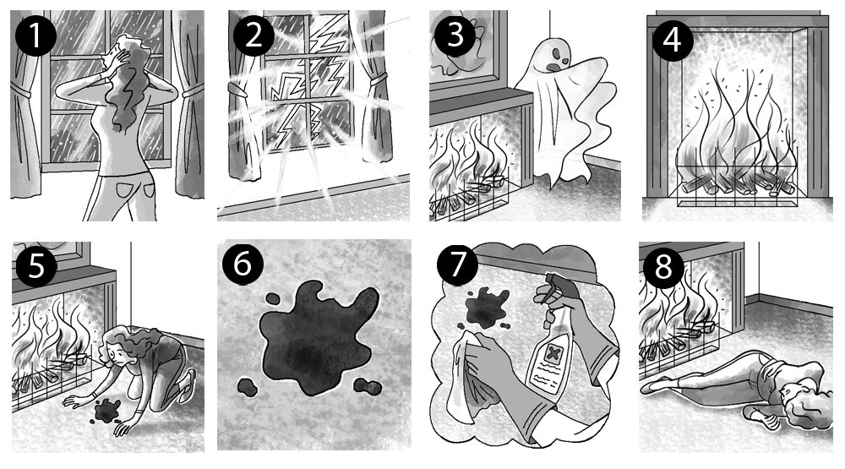

7 | Complete the text with the words in the box. There are three extra words.

majority rebellion incidents founded independent government autonomy

After Ireland became ⁽¹⁾independent, there was a period called ‘the Troubles’. There were lots of terrible ⁽²⁾incidents and it wasn’t until 1998 that the Irish people got a chance to vote on a peace deal. The ⁽³⁾majority of Irish people voted in favour of the Good Friday Agreement. After that the British ⁽⁴⁾government called their soldiers home.

8 | Circle the correct option to complete the sentences.

The passengers on the boat became more ⁽¹⁾distant / destroyed / desperate as the storm got worse.
The plane had to make a(n) ⁽²⁾emergency / ambulance / pilot landing in a field.
We realised that the coach was ⁽³⁾under / on / in trouble when we got onto the motorway.
A large explosion blew ⁽⁴⁾up / on / off the whole building.
We had to ⁽⁵⁾evaluate / evacuate / even the building because of a fire.
Emergency services ⁽⁶⁾returned / rescued / regretted passengers from the sinking ship.
The bus collided ⁽⁷⁾to / on / with a lorry in the town centre.

9 | Complete the dialogue with the words in the box. There are three extra words.

proper stunning improve intention fluent cheer foreigner nonsense interfere

Rachel | I really want to be ⁽¹⁾fluent in Spanish. I still feel like a ⁽²⁾foreigner when I visit Barcelona.
Zara | That’s ⁽³⁾nonsense! You speak Spanish really well.
Rachel | I want to ⁽⁴⁾improve my pronunciation so that I can get a ⁽⁵⁾proper job on my year abroad.
Zara | Well, if that’s your ⁽⁶⁾intention, then you should start applying for jobs now.

10 | Complete the dialogue with the words in the box. There are three extra words.

confidently deserve employer responsible for confident advice positive
unemployed ambitions smart memorise

Sam | Aunty Mary, you’re ⁽¹⁾responsible for doing interviews for new staff at your company, aren’t you?
Mary | Yes, I am.
Sam | Well, I’ve got a job interview for a position as a waiter next week. Have you got any ⁽²⁾advice for me?
Mary | Yes, of course. It’s important to find out as much as you can about the job and the ⁽³⁾employer before the interview. And make sure you can talk ⁽⁴⁾confidently about why you want the job. Don’t ⁽⁵⁾memorise your answer though because it’s best to sound natural.
Sam | What other questions do you think they might ask me?
Mary | They might ask why you think you ⁽⁶⁾deserve the job. Also, they might want to know what your ⁽⁷⁾ambitions are for the future.
Sam | Well, that one is easy! I just don’t want to be ⁽⁸⁾unemployed any more!

11 | Write the correct jobs under the pictures.

1 | 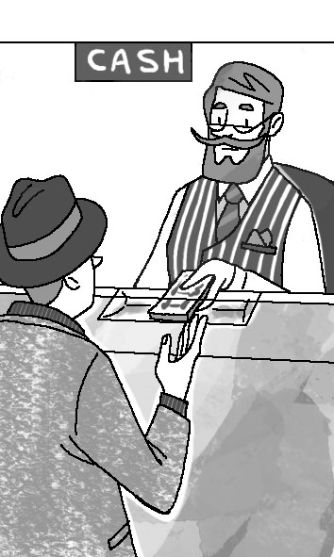  bank clerk |  | 2 | 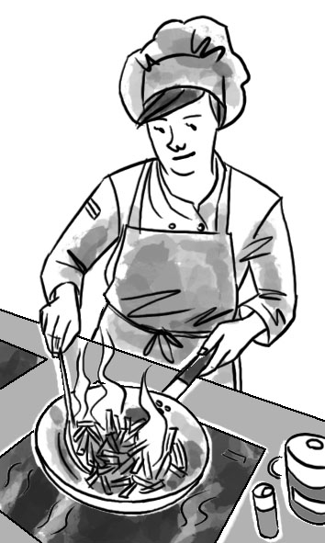  cook |  | 3 | 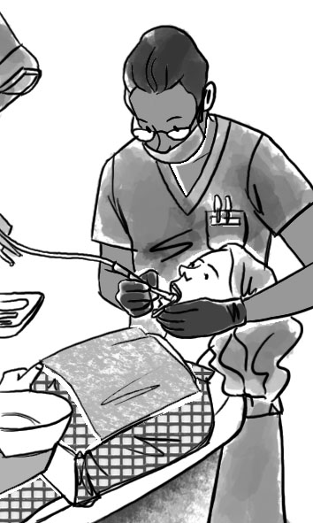  dentist
4 | 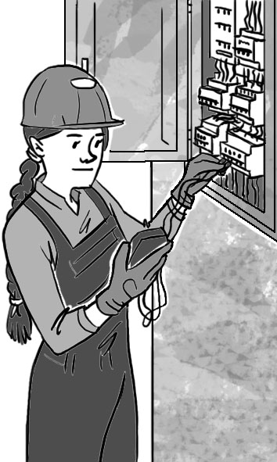  electrician |  | 5 | 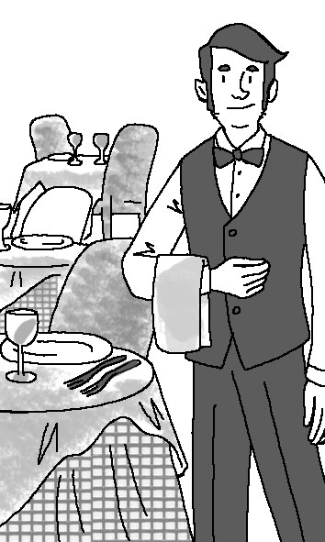  waiter |  | 6 | 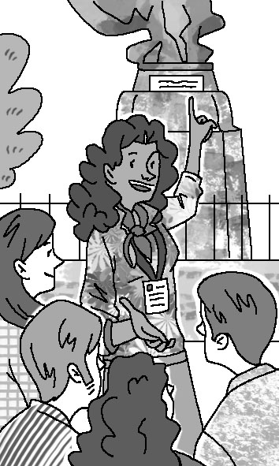  tour guide
7 | 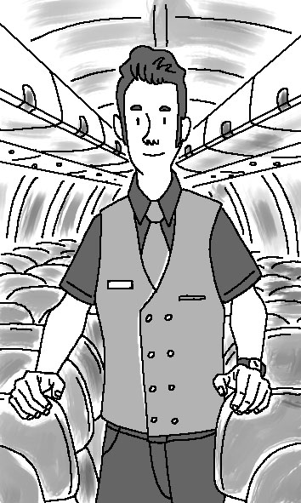  flight attendant |  | 8 | 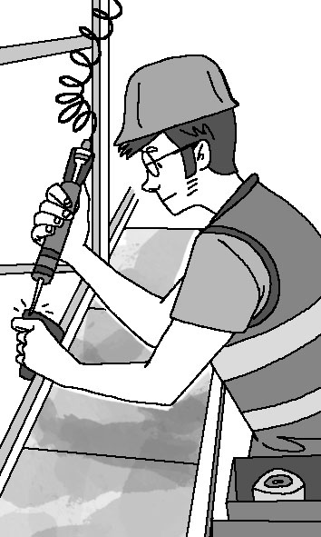  factory worker / mechanic |  | 9 | 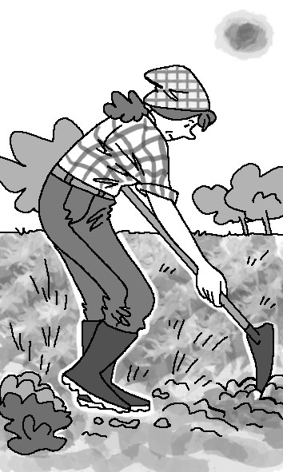  farmer
10 | 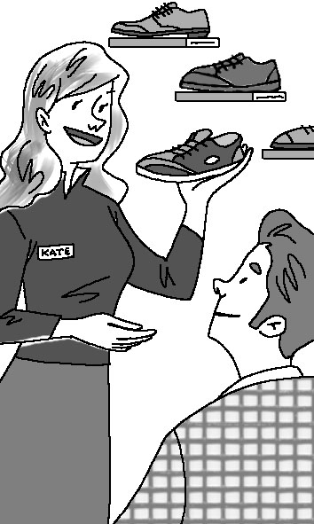  shop assistant

Language in context
12 | Circle the correct form to complete the sentences.

1 | Sarah bought / had bought the detective novel because she hadn’t read it before.
2 | When the detective writer turned on his computer, he found that someone hacked / had hacked into his files.
3 | The detective was worried because the police hadn’t found / didn’t find any evidence at the crime scene.
4 | By the time the police arrived at the crime scene, the criminals had disappeared / disappeared.
5 | By the time Detective Shaw arrived / had arrived at the police station, the inspector had started the meeting.
6 | The witness had been / was sure that she had seen the suspect at the crime scene.
7 | The criminal was sent to prison because he stole / had stolen some jewellery from his neighbour.
8 | I reported the crime, but another witness had told / told the police already.

13 | Complete the text with the past simple or past continuous form of the verbs in brackets.

Hi Sara,
We’re just back from our weekend in Dublin. We had an amazing time while we ⁽¹⁾were staying (stay) there!
On Saturday, we ⁽²⁾went (go) to an outdoor art gallery in the National Botanic Gardens. While we ⁽³⁾were looking (look) at the garden paintings, it started to rain! But it ⁽⁴⁾didn’t last / did not last (not last) for long and in the evening we went to an outdoor concert at Iveagh Gardens. I really enjoyed looking up at the stars while I ⁽⁵⁾was listening (listen) to the music! My brother ⁽⁶⁾didn’t like / did not like (not like) it much though. He ⁽⁷⁾wasn’t listening / was not listening / didn’t listen / did not listen (not listen) to the music, because he ⁽⁸⁾was playing (play) games on his phone!
Unfortunately our plane was delayed for two hours coming home. But while we ⁽⁹⁾were waiting (wait) at the airport, I ⁽¹⁰⁾bumped into (bump into) an old friend. While all the other passengers ⁽¹¹⁾were complaining (complain) about the delay, I ⁽¹²⁾was catching up (catch up) with my friend!
See you soon,
Lisa

14 | Complete the sentences with the past simple or the past perfect form of the verbs in brackets.

1 | The criminal was found (find) guilty and sent to prison. He had stolen / ’d stolen (steal) some jewellery from his neighbour.
2 | The detective writer turned on (turn on) his computer and something was wrong. Someone had hacked (hack) into his files.
3 | The witness recognised (recognise) the suspect. She had seen / ’d seen (see) him at the crime scene.
4 | Sarah bought (buy) the detective novel. She hadn’t read / had not read (not / read) it before.
5 | Detective Shaw knew (know) the criminal. She had met / ’d met (meet) her before.
6 | The police hadn’t found / had not found (not / find) anything useful at the crime scene. So the detective was (be) worried now because he didn’t have any evidence he could use.
7 | I reported (report) the crime, but the police already knew about it. Someone had told (tell) the police already.
8 | The criminals had run (run) away when the police reached (reach) the crime scene.

15 | Complete the sentences with said that or told.

1 | The editor told the reporters that he was retiring.
2 | The tour guide told the tourists that the park had been opened in 1963.
3 | Tom said that his car had collided with a lorry.
4 | Valerie said that her building had been evacuated the day before.
5 | The pilot told the passengers that the plane was delayed.
6 | Sarah said that she wanted to visit the museum.
7 | The students told their professor that they didn’t understand.
8 | The street vendor said that he sold the best hot dogs in New York.
9 | The historian told his students about Frank Lloyd Wright.
10 | The architect said that his new designs would be ready the following day.

16 | Complete the reported questions.

1 | “Why do you want to work in a bookshop?”  She asked me why I wanted to work in a bookshop.
2 | “What have you studied at university?”  She asked me what I had studied at university.
3 | “Do you know Spanish?”  She asked me if I knew Spanish.
4 | “What’s your favourite book?”  She asked me what my favourite book was.
5 | “Who’s your favourite author?”  She asked me who my favourite author was.
6 | “What do you like doing in your free time?”  She asked me what I liked doing in my free time.
7 | “Do you like working in a team?”  She asked me if I liked working in a team.
8 | “How did you find out about this job?”  She asked me how I had found out about that job.

17 | Put the sentences into reported speech.

1 | “I want to visit this museum in two days,” said Sarah.  Sarah said that she wanted to visit that museum two days later / she wanted to visit that museum in two days.
2 | “My car collided with a lorry three days ago,” Tom said.  Tom said that his car had collided with a lorry three days before.
3 | “The park was opened in 1963,” said the tour guide.  The tour guide said that the park had been opened in 1963.
4 | The architect said, “My new designs will be ready tomorrow.”  The architect said that his/her new designs would be ready the following day.
5 | “I sell the best hot dogs in New York City,” the street vendor said.  The street vendor said that he sold the best hot dogs in New York City.
6 | The editor said, “I am retiring next month.”  The editor said that he/she was retiring the following month.
7 | “Unfortunately the plane is delayed,” the pilot said.  The pilot said that unfortunately the plane was delayed.
8 | “My building has been evacuated yesterday,” Valerie said.  Valerie said that her building had been evacuated the day before.
9 | “We don’t understand this,” the students said.  The students said that they didn’t understand that.

18 | Complete the text with the past continuous form of the verbs in brackets.

Hi Sara,
We’re just back from our weekend in Dublin. We had an amazing time while we ⁽¹⁾were staying (stay) there!
On Saturday, we went to an outdoor art gallery in the National Botanic Garden. While we ⁽²⁾were looking (look) at the garden paintings, it started to rain! But it didn’t last for long and in the evening we went to an outdoor concert at Iveagh Gardens. I really enjoyed looking up at the stars while I ⁽³⁾was listening (listen) to the music! My brother didn’t like it much though. He ⁽⁴⁾wasn’t listening / was not listening (not / listen) to the music, because he ⁽⁵⁾was playing (play) on his phone!
Unfortunately our plane was delayed for two hours coming home. But while we ⁽⁶⁾were waiting (wait) at the airport, I bumped into an old friend. While all the other passengers ⁽⁷⁾were complaining (complain) about the delay, I ⁽⁸⁾was catching up (catch up) with my friend!
See you soon,
Lisa

19 | Read and report the pilot’s message from the plane.

“¹ Our plane is in trouble. ² The engine is making strange noises. ³ We can’t make it to the airport. ⁴ We must make an emergency landing. ⁵ I’ll land the plane here on this river. ⁶ I landed in a field last year. ⁷ I haven’t landed on a river before. ⁸ But I know what I’m doing. ⁹ I’m sure it will be fine.”

1 | The pilot said that their plane was in trouble.
2 | She said that the engine was making strange noises.
3 | She said that they couldn’t make it to the airport.
4 | She said that they had to make an emergency landing.
5 | She said that she would land the plane there on that river.
6 | She said that she had landed in a field the year before.
7 | She said that she hadn’t landed on a river before.
8 | She said that she knew what she was doing.
9 | She said that she was sure it would be fine.

20 | Read the pilot’s message from the plane. Then complete the reported message below.

“Our plane is in trouble. The engine is making strange noises. We can’t make it to the airport. We have to make an emergency landing. We will land the plane here on this river. I landed a plane in a field last year. I haven’t landed on a river before, but my co-pilot has done several sea landings. We know what we are doing, so I am sure that we will be fine.”

The pilot said that ⁽¹⁾their plane ⁽²⁾was in trouble. She said that the engine ⁽³⁾was making strange noises. She said that they ⁽⁴⁾couldn’t make it to the airport. She said that they ⁽⁵⁾had to make an emergency landing. She said that ⁽⁶⁾they would land the plane ⁽⁷⁾there on ⁽⁸⁾that river. She said that she ⁽⁹⁾had landed a plane in a field ⁽¹⁰⁾the year before. She said that she ⁽¹¹⁾hadn’t landed on a river before, but ⁽¹²⁾her co-pilot ⁽¹³⁾had done several sea landings. She said that they ⁽¹⁴⁾knew what they ⁽¹⁵⁾were doing, so ⁽¹⁶⁾she was sure that they ⁽¹⁷⁾would be fine.

21 | Sophie interviewed Harry. Write the questions either in direct or indirect speech.

1 | direct: “What do you like doing in your free time?”  indirect: She asked him what he liked doing in his free time.
2 | indirect: She asked him who his favourite author was.  direct: “Who’s your favourite author?”
3 | indirect: She asked him if he knew Spanish.  direct: “Do you know Spanish?”
4 | direct: “What have you studied at university?”  indirect: She asked him what he had studied at university.
5 | direct: “How did you find out about this job?”  indirect: She asked him how he had found out about that job.
6 | indirect: She asked him what his favourite book was.  direct: “What’s your favourite book?”
7 | direct: “Why do you want to work in a bookshop?”  indirect: She asked him why he wanted to work in a bookshop.
8 | indirect: She asked him if he liked working in a team.  direct: “Do you like working in a team?”

