Listening
1 | Listen and complete the sentences with 1–4 words. |  | 2/1

1 | The speaker’s first comic was one about ______________________________.
2 | The story involved ______________________________ that exploded.
3 | The speaker really wanted to ______________________________ next.
4 | The speaker has a collection of about ______________________________.
5 | Comics bring back memories ______________________________.
6 | The speaker describes her obsession as a ______________________________.
7 | She says other people think she spends ______________________________ time on her hobby.
8 | She loves the way her comics ______________________________.
9 | She thinks her hobby has been a good way of ______________________________.
10 | Her most valuable comic is worth about ______________________________.

2 | Listen to Liz and Jerry. Then answer the questions. What do the speakers say? |  | 2/2

1 | What did Jerry find surprising about the Maori’s tattoos?  _________________________________________________________________________________
2 | Why might Maori people think that Jerry is crazy?  _________________________________________________________________________________
3 | Since when have Maori tattoos existed?  _________________________________________________________________________________
4 | Why are all Maori tattoos different? Name all three reasons mentioned.  _________________________________________________________________________________
5 | What did James Cook think about Maori tattoos?  _________________________________________________________________________________
6 | Who of the Maori people were the first to have tattoos?  _________________________________________________________________________________
7 | What did the wounds of a fresh tattoo make the Maori think of?  _________________________________________________________________________________
8 | Today, which Maoris are normally not allowed to have tattoos?  _________________________________________________________________________________
9 | In the past, which Maoris were not allowed to have tattoos?  _________________________________________________________________________________
10 | Why can only Maori people have Moko tattoos?  _________________________________________________________________________________
11 | Where do people have Kiri Tuhi tattoos?  _________________________________________________________________________________
12 | Why do Maori people not want to cry?  _________________________________________________________________________________
13 | What does Liz think about that?  _________________________________________________________________________________

3 | Listen to three teenagers talking about their piercings. Choose the correct answer. What do the speakers say? |  | 2/3

1 | What is Emily’s newest piercing?  An ear piercing.  A navel piercing.  A nose piercing.
2 | How did Emily’s mum react to her daughter’s newest piercing?  She said she was happy that Emily had no problems.  First she was shocked.  She told her it looked good.
3 | What does Emily say about Anna? – She got her piercing because  she wanted to make her parents angry.  her mum always supports her.  she wanted to look good.
4 | Who did Emily look for a good piercing shop with?  Anna.  She did it all alone.  Her mum.
5 | What is special about Danielle’s first piercings?  She cried like a baby because it hurt so much.  She can’t remember waiting for them for months.  She got them without being asked before.
6 | Why did Danielle get her ears pierced?  Because she was bored while waiting for her mum.  Because her grandfather had bought earrings.  Because she was born in Czech Republic.
7 | What was her dad’s first reaction after she got her ear piercings?  He thought they looked good.  He felt proud.  He wasn’t very happy.
8 | Who told Barbara that a navel piercing looks good?  Her parents.  Nobody.  Her friends.
9 | Why did Barbara get the piercing?  Most of her friends got a piercing too.  She just wanted to do it, without much reason.  She felt very excited to do it.
10 | What did Barbara have to do because of her navel piercing?  Sleep in an uncomfortable position.  Clean her navel every day.  Remove some of her T-shirts.

4 | Listen and choose the correct answer. What does the speaker say? |  | 2/4

1 | What does Samuel say about his coffee farm?  His father started selling coffee beans in 1964.  He is the only one who picks its coffee beans.  He has more coffee trees than his father.
2 | What did Samuel’s family use the Fair Trade money for?  Buying food.  Lots of wood.  An oven.
3 | What effect does climate change have on Samuel’s farm?  Coffee trees produce less beans every year.  Things go wrong and people are helpless.  You never know.
4 | What does Samuel say about his farmers?  They get sports training.  They learn how to keep healthy.  They learn how to do their work better.
5 | What else does Samuel say?  His friends are also farmers.  He can ask for extra money.  Fair Trade means more beans growing on the trees.
6 | How else does Fair Trade money help?  A building was made new again.  Samuel’s grandson can pay the money for his school.  All the children get money for their future.
7 | What didn’t Samuel know in the past?  Which retailers buy his coffee.  How the coffee leaves his plantation.  How much money he got for his coffee.
8 | What’s the situation like now?  Farmers know where to buy better coffee beans.  Samuel gets money for his coffee from around the world.  The farmers feel glad when they can bring their products to a department.
9 | What do we learn about Samuel?  He sells his coffee beans in Kenya.  He and his friends produce coffee for 2.25 billion cups.  He also goes to a huge market to sell his beans.
10 | Who does Samuel say ‘Asante Sana’ to?  To helpers.  To his family.  To the listener.

5 | Listen and answer the questions. What do the speakers say? |  | 2/5

1 | What is Emma looking for?  _________________________________________________________________________________
2 | How many people around the world live on less than one dollar a day?  _________________________________________________________________________________
3 | How many people live on less than two dollars a day?  _________________________________________________________________________________
4 | What other Fair Trade products does Emma mention? Name three.  _________________________________________________________________________________
5 | How does it help the farmers if we buy Fair Trade products?  _________________________________________________________________________________
6 | What Fair Trade companies help local communities?  _________________________________________________________________________________
7 | How does Fair Trade protect children?  _________________________________________________________________________________
8 | What type of people say they are willing to buy Fair Trade products?  _________________________________________________________________________________
9 | How many countries around the world sell Fair Trade products?  _________________________________________________________________________________
10 | How can you identify a Fair Trade product?  _________________________________________________________________________________

6 | Listen to the text. Then do the tasks below. What does the speaker say? |  | 2/6

Complete the sentences.

1 | The speaker started _________________________________ when she was 7.
2 | She still remembers _________________________________ in the first comic she got.
3 | She has got _________________________________ in her collection.

Answer the questions.

4 | Why do some people think it’s strange she collects comics?  _________________________________________________________________________________
5 | What would she say to people who think it’s an obsession?  _________________________________________________________________________________
6 | What does she think about spending time and money on a hobby?  _________________________________________________________________________________

Choose the correct answer.

7 | How does she feel about her collection?  It helps her feel more relaxed.  It’s not a particularly good thing for her.  It causes problems with her relationships.
8 | What has been one of the best things about her hobby?  She has been able to share it with her children.  She has made friends through it.  It has kept her interested in reading when she was younger.
9 | Why does she keep a database of her comics?  To make it easier to sell them one day.  So she won’t buy the same comic twice.  So she has an idea of how much they are worth.

VOCABULARY: *hijack – entführen

7 | Listen to the text. Then do the tasks below. What do the speakers say? |  | 2/7

Tick T (True) or F (False).

 |  | T |  | F
1 | Jerry thinks New Zealanders are a bit unfriendly.
2 | Jerry finds it hard not to look at the tattoos that many Maoris have.
3 | Maoris have tattoos because they are fashionable.

Choose the correct endings to the sentences.

4 | Maori tattoos  are a recent expression of Maori thinking.  have a long history in Maori culture.  have no special significance for the Maori people.
5 | Women have ‘Moko’ tattoos on their faces  to remember people who are dead.  to attract their husband.  each time they have a child.
6 | Moko tattoos can  take a very long time to be completed.  be worn by anyone.  tell you about the person who has them.

Answer the questions.

7 | Why can’t Jerry have a ‘Moko’ tattoo?  _________________________________________________________________________________
8 | Where would you find a ‘Kiri Tuhi’ tattoo?  _________________________________________________________________________________
9 | Why is it important for a Maori not to cry when they have a tattoo done?  _________________________________________________________________________________

8 | Listen to the text. Then do the tasks below. What do the speakers say? |  | 2/8

Complete the sentences.

1 | Emily’s mum thinks Emily’s nose piercing ________________________.
2 | Anna wanted ________________________ her parents with her tongue piercing.
3 | Emily thinks she’s more attractive ________________________ with her new piercing.

Choose the correct answer.

4 | What is not true about Danielle’s ear piercing?  She was only a baby when it happened.  It hurt for a long time.  It was done in the Czech Republic.
5 | What was her dad’s first reaction after she got her ear piercings?  He wasn’t very happy.  He thought they looked good.  He felt proud.
6 | What did he think when he saw the pierced ears?  He wasn’t fine with what she’d done.  He thought she looked nice.  He was proud of his daughter for being so brave.

Answer the questions.

7 | Where was Barbara when she got her navel pierced?  _________________________________________________________________________________
8 | How did she feel after she’d had it done?  _________________________________________________________________________________
9 | How did her piercing change the way she sleeps?  _________________________________________________________________________________

9 | Listen to the text. Then do the tasks below. What does the speaker say? |  | 2/9

Tick T (True) or F (False).

 |  | T |  | F
1 | Samuel’s coffee farm was started by his father.
2 | Samuel has a machine to pick the coffee.
3 | Samuel’s wife cooks on an open fire.

Choose the correct endings to the sentences.

4 | Climate change means  coffee prices have gone up.  Samuel’s trees are growing less coffee each year.  it is difficult to know how much coffee to expect.
5 | Samuel uses the extra money he gets from Fair Trade  to help make his farm and village life better.  to go on holiday once a year.  to employ more people on his farm.
6 | Samuel thinks his son  doesn’t think coffee farming is very attractive.  will want to run the farm one day.  will move from their village.

Answer the questions.

7 | How has Samuel’s relationship with the retailers changed with Fair Trade?  _________________________________________________________________________________
8 | How much coffee is drunk each day around the world?  _________________________________________________________________________________
9 | What does ‘Asante Sana’ mean?  _________________________________________________________________________________

10 | Listen to the text. Then do the tasks below. What do the speakers say? |  | 2/10

Choose the correct answer.

1 | How many people in the world live on less than a dollar a day?  800 million  8 billion  2.1 billion
2 | How does Emma say we can help people living in poverty?  We can buy more bananas.  We can buy Fair Trade products.  We can pay more for food in general.
3 | The Fair Trade organisation guarantees local farmers  that companies can’t treat them unfairly.  that companies pay a high price for their products.  that companies can sell their products cheaply.

Complete the sentences.

4 | About ____________________________________ in developing countries live in the city.
5 | One of the goals of Fair Trade is to provide ____________________________________ water for people in developing countries.
6 | In some countries, very ____________________________________ are forced to work.

Answer the questions.

7 | What would 7 out of 10 students do?  _________________________________________________________________________________
8 | How many countries sell Fair Trade products?  _________________________________________________________________________________
9 | How do you know if a product is Fair Trade?  _________________________________________________________________________________

VOCABULARY: *rural – ländlich

Reading
11 | Read the newspaper article and complete it with the phrases in the box. Write the letters. There are two extra phrases.

A five common
B can be very sensitive and
C not all are true
D need do nothing but
E sometimes may be
F beside your body
G with your arms on your head
H when we are awake
I and find it difficult to trust
J when they fall asleep

You are how you sleep
There are many different types of tests designed to tell us what kind of person we are. These usually involve answering lots of different questions about how we might react in various hypothetical situations. But now scientists have come up with a personality test in which we ⁽¹⁾___ sleep. Researchers at the Sleep Advisory Service have spent hours studying people sleeping and now believe there is a link between the position in which we lie in bed and the type of person we are out of it. It is common knowledge that body language often gives away such important clues about the type of person we are ⁽²⁾___. Scientists now believe that our subconscious body language can do the same thing. They have identified ⁽³⁾___ sleeping positions and found out that each can be linked to specific personality traits.
The most common sleeping position is known as the foetus. This is when the person sleeps with their body curled up like that of the unborn baby in the womb*. People who adopt the foetus position ⁽⁴⁾___ are often seen as being very strong on the outside, but have very kind hearts. They are often shy on first encounters, but open up when they get to know someone better.
If you lie on your side with your arms down by your side when you fall asleep then you are in the log position. People who use the log tend to be very sociable and find it easy to make friends. They are also very trusting and ⁽⁵⁾___ a bit gullible*.
The yearner is a position in which the person falls asleep on their side, but with their arms out in front of them. These people can be very suspicious ⁽⁶⁾___. They also find it difficult to make decisions, but when they do, they very rarely change their minds.
If you lie on your back with your arms down ⁽⁷⁾___ then you fall asleep in the soldier position. People who do this are often very quiet and like to keep themselves to themselves. They often expect very high standards from themselves and other people.
The freefall is a position which sees the person falling asleep on their front with their head to one side and their arms around a pillow. These people are very outgoing and are often very loud in public. Underneath they ⁽⁸⁾___ take criticism very badly.
VOCABULARY: *womb – Mutterleib; gullible – leichtgläubig

12 | Read Jack’s story and decide if the sentences are T (True) or F (False).

Teenagers and tech
It’s 7.45 a.m. on a Saturday morning and 15-year-old Jack is already out of bed. He’s counting the minutes. They seem to be going by so slowly. At 8 a.m. he’s allowed to get out his tablet and go online. At 8 a.m. he can start gaming. It’s a deal he doesn’t really want to make with his parents. No tech time until 8 a.m. at the weekends. He doesn’t want to waste a minute of it.
Traditionally, teenagers have used the weekend mornings to catch up on sleep. Parents would yell up the stairs, “Thomas – it’s midday. Are you ever going to get out of that bed!” This no longer seems to be the problem. Many tech-obsessed teens are waking earlier and earlier so they can start their online life sooner. Suddenly it seems they are no longer tired out by school from Monday to Friday. If anything, many are getting up earlier than they would if they had school. But it’s not that they are going to bed any earlier. These same teens who are rising well before their parents on Saturdays and Sundays are also going to bed later and those evening hours are filled with – tech. If Jack was allowed to, he’d have his tablet in his bedroom, which would probably mean no sleep at all. His parents aren’t so silly. Another rule means that all Jack’s tech must be on the kitchen table overnight. Jack just thinks they’re mean.
The teenage obsession with technology is perhaps the biggest headache of modern parenting and trying to strike a balance between a healthy number of hours online and offline each day is causing more family arguments than ever before. Of course, parents have faced threats from other forms of teen addiction before. For my parents it was the TV, and it may seem crazy to us today, but there was a time when some parents were worried by the amount of time their children spent with their heads in books. Imagine if that was the only thing we had to worry about these days. But the tech obsession seems different. The companies behind it know how to make their games especially addictive. They add elements to them meaning the player has to return daily if they don’t want to lose progress up the leader boards. These games often start off free, but it’s not long before ways of spending money are introduced. These games are seductive and soon most teenagers fall under their spell leaving millions of anxious parents wondering what they can do to break it.

 |  | T |  | F
1 | Jack has free use of technology at the weekends.
2 | Jack is happy with the tech agreement he made with his parents.
3 | There has been a change in teenagers’ sleeping patterns* at the weekends.
4 | Many teenagers get up earlier at the weekend than they do on a school day.
5 | Teenagers like Jack go to bed earlier so they can get up earlier.
6 | Jack is allowed to take his phone to bed with him.
7 | The writer says that the use of tech is causing many teenagers and parents to fight.
8 | The writer says tech has taken the place of TV and books in family arguments.
9 | The writer says that companies design their games to make sure kids find it difficult to stop playing.
10 | The writer says addictive games often cost a lot of money.

VOCABULARY: *pattern – Muster

13 | Read the blog entries and put an X in the correct boxes. Sometimes X can be for more than one person.

What I think
I don’t think anyone should be allowed to get a tattoo or body piercing, with the exception of their ears, until they are 18. That’s the age that the law says you are an adult, so that is when you should be able to make these adult decisions. And I don’t think parents should be allowed to make these decisions for their children. I think each person should know exactly what they are doing and what the consequences might be for their future, and I don’t think anyone can make these decisions before the age of 18. I know some people might think I’m old-fashioned, but I’m not. I think tattoos can look really good and I might get one myself one day, but I think you need to take the decision whether or not to get one seriously.
Anna, 15
I’m not sure if getting a tattoo or a body piercing is really a big deal. I mean, loads of people have them these days. They’re almost normal. And I don’t agree with the argument that you might regret getting these things done in the future. These days it’s very easy to get these things undone if you decide you don’t like them any more. However, I think there should be an age limit. I don’t think anyone under the age of 12 should be allowed to get a body piercing and I would say that 15 would probably be the minimum age for getting a tattoo. Although I’m not very strict with my ideas on these things, I would never get a tattoo myself. I don’t think they look very good at all.
Jake, 16
My brother got his nose pierced when he was 17 and my parents weren’t very happy. I didn’t like the piercing and thought it looked a bit silly, but I supported his right to get it done. I think anyone over the age of 15 should be able to get their body pierced. I think tattoos are a bit different. I think there should be a minimum age limit of 18 because you should be sure you really want to have one. I know you can get them removed, but it’s quite painful and expensive. I think I might get a tattoo when I’m older – something small like a flower or a bird on my shoulder. I think it will look really cool, but I’m happy to wait a few more years before I get one done.
Jo, 15

This person thinks... | Anna | Jake | Jo
1 getting a tattoo is a serious thing.
2 tattoos don’t look good.
3 you should be 18 before you can get a tattoo.
4 children under 12 shouldn’t get nose piercings.
5 they would never get a tattoo.
6 it’s easy to get rid of a tattoo.

14 | Read the text and complete the sentences.

Celebrity obsession
Do you spend your time thinking about what Kim Kardashian is doing? Do you search the newspapers for the latest information on your favourite soap stars’ private lives? Well, you are not alone. More and more people are becoming obsessed with the lives of the rich and famous. In fact, it has become so common that this psychological condition has now been given a name: Celebrity Worship Syndrome or CWS for short.
And the statistics are quite concerning. CWS affects* around one third of the population with one in four suffering so badly that it interferes with their lives.
Researchers have identified three different levels of CWS. If you are suffering from the least serious form then the most serious thing you have to be worried about is your friends getting bored by you continually talking about your heroes. At the second level, things start to get a bit more serious and people suffering this have started to feel they have quite intense personal relationships with their chosen celebrities. The highest level of CWS is only shown by 2% of sufferers, but it is very serious. People suffering from it are often loners who find it difficult to make friends in real life. They feel they have a special bond with their celebrity. They believe they are friends with them and often say they would be willing to die for them. In the most extreme cases they may try to meet the celebrity in real life. This is when things can turn dangerous. If they feel the celebrity has ignored them, they may start to interfere more directly. This is known as stalking and can be very upsetting for the victim. Often police are called in and it can lead to the CWS sufferer spending time in prison if they cannot find a way to end their obsession.
Psychologists are not sure why more and more people are suffering from CWS, but there are several theories. Perhaps the most popular theory is that in this modern world where it is becoming more and more difficult to meet people in the real world, people are turning to online friendships instead. Since so many celebrities seem happy to share the details of their personal lives on social media with everyone, people have started to count them as their friends. They start to believe that the celebrities are posting their comments directly to them. But of course this is not true.
VOCABULARY: *affect – betreffen

1 | Many people have an obsession with ___________________________________________________  _________________________________________________________________________________.
2 | The letters CWS stand for a ________________________________________________ known as Celebrity Worship Syndrome.
3 | About one third of the population ________________________________________________.
4 | People with low-level CWS tend to make others feel ________________________________________________ when they talk about their heroes.
5 | People with medium-level CWS often believe they have ________________________________________________ with their heroes.
6 | Someone with high-level CWS finds it ________________________________________________ real friends.
7 | Stalking happens when a person with CWS ________________________________________________ the famous person’s life.
8 | The text says that in the most serious cases, some stalkers end up ________________________________________________.
9 | Some people start to believe that the ___________________________________________________  _________________________________________________________________________________.

15 | Read the story. Then do the tasks below.

Save the refugees
A friend of mine did something amazing the other day. Ella’s normally quite a quiet person, but the other day something inspired her to stand up and make her voice heard.
She was watching the news when there was a report about a ship carrying refugees from Africa across the Mediterranean to Europe. The report really upset my friend. It made her think that we live in an unfair world.
She went onto Facebook and wrote a short piece to all her friends. She talked about what she had seen, and said she wanted to tell our government to help these refugees – not treat them as criminals. She also asked people to meet outside the town hall on Saturday morning for a peaceful demonstration. It was Tuesday evening – she only had three days to organise everything.
Her first task was to ask the police if she was allowed to do this. Luckily they said she was, although she had to explain everything she planned. Then she had to find someone to speak at the demonstration. She asked a professor of Middle Eastern politics to say some words, and he agreed. Then she had to make banners for people to hold. She got in touch with the local newspaper, who agreed to send someone to report on the occasion. She had a good group of friends who all helped her, but she still had no idea how many people would turn up on the day.
On Saturday morning she woke up extremely nervous, but there was no need to worry. When she got to the town hall there were more than 100 people waiting. She picked up the microphone, thanked everyone for coming and the protest started. It was a great success and although it never really changed anything, it showed that there are plenty of people in the world who would like to make it a fairer place. It also proved what we can all do if we really want to make a difference.

Choose the correct words.

1 | What surprised the writer was that her friend acted as usually / unusually.
2 | She was inspired by something on Facebook / TV.
3 | She contacted her friends / the government.

Complete the sentences. Choose from the phrases in the box. There are three extra options.

a professor
a reporter
her friends
lots of people
the police
the writer

4 | She got permission from ______________________________.
5 | She invited ______________________________ to speak at the event.
6 | ______________________________ helped her.

Answer the questions.

7 | Why was she nervous?  _________________________________________________________________________________
8 | In what way was the event a success?  _________________________________________________________________________________
9 | In what way was it NOT a success?  _________________________________________________________________________________

16 | Read the blog entries and put an X in the correct boxes. Sometimes X can be for more than one person.

Body piercing – What I think
I don’t think anyone should be allowed to get a tattoo or body piercing, except their ears, until they are 18. That’s when the law says you are an adult. And I don’t think parents should be allowed to make these decisions for their children. I think everybody should know exactly what they are doing and what the consequences might be. I don’t think anyone can make these decisions before the age of 18. I know some people might think I’m old-fashioned, but I’m not. I think tattoos can look really good and I might get one myself one day. I just think you need to take the decision seriously.
Anna, 15
I’m not sure if getting a tattoo or a body piercing is really a big deal. I mean, loads of people have them these days. They’re almost normal. And I don’t agree that you might regret it in the future. These days it’s very easy to get them undone if you decide you don’t like them any more. However, I think there should be an age limit. I don’t think anyone under the age of 12 should be allowed to get a body piercing. I would also say that 15 should probably be the minimum age for getting a tattoo. I would never get a tattoo myself. I don’t think they look very good at all.
Jake, 16
My brother got his nose pierced when he was 17 and my parents weren’t very happy. I thought it looked a bit silly, but I supported his right to get it done. If you ask me, anyone over 15 should be able to get their body pierced. I think tattoos are a bit different. So there should be a minimum age limit of 18 because you should be sure you really want one. I know you can get them removed, but it’s quite painful and expensive. But I might get a tattoo when I’m older – something small. I think it will look really cool, but I’m happy to wait a few more years before I get one done.
Jo, 15

This person says... | Anna | Jake | Jo
1 getting a tattoo is a serious thing.
2 tattoos don’t look good.
3 you should be 18 before you can get a tattoo.
4 children under 12 shouldn’t get nose piercings.
5 they would never get a tattoo.
6 it’s easy to get rid of a tattoo.

17 | Read the text and match the sentence halves. There are two extra options.

Fair Trade for all
Every second in every part of the world, trade is taking place. Every time someone buys something, whether it be a 10-year-old boy buying a lollipop in the local sweet shop or a huge multinational software company paying billions for a new tech company, a trade has taken place. But trade is not just a way of buying goods and services; it’s also an extremely important way of helping poorer countries improve the standard of living for their citizens.
But of course, it needs to be fair. It often isn’t. If the poorer nations could access* just 1% of all the world’s trade, then 100 million people worldwide could be taken out of poverty. But the poor countries do not have the money they need to help them trade competitively with the richer nations.
All international trade is watched by the World Trade Organisation (WTO). Its rules are made up by its members. These rules often favour* the rich countries and ignore the poor ones. One of the biggest problems of international trade comes from tariffs on imported goods*. A tariff is a kind of tax that the richer countries put on products that come from other countries. These tariffs are higher on man-made goods and lower on natural goods such as cocoa and coffee.
Poorer countries need to improve their own conditions before they can trade internationally. For example, they need a good infrastructure so that they can export more easily. This means they need better ports, roads and airports. All of this costs money.
These countries can get loans* and foreign aid, but this money often comes at a price. The nations that accept foreign aid often find it difficult to sell the things they produce to their own people because they can be imported at a cheaper price.
VOCABULARY: *access – zugreifen; favour – bevorzugen; imported goods – Importgüter, Ware, die importiert werden muss; loan – Darlehen

1 | Trade happens when |  | a product or service is sold.
2 | A fair trading system helps |  | poorer countries get richer.
3 | Poor countries are doing |  | just a tiny amount of world trade.
4 | World trade is organised by |  | the World Trade Organisation.
5 | WTO rules are often |  | unfair for poorer nations.
6 | A tariff is |  | a tax on imported goods.
7 | Tariffs are higher on |  | things that have been made.
8 | Poor countries need |  | better transport systems.
9 | Foreign aid often causes |  | bigger problems.
 |  |  | very complicated.
 |  |  | simpler products.

18 | Read the text. Then do the tasks below.

Celebrity obsession
Do you spend your time thinking about Kim Kardashian? Do you search the newspapers for the latest information on soap stars’ private lives? Well, you are not alone. More and more people are obsessed with the lives of the rich and famous. In fact, it has become so common that this psychological condition has now been given a name: Celebrity Worship Syndrome or CWS for short. CWS affects* around one third of the population, and one in four of them suffer so badly that it interferes with their lives.
Researchers have identified three different levels of CWS. The least serious form just means that your friends get bored by you continually talking about your heroes. At the second level, things are a bit more serious. Sufferers feel they have quite intense personal relationships with their chosen celebrities. Only 2% suffer from the highest level of CWS, but it is very serious. These people are often loners who find it difficult to make friends in real life. They feel they have a special bond with their celebrity. They believe they are friends and often say they would be willing to die for them. In the most extreme cases they may try to meet the celebrity in real life. This is when things can turn dangerous. If they feel the celebrity has ignored them, they may start to interfere more directly. This is ‘stalking’, and can be very upsetting for the victim. Often police are called in. Sometimes CWS sufferers go to prison if they cannot find a way to end their obsession.
Psychologists are not sure why CWS is becoming more common, but there are several theories. This is perhaps the most popular theory: because it is more and more difficult to meet people in the real world, people are turning to online friendships. Since so many celebrities seem happy to share the details of their personal lives on social media, people have started to count them as their friends. They start to believe that the celebrities are posting their comments directly to them. But of course this is not true.
VOCABULARY: *affect – betreffen

Tick T (True) or F (False).

 |  | T |  | F
1 | It’s quite common to think about celebrities a lot.
2 | Most people with CWS are celebrities.
3 | CWS can be a serious problem.

Complete the sentence three times. Use the words and phrases in the box. There are three extra options.

want to be famous themselves.
can be very boring.
don’t have many friends.
have usually met the celebrities.
are friends with celebrities.
sometimes go to prison.

People who suffer from CWS very badly ...
4 ________________________________________________________________________________
5 ________________________________________________________________________________
6 ________________________________________________________________________________

Complete the sentences. What does the text say?

7 Perhaps people make friends online because __________________________________________
_________________________________________________________________________________.
8 Many famous people put ___________________________________________________________
_________________________________________________________________________________.
9 People with CWS look online and think _______________________________________________
_________________________________________________________________________________.

19 | Read the text. Then do the tasks below.

Teenagers and tech
It’s 7.45 a.m. on a Saturday morning and 15-year-old Jack is already out of bed. He’s counting the minutes. They seem to be passing so slowly. At 8 a.m. he’s allowed to get his tablet, go online and start gaming. It’s a deal he made with his parents, even though he didn’t really want to. No tech time until 8 a.m. at the weekends. He doesn’t want to waste a minute of it.
Traditionally, teenagers have used the weekend mornings to catch up on sleep. Parents would shout up the stairs, “It’s midday. Are you ever going to get up?” This no longer seems to be the problem. Tech-obsessed teens are waking earlier and earlier so they can start their online life sooner. Suddenly it seems they are no longer tired out by school from Monday to Friday. In fact, many are getting up earlier at weekends than on school days. However, they are not going to bed earlier. These same teens who are rising well before their parents on Saturdays and Sundays are also going to bed later. Those evening hours are filled with tech. If Jack’s parents allowed it, he’d have his tablet in his bedroom, which would probably mean no sleep at all. His parents aren’t so silly. There’s another rule – all Jack’s tech must be on the kitchen table overnight. Jack just thinks they’re mean.
The teenage obsession with technology is perhaps the biggest problem for parents these days. Trying to balance a healthy number of hours online and offline is causing more family arguments than ever before. Of course, parents have faced threats from other forms of teen addiction before. For my parents it was the TV. It may seem crazy now, but there was a time when some parents were worried by the time their children spent with books. Imagine if that was our only problem these days. But the tech obsession seems different. The companies behind it know how to make their games especially addictive. They design them so that the player has to return daily to keep moving up the leader boards. These games often start off free, but soon ways of spending money are introduced. These games are very interesting and soon most teenagers fall under their spell, leaving millions of parents wondering how to break it.

Choose the correct words.

1 | Jack doesn’t like getting up / wasting time at weekends.
2 | His parents have to wake him up / control his time online.
3 | Teens these days want to get up / go to bed early at weekends.

Complete the sentences with a maximum of six words.

4 | Jack mustn’t ___________________________________________________ at night.
5 | He has to put his tablet ___________________________________________________ at night-time.
6 | The amount of tech-time is causing ___________________________________________________.

Answer the questions.

7 | Why does the writer mention children and books?  _________________________________________________________________________________  _________________________________________________________________________________
8 | Why do people feel they have to play games every day?  _________________________________________________________________________________  _________________________________________________________________________________
9 | What usually happens to games when you play them a while?  _________________________________________________________________________________  _________________________________________________________________________________

20 | Read the text. Then do the tasks below.

Our brilliant bodies
We all have one. We use it every day, often without even thinking about it, but when something goes wrong it can be difficult to fix. It is one of the most amazing systems, a million times more complex than the world’s most advanced computer. It is, of course, the human body.
Blood is the life source of our bodies. It brings oxygen to every part of the body through a complex network of blood vessels*. If you pulled out all the blood vessels in one body and lay them in a line, it would stretch for 96,000 km. That’s more than twice the circumference* of the world. The time needed for one blood cell to travel around the body is about 60 seconds.
Our muscles depend on the oxygen that the blood brings. Which muscles do we use the most? You might be surprised to hear the answer is the muscles in our eyes. They move an incredible 100,000 times every day. You would need to walk 80 km a day to give your leg muscles a similar amount of exercise. But our eyes need the exercise. We use them to receive about 90% of all the information we get.
The skeleton* gives our body support. The average human adult has 206 bones – far fewer than the 350 bones we have when we are born. The reason for this is that many of our bones join together as we grow. Here’s another interesting fact about our bones – when we wake up in the morning we are about 8 mm taller than when we went to bed. We shrink during the day because we spend so much time sitting or standing up that the bones in our spines compress*, meaning we lose height. During the night, our spines* are allowed to stretch out again and we return to our maximum height.
Finally, a word or two about hair. You probably don’t think humans are very hairy, especially compared with chimpanzees. In fact, chimpanzees and humans have about the same number of hairs on their bodies – around five million. But whereas chimps have long dark hairs, we mostly have very short, almost invisible ones.
VOCABULARY: *vessel – Gefäß; circumference – Umfang; skeleton – Skelett; compress – verdichten; spine – Wirbelsäule

Complete the sentences with 1 or 2 words.

1 | Our bodies are much more ________________________ than computers.
2 | Oxygen is carried round the body in ________________________.
3 | Our ________________________ could go round the world more than twice.

Choose the correct option.

4 | The muscles in our eyes  work the most of all our muscles.  don’t work as much as our leg muscles.  are used about 90% of the time.
5 | We all  stop using certain bones as we get older.  have 206 bones all our lives.  had 350 bones when we were born.
6 | Some bones  get closer together as we grow.  disappear when we’re babies.  get smaller as we get bigger.

Complete the sentences.

7 | We are _______________ in the evening than in the morning because  _________________________________________________________________________________.
8 | Humans and chimpanzees are _______________ because  _________________________________________________________________________________.
9 | We don’t look ______________________________________________________________________ as chimpanzees, because  _________________________________________________________________________________.

21 | Read the review and put the events in the order they happen.

Save the refugees
A friend of mine did an amazing thing the other day. Ella’s normally quite a quiet person who you probably wouldn’t notice most of the time, but the other day something happened that inspired her to stand up and make her voice heard.
She was watching the news and there was a report about a ship carrying refugees from Africa across the Mediterranean to Europe that had sunk with more than 100 people on it. The report really moved my friend and made her think about how we are living in such an unfair world.
As soon as the report finished, she went onto Facebook and wrote a short piece to all her friends. She talked about what she had seen and about how she wanted to tell our government that it was time to start helping these refugees rather than treating them as criminals. She also asked everyone to turn up outside the town hall on Saturday morning for a peaceful demonstration. It was Tuesday evening – she only had three days to organise everything.
The first thing she had to do was to ask the police if she was allowed to do this. Luckily they said she was, although she had to explain everything she planned to do.
Then she had to find someone to speak at the demonstration. She asked a professor of Middle Eastern politics to say some words and he said he would. Then she had to make banners for people to hold. She got in touch with the local newspaper who agreed to send someone to report on the occasion. She had a good group of friends who all got together to help her, but she still had no idea how many people would turn up on the day.
On Saturday morning, she woke up extremely anxious, but there was no need to worry. When she got to the town hall there were more than 100 people waiting. She picked up the microphone, thanked everyone for coming and the protest started. It was a great success and it showed that there are plenty of people in the world who would like to make it a fairer place for all to live in. And it proved to me what we are all capable* of doing if we really want to try and make a difference.
VOCABULARY: *capable – fähig, imstande (sein)

Ella makes signs for people to carry.
Ella finds someone to speak at the event.
Ella asks a newspaper if they can report on the event.
The demonstration starts.
Ella starts thinking about the state of the world.
Ella starts organising an event on social media.
Ella checks with the police if she can have a demonstration.
Ella thanks people for coming.
Ella finds many people waiting outside the town hall.
Ella is watching the TV news.

22 | Read the newspaper article. Then do the tasks below.

You are how you sleep
There are many different types of tests that tell us our personality. They usually ask questions about how we might react in various imaginary situations. However, now there is a personality test for which we only need to sleep. Researchers at the Sleep Advisory Service have spent hours studying people sleeping. They now believe there is a link between our position in bed and the type of person we are. We all know that body language often gives important clues about this. Scientists now believe that our sleeping body language can do the same thing. They have identified five common sleeping positions and linked each one to personality types.
The most common sleeping position is ‘the foetus’. This is when the person sleeps with their body curled up like an unborn baby in the womb*. People who adopt the foetus position when they fall asleep appear very strong but have very kind hearts. They are often shy on first encounters, but open up when they get to know someone better.
If you lie on your side with your arms down by your side when you fall asleep then you are in the ‘log’ position. These people tend to be very sociable and find it easy to make friends. They are also very trusting.
‘The yearner’ is when the person falls asleep on their side, but with their arms out in front of them. These people can be very suspicious and find it difficult to trust. They also find it difficult to make decisions, but when they do, they very rarely change their minds.
If you lie on your back with your arms down beside your body then you fall asleep in the ‘soldier’ position. People who do this are often very quiet and like to keep themselves to themselves. They often expect very high standards from themselves and other people.
The ‘freefall’ is when the person falls asleep on their front with their head to one side and their arms around a pillow. These people are very outgoing and are often very loud in public. Underneath they can be very sensitive and take criticism very badly.
VOCABULARY: *womb – Mutterleib

Tick T (True) or F (False).

 |  | T |  | F
1 | The aim of the study is to help people sleep better.
2 | They studied people’s body language when they were awake and asleep.
3 | Most people sleep curled up.

Complete the sentences.

4 | If you sleep in the ‘foetus’ position, meeting new people might make you ______________________  _________________________________________________________________________________.
5 | If you sleep in the ‘log’ position you probably have lots of ___________________________________  _________________________________________________________________________________.
6 | If your arms are in front of you when you sleep, you might not be good at _____________________  _________________________________________________________________________________.

Answer the questions.

7 | What could be a sign that someone likes to do things perfectly?  _________________________________________________________________________________
8 | How might ‘soldiers’ and ‘freefallers’ differ in their characters?  _________________________________________________________________________________
9 | Why should you be careful with what you say to a ‘freefaller’?  _________________________________________________________________________________

23 | Read the text and answer the questions.

Our brilliant bodies
We all have one. We use it every day, most of the time without even thinking about it, but when something goes wrong it can be difficult to fix. It is one of the most amazing physical systems there is and it’s all powered by a central control system a million times more complex than the world’s most advanced computer – it is, of course, the human body.
Blood is the life source of our bodies and without it we’d be dead in seconds. It brings oxygen to the far reaches* of the body through a complex network of blood vessels*. If you unravelled* all the blood vessels in our body and lay them all out in a line, it would stretch for 96,000 km, more than twice the circumference* of the world. The time needed for one blood cell to travel around the body is about 60 seconds.
One of the body parts most dependent on the oxygen that the blood brings are the muscles. And which muscles do we use the most? You might be surprised to hear the answer is the muscles in our eyes. They move an incredible 100,000 times every day. You would need to walk 80 km a day to give your leg muscles a similar amount of exercise. But our eyes need the exercise. We use them to intake about 90% of all the information we get.
The skeleton* gives our body support. Without all those bones we’d be a blob* on the floor. The average human adult has 206 bones in their body which is far less than the 350 bones we have when we are born. The reason for this is that many of our bones join together as we grow. And another interesting fact about our bones is that when we wake up in the morning we are about 8 mm taller than when we went to bed. The reason we shrink during the day is that we spend so much time sitting or standing up that the bones in our spines* compress*, meaning we lose height. While resting during the night, our spines are allowed to stretch out again and we return to our maximum height.
Finally, a word or two about hair. Most of us wouldn’t describe the human being as a particularly hairy animal, especially when compared to something like a chimpanzee for example. Well, chimps and humans have about the same number of hairs on their bodies – around five million. But whereas chimpanzees have long dark hairs, we mostly have very short almost invisible ones.
VOCABULARY: *reach – Bereich; vessel – Gefäß; unravel – entwirren, aufwickeln; circumference – Umfang; skeleton – Skelett; blob – Klecks; spine – Wirbelsäule; compress – verdichten; circuit – Runde

1 | What is meant by the ‘central control system’ in the first paragraph?  _________________________________________________________________________________
2 | According to the text, what is the prime function of blood?  _________________________________________________________________________________
3 | How long does it take a blood cell to complete a circuit* of the body?  _________________________________________________________________________________
4 | What is special about the muscles in the eye?  _________________________________________________________________________________
5 | How many times do we use our eye muscles in a day?  _________________________________________________________________________________
6 | What happens to our bones over a lifetime?  _________________________________________________________________________________
7 | Why do we lose height during the day?  _________________________________________________________________________________
8 | What happens to our spines at night?  _________________________________________________________________________________
9 | Why do chimpanzees look hairier than humans?  _________________________________________________________________________________

Words in context
24 | Complete the text with the words in the box. There are three extra words.

pay rise defeat minimum increases recognition fixed price overcome claim
hurtful make a living suffered from

We’re trying to ⁽¹⁾_____________________ poverty in this small town, but it can be very difficult for local people to ⁽²⁾_____________________ their problems. Lots of workers have lost their jobs and for those who do have employment, it’s hard to ⁽³⁾_____________________ because they haven’t had a ⁽⁴⁾_____________________ for several years. Meanwhile the cost of living ⁽⁵⁾_____________________ every year, which makes life very difficult. As a result, more food banks are opening. The organisers don’t get a lot of ⁽⁶⁾_____________________ for their hard work. In fact, some politicians ⁽⁷⁾_____________________ that people take advantage of food banks when they can actually afford to buy food. This is a very ⁽⁸⁾_____________________ comment about people who are just trying to find a way to feed their families.

25 | Circle the correct options to complete the dialogue.

Kim | I’ve just finished reading this brilliant book that I got from the History section of the ⁽¹⁾library / librarian / title. I wasn’t going to choose it, but the ⁽²⁾librarian / library / bookcase recommended it.
Leo | Cool, what’s it about?
Kim | Well, it’s about a ⁽³⁾money / monastery / monk from Spain whose name was Carlos. He lived in a beautiful ⁽⁴⁾money / monk / monastery high in the mountains, which was called San Lorenzo. He liked collecting ⁽⁵⁾precious / true / obsessed books, which were worth a lot of money. He ⁽⁶⁾reversed / reserved / preserved his books by hiding them safely at San Lorenzo, so they wouldn’t get damaged. One day, Carlos went to an ⁽⁷⁾anthology / autograph / auction in a nearby city because he was hoping to buy a ⁽⁸⁾copied / copier / copy of a very famous book to add to his collection. But while he was gone, a ⁽⁹⁾robber / robbery / cybercriminal went to San Lorenzo because he wanted to steal the books.
Leo | Oh, no! Did he find the books?
Kim | No, he didn’t. He was ⁽¹⁰⁾funny / fury / furious because he went away with nothing. So before he left, he ⁽¹¹⁾flamed / fired / burned the monastery to the ground.
Leo | Oh, no! So what happened when Carlos got back?
Kim | He was very upset. All his books were destroyed, but he didn’t give up. He carried on collecting books and eventually he opened up his own ⁽¹²⁾bookshop / bookmark / birthplace, where he happily sold books for the rest of his life. He called the place San Lorenzo.

26 | Complete the text with the words from the box. There are three extra words.

rare shorten pale ending fascination collect judge sheets crazy precious
miss out on

I’m an editor at Fountain Books and I’ve had a ⁽¹⁾__________________ with antique books ever since I was a little girl. I’ve got a collection of about 500 antique books, but it isn’t worth very much because there are only about four or five ⁽²⁾__________________ books. I’ve got one book, which is particularly ⁽³⁾__________________ – in fact, there are only 10 copies in the whole world! I sometimes go to book auctions because I don’t want to ⁽⁴⁾__________________ the opportunity of finding interesting new books for my collection.
I think I get my love of books from my grandfather. He used to work as a ⁽⁵⁾__________________, but he spent most of his free time reading. I remember he usually looked a bit ⁽⁶⁾__________________ and unhealthy because he was always inside reading and never out in the sunshine! I used to visit him every summer and he had to keep me busy so he could get back to his books. I remember once he gave me lots of ⁽⁷⁾__________________ of paper and told me to fill them with a story. I wrote and wrote until the pages were full of thousands of words. When I’d finished, he sent me away and told me to ⁽⁸⁾__________________ it so that it was just one page! I ended up with a brilliant story! That was my first step on my path to becoming an editor!

27 | Use the pictures below to help you to complete the text.

Jane Did you have fun at the wedding on Saturday?
Marta Yes, I did! The ⁽¹⁾_____________________ looked beautiful! She was wearing the most amazing ⁽²⁾_____________________.
Jane What about the ⁽³⁾_____________________?
Marta He looked good too. He chose a smart ⁽⁴⁾_____________________. But I loved the little ⁽⁵⁾_____________________! They looked amazing!
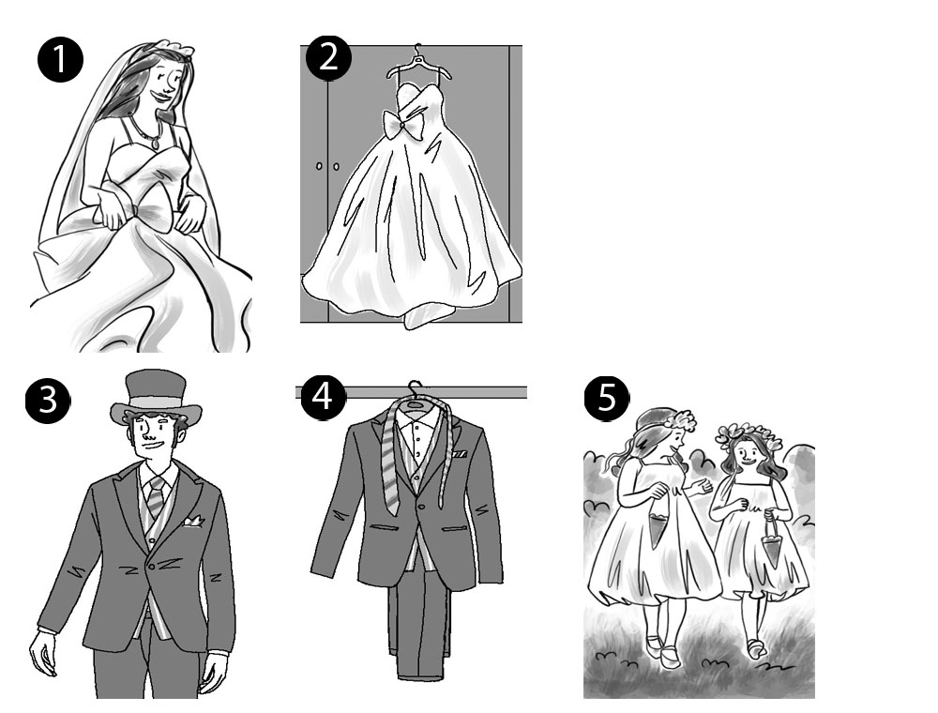

28 | Complete the dialogue with the words from the box. There are three extra words.

religious victory pierced health risks palm spirits gestures buried needles
sleeve hastily personal space insult

Tom | Hey, I like your new tattoo, Sally! How did you manage that? I thought you were afraid of ⁽¹⁾_____________________!
Sally | No, I’ve never been scared of them. I just used to be worried about the ⁽²⁾_____________________ of getting a tattoo, but I found a brilliant tattoo parlour, which was safe and clean. They did the tattoo very ⁽³⁾_____________________ too, so at least the pain didn’t last very long!
Tom | What does the tattoo mean? Is it a ⁽⁴⁾_____________________ symbol?
Sally | No, I don’t think so. The guy in the shop said that it’s an ancient symbol for ⁽⁵⁾_____________________ or success. In some places, people used to tattoo this symbol on soldiers before they ⁽⁶⁾_____________________ them. Hmmm. I hope it isn’t something that’s going to ⁽⁷⁾_____________________ or offend anyone from different cultures. It’s hard enough just learning about body language and hand ⁽⁸⁾_____________________ when you travel to a different country without having to worry about my tattoo as well!
Tom | I’m sure it won’t be a problem. It’s at the top of your arm, so you can always cover it up with your ⁽⁹⁾_____________________. It’s not on your ⁽¹⁰⁾_____________________ or back of your hand, which everyone can see.
Sally | Yes, you’re right.

29 | Complete the text with the words from the box. There are two extra words.

demons log book trendy funeral wealth permanent mark ancient

Body piercing and body art are not part of a ⁽¹⁾_______________, new style. People have been piercing their bodies and painting their skins since ⁽²⁾_______________ times. Some people were afraid of evil spirits and believed that metal piercings could stop ⁽³⁾_______________ from getting into the body.
Famous men in Elizabethan England used to wear gold rings in their ears. They thought that their gold earrings could pay for their ⁽⁴⁾_______________ when they died.
The word ‘tattoo’ comes from Tahiti. Explorer Captain James Cook wrote about Tahitian tattoos in his ship’s ⁽⁵⁾_______________ in 1769. He wrote that people put black ink under their skin, so that it was ⁽⁶⁾_______________.

30 | Circle the correct options to complete the comments.

How do you feel today? Are you happy or are you sad? Tell us!
I’ve been watching news reports about a natural disaster in Australia, but I can’t do anything about it. I feel ⁽¹⁾helpless / proud / misunderstood.
Sam, UK
My friends threw me a party and I didn’t know anything about it! I feel ⁽²⁾frustraded / proud / surprised!
Jon, Canada
My son won a race at school today for the first time. I feel ⁽³⁾frustated / annoyed / proud!
Luca, Italy
My boyfriend said he doesn’t love me any more. I feel ⁽⁴⁾proud / hurt / misunderstood.
Zara, South Africa
I didn’t do as well as I thought I would do in my exams. I feel ⁽⁵⁾frustrated / misunderstood / proud.
Li, China
Everyone thinks I’m shy, but I’m not. I feel ⁽⁶⁾hurt / helpless / misunderstood.
Bruno, Chile
I’ve just been offered a place at an amazing university! I wasn’t expecting it, so I feel ⁽⁷⁾helpless / shocked / annoyed!
Lisa, Sweden
Someone crashed into my car and damaged it. I feel ⁽⁸⁾proud / misunderstood / annoyed.
Martin, Indonesia

31 | Circle the correct options to complete the sentences.

I’m an editor at Fountain Books and I’ve had a ⁽¹⁾compilation / fascination / communication with antique books ever since I was a little girl.
I’ve got a collection of about 500 very old books – and one of them is very ⁽²⁾sure / near / rare as there are only 10 copies in the whole world.
A very valuable book was stolen from the museum, but the police caught the thieves and ⁽³⁾avoided / attracted / arrested them a day later.
John began collecting crime novels last year. Now he can’t stop – his hobby has become an ⁽⁴⁾expresssion / intention / addiction.
You have to be quiet in a public library, so we ⁽⁵⁾practiced / whispered / responded to each other while we were looking for some new science-fiction books.
Why hasn’t Mr Hoskins ⁽⁶⁾turned up / turned back / taken off for his interview? Something must have happened.
Now listen very carefully. When I give you the ⁽⁷⁾command / truth / service, you must stop what you’re doing and call this number on your mobile phone. Understood?
It’s been over two weeks now since I wrote to our local council. If I don’t get a reply soon, I think I’ll ⁽⁸⁾calm down / go crazy / get back.

Language in context
32 | Complete the sentences with the correct form of the verbs in the box. There are two extra verbs.

be not be visit buy study see go not have pay go

1 | The student would be frustrated if she __________________ a good teacher.
2 | If people __________________ fair prices for food, farmers would make a good living.
3 | If we __________________ Fair Trade chocolate, we’ll know that the farmers have received a fair price.
4 | If you __________________ more, you’d get better grades.
5 | If I have time, I __________________ to the supermarket.
6 | Your parents will be proud if you __________________ to university.
7 | Joe __________________ be surprised if you’re late for his party.
8 | Sarah __________________ angry if we don’t go to see her concert.

33 | Put the words into the correct order to make sentences. Use the past simple or present perfect form of the verb in italics.

1 | buy / yesterday / anything / at the market / you  _________________________________________________________________________________
2 | go / seven months ago / to Jamaica / I  _________________________________________________________________________________
3 | sell / already / his collection of coins / John  _________________________________________________________________________________
4 | collect / last month / a lot of shells / Samira  _________________________________________________________________________________
5 | not finish / yet / our computer game / we  _________________________________________________________________________________
6 | buy / never / anything / at an auction / Louis  _________________________________________________________________________________
7 | visit / recently / the library / you  _________________________________________________________________________________
8 | start / just / a new hobby / Emma  _________________________________________________________________________________

34 | Complete the sentences with the correct words.

1 | Valerie _______________ likely to study medicine. She really wants to be a doctor!
2 | There’s a _______________ that we’ll be home late tonight.
3 | The likelihood _______________ passing this exam is quite high.
4 | Ben _______________ likely to get his ears pierced. He doesn’t like needles!
5 | The plane isn’t _______________ to take off on time.
6 | The footballers are likely _______________ be hungry after the match.
7 | The _______________ of winning the match is quite low.
8 | Do you think _______________ a chance that it will rain tomorrow?

35 | Rewrite the sentences using the words in brackets.

1 | Maybe Sophia needs some help. (might)  _________________________________________________________________________________
2 | It’s possible that Kate is ill. (may)  _________________________________________________________________________________
3 | Maybe the children are asleep. (could)  _________________________________________________________________________________
4 | Perhaps Jasmine will go for a bike ride tomorrow. (might)  _________________________________________________________________________________
5 | Maybe Mark is in the garden. (might)  _________________________________________________________________________________
6 | It’s possible that it’ll snow later. (could)  _________________________________________________________________________________
7 | Perhaps Anne knows where the key is. (could)  _________________________________________________________________________________
8 | It’s possible that Nina is at work. (may)  _________________________________________________________________________________

36 | Look at the pictures and make sentences about what might happen this weekend. Use might, may or could and the phrases in the box. There are two extra phrases.

get a tattoo go shopping watch a film go out for dinner swim in the sea
get a nose stud go camping get her ears pierced have a picnic go for a bike ride

1 | 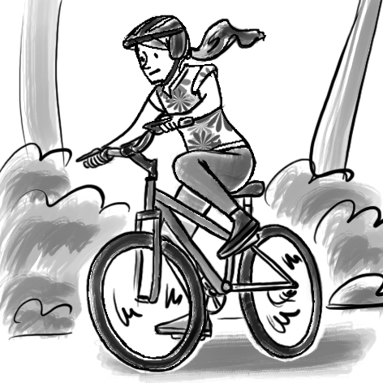  Jasmine __________________________________________________________________________
2 | 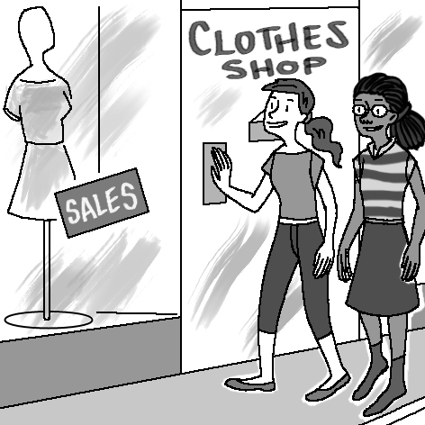  Therese and Sue ___________________________________________________________________
3 | 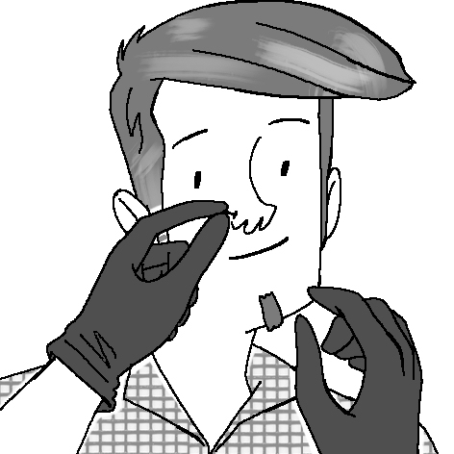  Frank ____________________________________________________________________________
4 | 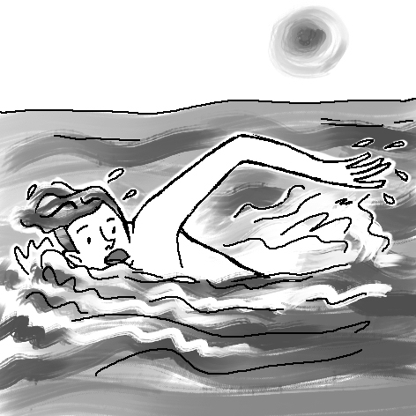  Sam _____________________________________________________________________________
5 | 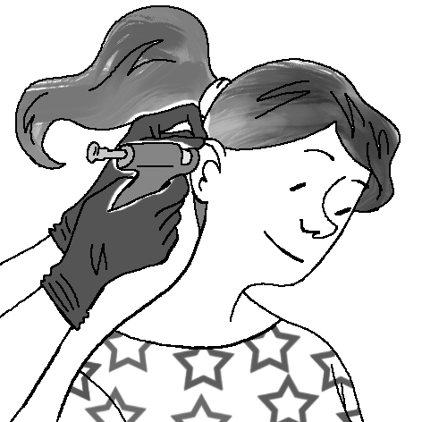  Sarah ____________________________________________________________________________
6 | 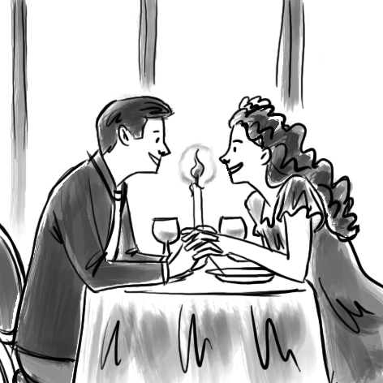  Ron and Sarah _____________________________________________________________________
7 | 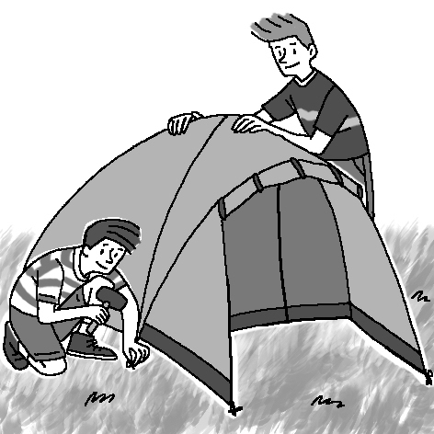  John and Kurt ______________________________________________________________________
8 | 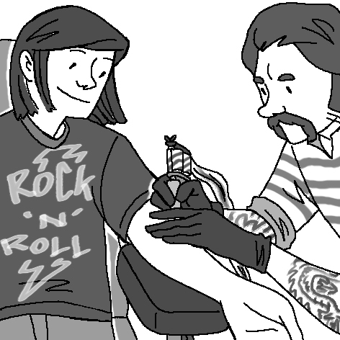  Marco ____________________________________________________________________________

37 | Complete the sentences using the words from the box. There are two extra words.

chance likelihood there’s isn’t for likely of to possible is

1 | There’s a __________________ that we’ll be home late tonight.
2 | Ben __________________ likely to get his ears pierced. He hates needles!
3 | The __________________ of winning the match is quite low.
4 | The footballers are likely __________________ be hungry after the match.
5 | Do you think __________________ a chance that it will rain tomorrow?
6 | The plane isn’t __________________ to take off on time.
7 | Valerie __________________ likely to study medicine. She loves science.
8 | The likelihood __________________ passing this exam is quite high.

38 | Complete the sentences with the present perfect or past simple form of the verbs in brackets.

1 | ___________________________ (you / buy) anything at the market yesterday?
2 | Louis ___________________________ (never buy) anything at an auction.
3 | I ___________________________ (go) to Jamaica 7 months ago.
4 | ___________________________ (you / visit) the library recently?
5 | We ___________________________ (not / finish) our computer game yet.
6 | Samira ___________________________ (collect) a lot of shells last month.
7 | Emma ___________________________ (just / start) a new hobby.
8 | John ___________________________ (already / sell) his collection of coins.

39 | Complete the sentences with the correct form of the verbs in brackets.

1 | If you __________________ (study) more, you’d get better grades.
2 | I’d be frustrated if I __________________ (not / have) a good teacher.
3 | If I have time, I __________________ (go) to the supermarket.
4 | Sarah will be angry if we __________________ (not / go) to see her concert.
5 | If we __________________ (buy) Fair Trade chocolate, we’ll know that the farmers have received a fair price.
6 | If people __________________ (pay) fair prices for food, farmers would make a good living.
7 | Your parents __________________ (be) proud if you go to university.
8 | Joe __________________ (not / be) surprised if you’re late for his party.

40 | Complete the third conditional sentences with the correct form of the verbs in brackets.

1 | If the weather ___________________________ (not / be) bad, we ___________________________ (play) football.
2 | If Sam ___________________________ (see) us, he ___________________________ (say) hello.
3 | If there ___________________________ (be) some Fair Trade coffee, we ___________________________ (buy) it.
4 | If I ___________________________ (have) enough money, I ___________________________ (go) on holiday.
5 | If Mark ___________________________ (eat) breakfast, he ___________________________ (not / be) hungry later.
6 | If Kate ___________________________ (not / be) ill, she ___________________________ (go) to school.
7 | The students ___________________________ (not / fail) their exams if they ___________________________ (study).
8 | Sara ___________________________ (go) to the play if she ___________________________ (have) a ticket.

41 | Write sentences in the third conditional.

1 | Sara didn’t have a ticket. She didn’t go to the play.  If ________________________________________________________________________________.
2 | Sam didn’t see us. He didn’t say hello.  If ________________________________________________________________________________.
3 | Mark didn’t eat breakfast. He was hungry later.  If ________________________________________________________________________________.
4 | The weather was bad. We didn’t play football.  If ________________________________________________________________________________.
5 | There wasn’t any Fair Trade coffee. We didn’t buy it.  If ________________________________________________________________________________.
6 | I didn’t have enough money. I didn’t go on holiday.  If ________________________________________________________________________________.
7 | The students didn’t study. They failed the exam.  If ________________________________________________________________________________.
8 | Kate was ill. She didn’t go to school.  If ________________________________________________________________________________.

42 | Complete the text with the present perfect or past simple form of the verbs in brackets.

I collect football cards! I ⁽¹⁾________________________ (start) collecting them when I was a child. My grandmother ⁽²⁾________________________ (give) me a set of cards for my 12th birthday. Since then, I ⁽³⁾________________________ (collect) more than 5,000 cards! I ⁽⁴⁾________________________ (never / meet) anyone who has as many cards as I do! Last summer, there ⁽⁵⁾________________________ (be) a football exhibition at our local sports centre and I ⁽⁶⁾________________________ (take) my collection of cards along to show everyone. I ⁽⁷⁾________________________ (never / go) anywhere like that before! It ⁽⁸⁾________________________ (be) so exciting! I ⁽⁹⁾________________________ (meet) other collectors and also people who sell football cards. In fact, they ⁽¹⁰⁾________________________ (just / sell) me a special set of cards of Real Madrid!

43 | Complete the sentences using the correct conditional form of the verbs in brackets.

1 | If those shoes ________________________ (not / be) so expensive, I would have bought them.
2 | If you ________________________ (have) a million pounds, what would you buy?
3 | If Rita and Sam ________________________ (not / have) school today, they would go shopping.
4 | If I found a mobile phone on the street, I ________________________ (take) it to the police station.
5 | If I hadn’t forgotten my wallet, I ________________________ (pay) for the coffees.
6 | We wouldn't have arrived on time if we ________________________ (not / catch) the bus.
7 | I ________________________ (go) to the shop after school if I have time.
8 | If Tom ________________________ (buy) some chocolate, he’ll share it with us.

