1st Test 1b, Group A January 2013

1. Choose the correct pictures 6p
Listen to the picture descriptions. Choose one picture in each line. Then write the correct letter in the box on the right side.


A B C

D E F
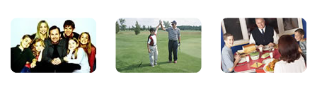
G H I

J K L
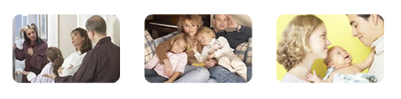
M N O

P Q R

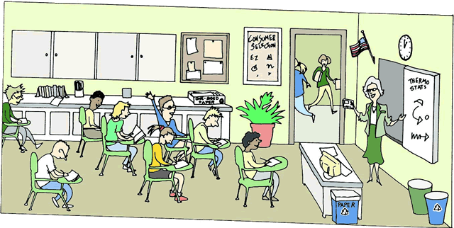
2. Answer the questions in complete sentences. 12p

Where is the clock in this classroom?

Where is the plant?

Where is the computer?

What question does the boy want to ask? Guess .(Rate: Welche Frage könnte das Kind haben?)

3. What time is it? Write sentences. (Schreibe auch die Zahlen aus.) 6p

A | B | C
 |  | 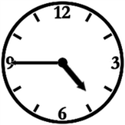

A:
B:
C:

4. Fill in the words from the box: There are more words than you need!!! 16p

plays lives gets up breakfast goes leaves they
homework his brothers’ brothers off is walk comes walks go get up play starts dinner start


This is Tony. He ………………. in New York. New York ……..a big city, so Tony has to get up very early to go to school. He ………………….at 6:30 and quickly gets dressed. Then he has …………………..with his mom, his dad and his two little brothers. Tony …………………for school at quarter past seven. He walks to school with his friend who lives in the same street. They ……………. quickly for about 20 minutes. School ………………. at eight o’ clock and ends at half past three or four o’ clock. Tony has lunch at school. After school Tony walks home and ……………………with his two………………………… Max and Sam. His ……………………….. favorite game is “Snakes and Ladders”. They play it every day. Then Tony does his…………………………. At 7 p.m. his dad …………………… home and ……………… have dinner together. Then Tony goes to his room and reads one of ………….. favorite books. At 9 o’clock Tony ………………to bed and Tony’s mom comes to turn ………….the lights.

5. My Family: 60p

Write about the members in your family, what they like and don’t like, their hobbies, age etc. You can also write about your pets.

Use the space below and on the right side.

1st Test 1b, Group B January 2013

1. Choose the correct pictures 6p
Listen to the picture descriptions. Choose one picture in each line. Then write the correct letter in the box on the right side.
.
A B C


D E F
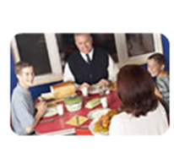
G H I
J K L
M N O

P Q R

2. Fill in the words from the box: There are more words than you need!!! 16p

gets up lives breakfast goes leaves favorite they off homework his brothers’ brothers friends is walk walks friend comes go start get up plays play Sam Sam’s dinner starts

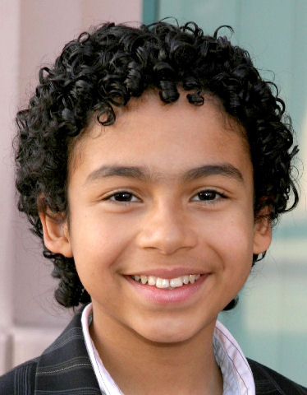
This is Sam. He ………………. in New York. New York ……..a big city, so Sam has to get up very early to go to school. He ………………….at 6:30 and quickly gets dressed. Then he has …………………..with his mom, his dad and his two little brothers. Sam…………………for school at quarter past seven. He walks to school with his friend who lives in the same street. They ……………. quickly for about 20 minutes. School ……………. at eight o’ clock and ends at half past three or four o’ clock. Sam has lunch at school. After school Sam walks home and ……………………with his two………………………… Joe and Tom. His ……………………….. favorite game is “Snakes and Ladders”. They play it every day. Then Sam does his…………………………. At 7 p.m. his dad …………………… home and ……………… have dinner together. Then Sam goes to his room and reads one of ………….. favorite books. At 9 o’clock Sam ………………to bed and Sam’s mom comes to turn ………….the lights

3. What time is it? (Schreibe auch die Zahlen aus.) 6p

A | B | C
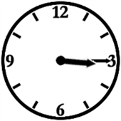 | 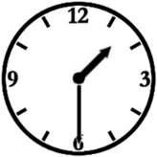 | 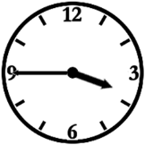

A:
B:
C:

4. Answer the questions in complete sentences. 12p

Where is the clock in this classroom?

Where is the plant?

Where is the computer?

What question does the boy want to ask? Guess. .(Rate: Welche Frage könnte das Kind haben?)

5. My Family: 60p

Write about the members in your family, what they like and don’t like, their hobbies, age etc. You can also write about your pets.

Use the space below and on the right side.

Slap game: http://www.elllo.org/english/Games/G033-Family.html
Audio file: http://www.elllo.org/AudioGames/033-Family.mp3

OK, first one, in this picture we have a mother and her children and it looks like she is with her daughters. She has two children, two daughters and she is helping them most likely do their homework.
OK, in the next picture, we have a picture of a baby, a very young baby, and the baby is with it's mother, and just it's mother. We can't see the father, and it looks like they are taking a nap.
OK, in this next picture we have the whole family together, and we can see the father and the mother and there are two children. It looks like there are two boys. There are two boys in the family and they are eating dinner.
OK, in this next picture we have a father with his child and they are outside and the father is with the son, and it looks like they are playing a little golf and the father just gave the son a high five.
OK, in this next picture we can see a family all together and they are taking it easy and just relaxing. You can see the mother and the father and two daughters and the daughters are sleeping and it looks like the parents are watching TV.
OK, in the last picture, uh, we can see a big family, and we can see the mother and the father and two sons and it looks like three daughters and from the looks of it they are taking their family portrait.

