1st test
Datum | 11/11/21 | Klasse | 4F

Name
Part 1 (Just Listening and Speaking Pre-Intermediate / Harmer)
Listen to the audio and answer the questions

How old is the babysitter?

Why did the babysitter watch TV?

How did the babysitter feel after the second phone call?
extremely scared quite angry a bit worried very annoyed a little bored

Who did the girl think the caller was after the second call?

What did the caller tell her to do?

What did she see when she went to the baby’s room?

What is a “cot”?

Part 2 (Just Listening and Speaking Upper-Intermediate – bis 1:57)
Listen to the audio and answer the questions

How did Laura feel when she woke up? Find all the correct answers.
angry cold annoyed scared scary hungry

Where was Laura? Find all the correct answers.
in a forest at the garden wall outside inside in a house in the doorway

Describe the big wolf. Give at least 3 details.
frightened angry worried annoyed scared

Writing – Part 3
Write the beginning of a spooky story. Describe the atmosphere and the setting of the first two pictures in detail. What can you see/hear/smell? What happened in picture 3 (plot, story: Suddenly…)
Then describe what happened after picture 3 in 4-6 sentences.

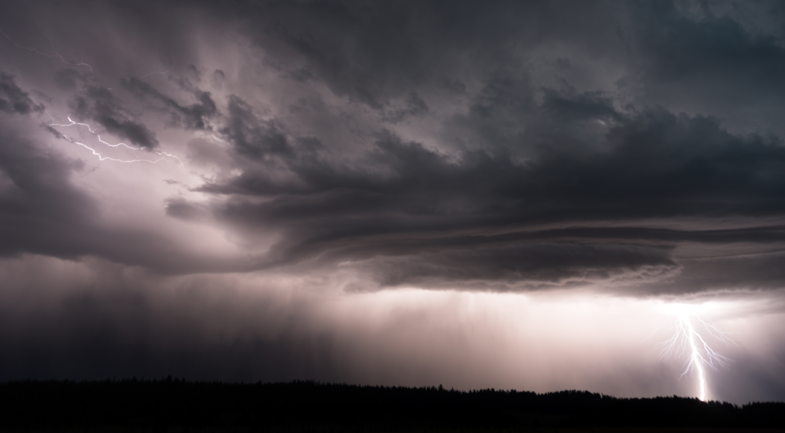
pic 1

Setting and atmosphere

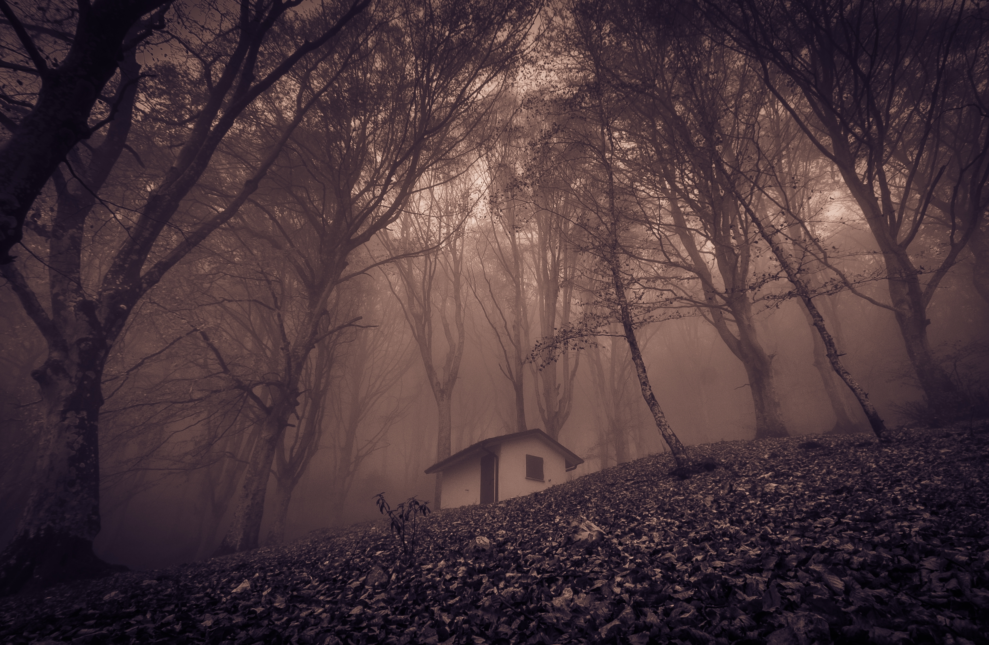
pic 2
It was a stormy night in late October…….

pic 3

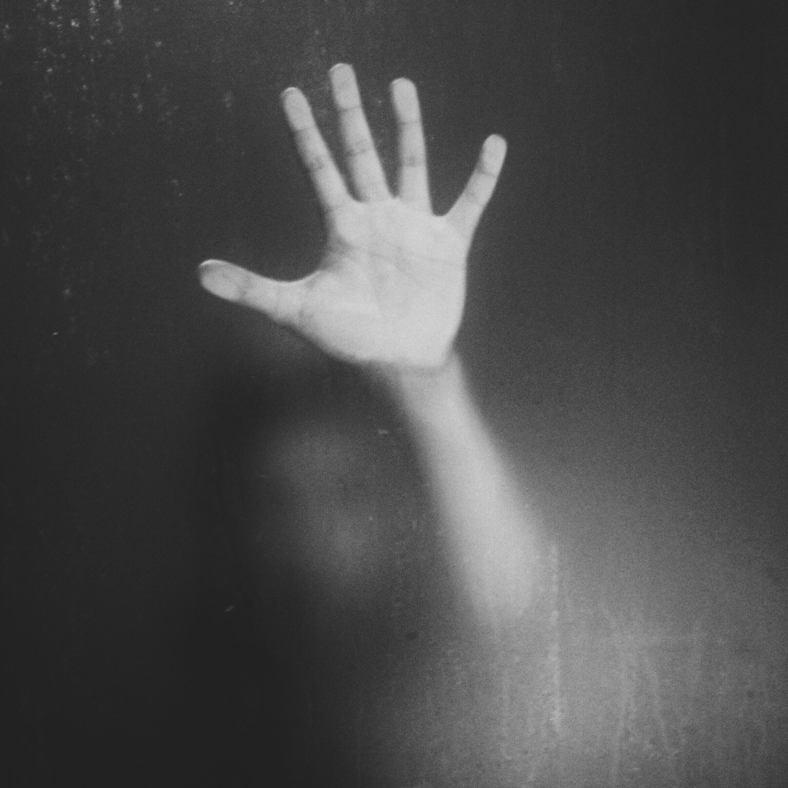
Suddenly.
Then …..

(story, plot)

Part 1 |  |  | Part 2
Listening 1  = 70% der Gesamtnote | / 7P |  | Writing 1 |  | %
Listening 2  = 30% der Gesamtnote | / 3P |  | Writing 2 |  | %
Grade Listening | % |  | Grade Writing |  | %  according to assessment scale – see online (eduvidual)
Schularbeitennote Einstufung  AHS  STANDARD |  | %

Notenschlüssel

AHS
Sehr gut: 90 – 100%
Gut: 80-89%
Befriedigend: 70 – 79%
Genügend: 60 – 69%
Nicht genügend <60%

STANDARD
Sehr gut: 70 – 100%
Gut: 60-69%
Befriedigend: 50 – 59%
Genügend: 40 – 49%
Nicht genügend <40%

