1st test, Flexi year 1
Name:
Writing:My friend Mary/ Thomas

Write about your friend Mary or Thomas
Use all the information from the pictures. Then invent more details (Erfinde noch weitere Dinge)
Write a long text with lots of details. Plan your text well and structure it clearly. Use little words to organize your ideas: and, but, because

Graz  from: Croatia  Engl. and Cro. |  | 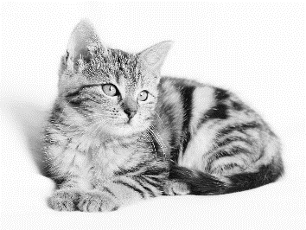 | 
 |  |   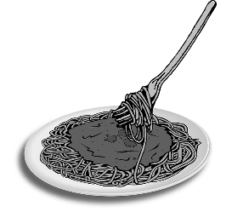 |   
all images: pixabay CC0

Writing Scale: Year 1
Task achievement and organization
not yet | very poor |  | poor | average | good |  | excellent
Range of Vocabulary and Structures
not yet | very poor |  | poor | average | good |  | excellent
Accuracy
not yet | very poor |  | poor | average | good |  | excellent
Willingness to experiment
not yet |  | a bit |  | good |  | excellent
Overall writing performance:
  Listening | ??-59% | 60-69% | 70-79% | 80-89% | 90-100%
 | very poor | poor | average | good | excellent
GESAMTNOTE:

