1st test, Flexi year 1
Name:
Writing:My best friend
Your best friend is a very special person in your life. Tell us everything about her/him.
Write a long text with lots of details. Plan your text well and structure it clearly. Use little words to organize your ideas: and, but, because

Write about Mary
- Where does she live?
- Where does she come from?
- What languages does she speak in school and at home?
- What are her hobbies.
- What does she (not) like?
- What can you say about her family?
Use all the information from the pictures. Then invent more details (Erfinde noch weitere Dinge über …) Write as much as you can.
Graz  from: Croatia  Engl. and Cro. |  |  | 
 | 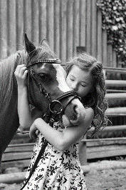 |   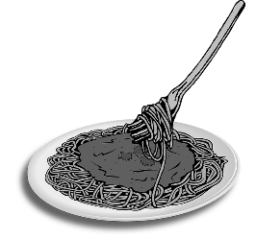 |   
all images: pixabay CC0
Writing Scale: Year 1
Notenschlüssel

Sehr gut: AA – AB
Gut: BB, AC
Befriedigend: BC, CC, AD
Genügend: BD, CD, DD, AE, BE
Nicht genügend:
BC, CE, BD, ED, EE

Task achievement and organization
not yet | very poor |  | poor | average | good |  | excellent
Range of Vocabulary and Structures
not yet | very poor |  | poor | average | good |  | excellent
Accuracy
not yet | very poor |  | poor | average | good |  | excellent
Willingness to experiment
not yet |  | a bit |  | good |  | excellent
Overall writing performance:
Focus on Form:

GESAMTNOTE:

