
3rd Test 2b/Group A April 2014

Your Easter holidays
40pts
What are you going to do in your Easter holidays? Give lots of details and include
- PLANS that you have made with your family or friends and
- make some PREDICTIONS about things that might happen
Tip: your plans don’t need to be big – going to the cinema is just as good.
Write about 200 words.
Oh no!...
Look, …
Wow, …

Interpreting Signs:
20pts
Write one sentence for each picture and sentence. What is obviously going to happen next?
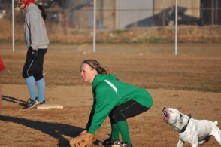  1 | 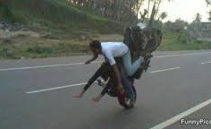  2 | 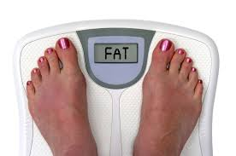  3
  4 | 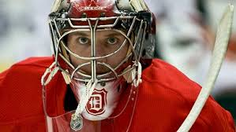  5 | 6. Oh no! We’ve missed the tram. We…  7. Look, Mrs. Pö has left her key in our  classroom. She…  8. Look at the sky. We…  9. Look, we’ve broken the door. Mr.  Dworak…  10. Look at the clock. The bell…

Your favorite food
40pts
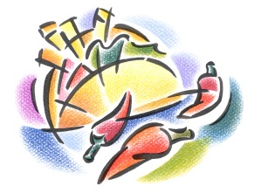
For our last project you cooked one of your favorite dishes. What did you cook and how did you do it?
List all the ingredients and describe all the steps you took.
Write about 200 words. Earn extra points for using adverbs to make your text more interesting!!

3rd Test 2b/Group B April 2014

Your Easter holidays
40pts
What are you going to do in your Easter holidays? Give lots of details and include
- PLANS that you have made with your family or friends and
- make some PREDICTIONS about things that might happen
Tip: your plans don’t need to be big – going to the cinema is just as good.
Write about 200 words.
Oh no!...
Look, …
Wow, …

Interpreting Signs:
20pts
Write one sentence for each picture and sentence. What is obviously going to happen next?
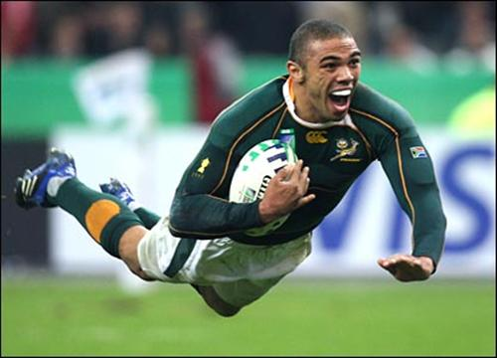  1 | 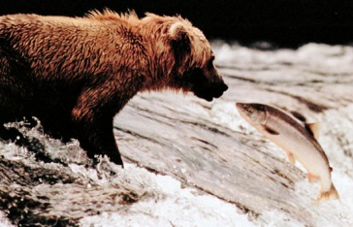  2 |   3
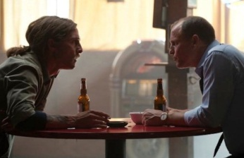  4 | 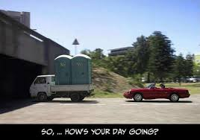  5 | 6. He smokes too much. He….  7. Look, you’ve spilt your hot chocolate on  your new shirt. Mom…  8. Look at the sky. We…  9. Look, we’ve made a total mess of this  classroom. Mrs. Pö…  10. Oh no! I’ve left all my math things at  home. Mrs. Rathofer…

Your favorite food
40pts
For our last project you cooked one of your favorite dishes. What did you cook and how did you do it?
List all the ingredients and describe all the steps you took.
Write about 200 words. Earn extra points for using adverbs to make your text more interesting!!

