2nd Test 2b-Group A January 2013
Reading Project

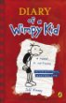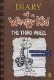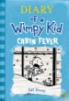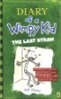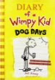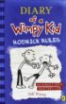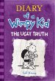
Write 150 - 200 words for each of the two texts.

Be a friend

When you are faced with a problem, it often helps to get some good advice and tips from a friend. Go through your novel and choose a moment where your main character is in trouble or sad and needs some help from a friend. Write him/her a letter giving encouragement and advice in this difficult situation.

Diary
Choose an interesting point in your novel (a high point or a low point) and slip into your character’s mind. Write a diary entry for that day.

In your diary write about the events that have happened, your feelings about them and possible solutions or consequences in the future.

How would you do these things?
Write one meaningful sentence for each picture.

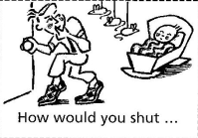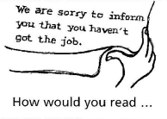

2nd Test 2b-Group B January 2013
Reading Project

Write 150 - 200 words for each of the two texts.

Be a friend
When you are faced with a problem, it often helps to get some good advice and tips from a friend. Go through your novel and choose a moment where your main character is in trouble or sad and needs some help from a friend. Write him/her a letter giving encouragement and advice in this difficult situation.

Diary
Choose an interesting point in your novel (a high point or a low point) and slip into your character’s mind. Write a diary entry for that day.
In your diary write about the events that have happened, your feelings about them and possible solutions or consequences in the future.

How would you do these things?
Write one meaningful sentence for each picture.
