by Elisabeth Pölzleitner
and
Laura Bergmann

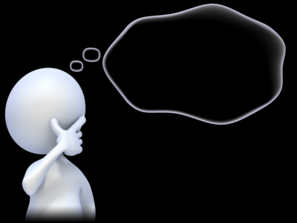

Solutions 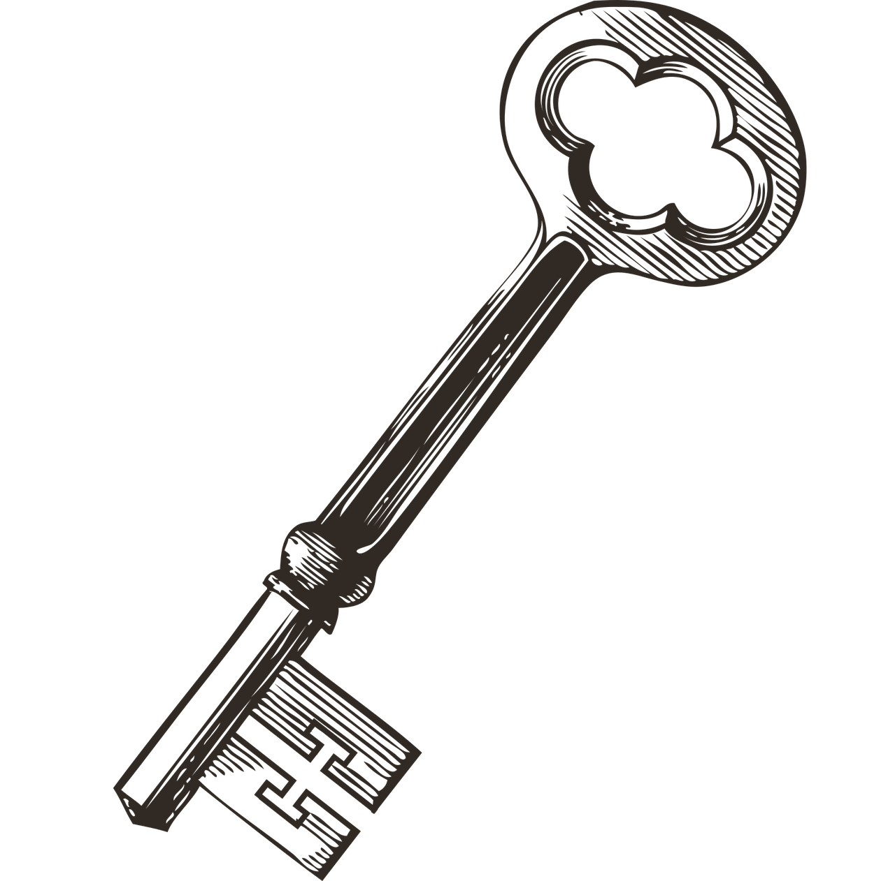

Grammar Detectives can find their own rules.
My Personal Grammarbook

Name: …………………………………………………..

Impressum:
Elisabeth Pölzleitner und Laura Bergmann
Kontakt: creative.languageteachers@gmail.com
Elisabeth Pölzleitner und Laura Bergmann

Dear student,
This is your personal grammar book for years 1 to 4. You can always use it to look up how the English language works.
Therefore, ALL the language in this book MUST be correct.

Always write your answers in pencil so you can easily correct them. Then ask a teacher to check your answers.
Das ist dein persönliches Grammatikbuch für das 1. bis 4. Jahr. Du kannst immer nachschlagen, wenn du Fragen bezüglich der englischen Grammatik hast.
Aus diesem Grund muss hier alles GANZ RICHTIG sein. Schreibe deine Antworten immer mit Bleistift, sodass du sie leicht ausbessern kannst. Bitte deine Lehrperson deine Sätze zu korrigieren.

For the Teacher
In this grammar book the learners take on the role of active language detectives. They will explore the examples and develop basic rules themselves (or with a bit of guidance from the teacher) and thus develop their language awareness. This step is always followed by a personalized task, where the learners are asked to write true and meaningful sentences about their own lives. In this step the learners will make strong meaning - form connections that are even more important than the declarative knowledge of the language rules. Supporting the learners to create meaningful answers at this stage is crucial for developing their grammatical competence.
After these phases of awareness raising, finding their own rules and writing personal examples, the learners will be ready to practice and use the new grammar in productive tasks. Examples of such tasks can be found in our Me-book.
For more information on this approach, read the chapter “Teaching Communicative Grammar” in English Language Teaching in Austria: From Theory to the Classroom and Beyond, J. Jauster and U. Fürstenberg, Eds. 2023. Free download from: https://doi.org/10.25364/978-3-903374-05-8
Direct link to the chapter on Teaching Grammar: https://tinyurl.com/Grammar-Newby-Poelzleitner

Table of Contents
Table of Contents 1
a or an 3
BIG LETTERS – small letters 4
To be: am – is – are 5
I speak – She speaks – I live – He lives 6
Short forms – Long forms 8
Plural: many things 9
Personal pronouns: I, you, he, she, it, we, you, they 10
Numbers 12
Ordinal numbers: first, second, third… 14
Days of the week and months 15
Giving the date in English 16
Possessive pronouns: my, your, his, her, our, their 17
Whose things are these? Look closely: 18
Whose things are these? What’s the difference? 19
Asking questions in English 20
More questions: Interview a student teacher 22
Negation in English 23
Telling the time 24
Routines: What we do regularly 25
Routines versus Present activities 26
There is --- There are 27
Asking questions with there is—there are 28
Where things are: Prepositions of place 29
Talking about the past 30
Past tense, Irregular forms 31
Past tense: Regular Verb forms 32
Past tense - Negation 33
Past tense – Questions 34
Irregular Verb Forms (in groups) 35
Irregular verbs in alphabetical order 36
Comparing 37
Talking about the future 39
Talking about our PLANS 39
Talking about the future: What‘s the difference? 40
Talking about general experiences: Have you ever ….. 42
My exciting life: I have done lots of cool things 44
Wishful thinking: Conditional II 45
Life could be even cooler… 45
one or ones --- this or these 48
some or any 49
Adjectives and adverbs: Colorful and detailed descriptions 54
Describing people and things: What are they like? 55
Describing how people do things 56
How did they do it? 57
Telling stories in the past 58
Describing the setting and atmosphere 58
and talking about events that happened in a story. 58
Talking about rules: Modal verbs 60
School Rules in different countries 60
Giving essential details: Defining Relative Clauses: who and that 62
Conditional III: How would things have been different? 63
What if… 64
If they had given up, you would never have heard of them 64
Duration: How long have you…? 65
How long have you... 67
Active or passive: What’s your choice? 68
How do we form the passive? 69
Fake news: Reporting unbelievable things that someone said 70
The Reporting Circle 72
Reporting neutral information that someone said in the past – 76
We are thinking back to the conversation. 76
Reporting what someone asked me to do 78
Reporting questions 79
Past perfect – What had happened before 80
Bildnachweise 82

a or an

Challenge 1


Look at the two boxes below. What do you notice? When do we use a and when do we use an in front of a word? SAY the words and LISTEN carefully.
an apple  an English book  an ice-cream | an orange  an ugly duck  an interesting book | a boy  a girl  a chair | a dog  a garden  a school

My rule
Wenn ich am Beginn eines Wortes ……a,e,i,o,u………………………………höre,
verwende ich an.

Now it’s your turn
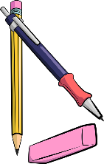
Write the words in the correct boxes. (Schreibe die Wörter in das richtige Kästchen.)
tiger, banana, book, exercise book, pencil, eraser, door, old man, internet-café,
English teacher, blackboard, window, American film, elephant
exercise book eraser
old man internet-café

English teacher elephant
American film
tiger banana book
pencil

door blackboard window
an
a

Challenge 2 for pros:


a or an? Scan the QR code and listen VERY carefully. What sounds do you hear at the beginning of these words? In which of the two circles do they go: a or an?
__a__university, _ a ___uniform, __ a __unicorn, __ a __unit in my coursebook
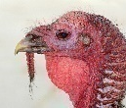

_ an___mp3-player, _ an ___XL-pullover,

_ an ___uncle, _ an ___umbrella , _ an ___ugly bird

Do we need a or an here? Write in the words, then listen to the words again.

My rule
Ich sage a unicorn, a unicycle, weil ich am Beginn des Wortes ein J höre.
Ich sage an mp3 player, an XL-pullover, weil ich am Beginn des Wortes ein E(em) oder I(ix) höre:

BIG LETTERS – small letters

In English we use big letters for
- I (I am happy.)
- names (Paula, Thomas),
- countries (England, Austria, Croatia)
- cities (Vienna, Graz, London, Paris)
- languages (German, Croatian, English)
- and at the beginning of sentences.

In the English lessons we speak English. Elisabeth and Selina are talking about London and England but I am reading a book about America.

Now it’s your turn:

Write 3-5 sentences and mark the BIG LETTERS. Ask your teacher to check.

Examples:
name + beginning of sentence: My best friend is called Seba.
I + beginning of sentence: My mother and I like shopping.
country and I: I am from Austria.
city and I: I live in Linz.
languages and I: I speak German, Arabic and English.

To be: am – is – are

Look at these examples:
My name is …………………….  I am a student at PraxisNMS.  I am ten years old.  I am not in class 4b. | 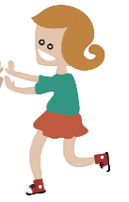  How old are you?  You are a very nice person.  You are my best friend. | 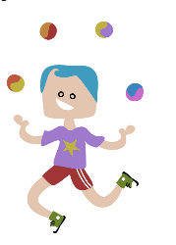  Anton is not in my class.  He is at NMS Kepler.  He is funny.
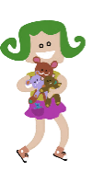
Sally is a student in England.
She is very nice.
She is not very tall.
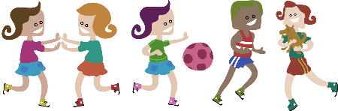  We are also happy.  We are not sad. | 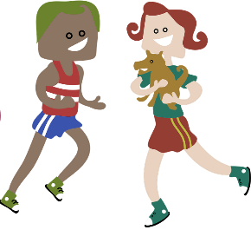  Mary and Peter are good friends.  They are very happy.  They are not from Austria.

Now it’s your turn:

Write 10 sentences with am | am not | is | is not | are | are not
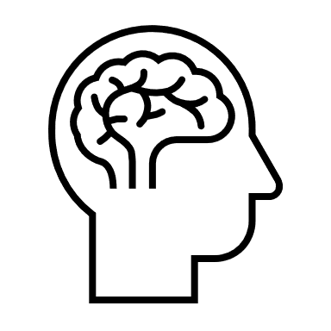

Write true sentences about yourself, your friends, your classmates and teachers and your
family members or pets. Write a first draft on a piece of paper.
Schreibe immer wahre, sinnvolle Sätze. Schreibe einige der korrigierten Sätze hier auf:

Examples:
I am not eleven years old. I am ten years old.
Ahmed is not in my class, but Elia is in my class.
Sarah and Rina are not best friends. Melissa are best friends.

I speak – She speaks – I live – He lives

Challenge1: Find the rule
This is Ms. Pölzleitner.
She lives in a blue house in Graz. She is an English teacher. She loves reading books and learning languages. She speaks English, German, French, Italian and Greek. She also likes sports. In winter she goes skiing and in summer she goes jogging. She rides her bike to school every day. Her favorite food is Indian curry. She is a vegetarian, so she does not eat meat.
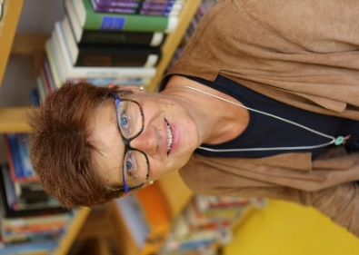
Hello, I am Ms. Pölzleitner.
I live in a blue house in Graz. I am an English teacher. I love reading books and learning languages. I speak English, German, French, Italian and Greek. I also like sports. In winter I go skiing and in summer I go jogging. I ride my bike to school every day. My favorite food is Indian curry. I am a vegetarian, so I do not eat meat.

What do you notice?


Challenge: Read the texts and find a rule!

Hello, we are Naomi and Michael.
We live in a small white house in Graz. We love riding our bikes and watching animals. We also like gardening. In summer we go swimming in our little pool and read lots of books. We have three guinea pigs.
These are Naomi and Michael.
They live in a small white house in Graz. They love riding their bikes and watching animals. They also like gardening. In summer they go swimming in their little pool and they read lots of books. They have three guinea pigs.

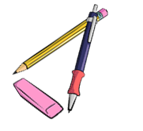

My rule:
Wenn ich über EINE andere Person spreche/schreibe.... hänge ich beim Verb/Tunwort
ein S oder ES an. (Additional info: Ändert sich I zu she/he und MY zu her/his)
Wenn ich über MEHRERE Personen spreche/schreibe... verändert sich das Verb/Tunwort nicht. (Additional info: Ändert sich WE zu they)

Now it's your turn

Step 1: Write a text about yourself. Hand it in to your teacher.

Step2: Get a speech bubble from your teacher and write your text on it. Put it on the pin board.
This is ...
NAME
Step 3: Find a speech bubble from a classmate on the pin board or get one from your teacher. Then write about your classmate. Hand your text in to your teacher.
(Write YOUR NAME on the sheet, too.)
Step 4: Write the corrected text from step 3 in the box .
Step 5: Copy your speech bubble in the bubble below
Individual answers!
Example solution: Hello, I am Lion.
I live in a big white house in Vienna. I am eleven years old. I have two sisters. I speak German and a little bit English. I love playing computer games and l playing soccer. In winter I go skiing and in summer I go swimming. I go to school by bus. My favorite food is spaghetti.

This is ...

individual answers – depending on the speech bubble the students get from a partner.

Short forms – Long forms

CHALLENGE
Look at these sentences. What do you notice? Mark the differences with a highlighter.
Maria does not like spinach. | Maria doesn’t like spinach.
We do not speak Croatian in school. | We don’t speak Croatian in school.
Peter is not from Austria. He is from England. | Peter isn’t from Austria. He’s from England.
We are good students. | We’re good students.
My friends are not at my school. | My friends aren’t at my school.
Now it’s your turn:  Write the LONG forms here: | Write the SHORT forms here:
My friend Sally is not from Austria. | My friend Sally isn’t from Austria.
My mother is not very tall. | My mother isn’t very tall.
In my family, we do not eat meat. | In my family, we don’t eat meat.
I am happy. | I am happy.
My dad does not like sweets. | My dad doesn’t like sweets.
We do not have any pets. | We don’t have any pets.
Peter and Sally do not speak German. | Peter and Sally don’t speak German.
We are not twins. | We’re not twins.
He is my best friend. | He’s my best friend.

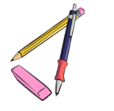
Plural: many things

Plural 1
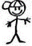  one boy | 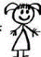  one girl | 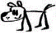  one dog | one desk
two boys | two girls | 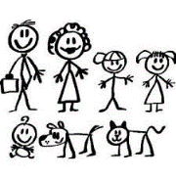  two dogs | two desks
one pencil | one erasor | one window | one book
two pencils | two erasors | two windows | two books
one student | one teacher | one door | one schoolbag
two students | two teachers | two doors | two schoolbags

How do we form the plural in English?
Wir hängen ein S an das Wort an. / We add an S to the word.


Plural 2: tricky words
Why not this?
Listen and speak!

- boxs
- buss
- kisss
- wishs
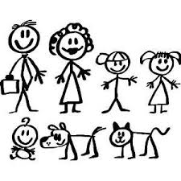  one baby  two babies | one box  two boxes
one country  two countries | one bus  two buses
one pony  two ponies | one kiss  two kisses
one story  two stories | one wish  two wishes
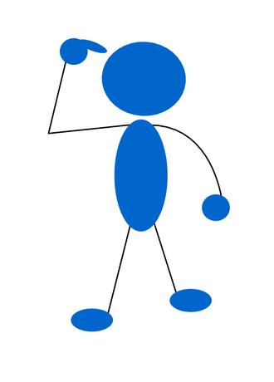

Plural 3: more tricky words: add more words later
one child  two children | one man  two men | one woman  two women
one mouse  two mice | added as they come up e.g. shelf - shelves | e.g. loaf - loaves
e.g. fish - fish | e.g. man – men  woman - women | e.g. half- halves
e.g. quiz - quizzes | e.g. foot – feet  tooth - teeth | e.g. sheep-sheep

Personal pronouns: I, you, he, she, it, we, you, they

Look at these examples.
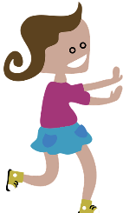 | 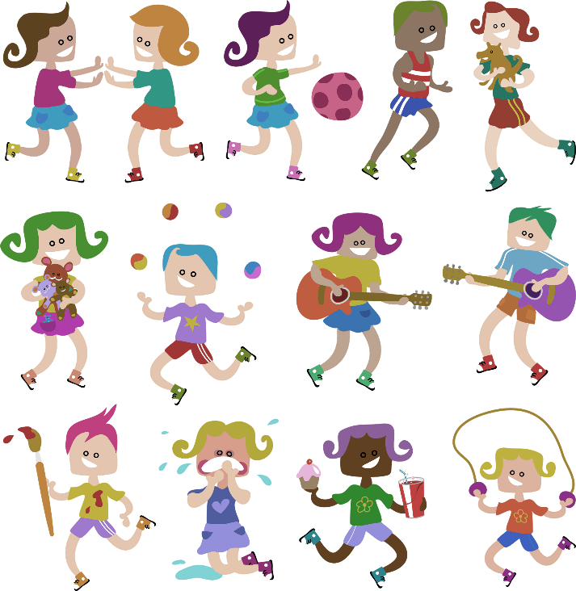 | 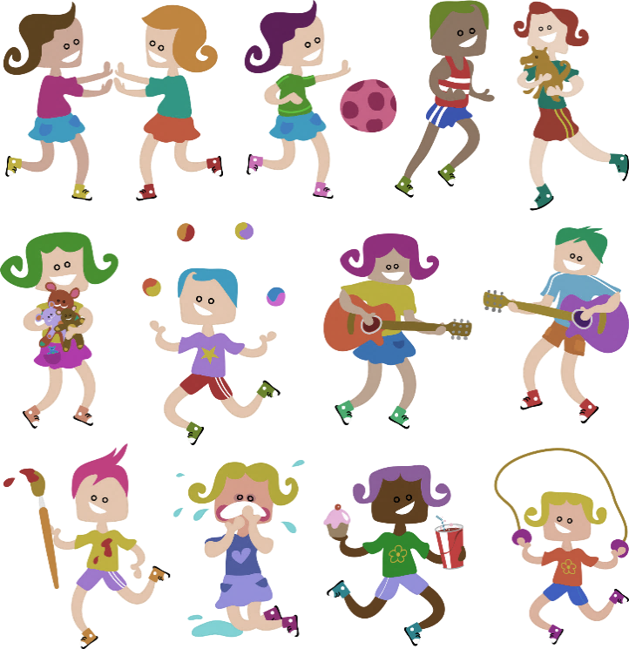 | 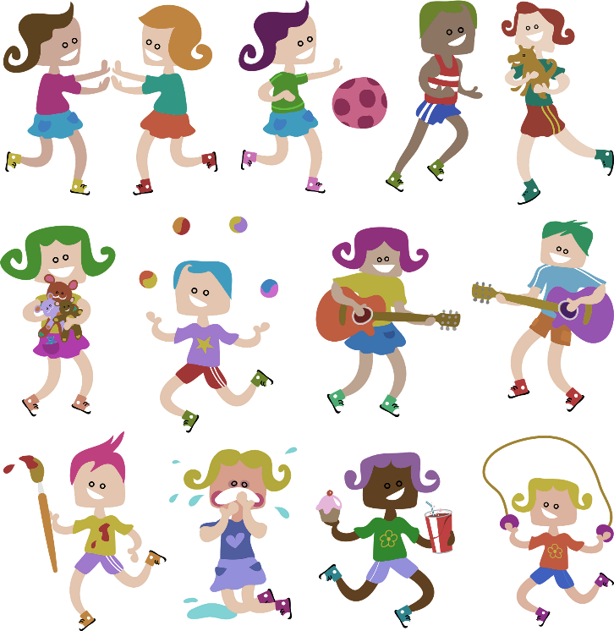 | 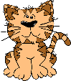an animal    OR  a thing
I  I live in London.  I am 10 years old.  I like chocolate. | you  You are my best friend.  I like you.  Do you like cats? | he  He is called Peter.  He is 10 years old.  He likes pizza. | she  She is called Mary.  She is from Austria.  She likes cupcakes. | it  It is called Toby.  It is really cute.  - It is red.  - It is sweet.

 | 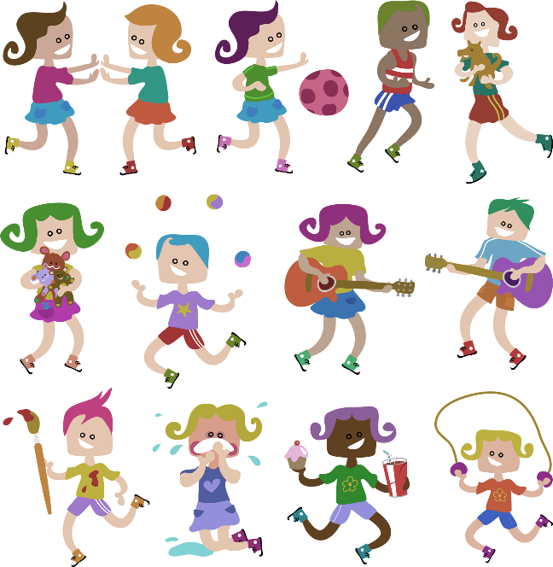  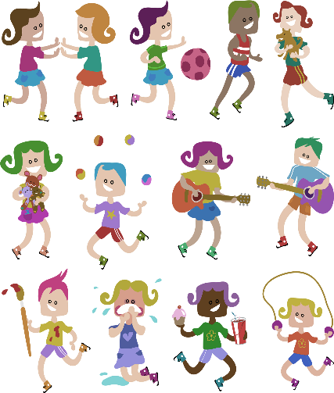  Hi! | 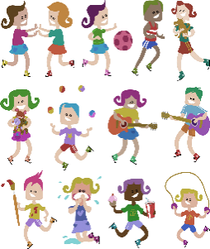  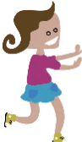
we  We are in the same class.  We speak English and German.  We like our new school. | You  Do you speak English?  You are my friends.  Do you want to work in my group? | they  They are very nice people.  They are from America.  They speak English but they do not speak German.

Now it’s your turn:
Now write similar (ähnliche) sentences about your friends and family. Write true sentences!!!
Tip: In this grammar book we always ask you to write TRUE and meaningful sentences about your own life. Your brain will remember TRUE sentences much better. Think carefully how you can use the new words and grammar to say things about your own life.

Use ALL the pronouns: I, you, he, she, it, we, you, they Ask your teacher to check.
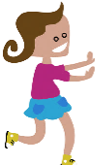
Individual answers!
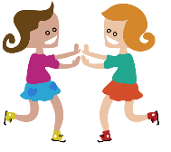
e.g. I live in Innsbruck.
I am eleven years old. I like skiing.
Individual answers!
e.g. Birgit, you live in Innsbruck, too.
You are ten years old. You like snowboarding.
Birgit
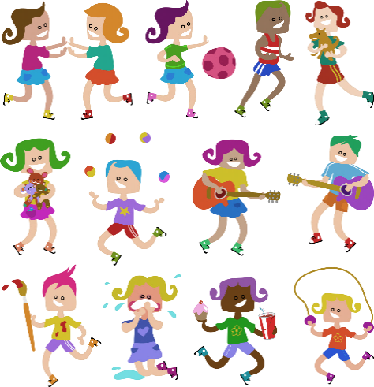
Individual answers!
e.g. My best friend Georg lives in Hall.
He is eleven years old. He likes soccer.
Georg
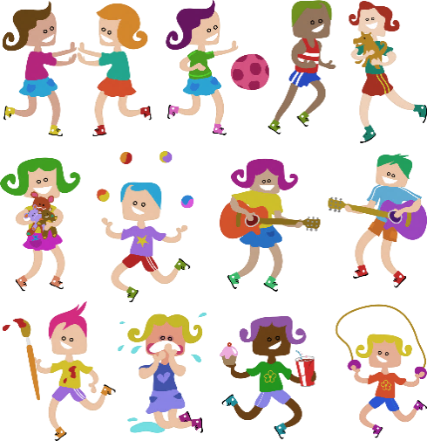
Individual answers!
e.g. My aunt Renate lives in Salzburg.
She is 34 years old. She likes reading books.
Renate
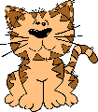
Individual answers!
e.g. My dog is brown.
It is funny. It loves playing in the park.
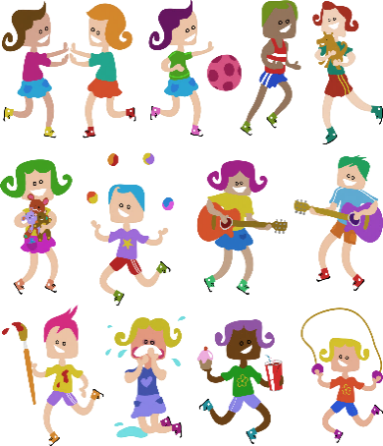
Individual answers!
e.g. We are classmates.
We like English. We speak German and English.
Class 1c
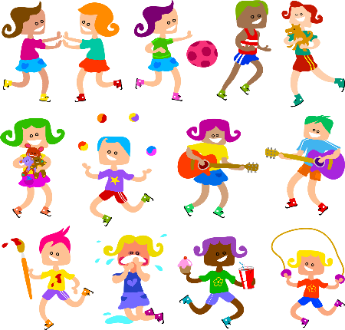
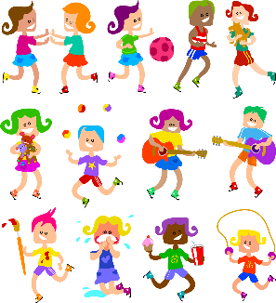
Individual answers!
Hi!
e.g. Ahmed and Melis, do you like English?
Do you live in Vienna?
Ahmed, Melis
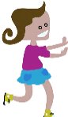
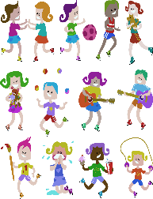
Individual answers!
e.g. Betty and Mario are my best friends.
They love playing soccer. They go to my school.
Betty, Mario

Numbers
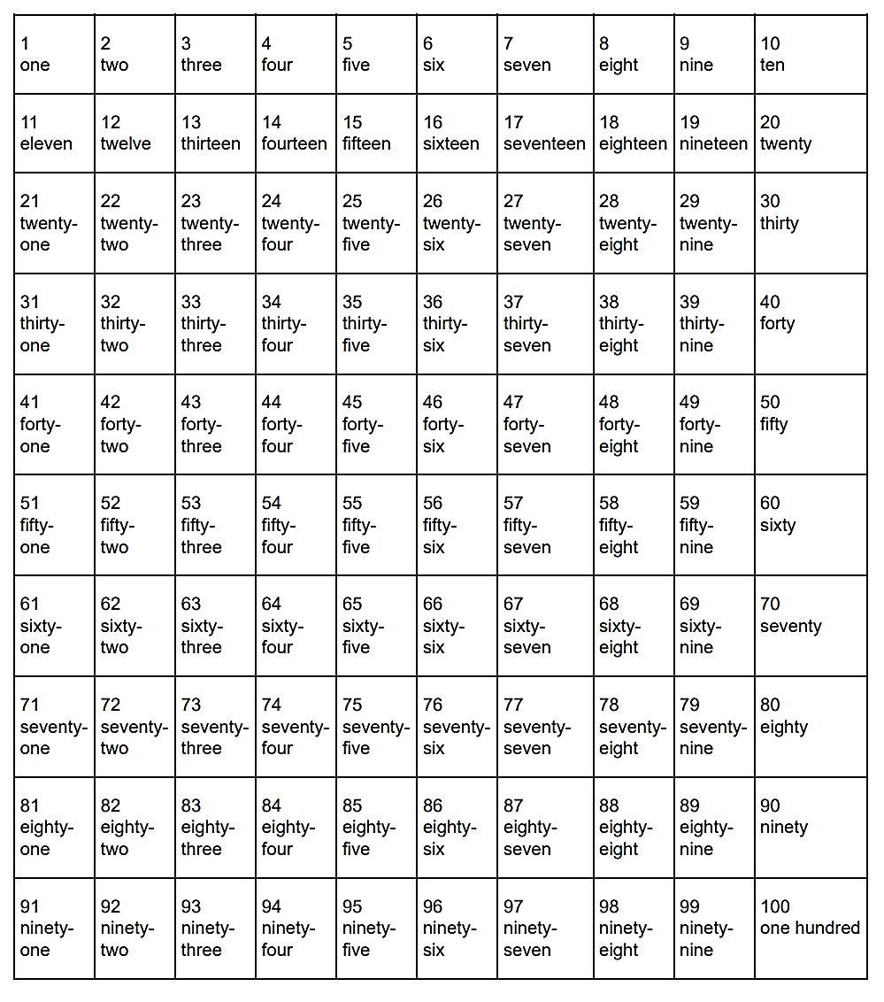
Now it’s your turn:
Number the pages of your ME-book or English exercise book.
Write numbers and words: 1 -one, 2 – two 3—three…..

Now it’s your turn:
My special numbers
Choose one number from each row on page 11 and colour it. Tell your teacher what it means for you.
Then write your answers on this page. Ask your teacher to check your answers.
Examples:
- 1-2-3-4-⑤-6-7-8-9-10
five: My brother is five years old.
- 31-32- 33 -34-35-36-37-38-39-40
thirty-three: Thirty-three is my lucky number. My phone number starts with thirty-three.
- 71-72-73-74-75-76-77-78-79-80
seventy-four: I live in Scheigergasse seventy-four.

1-2-3-4-5-6-7-8-9-10
Individual answers like in the examples
11-12-13-14-15-16-17-18-19-20
21-22-23-24-25-26-27-28-29-30
31-32-33-34-35-36-37-38-39-40
41-42-43-44-45-46-47-48-49-50
51-52-53-54-55-56-57-58-59-60
61-62-63-64-65-66-67-68-69-70
71-72-73-74-75-76-77-78-79-80
81-82-83-84-85-86-87-88-89-90
91-92-93-94-95-96-97-98-99-100

Ordinal numbers: first, second, third…
Who is winning the race?

first 1st
second 2nd
third 3rd
fourth 4th
fifth 5th
sixth 6th
seventh 7th
eighth 8th
ninth 9th
tenth 10th
eleventh 11th
…
twenty-first 21st
twenty-second 22nd
thirty-third 33rd
forty-fourth 44th
…


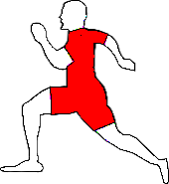
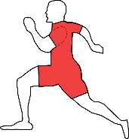
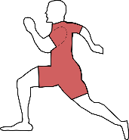
Leo
Mike
Tim
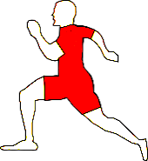
Boris
Gordon

Alan
Jim
Sam
Andi
Tom

Use a marker and highlight the letters in the circles.

Write sentences about all the runners:
Examples:
Boris is in first place.
Alan is in second place.

Now it’s your turn:
Gordon is in third place.
Jim is in fourth place.
Leo is in fifth place.
Sam is in sixth place.
Mike is in seventh place.
Andy is in eighth place.
Tim is in ninth place.
Tom is in tenth place.

Days of the week and months
Examples:

On Monday we have English.
On Tuesday I always play soccer.
On Saturday and Sunday I sleep in.

In winter I go skiing.
In summer I go swimming.
In spring there are lots of flowers.
In autumn the trees are very colorful.

School starts in September.
Christmas is in December.
In May there are lots of long weekends.
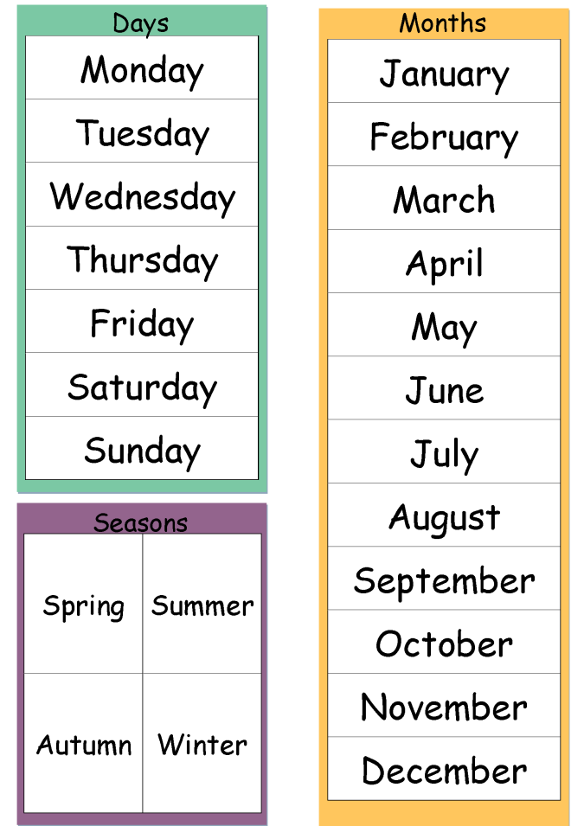
autumn
winter
summer
springhttp://www.polzleitner.com/epep/0-NMS/ErasmusGOALproject/Projektwoche.pptx

Now it’s your turn:

What is your favorite season?
e.g. My favourite season is spring!
What is your favorite month? Tell us why.
e.g. My favourite month is August because my birthday is in August.
In which months do you go swimming?
e.g. I go swimming in May, June, July and August.

In which months do you wear short sleeves?
e.g. I wear short sleeves in May, June, July, August and September.
What is your favourite day of the week? Tell us why.
e.g. My favourite day is Saturday because there is no school on Saturday.
What is your least favourite day of the week? Tell us why.
e.g. My least favourite day is Monday because school starts on Monday.

Giving the date in English
GIVING THE DATE
British:
1st October 2021
2nd November 2021
American:
December 3rd, 2021
January 4th, 2022
February 5th, 2022

Example:
When is your birthday?

You write: My birthday is on August 22nd.

You say:
My birthday is on the 22nd of August.

Now it’s your turn.

When is your birthday?
You write: My birthday is on …………individual answers………………………………………..

You say: ………………………………………………………………………………………………………………………….
When do the holidays start?
You write: The holidays start on …………different every year ………………………………..

You say: ………………………………………………………………………………………………………………………………………………
When is Christmas?
You write: Christmas is on ……December 24th………………………………….

You say: …………………Christmas is on the 24th of December
When does Ramadan start this year?
You write: It starts on …………… different every year …………….

You say: …………………………………………………………..…………………………………………………………………………………
On which floor is your English teachers’ office?
You say and write: It’s on the ………………………floor.

Possessive pronouns: my, your, his, her, our, their
Wem gehören diese Dinge? Read the dialogues (Look at the colours of the speech bubbles)
Look at Mr and Ms Brown and their children. They are really cute.
Yes, these are our children.
Yes, these are our children.
Are these your children?
Is this your dog, Tom?
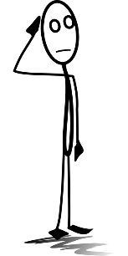
Yes, it is my dog.
Yes, this is his dog.


Is this Susan’s cat?
Yes, this is her cat.


Whose dog is it?
Draw a leash (Leine).

Is this the dog‘s ball?
Yes, the dog loves its ball.

More examples:
Thomas has a sister. His sister is called Mary.
Ms. Pölzleitner goes to school by bike. Her bike is white.
Ms. Bergmann has three children. Her children are called Martina, Julia and Matthias.
We have a very nice classroom. Our classroom is the best.
Some children from my old school go to a “Gymnasium”. Their school is not as cool as ours.

Now it’s your turn:
Write 7 TRUE and meaningful sentences about yourself and your friends and family.
Use: your, his, her, our, their Individual answers! Examples below
Example: My uncle has a new car. His car is red.
My friend …Michi.. has a cool jacket. Her jacket is black.
My mom has a bike. Her bike is very old.
My dad has an office. His office is small.
In my classroom we have a plant. Our plant is on the teacher’s desk.
My neighbors have a dog. Their dog is big.
Hello Tina. Can I please borrow (ausborgen) your pencil.
My grandparents have a house. Their house is white.

Whose things are these? Look closely:



Challenge 1:
Peter’s brother is called Thomas.
Andrea’s sister is very funny.
My mom’s favorite food is pizza.
My dad’s mom is my grandmother.


My aunt’s dog is really big.

’s
What does it mean?

My rule:
Ich schreibe ein ‘s …......
Wenn etwas jemandem gehört, oder zu jemandem gehört. Das xx von jemandem.

Now it’s your turn:
Write 5 similar (ähnliche) sentences.
Remember: Always write TRUE and meaningful sentences.
Individual answers like the examples above.

Whose things are these? What’s the difference?

Challenge 2:

What is the difference? Tip: How many friends, houses, girls and cats are there in these sentences?
s‘s
Tick the correct answer.
My friend’s house is beautiful. | My friends’ houses are beautiful.
1 friend more friends  house houses | 1 friend more friends  1 house more houses
The girl’s cat is called Minnie. | The girls’ cats are called Minnie and Tommy.
1 girl more girls  1 cat more cats | 1 girl more girls  1 cat more cats
Now match the pictures and the sentences. Write the numbers in the pictures:
3 4 6

5 1 2
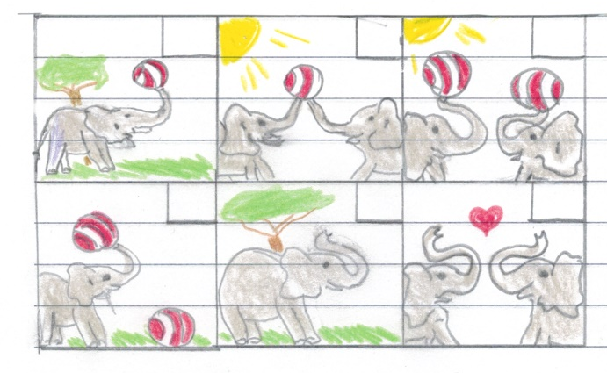
1: The elephant doesn’t have a ball.
2: The elephants don’t have a ball.
3: This is the elephant’s ball.
4: This is the elephants’ ball.
5: These are the elephant’s balls.
6: These are the elephants’ balls.



Now it’s your turn:
Make your own drawings. Choose one animal (e.g. a cat, dog, bird ….) and one thing (e.g. a ball, a bone, an egg) Write sentences with …‘s or s’ and draw a picture for each one. Show them to your teacher.
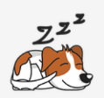  (draw 1 animal) | e.g. The dog doesn’t have a house.  Individual answers depending on their drawings
    (draw 1 animal and 1 thing) | This is the dog’s house.
    ( draw 1 animal / 2 things) | These are the dog’s houses.
  (draw 2 animals) | The dogs don’t have a house.
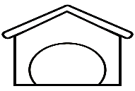  (draw 2 animals / 1 thing) | This is the dogs‘ house.
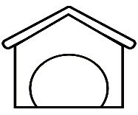  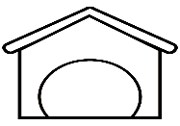  (draw 2 animals / 2 things) | These are the dogs‘ houses.  DOGS: Image by Jennifer R. from Pixabay  HOUSE: Image by Maggiechristine1 from Pixabay

Asking questions in English

The new English teacher…
Ms. Bergmann meets the new English teacher at her school.
She asks him lots of questions.
Do you like Great Britain?
Where do you come from?
Where do you live?
What languages do you speak?
Do you go to school by bike?
How do you get to school?
When do you get up?
Do you drink coffee?
Why don’t you drink coffee?
Do you have a pet?

How do your classmates study vocabulary?
How does your best friend get to school?
Ms. Pölzleitner wants to know everything about the new teacher. She texts Ms Bergmann.
Questions, questions, questions

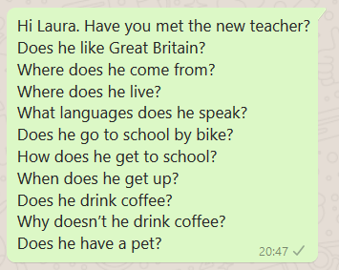

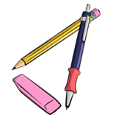

Challenge
What do you notice? (Was fällt dir auf?)
Man kann für Fragen Fragewörter verwenden. Schreibe die Fragewörter auf:
………Where, What, When, Why, How
Die meisten Fragen bildet man mit do oder does:
Do you like spinach? Does she like spinach? Does he like pizza? Does your cat catch mice. Where does he live?
Does verwendet man wenn man über 1 Person fragt (Tipp: Schaue auf Seite 6 nach.)
Das verb (z.B like, come, live, speak, go, get, drink, have) bleibt gleich.

Now it’s your turn:

Write your own questions
Write 5 interesting questions that you want to ask your teacher.
individual questions, e.g.
Where do you come from? How do you get to school? ….

Write 5 interesting questions about one of your classmates. Talk to your teacher and see if she/he can answer them. How many questions can your teacher answer correctly? _______________
individual questions, e.g.
Where does Melisa come from? How many brothers and sisters does she have? When does Melisa get up? Does Melisa speak Serbian?....

More questions: Interview a student teacher
Make a questionnaire (Fragebogen)
Write a lot of questions to interview guests and student-teachers.
Whenever we have guests in class, talk to them and ask them all your questions.
individual questions, e.g.
What’s your name?
Where do you come from?
Do you have a pet?
What languages do you speak?
Why are you at our school?
What’s your favourite food?
Do you have any hobbies? What do you do in your free time?
When do you usually get up?
How do you go to work?
What’s your favourite subject?
Do you have any children?
Do you like our school?

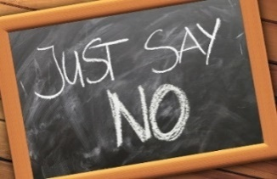
Negation in English

Challenge
Laura has a problem. She needs Lis’ help.
Read the text. What do you notice?
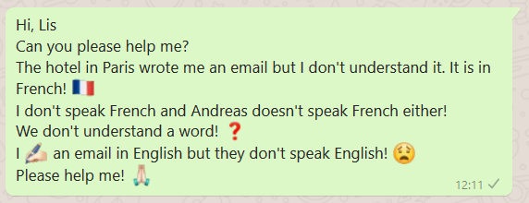

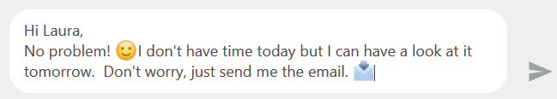

What do you notice? (Was fällt dir auf?)
In der Verneinung verwendet man don’t oder doesn’t vor dem Verb (z.B. speak, like, eat)
Doesn‘t verwendet man wenn man über 1 Person spricht.
Das verb (z.B. understand, speak, have,) bleibt gleich.

Now it’s your turn.
Say what people DON’T do! Write your own examples. Start your sentences like this:
I…individual answers! E.g. I don’t like dogs.
My best friend doesn’t eat any meat. He is vegetarian.
My teacher doesn’t like Nutella.
My cat/dog/ mouse doesn’t eat meat.
My parents don’t live together.
My friends Anna and Peter don’t go to my class.
We don’t have a smartboard in our classroom.

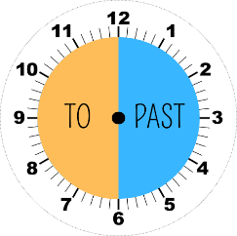
Telling the time

Analogue | Digital | You say: | Hints | Timetables, TV etc.
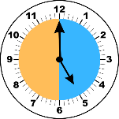 | 5:00 | “It’s five o’clock“
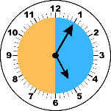 | 5:05 | “It’s five past five“ | past
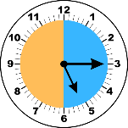 | 5:15 | “It’s quarter past five“ | past | It’s five fifteen.
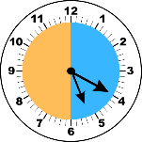 | 5:20 | “It’s twenty past five“ | past | It’s five twenty.
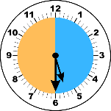 | 5:30 | “It’s half past five“ | past | It’s five thirty.
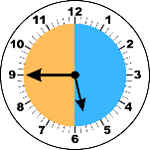 | 5:45 | “It’s quarter to six“ | to | It’s five forty-five.
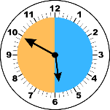 | 5:50 | “It’s ten to six“ | to | It’s five fifty.
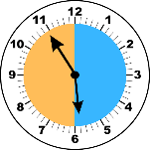 | 5:55 | “It’s five to six“ | to | It’s five fifty-five.

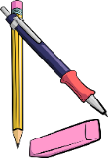
Now it’s your turn:
Answer the following questions. Write complete sentences.
What time is it right now? It is …depending on when you do the task
What time do you usually get up in the morning? At … individual answers
What time does school start? At … depends on your school
What time do you have lunch? individual answers
What time does school finish? depends on your school
What time do you usually study vocabulary? individual answers
What time do you go to bed in the evening? individual answers

Routines: What we do regularly

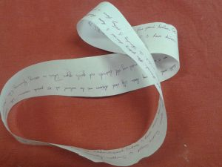 | Maria usually gets up at half past six. Then she takes a shower and gets dressed. At seven o’clock she has breakfast with her family. She eats bread, butter and jam and she drinks a cup of hot chocolate. Then she goes to school by bus. She arrives at school at half past seven. She goes to her locker to change her shoes and to hang up her coat or jacket. School starts at quarter to eight….
xxxx

Here we are talking about

……………………(daily) routines
We use the present simple (get up, take, have, go…).

Now it’s your turn:

My daily routines
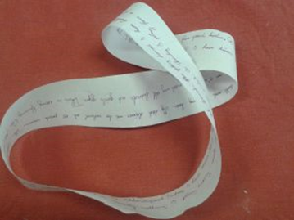
Ask your teacher for a Moebius strip. Then write down all the things you do every day – and every week.
Write as much as you can. Fill all the paper.
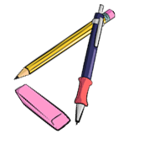
Read your text to your teacher and to a friend.
Then put it into an envelope and glue it on this page.
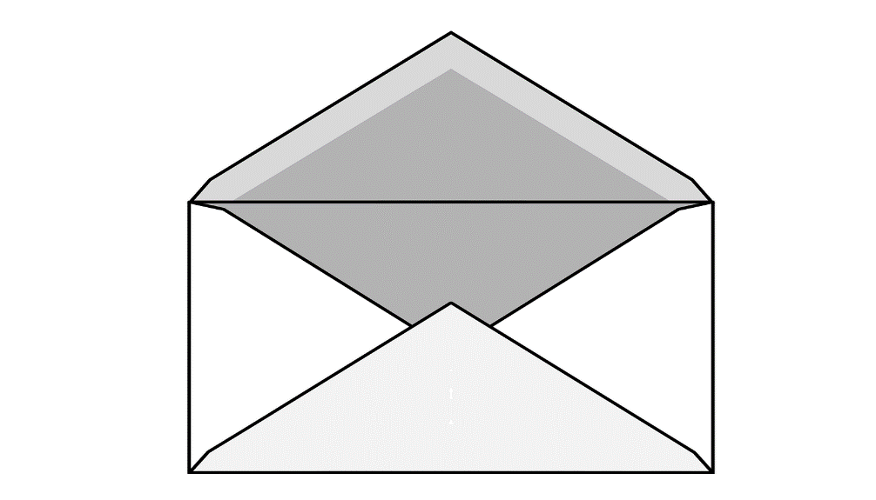

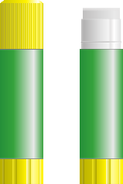


For the teacher:
https://www.polzleitner.com/epep/Grammar/PresentRoutines.pdf

Routines versus Present activities

Challenge:
Look at the examples on page 25 and here. What’s the difference?
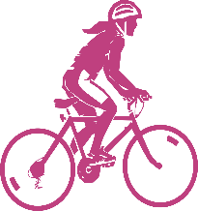  The girl is riding her bike. | 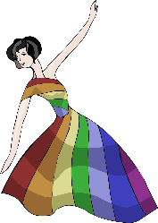  The girl is dancing. | 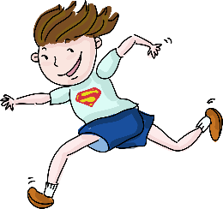  The boy is running.
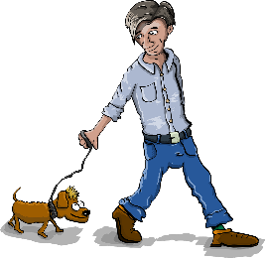  The man is walking his dog. | 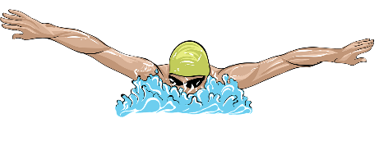  The man is swimming. | 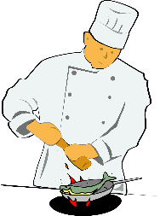  The cook is cooking.
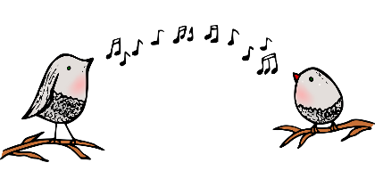  The birds are singing. | 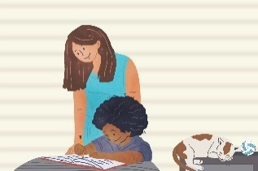  The child is doing her homework. | 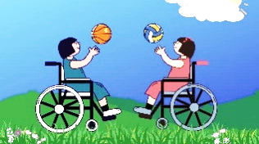  The children are playing  with their balls.


Here we are describing what…people are doing at the moment.
We use the present continuous form (is singing, is riding, are dancing).

Be a detective: What is going on in your class and your school?
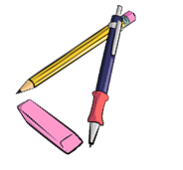
Look around the classroom. What are your classmates doing right now? Write 5 true sentences on a sheet of paper.
Show your sentences to your teacher, then correct your sentences and
write them in the box.
1 individual answers: e.g.: Thomas is writing in his workbook.
2 individual answers: e.g.: Maria is chatting with Eva.
3
4
5

There is --- There are
Describing what you see and what is there:

In our classroom there are 22 children.
There are also 22 chairs and many tables.
There is a computer under the teacher’s desk and there is a projector on the ceiling.
There are two big cupboards at the back of the classroom and there is a big green board on the front wall. Next to the door there is a washbasin and underneath there are three garbage bins.

Explain: When do we use there is? When do we use there are?

My rule:

We say THERE IS….when we talk about 1 thing

We say THERE ARE…when we talk about 2 or more things

Now it’s your turn:

Write five sentences about your room. Use there is and there are

individual answers

Asking questions with there is—there are

Is there | a | sofa | in your classroom?
Is there | an | orange | in your classroom?
Are there | any | laptops | in your classroom?

Yes, there is.  No, there isn’t. | Yes, there are.  No, there aren’t.

There is a | sofa | in/on/under/next to/in front of/behind/between…..the
There are some | posters | in/on/under/next to/in front of/behind/between…..the

Now it’s your turn:
Work with a partner. Ask your partner 5 questions about his/her room.
Then write your questions and your partner’s answers.
Question 1: individual questions and answers
…………’s answer:
Question 2:
…………’s answer:
Question 3:
…………’s answer:
Question 4:
………..’s answer:
Question 5:
…………’s answer:

Where things are: Prepositions of place

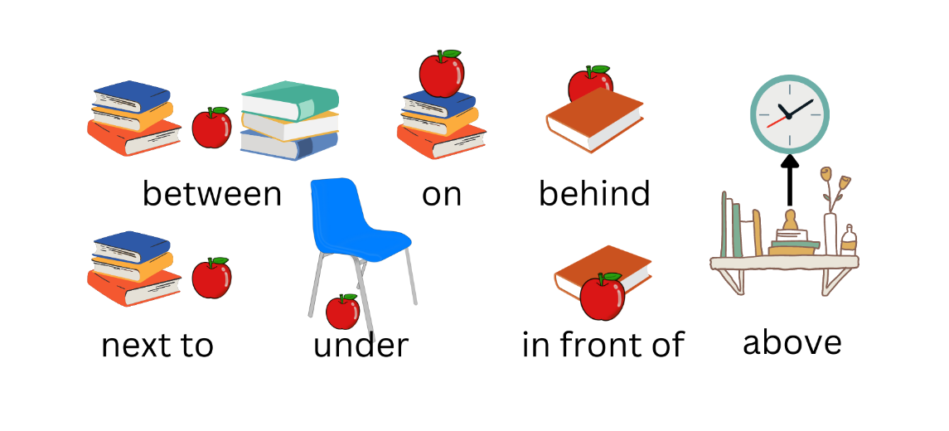
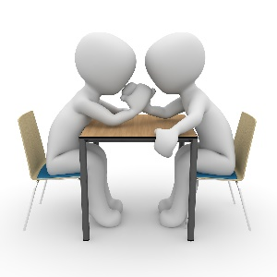

opposite
They are sitting opposite each other.

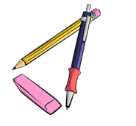
Now it’s your turn:

Write 8 true sentences about your classroom, or your room on a piece of paper.
Show your sentences to your teacher. Correct your sentences. Copy them in here.

Individual answers
e.g.
In our classroom there is a sink next to the blackboard.
Under the sink, there is a bin.
Above the sink, there is a mirror.
Next to the mirror, there is a clock.

There are 25 chairs in our classroom.

Talking about the past

Usually, .. |  | Yesterday …
I | am happy. | I | was sad.
We | are happy. | We | were sad.
I | do my homework. | I | did my math exercises.
I | go to school by bus. | I | went to school by bike.
I | spend 6 hours in school. | I | spent 7 hours in school.
I | have breakfast with my mom. | I | had breakfast with my dad.
I | take a shower. | I | took a bath.
I | read a book in bed. | I | read a newspaper.
I | speak with my friends. | I | spoke with my sister.
I | drink water. | I | drank Coke.
I | get up at 6 o’clock. | I | got up at 7 o’clock.
We | drive to my grandmother’s house. | We | drove to my aunt’s house.
I | say funny things. | I | said sad things.
I | usually eat cornflakes for breakfast | Today, I | ate eggs and toast.
We | stand up when a teacher comes in. | We | stood up when Frau Wagner came in.
We | buy our food at SPAR. | We | bought our food at BILLA.
I | write a shopping list | I | wrote an e-mail to my teacher.
I | buy a bottle of water. | I | bought a bottle of Coke.
I | try to speak English with my teacher. | I | tried to speak English with my teacher.
I | copy the new words on vocabulary cards. | I | copied the new words on vocabulary cards.
I | carry the books to the library. | I | carried the books to the library.

Past tense, Irregular forms

Now it’s our turn:
Choose 10 verbs from page 30 and write true and meaningful sentences about yourself, your friends and family.
Remember: Your brain will remember TRUE sentences better than nonsense sentences.
What DID YOU DO (yesterday, in the holidays, last weekend….)?
Individual answers
e.g. Yesterday I got up at 5 o’clock.
e.g. In the holidays I went to Croatia.
e.g. Last weekend I studied for the math test.

Past tense: Regular Verb forms
Usually, .. |  | Yesterday … / In summer...
I | always greet my teachers in the hallway. | I | greeted the guests and showed them the way to our classroom.
I | play football every Friday. | I | played football in the morning.
We | usually stay in a hotel in the holidays. | We | stayed with friends.
I | watch TV every evening. | I | watched TV all day long.

Write 5 true sentences about what you usually do and what you did last week/last summer/last year.
Use only regular verbs (-ed).
watch | play | start | stay | visit | stop | clean | open | close | talk | study | travel |

Examples:
I usually watch TV in the evening but yesterday I watched a movie in the cinema.
I usually play basketball during recess. Yesterday I played with Tom and Paul.
individual answers like the example

Past tense - Negation

Now it’s your turn:
I can say what I did and what I did not do in the holidays.
I did not go to America, but | I went to Turkey.
I did not eat any Sauerkraut, but | I ate lots of ice-cream.
I did not buy any souvenirs, but | I bought a new t-shirt.
I did not take a shower, but | I took a bath.
I did not play chess, but | I played football with my friends.



Write 10 sentences on a sheet of paper. Show your sentences to your teacher. Then write the correct sentences on this page. Examples:
I did not go to Greece this summer, but I went to Turkey.
I did not read many books this summer, but I watched lots of movies.
individual answers like the example

Challenge:
What do you notice about the verb forms? Tell your teacher. Then write your rule in this box.
e.g. If I use “did” I use the first form of the verb, not the past tense.

Past tense – Questions

Yes, I did.
Did you go swimming in the holidays?

Did you speak English in the holidays?
No, I didn’t.
Did you visit your grandmother?

Did you like your hotel?

Now it’s your turn:

What did your English teacher do in the holidays?
Write 5 questions that you would like to ask your teacher. Then talk to him/her and ask your questions.

Did you… individual questions e.g. Did you go to England. Did you go
swimming? Did you go on holiday by plane?
Did you…

Irregular Verb Forms (in groups)
There are about 185 irregular verbs in English. You will only need these 90. Study them carefully. Start with the red ones, they are the most important verbs that you will need almost every day.
Base form | Past form | Last form | German | Base form | Past form | Last form | German
All forms different |  |  |  | Past form and last form end in [d]
be (is/was) | was / were | been | sein | find | found | found | finden
become | became | become | werden | have | had | had | haben
come | came | come | kommen | hear | heard | heard | hören
do | did | done | tun | hold | held | held | halten
go | went | gone | gehen | lay | laid | laid | legen
run | ran | run | laufen | make | made | made | machen
see | saw | seen | sehen | pay | paid | paid | zahlen
show | showed | shown | zeigen | read [ri:d] | read [red] | read [red] | lesen
 |  |  |  | say | said | said | sagen
All forms the same |  |  |  | sell | sold | sold | verkaufen
cost | cost | cost | kosten (Preis) | stand | stood | stood | stehen
cut | cut | cut | schneiden | understand | understood | understood | verstehen
hit | hit | hit | schlagen | tell | told | told | erzählen
hurt | hurt | hurt | verletzen
let | let | let | lassen | Same sound patterns
put | put | put | stellen/legen | bring | brought | brought | bringen
set | set | set |  | buy | bought | bought | kaufen
shut | shut | shut | schließen | fight | fought | fought | kämpfen
 |  |  |  | think | thought | thought | denken
Past form and last form the same |  |  |  | catch | caught | caught | fangen
dig | dug | dug | graben | teach | taught | taught | lehren
win | won | won | gewinnen
 |  |  |  | sing | sang | sung | singen
Past form and last form end in [t] |  |  |  | swim | swam | swum | schwimmen
build | built | built | bauen | begin | began | begun | beginnen
burn | burnt | burnt | (ver)brennen | drink | drank | drunk | trinken
creep | crept | crept | kriechen | ring | rang | rung | läuten
feel | felt | felt | fühlen
keep | kept | kept | behalten | freeze | froze | frozen | frieren
leave | left | left | verlassen | steal | stole | stolen | stehlen
light | lit | lit | anzünden | break | broke | broken | brechen
lend | lent | lent | borgen | wake | woke | woken | aufwecken
mean | meant | meant | meinen | choose | chose | chosen | auswählen
meet | met | met | treffen | drive | drove | driven | fahren, lenken
send | sent | sent | schicken | write | wrote | written | schreiben
shoot | shot | shot | schießen
sleep | slept | slept | schlafen | beat | beat | beaten | schlagen
smell | smelt | smelt | riechen | bite | bit | bitten | beißen
spend | spent | spent | ausgeben | eat | ate | eaten | essen
spill | spilt | spilt | ausschütten | fall | fell | fallen | fallen
spoil | spoilt | spoilt | verwöhnen | forget | forgot | forgotten | vergessen
get | got | got | bekommen | forgive | forgave | forgiven | verzeihen
lose | lost | lost | verlieren | give | gave | given | geben
sit | sat | sat | sitzen | hide | hid | hidden | verstecken
sweep | swept | swept | kehren | shake | shook | shaken | schütteln
 |  |  |  | take | took | taken | nehmen
Same sound pattern |  |  |  | tear | tore | torn | zerreißen
grow | grew | grown | wachsen | wear | wore | worn | tragen(Kleider)
fly | flew | flown | fliegen
know | knew | known | wissen
throw | threw | thrown | werfen

Irregular verbs in alphabetical order
be (Is / are) | was/were | been
beat | beat | beaten
become | became | become
begin | began | begun
bend | bent | bent
bet | bet | bet
bind | bound | bound
bite | bit | bitten
blow | blew | blown
break | broke | broken
bring | brought | brought
build | built | built
buy | bought | bought
can | could | … (been able)
catch | caught | caught
choose | chose | chosen
come | came | come
cost | cost | cost
creep | crept | crept
cut | cut | cut
dig | dug | dug
do | did | done
draw | drew | drawn
drink | drank | drunk
drive | drove | driven
eat | ate | eaten
fall | fell | fallen
feed | fed | fed
feel | felt | felt
fight | fought | fought
find | found | found
fly | flew | flown
forbid | forbade | forbidden
forget | forgot | forgotten
forgive | forgave | forgiven
freeze | froze | frozen
get | got | got
give | gave | given
go | went | gone
grow | grew | grown
hang | hung | hung
have | had | had
hear | heard | heard
hide | hid | hidden
hit | hit | hit
hold | held | held
hurt | hurt | hurt
keep | kept | kept
know | knew | known
lay | laid | laid
lead | led | led
leave | left | left
lend | lent | lent
lie (in bed) | lay | lain
lie (lügen) | lied | lied
lose | lost | lost
make | made | made
mean | meant | meant
meet | met | met
must | had to | …
pay | paid | paid
put | put | put
read | read | read
ride | rode | ridden
ring | rang | rung
rise | rose | risen
run | ran | run
say | said | said
see | saw | seen
sell | sold | sold
send | sent | sent
set | set | set
shake | shook | shaken
shine | shone | shone
shoot | shot | shot
show | showed | shown
shrink | shrank | shrunk
shut | shut | shut
sing | sang | sung
sink | sank | sunk
sit | sat | sat
sleep | slept | slept
slide | slid | slid
smell | smelt | smelt
speak | spoke | spoken
spend | spent | spent
spit | spat | spat
spread | spread | spread
stand | stood | stood
steal | stole | stolen
stick | stuck | stuck
sting | stung | stung
stink | stank | stunk
strike | struck | struck
swear | swore | sworn
swim | swam | swum
swing | swung | swung
take | took | taken
teach | taught | taught
tear | tore | torn
tell | told | told
think | thought | thought
throw | threw | thrown
wake | woke | woken
wear | wore | worn
win | won | won
wind | wound | wound
write | wrote | written

Comparing

1. Read the descriptions of these exotic animals and highlight all the comparisons (Vergleiche). Then match them with the pictures. Draw lines.
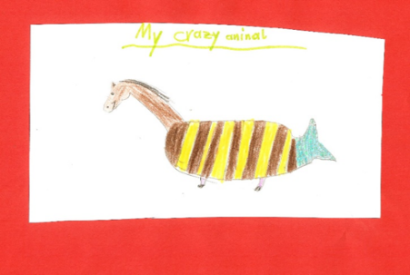
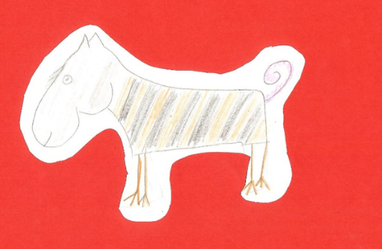
Crocosharkopeacock
The crocosharkopeacock is a very strange animal. It has a crocodile’s head, the body of a shark and the tail and feathers of a peacock. Its legs are as short as a crocodile’s and it cannot run very fast, but the crocosharkopeacock can fly faster than any other bird. It is the fastest animal in the world. It has very sharp teeth and it is one of the most dangerous animals in the world. It is more dangerous than a crocodile or a shark.
Tigohorsophin
The tigohorsophin is a lovely animal. It has the head and neck of a horse, the body of a fat tiger and the tail and fin of a dolphin. It has the smallest, shortest legs of all the exotic animals. Normally it doesn’t walk but it can swim. The tigohorsophin is the heaviest of the exotic animals and it is even slower than the horsotigopigchick but it is the most intelligent of all the exotic animals. It is more intelligent than a dog.
Horsotigopigchick
The horsotoigopigchick has the body of a tiger, the head of a horse, the tail of a pig and the feet of a chicken. Its head is bigger than a tiger’s head and a lot heavier. The horsotigopigchick’s legs are much thinner than a tiger’s legs and it is slower than a tiger. It has a thin pink tail and it is less intelligent than the Tigohorsophin but is the friendliest of these animals and makes a perfect pet.

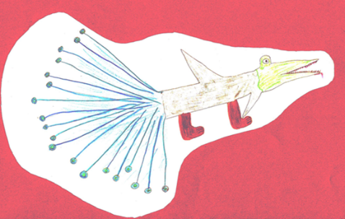

2. Are these sentences true or false? Tick the correct ones and correct the false ones.

Challenge:
Find the rule.
How do we compare adjectives?
How would you explain this to your mom?
Horsotigopigchicks are as fast as tigers. not as fast as/slower than
Tigohorsophins are the heaviest and slowest animals in this group.
Tigohorsophins are the most intelligent of the exotic animals.
Tigohorsophins
The crocosharkopeacock has shorter legs than the other animals.
less
The horsotigopigchick is more dangerous than the other animals.
more
The crocosharkopeacock is less dangerous than the horsotigopigchick.

Challenge:
Write the three forms to show that you can compare things.
  thin |   thinner |   the thinnest
kind | kinder | kindest
cold | colder | coldest
intelligent | more intelligent | most intelligent
beautiful | more beautiful | most beautiful
interesting | more interesting | most interesting

Explain it!

Now it’s your turn:
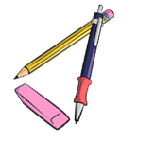
Choose two animals and compare them. Use a piece of paper for your first draft.
Write at least 5 sentences. Ask your teacher to check.
Then copy the corrected sentences into this box.

Individual answers
e.g. Dogs are more intelligent than cats.
Cats are nicer than dogs.
Dogs are more dangerous than cats.
Cats are smaller than dogs.
Dogs are bigger than cats.

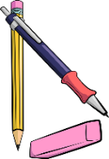
My rule: in English or German
Kurze Adjektive werden mit „-er“ und „the …-est“ gesteigert.
Slow – slower – the slowest
Längere Adjektive werden mit „more“ und „the most“ gesteigert. Intelligent – more intelligent – most intelligent.

Talking about the future

Talking about our PLANS
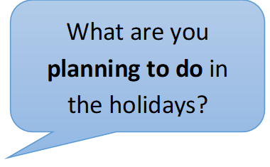
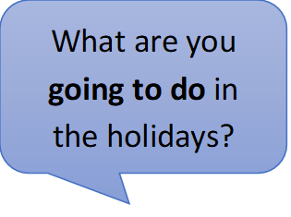
Write 3 sentences about your holiday plans
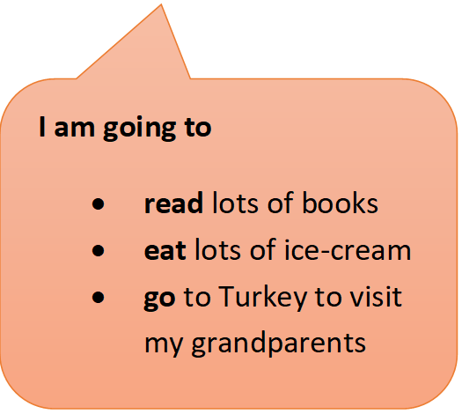
and
3 sentences about your friend’s holiday plans
and
We are going to
- visit our family
- play a lot of games
- go swimming
3 sentences about your teachers’
holiday plans.

Now it’s your turn:
My holiday plans
I am going to individual answers
Iam…
I…

My friend’s holiday plans
Name………….. is going to… individual answers

My teacher’s holiday plans
Name………….. is going to… individual answers

Talking about the future: What‘s the difference?

Challenge:
Read the following examples where people talk about the future. Highlight all the verbs (Zeitwörter).
What do you notice? What is the difference between text A and text B? Tell your teacher what you have found out.
A
I’m not sure. I think I will live in a flat or in a house with my partner. Maybe I will have some children.
I’ll work in a big company and I’ll have a car of my own. It will probably be an electric car – or maybe I’ll go to work in a self-driving car.
What will your life be like in the year 2040?

My Rule:
Here we are talking about vague ideas about the future. We are not sure what will happen. We use the form…………………………………………………

Tip: Remember
I am = I’m
I will = I’ll



B
This weekend I am going to Klagenfurt to celebrate my grandmother’s birthday. All my cousins are going to be there too.
On Saturday evening we are going to watch all the Harry Potter movies together, my cousin Peter has them all on DVD.
On Sunday we are going to celebrate my grandmother’s birthday in a restaurant. I am going to order Wienerschnitzel, my favorite food.
I am really looking forward to this weekend.
What are you going to do next weekend?

My Rule:
Here we are talking about our plans for the future. We use the form ………………………

That sounds like fun. My weekend is going to be boring. I am going to study for the math test, and I am going to work on my module in English. And then, I am going to clean up my room, it’s a real mess.
Your weekend
Your teacher’s weekend
If …

Perhaps…
Maybe…

Perhaps, I’ll go to the bookstore and buy a new book.
Maybe, I individual answers
e.g. … will go to the park.

Perhaps, I individual answers
e.g. … will eat some ice cream
Maybe, my sister will visit me. She is very busy, I don’t know if she has got time.
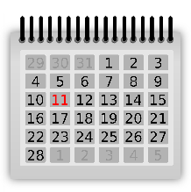


On Sunday I am going to sleep in and have a nice, long breakfast.
I am going to meet my friend Nancy on Saturday afternoon. We are going to have coffee and cake and chat about work.

On Sunday afternoon I am going to do some work for school. I have a long to-do list.
On Saturday morning I am going to do my grocery shopping for the week, and I am going to clean my house.
If the weather is nice,
I… individual answers
e.g. … will go swimming.
e.g. I am going to buy a new pair of jeans with my mom.

Now it’s your turn:
What are YOU going to do next weekend (or in the upcoming holidays)? Do you have any PLANS and VAGUE IDEAS? Write your plans and some vague ideas on the left side.
Write them on the left side of the arrow.

e.g. I am going to study for the English test.
e.g. I am going to play football with my friends on Saturday afternoon.
My PLANS
My plans…
I’ll go jogging if the weather is good.

Talking about general experiences: Have you ever …..

Grammar Challenge: Find out about your teacher…

- Step 1: Read the interview. Highlight the verbs. What are the differences in the round and square speech bubbles?

- Step 2: Find the rule and tell it to your teacher. Then write it in the box below.

Have you ever been to America?

Yes, I have been to America twice.

Where did you go?

The first time I went to California and stayed there for four weeks.
The second time I went to America on my honeymoon. My husband and I stayed in New York for a week.

Have you ever visited the White House.

No, I have never visited the White House

Have you ever touched a snake or a tarantula?
I have never touched a tarantula but I have touched a snake.
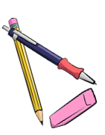

My rule

We use „have + 3rd form“ (present perfect tense) to talk about
our general experiences / things we have done in our lives / Erfahrungen die wir irgendwann gemacht haben.
We use the past tense to talk about specific events.
bestimmte Ereignisse in der Vergangenheit (wo, wann, mit wem….)
I went skydiving when I was twenty years old. It was fantastic. We went up to almost 4000 metres in a little plane and then we jumped down.
We loved it and wanted to do it again, but it was too expensive.
When did you go skydiving?
Did you like it?

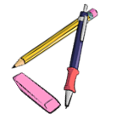
Now it’s your turn:

Find your own questions and answers that you want to ask your teacher or a classmate. Use the correct tenses. Ask until you get the answer: “Yes, I have.”
Have you ever …
individual question
e.g. eaten insects?
Yes, I have.

Find out: when – where - why –who- how….

Write down the questions:

name: of the person who said YES
e.g.
When did you eat insects?
Why did you eat insects?
What did they taste like?
Where did you eat insects?
How did you cook them?

Write down the answers:
Individual answers


My exciting life: I have done lots of cool things
Look at the example.
Step 1: Write about three interesting things you have experienced (erlebt). Use the speech bubbles.
Step 2: Give details in the box.

Step 3: Ask your teacher to check.
details

It happened a few years ago. I was at the beach in Caorle. Suddenly I saw a group of children. They were very excited because they had a baby shark in a bucket.
I took the shark and took it back to the sea. It was very weak so I moved it around in the water. After some time, it swam away.
experience
I have touched a shark.

when – where - why –who- how….

details
I have ____________ ___________________
Individual answers. Details of the event written in the past simple.
when – where - why –who- how….

experience



Individual answers. Details of the event written in the past simple.
I h _ _ _ _______________
- - - - - - - - - - - - - - - - - - - - .

experience

when – where - why –who- how….


Individual answers. Details of the event written in the past simple.
I _______ __________ _____________________
- - - - - - - - - - - - - - - - - - - - .

when – where - why –who- how….
experience

Wishful thinking: Conditional II

Life could be even cooler…
- if we had lots of money
- if we had a lot of time
- if we could do magic
Step 1: Read about Ms. Bergmann’s dreams.
Step 2: Underline all verbs. The first one has been done for you. What do you notice?
Step 3: What would you do if …. ? Write at least 2 sentences per topic.
If I had a superpower and could become invisible, I would go to Buckingham Palace and watch the Royal family.
I would also go to a film set of Dr Who. If I was invisible, I would go to a spa in the evening when it is closed and be there all on my own.

Well, if I won a thousand Euros in the lottery, I would book a flight to Great Britain or to Ireland and spend a wonderful week there. Of course, I would take my family with me.
If I won a million Euros, I would buy a house or a castle in Scotland where I would spend the summer. I would have a butler, of course.

If I could travel in time, I would visit many interesting times. I would go to Scotland in the 17th century and visit the Scottish clans. Then I would go to the 19th century and meet Sissi. Then I would go to the 20th century and take a picture with Albert Einstein. And if I could travel in time, I would also go to the future and meet my great-grandchildren.

Now it’s your turn

Step 1: Read the sentences and look at the underlined words.

If I had a bike, I would go to school by bike every day.
If I was invisible, I could find out all my friends’ secrets.
If I could play the guitar, I would join a band.
I would go for a walk every day if I had a dog.
I would stay in bed all day if I did not have a test today.

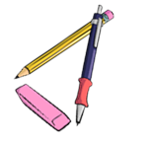
Now it’s your turn.

Use the same structure to complete the sentences
If I had a pet, … individual answers e.g. … I would feed it every day.
If I had 50 euros, I … individual answers e.g. … I would buy this cool t-shirt that I saw in town.
I would go to America if … individual answers e.g. it wasn’t so expensive
If I could fly, I … individual answers e.g. …would fly to Italy.
If I had a twin sister/ brother, I … individual answers e.g. …would send him to my English class to write my tests.
If I could travel in time, … individual answers e.g. I would go to my parents’ wedding.
I would not leave the house if … individual answers e.g. … I was ill
If I was super strong, I … individual answers e.g. would win every fight.
If I could speak every language in the world, I… individual answers e.g. I would travel a lot and make new friends all over the world.
I would…build a big house with a swimming pool . if I was…rich.
I would …play computer games all day …… if I didn’t have to go to school.
I would buy a playstation if it wasn’t so expensive.

It’s your turn

What are your wishes and dreams? What would you do if they came true?
I would like to …
If I ……

I would like to be 16 years old.
If I was 16 years old, I could stay out really late.

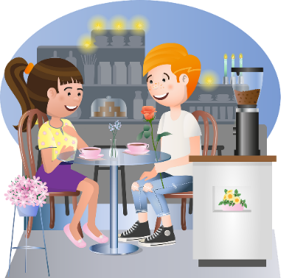

Write at least 5 wishes and dreams of your own.
Use the same structures.

individual answers e.g. I would like to have a new gaming computer. If I had a new computer I could play cooler games.
individual answers e.g. I would like to speak Italian. If I spoke Italian, I would go to Italy in the summer.
individual answers e.g. I would like to be rich. If I was rich, I would buy a big house for me and my parents.
…

one or ones --- this or these

Challenge 1
Look at the two dialogues below and highlight “one” and “ones”. What do you notice?
When do we use one and when do we use ones and this and these?

Shop assistant: Good morning. How can I help you?
Customer: I’m looking for a new sweater.
S: How about the blue one here?
C: I don’t like blue… Do you have any grey ones?
S: Yes, over there. Do you like this one?
C: Yes, this one is beautiful.
S: What size do you wear?
C: Small.
S: Ok, try this one
C: It’s too small. Do you have a larger one?
S: No, sorry. The large ones are sold out.

Shop assistant: Good afternoon. What can I do for you?
Customer: I’d like a pair of boots.
S: What size do you wear?
C: I usually wear size 7. I’d like some green ones.
S: Sorry, we don’t have any green ones. But these blue ones are really trendy, or these brown ones. The brown ones are very popular this winter!
C: Can I try them on?
S: Of course.
C: I really like them. How much are they?
S: 110 pounds.
C: That’s too expensive. I can’t afford that. What about the black ones?
S: They are on sale. They only cost 50 pounds right now.
C: Great, I’ll take the black ones!

My rule

We use (THIS) ONE for ….for 1 thing

We use (THESE) ONES for …..for 2 or more things

some or any

Challenge 1

More and more young people are becoming vegetarians. They have decided not to eat any meat or fish. Some people do not eat any animal products, not even milk, eggs or honey. They are called vegans. Let’s see what kind of food Lea, Tim and John have at home.
Read the texts and mark SOME and ANY in two different colors.
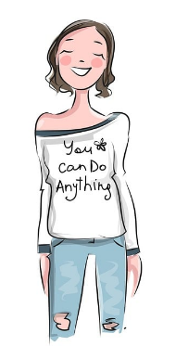
Lea
I’m a vegan, but my parents eat meat and other animal products. Therefore, we have all kinds of foods in our kitchen. There are always some eggs in our fridge and we usually have some milk and yogurt at home. My mom makes sure there is always some soy milk or oat milk for me. We don’t usually have any tofu, but once in a while my mom buys some tofu and prepares a delicious Chinese stir-fry for the whole family. We all like that a lot.

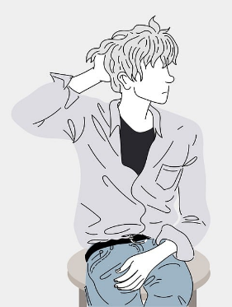
In my family we are all vegetarian. We don’t eat any meat or fish. So, we never have any meat or sausages or fish in our fridge. We always have some yogurt, because we eat yogurt with fruit for breakfast every day. We always have some milk in our fridge, and we love cheese. There is always some cheese in our fridge. We eat lots of vegetables and salad, so there are usually some zucchini, some tomatoes and some carrots in our fridge.

Tim

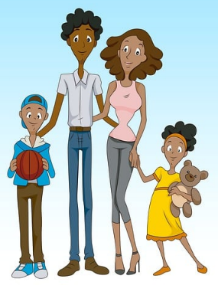
In my family we like to eat a mixed diet. We eat all kinds of foods, including meat, fish and milk. Unfortunately, I am allergic to nuts. Therefore, we never have any nuts at home. My mom makes sure not to buy any breakfast cereals that contain any nuts. When I buy sweets or snacks in the school cafeteria, I always check the list of ingredients to see if they contain any nuts.

John

Challenge 2

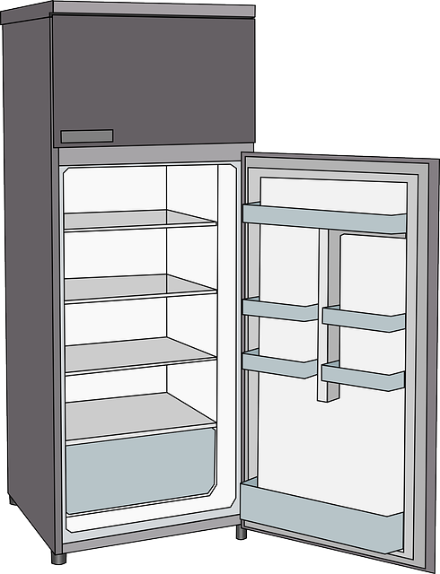
Choose one of the three students. What kind of food does their family eat? What do they usually keep in their fridge? Draw the things and label the picture.
some carrots
Lea | some eggs, some milk, some yogurt, some soy milk or oat milk , (some meat, some tofu possible)
Tim | some yogurt, some milk some cheese some zucchini, some tomatoes and some carrots
John | some meat, some fish and some milk.

Challenge 3
Lea, Tim and John are going on a class trip. When they sign up for the trip they are asked about their food preferences and allergies. What do these kids NOT eat?
Lea does not eat any …meat, fish or animal products.

Tim doesn’t eat any meat or fish.

John doesn’t eat any nuts.

Challenge 4***
???
Look at these questions. What is the difference? Why does the speaker use some or any?
Ms. Pölzleitner, do you know some good English books that I could read?  (Hint: Ms Pölzleitner is the English teacher.) | Mr. Grasser, do you know any good English books that I could read?  (Hint: Mr. Grasser is the math teacher.)
We expect the answer to be YES because she is the English teacher. | It’s a real question.  We don’t know the answer.
Ms. Bergmann, I know that your family likes chicken. Do you have some good chicken recipes? | Ms. Pölzleitner, I know you are vegetarian, but do you know any good chicken recipes?
We expect the answer to be YES because she likes chicken. | It’s a real question.  We don’t know the answer.
Lea, I see that you always put oat milk in cereal. Could I try some, please? | Is there any oat milk in the teachers’ fridge at school?
We expect the answer to be YES | It’s a real question.  We don’t know the answer.
Ms Wagner, can I have some colored paper for my collage, please?  (Hint: Ms Wagner is the art teacher). | Tim, do you happen to have any non-permanent markers that I could use?
We expect the answer to be YES because she is the arts teacher. | It’s a real question.  We don’t know the answer.
 | 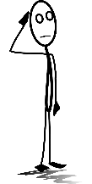

My Rule
Think YES!

We use some … if we want to say that we have these things
In a question we use some if we expect the answer to be YES.
Think No
or maybe!

We use any ... if we don’t have any.
In a question we use any if we don’t know if this person has these things of if we expect the answer to be No.

Now it’s your turn!

What do you never/sometimes/usually/always have in your fridge?
Draw the things that you have in your fridge! Then write 7 sentences. Use some and any.
individual answers

much, many, a lot of, lots of

Challenge 1
Look at the examples. Guess how many there are.
here you can say: many or a lot of or lots of | How many do you think there are? Guess !
On the teacher’s desk there are many exercise books and many pens. | I think there are 20 exercise books and 10 pens.
How many cousins do you have? | e.g. I think she has 5 cousins.
There are too many desks in our classroom. | e.g. I think we have 15 desks.
There were a lot of people at the concert. | e.g. I think there were 1000 people.
I have a lot of books. | e.g. I think I have 200 books.
Eray has many brothers and sisters. | e.g. I think he has 6 sibilings.
How many days are there till summer? | e.g. I think there are 45 days till summer.
here you can only say: a lot of | What about these sentences?  Can you count these things?  How?
We don’t have a lot of time to do this exercise. | e.g. 5 times does not work – I can only count minutes, hours, days
I spend a lot of money on computer games. | e.g. 20 money does not work – I can only count Euros, Dollars….
There is a lot of food on the table. | e.g. 4 food does not work – I can only count plates, sausages, rolls…
There is a lot of milk in the fridge. | e.g. 3 milk does not work – I can only count bottles of milk, cartons of milk
Last winter there wasn’t a lot of snow in Austria. | e.g. 30 snow does not work – I can only count metres, centimetres of snow

Sort the words into the two boxes:
oranges, cats, video games, girls, teachers, time, seconds, weeks, money, coins, water, orange juice, milk, oil, food, sand, flowers, air, love, snow
here you can use: many / a lot of / lots of | here you can only say: a lot of
oranges, cats, video games, girls, teachers, seconds, weeks, coins, flowers | time, money, water, orange juice, milk, oil, food, sand, air, love, snow
My rule
We say many / a lot of/ lots of when ….we can count it
We can only say a lot of when …we cannot count it

Challenge 2

not many | not much // not a lot of
In my old school, we did not have many teachers. | She doesn’t have a lot of money. She is poor.  She doesn’t have much money. She is poor.
Kevin has many computer games, but not many books. | In my old school we did not speak a lot of English.  We didn’t speak much English.
Last winter I did not build many snowmen. | In Graz there was not much snow last winter.  In Graz there was not have a lot of snow last winter.
There are not many days left to practice for our test. | We need to hurry! There is not much time left.
Ms. Thomson, our Music teacher, does not know many famous soccer players, but she knows many famous singers. | There is not much food left, we have to go shopping.

My Rule
We say not many when….we can count them
We say not much or not a lot of when ….we cannot count it

Now it’s your turn

Write true and meaningful sentences about yourself, your family and your friends.
Use much, many, a lot of, not much, not many,

many | Individual answers e.g. I have many good friends.
many | Individual answers e.g. We have many pets.
a lot of | Individual answers e.g. I have a lot of food at home.
a lot of | Individual answers e.g. We have a lot of flowers in the garden.
not many | Individual answers e.g. I don’t have many English books.
not many | Individual answers e.g. I don’t have many posters in my room.
not much | Individual answers e.g. I don’t have much money.
not much | Individual answers e.g. We don’t have much milk left.

Adjectives and adverbs: Colorful and detailed descriptions


Challenge
Ask your teacher for a set of vocabulary cards for this activity. Then sort the cards into two groups.
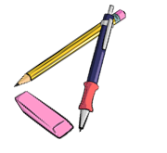
Ask your teacher to check your cards, then write the sentences in the correct boxes below.
Group A: What people and things are like:
Nora is a hardworking student. Clyde is a bit cheeky but the teachers like him.
Ben is intelligent but he is always nervous before tests.
I'm sorry that I was bad-tempered yesterday.
When I was a kid I was really shy. Everybody wants to be popular.
I'm not very tidy. Pleasy tidy up your desk. It is very untidy.
My brother is extremely selfish, he never shares anything.
Some students are a bit disorganized and forget to hand in their texts.
Some kids hand in sloppy work. A few kids are very noisy. Many students are nervous during tests.
Some kids are impatient. The reading diaries are really beautiful.
The videos are excellent. The kids can write very creative stories.
Ms Pö is very generous. She bought ice-cream for everybody.
He is a good singer. He is quite fast.

My Rule:
When we describe what something or someone is like we use …adjectives..

Group B: How we DO things.
If you ask politely, Ms Walch will allow it. She shyly entered the room. Most students of 3F do their vocab work regularly. Most students do their work carefully. Most kids work quietly in class.
Most students work quickly and efficiently. Some students work slowly but very carefully.
The class can sing beautifully. The children looked around nervously.
The students of 3F work well in projects.
The students can think creatively and they can use the new language creatively.
He looked at his watch impatiently.
I’m really proud because I worked hard and got an A.
She sings well. She learns fast.

My Rule:
When we describe how we do things, we use adverbs (-ly)

Describing people and things: What are they like?

Read the following text about Willy the Vampire and underline all the adjectives.
ADJECTIVES describe WHAT THINGS and PEOPLE ARE LIKE. The first ones have been done for you:
Willy the Vampire
When I went to elementary school, I had a classmate who was a bit strange. He was very small and thin, and his skin was very pale. He had short, blond hair and very long fingers and toes. Willy always sat in the last row. He seemed very tired and shy.
Willy was a good student. His math grades were always excellent, and he was a talented storyteller. He always got As for his stories in German. Willy liked to draw and paint, and we all liked his pictures. Our teacher often hung his pictures up in the hallways because they were so special.
Willy lived far from the school at the edge of our town. He lived in a large, very old house with his family. They were all as pale as Willy and they were all very shy.
There were lots of wild rumors about Willy and his family. Many people said that they had seen them walking the streets in the middle of the night. Others said that they had heard strange, howling noises in their house at full moon.
We never dared to ask Willy about these rumors, but even if he was a vampire, he was a nice and friendly classmate and he did not do any harm to anybody.

Now it’s your turn

Choose five interesting adjectives and write your own sentences with them. Make sure all your sentences are TRUE and tell us TRUE things about yourself, your family and friends.
Write the adjectives into column 1, then write your sentences into column 2
Adjectives | My TRUE sentences
e.g.  friendly | individual answers  e.g. Our dog is very friendly
e.g.  large | individual answers  e.g. My father’s house is large.
e.g.  excellent | individual answers  e.g. My English teacher said that my last story was excellent.
e.g.  talented | individual answers  e.g. I am a talented musician.
e.g,  pale | individual answers  e.g. Last week I was pale because I had the flu.

Describing how people do things

Now read the text about Willy again. Some parts have been changed or added.
Use a new color and highlight all the words and phrases that show us HOW people DO things.
Example: How did Willy speak? He spoke very quietly.

Willy the Vampire
When I went to elementary school, I had a classmate who was a bit strange. He was very small and thin, and his skin was very pale. He had short, light-blond hair and very long fingers and toes. Willy always sat in the last row. He seemed very tired and shy.
When Willy spoke, he did it very quietly. He always looked around shyly and nervously and watched very carefully what his classmates were doing. In the breaks Willy sat quietly in a corner and read a book, while the other students were running around wildly and shouting loudly at each other.
Willy was a good student. He worked very carefully in all subjects and did very well on all tests. In German he loved to write stories and spent a lot of time planning them very carefully. Willy could draw and paint really well.
Willy lived far from the school at the edge of our town. He lived in a large, very old house with his family. They were all as pale as Willy and they were all very shy.
There were lots of wild rumors about Willy and his family. Many people said that they had seen them walking in the streets in the middle of the night. Others said that they had heard the family howl loudly at the full moon, others had heard them whisper silently in the graveyard.
We never dared to ask Willy about these rumors, but even if he was a vampire, he was a nice and friendly classmate and he did not do any harm to anybody.
Now it’s your turn
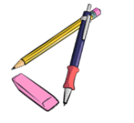
Choose five interesting adverbs (how they DO things) and write your own sentences. Make sure all your sentences are TRUE and tell us how you, your family and friends do things.
Write the adverbs into column 1, then write your sentences into column 2
Adverbs | My TRUE sentences
silently | individual answers: e.g. My mother gets up silently in the morning because my father sleeps longer than her.
loudly | individual answers: e.g. My alarm clock rings loudly in the morning.
well | individual answers: e.g. I can speak English very well.
Carefully | individual answers: e.g. I always do my homework carefully.

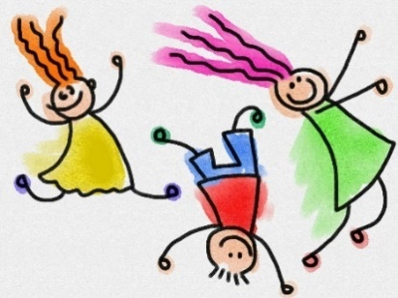
How did they do it?
How did they …

Think of things you or people around you did last week and write one true sentence with each of these adverbs. You can also write about your pets. Highlight the adverbs in your sentences.

happily | Elias smiled happily when Mr. Grasser praised him.
quietly | Individual answers e.g.  I worked very quietly in our English class.
quickly | Individual answers e.g.  I quickly got up when our headmaster entered.
carefully | Individual answers e.g.  I did my German homework carefully.
nervously | Individual answers e.g.  Ahmed nervously asked the teacher for his mark.
politely | Individual answers e.g.  I politely opened the door for Ms Harb.
patiently | Individual answers e.g.  I waited patiently for my friend Leo who was late again!
slowly | Individual answers e.g.: In math I worked very slowly because the exercises were so difficult.
angrily | Individual answers e.g.  In the big break Dominic shouted at me angrily.
aggressively | Individual answers e.g.  When we played football Lucas pushed Liam aggressively.
noisily | Individual answers e.g.  I hate it when George eats his nuts so noisily.
loudly | Individual answers e.g. : Kevin laughed loudly in the English lesson. The game was a lot of fun.
sadly | Individual answers e.g.  Nina gota bad mark and walked around sadly all day.

Telling stories in the past

Describing the setting and atmosphere

and talking about events that happened in a story.

Challenge:
1- Read the following mini-story. Where does the writer describe the setting and atmosphere?
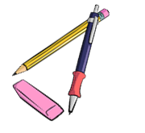
Where does the writer talk about events that happened that night. Use a red and a green color pencil and color the parts that describe events red and the setting and atmosphere passages green.
It was a cold night in October. The moon was shining but dark clouds were moving across the sky.
A storm was howling and the branches of the trees were moving in the wind.
Lots of leaves were flying through the air.
I was walking along a dark road. The leaves were rustling under my feet. An owl was hooting and a dog was barking nearby.
Suddenly…
a cat rushed out of a side-street and stopped in front of me. It looked at me with burning green eyes and growled.
I screamed in shock and hid behind the nearest car.
My heart was pounding and I was really scared. I heard the cat moving around silently. It was still growling – not like a little housecat, but more like a tiger. The cat’s green eyes were shining in the dark.
The cat crossed the street and came towards me.
With each step it grew bigger and bigger and the growling got louder and louder.
That’s when I remembered the magic coin in my pocket. I took it out, held it up in the air towards the cat and hoped…
Yes, … it worked. The cat saw the shining coin,
froze – and then turned around and ran away.

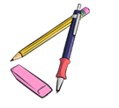
My rule:
When we describe the atmosphere and the background in a story,
we use the ……past progressive / ing-form…

When we talk about events and things that happened in the story,
we use the ………past simple form

Now it’s your turn:
Write a similar mini story. Write about 5 sentences that describe the setting and atmosphere and about 5 sentences showing what happens in the story.


Ask your teacher to check your sentences. Then use your text to make a flip-flap story and record your story on Flipgrid.
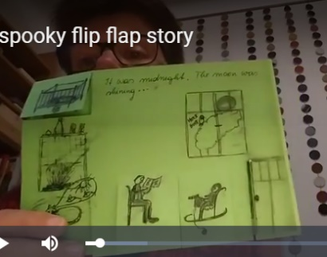

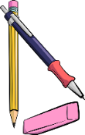
It was a …. individual stories – this part in past progressive

Suddenly… individual stories – this part in past simple

Talking about rules: Modal verbs

School Rules in different countries
Common school rules in Austria. Which of these do you have to follow at your school? Mark the ones that are true for you.
- Students must arrive on time and have their materials ready for each lesson.
- Outdoor shoes and coats must be kept in the lockers.
- The use of mobile phones is not allowed during lessons. Phones must be turned off and stored in the lockers.
- Students should raise their hands before speaking in class.
- Students have to complete their homework assignments on time.
- Everyone should help keep the school clean and tidy.
- Students must not leave the school-building without permission.
Now it’s your turn:
What other school rules do you have at your school?
We must…individual answers e.g. stand up when a teacher comes in.
We have to… individual answers e.g. greet our teachers politely.
We are not allowed to… individual answers e.g. leave school during break.
We must not… individual answers e.g. leave the windows open after school
We should… individual answers e.g. help each other.
And what are the rules in your family?
individual answers

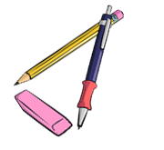


School rules in the USA
Mona has just spent a year as an exchange student in the USA. We asked her to tell us about her experiences at an American middle school.
Hi everyone,
As you all know, I spent a year in Kansas City. I lived with a host family and went to school there. School was really different in the USA. First of all, we did not have our own classroom, but we had to go to a different room for each subject. So I had to check my schedules all the time in order to be in the right place at the right time. This was quite stressful for me, and it took me some time to get used to this system. One rule that I found very strange was the toilet rule. You had to get a toilet pass from the teacher. Only one person at a time was allowed to go to the toilet and if a teacher saw you in the hallway, you had to show the toilet pass.
Another thing that was new to me was the school uniforms. Not all American schools have them, but I went to a private school and there we had to wear dark blue pants or skirts, light blue shirts or blouses and dark blue sweaters or jackets. We were not allowed to wear tank tops or miniskirts. On Fridays we did not have to wear our uniforms, but we were allowed to wear jeans. Sweatshirts, hoodies and sweatpants were only allowed in the gym class.
School was from 8 a.m. to 4 p.m., so all students had to stay for lunch. The food in the school cafeteria was really delicious, but the cafeteria staff was very strict about noise and cleanliness. We were only allowed to talk quietly, and we had to return our trays and leave the tables clean after eating.
All in all, these rules were okay, but I prefer the rules at our school.

What were the rules in your primary school?
We had to… individual answers e.g. wear slippers
We did not have to… individual answers e.g. stand up when a teacher came in.
We were allowed to… individual answers e.g. work in the hallway
We were not allowed to… individual answers e.g. use our phones in class.

Giving essential details: Defining Relative Clauses: who and that

Let’s be very specific about the things and people that we are talking about.
When we are referring to things, we use THAT
The scariest film that I have ever watched was individual answer
The book that I like best is… individual answer..…

The best food that I have ever eaten is … individual answer

When we are referring to people, we can use WHO or THAT. THAT is less formal.
The teachers who teach languages must spend a lot of time correcting our mistakes.
The students who do their vocab work regularly are really good at English.

The team that won the volleyball game practiced a lot.
The children who do not have a computer at home can borrow a tablet from school.

The person that I admire most is individual answer
The actor/actress that I like best is…… individual answer

Your Turn:
Write true and meaningful sentences. Use WHO and THAT.

individual answers e.g. I like the teachers who don’t give us homework.
individual answers e.g. The classmates who always talk in class are annoying.
individual answers e..g. The best kebab that I have ever eaten was from Kapadokia.
individual answers e..g. I still remember the time that Frederic fell asleep in class.

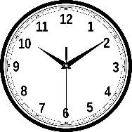
Conditional III: How would things have been different?

Regrets: Have you ever wanted to turn back time?
Have you ever done anything that you regret?
Let’s look at some examples:
I did not study enough for the math test.
If I had studied more for the last maths test, I would not have failed it.

If I had not left my phone on my desk, it would not have been stolen.
I left my phone on my desk in school.

If I had not played computer games all night,
I could have concentrated better during the English test
and I would have done a lot better.
I played computer games all night.

My rule:
Look at the words in bold letters. If you talk about how things in the past
could have been different (but you cannot change them any more) you use:
If I _had + __________________, I would + _________+___________

Your turn:
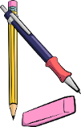
Think of some things that you regret. How would things have turned out if you had acted differently?
Write 5 sentences. Write meaningful and true sentences, not just anything.
individual answers e..g. If I had gone to the cinema I would have met Ryan.
individual answers e..g. If I had not shouted at my mum I would have been allowed to go to the cinema.
individual answers e..g. If I had not bought so many sweets and snacks I would have had enough money to buy a cool new t-shirt.

What if…

If they had given up, you would never have heard of them

Who are these famous people who all failed miserably, but did not give up?
Match the life stories with the names.
Steve Jobs, Steven Spielberg, Henry Ford, Thomas Edison, The Beatles, Walt Disney, Bill Gates, Michael Jordan, J K Rowling, Albert Einstein, Charly Chaplin

Then watch the video and check your answers. Be careful. Not all examples in the video have been used.
If he had given up after being fired from his basketball team, he would not have become the most famous basketball player of all times. | Michael Jordan
If they had stopped playing music with their band after several record labels told them that guitar music was not cool, they would not have become the most famous band of all times. | The Beatles
If he had given up drawing cartoons because nobody wanted to hire him as an artist, he would not have created the most famous cartoon figure in the world. | Walt Disney
If he had given up his dream of building computers after dropping out of university, he would not have become one of the richest men on Earth. | Bill Gates
If she had stopped writing because several publishers rejected (=did not want) her first book, she would not have become one of the most famous authors of children’s books and the second-richest female entertainer. | J K Rowling
If he had listened to his teachers who told him that he “would never amount to much”, he would not have won the Nobel prize in physics. | Albert Einstein
If he had given up after being fired from three computer companies, he would not have become one of the richest men and the owner of one of the most famous industrial designers in the world. | Steve Jobs
If he had given up his dream after going bankrupt five times, he would not have become one of the most successful car producers of the USA. | Henry Ford
If he had given up when his teachers told him that he was “too stupid to learn anything”, he would not have invented the light bulb. | Thomas Edison
If he had listened to the Hollywood studio chiefs, who said that his acts were too stupid and nonsensical, he would not have become one of the most famous English comic actors of all times. | Charly Chaplin
If he had given up after being rejected from film-school, he would not have become one of the most famous film directors of our times. | Steve Spielberg
https://www.youtube.com/watch?v=5cZh6tYVM2w

Duration: How long have you…?

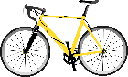
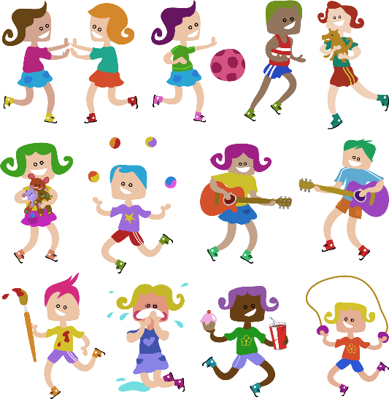
I’ve had my bike for five years.
I have known my friend Mary for 8 years.

I’ve had this T-shirt for ages.
Ms. Pö has been an English teacher for more than 25 years.

Your turn: How long have you had ....?
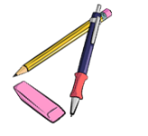
We are going to find the oldest items that you have brought to school today. Check your stuff in your schoolbag and in your lockers and choose the oldest item that you have with you today.
Write five true sentences about this item. Be prepared to present your old item.
I've had my__pencil case______for ___two years____________ years/months/days.
I've had my pencil case since 1st grade last year//my birthday//May//June..//I was born…
Any other details about your item: When did you get it? Who gave it to you? What does it look like?...
individual answers e.g. I got it at the beginning of 1st grade. My grandma gave it to me. It is blue and quite big.


Old friends
Think of some of your oldest friends who is still around and tell us how long you have known them.
My oldest friend is e.g. Lara I've known him/her for e.g. 5 years.
My second oldest friend is ___________ I have known him/her since 20_ _
Another good friend of mine is ______________. I have known him/her for _____ years.



My rule:
Do you remember?
We have used the present perfect tense before. Do you remember what we have used it for? Check page 42.
We also use the present perfect tense to talk aboutgeneral experiences
Which tense form do we use to talk about specific details and events?
The simple past tense
Duration (Dauer)
When we talk about how long we have had something, or how long we have been doing something we use the present perfect tense.

For and Since

Work with a partner. Use all the phrases from the box to write true sentences about yourself and the people around.
since 20_ _ … for three years… since September…. for more than xxx years… since Monday… for three days… for many years… since Christmas… for almost an hour… since 7.40

Example: I have been a student at this school since 20_ _.

Individual answers
e.g.
I have known XX since the beginning of this schoolyear.
I have not eaten for three hours.
I have had this schoolbag since primary school.
I have tried to come up with sentences for this exercise for 10 minutes.


Find a rule: Look at the sentences again. When do we use for, when do we use since?

My rule:
We use “for“when we talk about periods of time, (hours, days, months, years…)
How would you draw “for 3 years”?
How would you show “for” with your hands? Mime it.
We use since when we talk about points in time, we think of when it started.
How would you draw “since my birthday”.
How would you show “since” with your hands? Mime it.

How long have you...

Work with a partner.
How well do you know your partner?
Step 1: Answer the questions below truthfully and guess your partner’s answers.
Step 2: Then talk to your partner to find out whether your guesses are correct.
Example:
Student A: “I think you have played the violin for three years, is that correct?”
Student B: “Yes, that’s right.” OR “No, I have only played it for one year.” OR “No, I do not play the violin, but I play the piano. I have played the piano for about 5 years.”

Now it’s your turn:
Question “How long have you…” | You | Your partner (guess!)
known your best friend? | individual answers
lived in your house?
owned your pet?
practiced your favorite sport?
been a student at this school?
played the guitar/piano/drums/…or any other instrument
have you had your favourite lucky charm?
have you had your computer?
known your neighbour?

Use your spiral notebook to write down your partner’s answers in full sentences. Always write two sentences. Look at the examples.
My best friend is ….. I have known him/her for … years.
Max lives in a blue house. He has lived in this house for 12 years.
Maria has a dog. She has had her dog for 2 years.
Tim plays soccer at GAK. He has played in this club for 3 years.
My neighbors are called … They have lived next to us for ….

Active or passive: What’s your choice?

Work with a partner and look at these examples. What do you notice?
Both texts are about Potato chips. In text 1 many passive constructions are used. In text 2 the writer has only used active voice. What’s the reason?
What is the main focus of text 1 and what does text 2 focus on?
Text 1: The Story of Potato Chips  Potato chips are thin sliced potatoes, fried quickly in oil and then salted.  The potato chip was invented in 1853 by a chef named George Crum in New York. When a customer returned his French fried potatoes to the kitchen because they were too thick George Crum got so angry that he sarcastically cut them paper thin and sent the plate back out. The customer and others around him, loved the thin potatoes.  The chips were usually prepared in someone's kitchen and then delivered immediately to stores and restaurants, or sold on the street. They had to be eaten immediately.  Two innovations paved the way for mass production. In 1925, the automatic potato-peeling machine was invented. The chips were hand-packed into the bags, which were then ironed shut. In these air-tight bags the chips could be kept fresh and stored for a longer time.  Today, potato chips are the most popular snack in the United States. | Text 2: George Crum: The Inventor of Potato Chips  George Crum was a chef in a little restaurant in New York. He was a very creative man and liked to try out new recipes. One day, a customer returned his French fried potatoes to the kitchen because they were too thick. George Crum got so angry that he sarcastically cut them paper thin and sent the plate back out. The customer and others around him, loved the thin potatoes.  From that day on, George Crum fried paper-thin potatoes every day in his restaurant. His potato chips soon became famous in the area and other restaurants and stores also wanted to sell them.  Many other cooks copied Crum’s idea and prepared potato chips. They made them fresh every day and delivered them to local stores and restaurants.  Now we can buy potato chips in air-tight sealed bags. They stay fresh and crisp for a long time.  Today, potato chips are popular all over the world. We all love to eat them.

My rule:
We can use the active or passive voice to underline important parts of a sentence.
In text 2 the writer has used active voice because he tells us what George Crum did. He thinks of the person who did it.
In text 1 the passive is used because the CHIPS are important. (how they were invented)

How do we form the passive?

The subject  (WHAT or WHO) | form of “be”:  is, are, was, were | 3rd form of the verb | additional information
My shoes | are | made | of leather.
Potato chips | were | invented | in 1853.
The Mona Lisa | was | painted | by Leonardo da Vinci.
The Eiffel Tower | was | built | in 1889.
The Harry Potter books | were | written | by J.K. Rowling.
Ketchup | is | eaten | all over the world.
Kiwis | are | grown | in New Zealand
Mary | was | invited | to the party.
I | was | praised | by my teacher.

Now it’s your turn
Scan the QR codes and do the following exercises online.
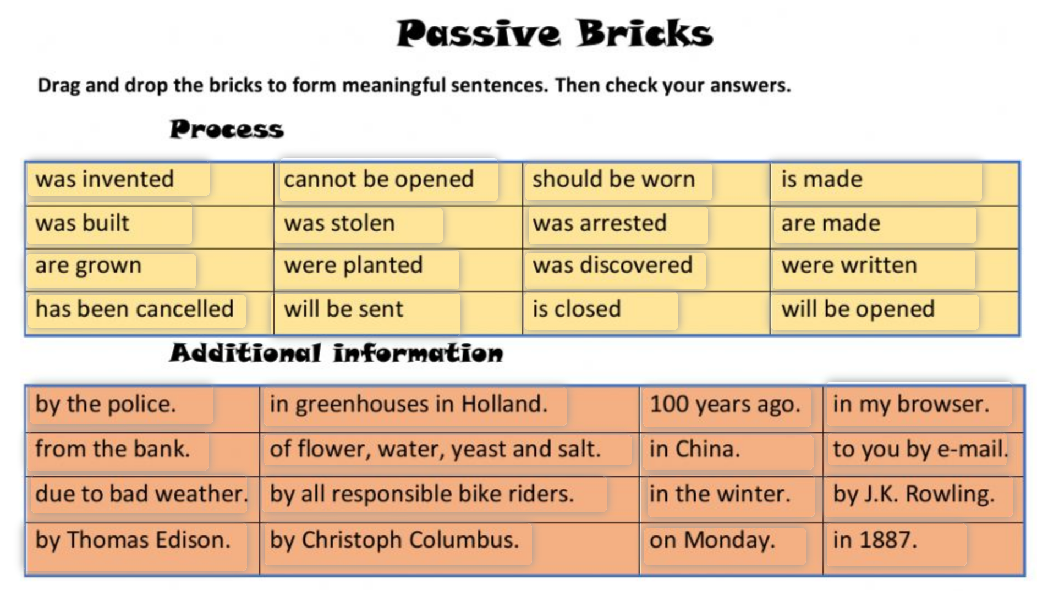 | 
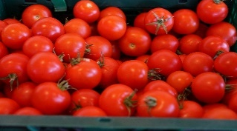  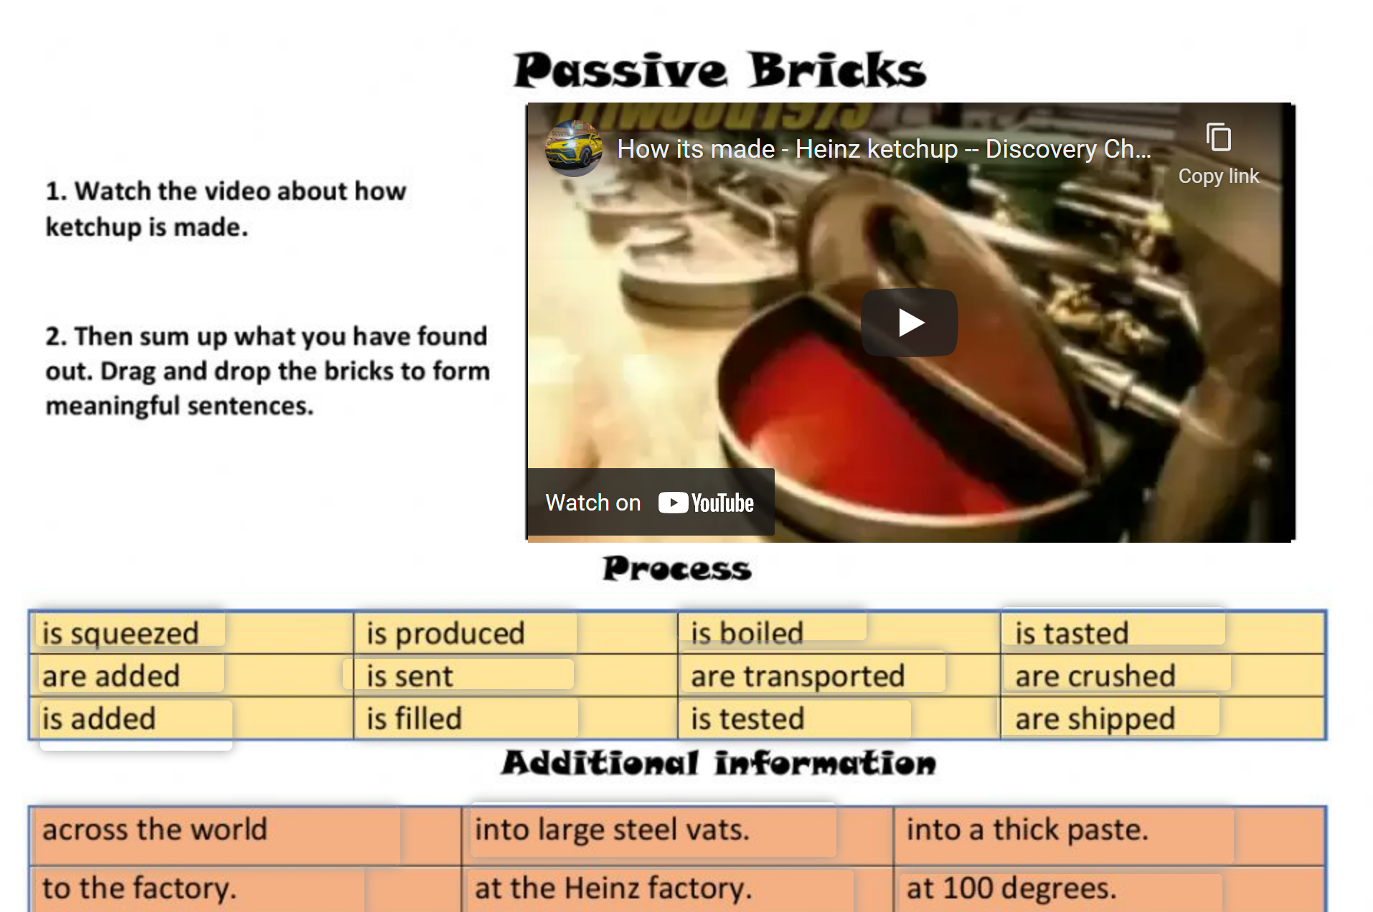 | 
  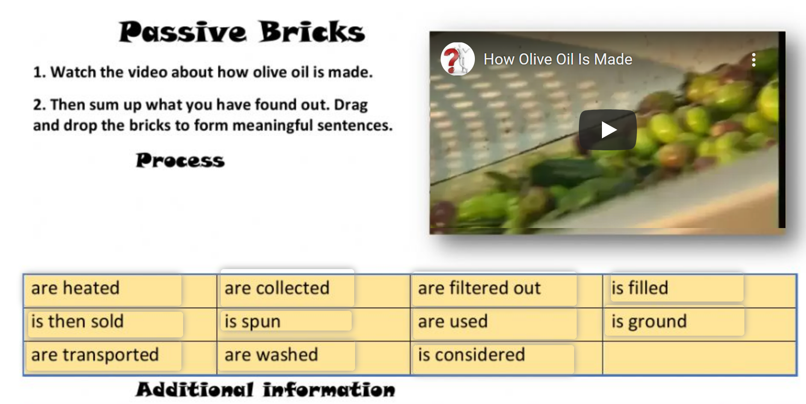 | 

Fake news: Reporting unbelievable things that someone said

Flying penguins? Watch the BBC video.

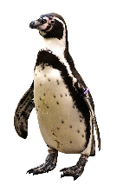
This is what the explorer said This is what Robert told his friends

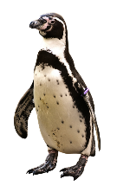
I saw a cool video on YouTube the other day. It was about penguins that can fly!
It was a BBC documentary but it can’t be true! The reporter said that they had recently discovered a colony of penguins that was unlike any other. He claimed that they could fly and actually flew south every winter and spent the cold season in warmer regions.
He showed the video and you could see the penguins flying! He said that they didn’t need to huddle together to keep warm because they could fly to the South.

“This recently discovered colony of penguins is unlike any other.”

“These little fellas can do something no other penguins can.”

“They fly thousands of miles to the rainforests of South America where they spend the winter basking in the tropical sun.”

“They don’t need to huddle together every winter for protection against the bitter cold.”
They didn’t need to huddle together every winter for protection against the bitter cold.

Now it’s your turn:
STEP1: Look at the words in bold. What do you notice?
The words are in the present tense on the left side and in the past tense on the right side.

Then read what Maxi and his brother said about it.
Maxi is announcing some cool news | Robert is reporting fake news
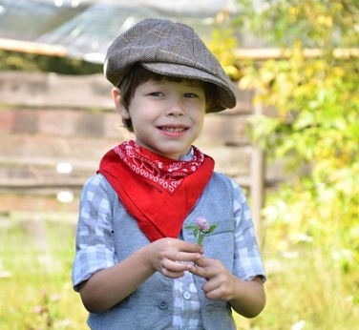 | 
“Wow, you won’t believe what they have discovered in Madagascar.  I saw a BBC video where an explorer showed some flying penguins. I didn’t know they can do that. I thought penguins were too heavy to fly, but the video really showed flying penguins. How amazing.  The explorer explained that they are unlike any other penguins in the world. They don’t spend the winter in the ice, and they don’t need to huddle together to protect themselves against the cold. They fly south to warmer countries, just like other birds. He said that they can fly thousands of miles and spend the winter in the tropical sun. Isn’t this amazing? I would really like to see these flying penguins myself.” | “Have you seen the BBC video about flying penguins? It went viral on all the social media. It showed an explorer in Madagascar and he said that he had discovered a colony of penguins that was unlike any other in the world. He said that these penguins didn’t spend the winter in the ice – huddling together against the cold, but that they could fly. He explained that these special penguins could fly to warmer regions and spend the winter there, just like other birds do. In the video you could see the penguins running and then starting to lift off. Then the video showed lots of black birds flying in the sky. At first it seemed very convincing – but then I noticed that it was published on April 1st. So, the whole thing is obviously a hoax. Of course, penguins do not fly.

What do you notice?
Both Maxi and his brother Robert are talking about the same video. Why are they using different tenses here?
Maxi uses the present tense because he is telling us interesting news.
Robert uses the past because he doesn’t believe that penguins can fly. He reports fake news and distances himself from the false information.

The Reporting Circle
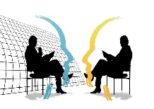
FAKE NEWS!
T E N S E
I don’t quite believe this.
I don’t trust this.
I don’t care. It’s just a fact.
TENSE
ME
HERE
NOW
WOW! This is interesting!
This is so real and so relevant for us….
yesterday, last week, five years ago, in 1875…
Thinking back to the conversation


For the teacher


Let’s explain:
Announcing interesting news | Reporting fake information
Maxi is announcing cool news. He thinks this is great and wants to tell us about these cool animals.  Therefore, he is using the ……………………………….. tense. | Robart knows that penguins are too heavy to fly, and he does not believe that the information is correct. He thinks this is fake news.  Robart is reporting the news in the …past……… tense.
In everyday situations we often use the present tense to talk about interesting news or facts that we have heard of or read.  We use the present tense, because these facts seem important and relevant to us now.  “I have some good news for you all. We are going to buy a new basketball hoop for the schoolyard.”  Ms. Wagner said that we will get a new basketball hoop for our schoolyard.  Your Turn  What did the teachers actually say?  We are going to visit the Zotter chocolate factory next week.  Our teacher told us that we are going to visit the Zotter chocolate factory next week.  Cool, isn’t it?  We can take part in the GOAL project and….  Ms. Pö said that we can take part in the GOAL project and write our own online story books with our international friends.  We will watch a film in the next lesson.  Ms. Bergmann promised that we will watch a film in the next lesson. | When we report fake news or things that are no longer true, we report these in the … past ….. tense.  We use the … past ………tense to “push the information away from us” – that means – to show that we do not trust it.  The phrase he/she claimed that – also shows that we do not trust the information that we are reporting.  Your Turn  What did the people actually say?  The special penguins in Madagascar can fly.  The reporter claimed that the penguins in Madagascar could fly.  I will build a wall at the border to Mexico.  Trump announced that he would build a wall at the border to Mexico.  We will watch a film in the next lesson.  Ms. Bergmann promised that we would watch a film but then we had to do a grammar exercise!

More examples of reporting fake news

Last week I met an old friend of mine and we got into a really weird conversation. Mark really thinks that aliens exist and are all around us. He claimed that they were abducting humans and were doing strange experiments on them. He was really scared and said that he didn’t leave the house at night anymore.
He then added that you also had to be careful outside, even during the day. He asked if I knew about chemtrails. He claimed that politicians wanted to control people, so they added chemicals to the fuel of airplanes and if you wanted to be safe, you had to wear a helmet made of metal or stay inside.
I tried to reassure him, but he didn’t want to hear my arguments. He told me to read the warnings on Facebook and Telegram and he promised to send me some links to shocking videos. Mark seemed really scared – I don’t know where he got all the fake news from. Maybe he spends too much time on the internet!

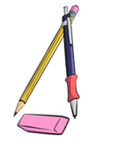
What were Mark’s exact words?

He said: “I am sure that aliens …………… and …………………..all around us. They are abducting humans and …………………………..………… strange experiments on them. I …………… really scared. I ……………………………. the house at night anymore.
But you also ……………………. careful when you go outside during the day. Do you ____________ about chemtrails? The politicians ……………………………… people, so they ………………….. chemicals to the fuel of airplanes. If you ……………… to be safe, you ……………………………….. a helmet made of metal or stay inside.
I’ll send you some links so you can watch the shocking information yourself. You won’t believe it – it’s really scary what they are trying to do to us. “

Now it’s your turn.
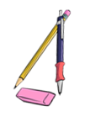
Here are a few examples of recent fake-news headlines. Report in 1 sentence what the articles or videos said.
Research Team taught Gorilla to Knit
The article said that a research team …………………………………………….. ………………………………………………….but I don’t think gorillas can do this.
Boy saw UFO over Vienna
The boy claimed that he ………………………………………………..………………...…….
but I am sure it was just an airplane.
Facebook: Global warming does not exist
I saw a comment on Facebook. The writer claimed that ………………..………………………………………………………………………………………………….... but ………………………………………………………………………………………………………………………………………………………..
Now add 3 more examples of fake news that you have come across.
I read on the internet that _______________________________________________
Someone told me that ______________________________________________________
My classmate claimed that ________________________________________________

Let’s recap: Reporting fake news

We report fake news in the past tense (or the past perfect tense) . We use the tense to show that we are distancing ourselves from information that we doubt (anzweifeln)
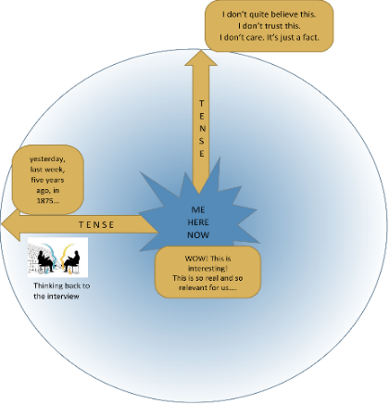
The phrase he/she claimed that – also shows that we do not trust
the information that we are reporting.

“Aliens are abducting humans.” He claimed that Aliens were abducting humans.
“Gorillas can learn to knit.” He said that gorillas could learn to knit.
“I have discovered flying penguins.” The explorer explained that he had discovered flying penguins.

But, we can use the present tense to announce important, interesting and trustworthy information that we have heard or read.

Our teachers promised that we will soon get a new basketball hoop for our schoolyard. (Here you trust your teachers)

Mom told us that she is going to have another baby. I am so excited.

Reporting neutral information that someone said in the past –
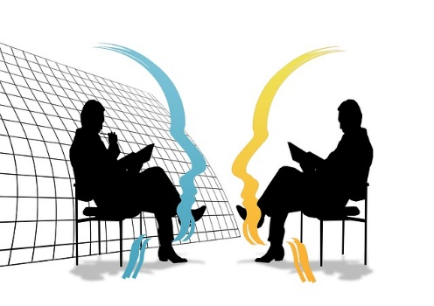

We are thinking back to the conversation.

Yesterday I met the new Math teacher during the big break.

Hello, are you the new Math teacher?  Yes, it’s my first day here at your school.  Where did you teach before?  The last 3 years I taught at a school in Vienna,  and before that I taught at a school in Salzburg.  Why did you come to Graz?  I decided to move to Graz because my wife got a good job here and my parents live here as well.  Do you also teach any other subjects?  Yes, I also teach Geography, but I prefer Math. | We had a little chat. He seems quite nice.  He told me that it was his first day here at our school.  He said that he (had) taught in Vienna before and before that he had taught at a school in Salzburg.  When I asked him why he came to Graz he told me that his wife got a good job here and that his parents lived here as well.  He is also a Geography teacher, but he told me that he liked teaching Math more. That’s strange. Math is much more difficult than Geography.

Reporting: Thinking back to the conversation

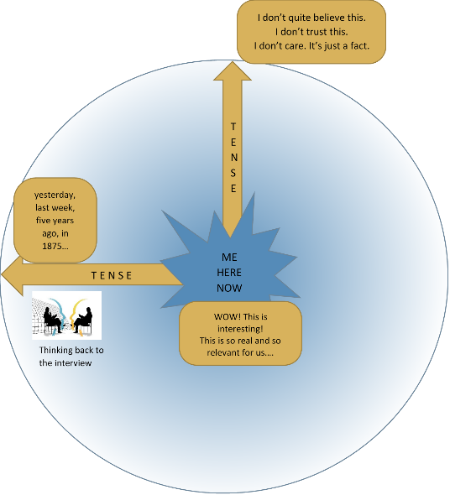
We report in the past tense (or the past perfect tense) to show that we are thinking about the past and reporting what other people said in that situation.


- neutral facts that someone else said in the past
- a situation that is past and no longer true

In last week’s interview, the actress said that she was working on a new film.
Last night the minister of education said in the news that all students would get free laptop computers.
I knew she would not show up for the date. She is too shy.
He promised he would come to the party and bring some food, but he didn’t even show up.

Your Turn
What did they actually say?
“…

She said she could speak five languages.

The reporter asked the actress if she had ever played in a movie with Daniel Radcliffe.

The witness said that he was looking (or had been looking) out of his window when the accident happened. He told the police that he saw (or had seen) the red car racing down the street.

Socrates said he could not teach anybody anything. He could only make them think.

Einstein said that he had no special talent. He was only passionately curious.

Churchill said the best argument against democracy was a five-minute conversation with the average voter..

Reporting what someone asked me to do

So much to do! This is what This is what you tell your friend
Ms Bergmann told us last week
Don’t forget to hand in your vocab books tomorrow and show your test to your parents. Complete the text at home and bring it to class tomorrow.
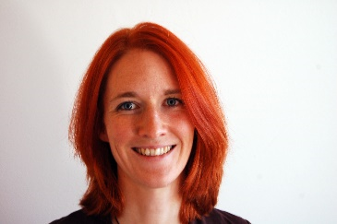
Last Monday, our teacher was quite strict. She told us to hand in our vocab books on Monday and to show our tests to our parents. She also told us to complete the text and to bring it to class the next day.

Then she promised to show us a film.
If everybody finishes their project by Friday, I will show you a film in the next lesson.
Friday,

She asked us to bring some cookies and popcorn.
Can you bring some cookies and popcorn, so that we have a real cinema experience.
Friday,

Your turn:
Now find your own examples. Report what your teachers, parents, friends, brothers and sisters asked you to do and told you to do last week?
________________________________________________________________________________________
________________________________________________________________________________________
________________________________________________________________________________________
________________________________________________________________________________________
________________________________________________________________________________________
________________________________________________________________________________________
________________________________________________________________________________________
________________________________________________________________________________________

Reporting questions

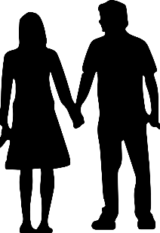
Nosy parents! You spent the weekend This is what you tell your
with a friend. Your parents want to know friend
everything!
My mother wanted to know everything!
She asked me if we went to the park.
She wanted to know if we had a picknick.
She asked me if we drank alcohol!
She wanted to know if we met other friends.

Did you go to the park?
Did you have a picknick?
Did you drink alcohol?
Did you meet other friends?

Where did you go afterward.
When did you come home?
Why are your clothes dirty?
What did you do all day?
My father asked me where we went afterwards.
He wanted to know when I came home.
He wanted to know why my clothes were dirty.
He asked me what we did all day.
HE



Your turn:
Now find your own examples. What did teachers, parents, friends, brothers and sisters ask you last week?

________________________________________________________________________________________
________________________________________________________________________________________
________________________________________________________________________________________
________________________________________________________________________________________
________________________________________________________________________________________
________________________________________________________________________________________
________________________________________________________________________________________
________________________________________________________________________________________

Past perfect – What had happened before

Dan, from the book 39 Clues, has written a diary.
Look at the underlined phrases. Why has he used the past perfect tense here?
had finished… had found…had met…had stayed…
Link to the book

January 2nd, 2021
Dear Diary,

Today I got into a really tricky situation again. A few minutes ago, I was hanging upside down in a mine, copying and memorizing a text. This was one of the scariest things I have ever done. It was totally dark, and I was scared of falling down even deeper into the hole below me.
I was hanging in there, head down because I was copying a text that was carved into the stone wall. I knew it was an important message for the next clue in South Africa.
When I had finished copying the text, Nellie pulled me up and Amy and Nelly wanted to know what I had found out down there and why I had stayed down there so long. But there was a problem: we were not alone. Court, the strange boy that we had met earlier was also there. I did not trust him at all, he might be following us in order to get to the clue first. Therefore, I said that there was nothing special down there, just bats and rats.

When we were finally alone, I told Amy and Nelly what I had found. I am soooo excited – I am sure this will lead us to the next clue. I hope Court won’t follow us tomorrow. We have to get away from here as fast as possible…
For the teacher
Wish me luck!
Tip: In what order did these things happen? Write the events on the timeline:
Example:
When I had finished copying the text, Nellie pulled me up and Amy and Nelly wanted to know what I had found out down there.

The strange boy that we had met earlier was also there.

Now it’s your turn

Draw the arrows to show in what order these things happened.

Nelly wanted to know what I had found out.

When Mrs. Miller came home, she noticed that a burglar had broken the terrace door and stolen her computer and her TV.

I could not do my homework because I had forgotten my math book at school.

I was tired and frustrated because I had studied for the test all weekend but could not solve any of the problems correctly.

For experts: Find your own examples
When you read your next book, watch out for examples of the past perfect tense.
Write the sentences here and draw the arrows to show in what order these things happened.

Bildnachweise

Titelseite https://pixabay.com/de/illustrations/lupe-suchen-finden-anschauen-1020142/
Seite 1: https://pixabay.com/de/vectors/bleistift-scharf-schulmaterial-153561/
Seite 3 https://pixabay.com/de/vectors/ohr-h%c3%b6ren-tratsch-klang-fl%c3%bcstern-25595/
mehrmals/radiergummi: https://pixabay.com/de/vectors/schule-schulmaterial-bildung-1555909/
https://pixabay.com/de/vectors/regenschirm-regen-rot-wetter-159361/
https://pixabay.com/de/photos/truthahn-vogel-tier-schnabel-auge-4251052/
Seite 5, 10 + 11 https://pixabay.com/de/illustrations/kinder-aktivit%c3%a4t-erholung-menschen-6510214/
mehrmals: Blatt https://pixabay.com/de/vectors/papier-notizbuch-hinweis-34910/
mehrmals: Gehirn Piktogramm Word
Seite 6 Bilder Lis Pölzleitner und https://pixabay.com/de/photos/portr%c3%a4t-paar-liebe-menschen-frau/
Seite 9 Gernot Schirmbacher und https://pixabay.com/de/vectors/matchstick-man-mann-strichm%C3%A4nnchen-25562/
Seite 10/11 apple: Piktogramm Word
Seite 14: https://pixabay.com/de/vectors/mann-laufen-m%c3%a4nnlich-lauf-sport-312016/
https://pixabay.com/de/vectors/flagge-grand-prix-tor-ziellinie-7560075/
Seite 15: https://pixabay.com/de/vectors/t-shirt-vorderseite-kurz-orange-306168/
Seite 16: Seite https://pixabay.com/de/vectors/hand-bleistift-stift-bearbeiten-160538/
Seite 17+38: Gernot Schirmbacher, https://pixabay.com/de/vectors/berufung-strichm%c3%a4nnchen-151869/ https://pixabay.com/de/vectors/mann-milit%c3%a4r-gru%c3%9f-strichm%c3%a4nnchen-151816/ https://pixabay.com/de/vectors/football-ball-sport-fu%c3%9fball-runden-157930/
Seite 18 Logos – erstellt mit Canva und Pixabay https://pixabay.com/de/vectors/schnurrbart-silhouette-gesicht-haar-303571/ / https://pixabay.com/de/vectors/mann-bart-barbier-friseur-schere-5790747/ https://pixabay.com/de/photos/spaghetti-pasta-nudeln-italienisch-2931846/
Seite 19 Laura Bergmann
Seite 20 https://pixabay.com/de/illustrations/fragezeichen-eine-notiz-duplikat-2110767/
Seite 23 https://pixabay.com/de/illustrations/nein-negativ-tafel-kreide-schrift-1532840/
Seite 24 https://pixabay.com/de/vectors/uhr-zeit-stunde-minute-zahlen-std-42809/ Laura Bergmann
Seite 25 Lis Pölzleitner https://pixabay.com/de/vectors/raupe-gras-kleber-fix-anf%c3%bcgen-1135242/ https://pixabay.com/de/illustrations/briefumschlag-brief-kuvert-5989704/
Seite 26 https://pixabay.com/de/vectors/m%c3%a4dchen-kreislauf-helm-sport-311181/ https://pixabay.com/de/vectors/abstrakt-bunt-komische-charaktere-2029929/ https://pixabay.com/de/vectors/man-mann-betrieb-%c3%bcbung-joggen-2034538/
https://pixabay.com/de/vectors/menschlich-hund-gehen-tiere-2885709/https://pixabay.com/de/illustrations/schwimmer-schwimmen-see-sport-3559767/https://pixabay.com/de/vectors/koch-braten-fische-bratpfanne-311680/https://pixabay.com/de/vectors/v%c3%b6gel-zweig-singen-musiknoten-5765100/
https://pixabay.com/de/illustrations/hausaufgaben-studieren-familie-kind-6666003/
Seite 29 Laura Bergmann made with Canva,
https://pixabay.com/de/illustrations/bankdr%c3%bccken-kampf-armdr%c3%bccken-sieger-1013857/
Seite 37 Lis Pölzleitner
Seite 41 https://pixabay.com/de/vectors/fragezeichen-denken-frage-verwirrt-5656992/
Seite 42/65 https://pixabay.com/de/vectors/post-it-kurznotiz-hinweis-memo-150262/
https://pixabay.com/de/vectors/kalender-februar-elf-rot-31953/
Seite 44/76 https://pixabay.com/de/vectors/lupe-lupe-glas-glas-vergr%c3%b6%c3%9fern-189254/
Seite 47 https://pixabay.com/de/vectors/valentinstag-paar-liebe-restaurant-5935031/
Seite 49/51 https://pixabay.com/de/illustrations/m%C3%A4dchen-zuversichtlich-portr%C3%A4t-3316342/
https://pixabay.com/de/illustrations/mann-sitzung-lebensstil-beil%C3%A4ufig-5904712/
https://pixabay.com/de/illustrations/familie-einheit-liebe-kind-zukunft-4856744/
https://pixabay.com/vectors/refrigerator-fridge-cooling-cold-158634/ https://pixabay.com/de/vectors/karotte-m%c3%b6hre-mohrr%c3%bcbe-gelbr%c3%bcbe-320081/
Seite 57 https://pixabay.com/de/illustrations/kinder-gekritzel-skizzieren-1099709/
Seite 61 https://pixabay.com/de/vectors/covid-coronaviren-covid-19-corona-5247929/
Seite 63 https://pixabay.com/de/vectors/uhr-zeit-stunde-beobachten-1300646/
Seite 65 https://pixabay.com/de/vectors/fahrrad-geschwindigkeit-gelb-159680/
Seite 69 https://pixabay.com/de/photos/tomaten-gesund-rot-markt-gem%c3%bcse-862769/
https://pixabay.com/de/photos/oliven%c3%b6l-oliven-lebensmittel-%c3%b6l-968657/
Seite 70/71 https://pixabay.com/de/photos/pinguin-tier-tierwelt-wasservogel-2691407/
Seite 71 https://pixabay.com/de/photos/junge-blume-klee-portr%c3%a4t-sonnig-4577721/
Seite 71 created with/by DALL-E
Seite 72ff https://pixabay.com/illustrations/silhouettes-man-to-sit-compared-to-77496/
Seite 73 https://pixabay.com/vectors/student-teenager-book-learning-147783/
Seite 79 https://pixabay.com/de/vectors/junge-kind-vati-tochter-familie-2027487/

