____________‘s
Me-Book

by Elisabeth Pölzleitner

Impressum:
Elisabeth Pölzleitner
Kontakt: creative.languageteachers@gmail.com
Elisabeth Pölzleitner
TABLE OF CONTENTS

My English Words……………………….……….. 2+3
That’s Me……….…………………..………… 4+5
My Languages………………..……………… 6
My Friends ………………………..…………. 7
My Family………………………..….……….. 8+9
Timeline: Our Daily Routines……. 10+11
Our Daily Routines…………………... 12+13
My Room ………….…………………….. 14+15
My Dream House…………………….. 16-17
Our Perfect School Cafeteria….... 18+19
My Holidays…………….……………….. 20+21
My Fantasy Animal……………………..…. 22-25
My Time Capsule…………………………….. 26-27
Great Kids Contest ………….. 28-29
Clothes: What’s your style? ……….. 30-31
English outside of School …………… 32-33

All pictures: creative commons: pixabay or private pics.
page 1 - one
My English Words


Collect English words (in newspapers, on labels and glue them in here – you can also write down words you know)

page 2 – t _ _

My English Words
page 3 – t _ _ _ _
Keep collecting English words and glue them here

That’s Me
Make a page about yourself here: Add pictures, drawings…

page 4 – f _ _ _
That’s Me
Write about yourself
name / age / country / city /languages

Tips: hobbies / sports / freetime/ school

page 5 – f _ _ _
Tips: likes / dislikes / favourites
(e.g. food / colours/ animals)

)

My Language Portrait
What languages do you speak?
Where are they in your body?
Choose a color for every language and draw it into your body. Label the language.



page 6 – _ _ _
My Friends
name / age / country / city /languages / likes / favourites
My best friend
Another good friend
name / age / country / city /languages / likes / favourites
Another friend
page 7 – _ _ _ _ _
name / age / country / city /languages / likes / favourites

My Family
Make a page about your family here: pictures, drawings…

page 8 – _ _ _ h_

My Family
Members of my family
my mother’s name is: | my grandmother(s):
my father’s name is: | my grandfather(s):
my brother(s): | my aunt(s):
my sister(s): | my uncle(s):
my cousins (boys and girls)


Scan the code and learn how to fold the booklet. Use A3 paper.
My family booklet
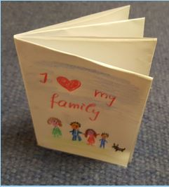
Make a beautiful booklet about your family for your ME-book.
Write the first draft on a sheet of paper and show it to your
teacher! Write about 6 people (1 page per person).

Write about different things for every
person: Tell us about the languages one family member speaks or doesn’t speak, the hobbies of one family member, which sports someone does or doesn’t do, which animals someone has or doesn’t have….
Make your booklet interesting to read!
Glue an envelope in here and put your family booklet into the envelope.

page 9 – _ _ _ _
page 10– _____________
Timeline – Our Daily Routines
Make a timeline for every member of your family (you can get an extra sheet from your teacher)
Example Sam:
 | Gets up/ breakfast | To school by bus / school starts 7:40 | Lessons in school | Recess 9:20-9:40 | lessons | lessons | lessons | Lunch / cafeteria ten past one | Recess – plays with friends | lessons | School ends 4:05  Home by bus | Goes to garden / walks dog | Vocab work / Dinner at 6:30 | Watches TV or listens to music | Shower / brush teeth / bed 8.30 | Reads / goes to sleep
5 am | 6 am | 7 am | 8 am | 9 am | 10 am | 11 am | 12/midday | 1 pm | 2 pm | 3 pm | 4 pm | 5 pm | 6 pm | 7 pm | 8 pm | 9 pm | 10 pm | 11 pm | 12/midnight

MY DAILY ROUTINES
5 am | 6 am | 7 am | 8 am | 9 am | 10 am | 11 am | 12/midday | 1 pm | 2 pm | 3 pm | 4 pm | 5 pm | 6 pm | 7 pm | 8 pm | 9 pm | 10 pm | 11 pm | 12/midnight

MY MUM’s DAILY ROUTINES
5 am | 6 am | 7 am | 8 am | 9 am | 10 am | 11 am | 12/midday | 1 pm | 2 pm | 3 pm | 4 pm | 5 pm | 6 pm | 7 pm | 8 pm | 9 pm | 10 pm | 11 pm | 12/midnight
page 10 – _ _ _

MY DAD’S DAILY ROUTINES
5 am | 6 am | 7 am | 8 am | 9 am | 10 am | 11 am | 12/midday | 1 pm | 2 pm | 3 pm | 4 pm | 5 pm | 6 pm | 7 pm | 8 pm | 9 pm | 10 pm | 11 pm | 12/midnight

MY SISTER’S DAILY ROUTINES
5 am | 6 am | 7 am | 8 am | 9 am | 10 am | 11 am | 12/midday | 1 pm | 2 pm | 3 pm | 4 pm | 5 pm | 6 pm | 7 pm | 8 pm | 9 pm | 10 pm | 11 pm | 12/midnight

MY _______________’s DAILY ROUTINES
5 am | 6 am | 7 am | 8 am | 9 am | 10 am | 11 am | 12/midday | 1 pm | 2 pm | 3 pm | 4 pm | 5 pm | 6 pm | 7 pm | 8 pm | 9 pm | 10 pm | 11 pm | 12/midnight
page 11 – _ _ _ v _ _
Text – Our Daily Routines
page 12 – _ _ _ _ _ _
Write about a typical day in your family. What do people do in the morning/at midday/in the afternoon/in the evening?
In the morning….
Write about all members of your family
Structure your text: First, then, after that, later, at ….o’clock

page 13 – _ _ _ _ _ _ _ _
My Room
Draw a plan of your room here or glue in some pictures
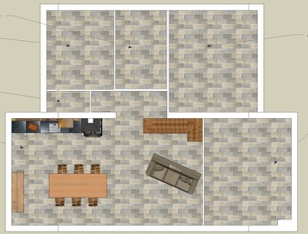
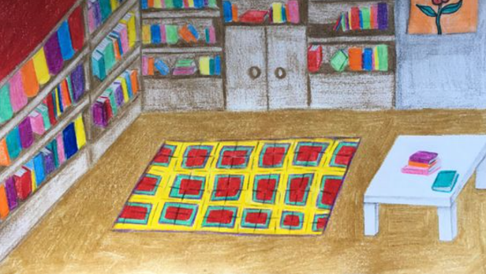

page 14 – _ _ _ _ _ _ _ _
This is my room
page 15 – _ _ _ t _ _ _
Describe your room in detail. What is there in your room? Where are the things and what do they look like? What’s your favourite place in your room? Why?
Don’t forget to add pictures or drawings!
My Dream House
Here you can draw your dream house. Be creative and add lots of really cool details. Where is it? What does it look like? What rooms and other special things does it have? Does it have a garden? What is it like?

Now describe your dream house in detail.
page 16 – _ _ _ _ _ _ _
My Dream House
page 18 – _ _ _ _ _ _ _ _

page 17 – _ _ _ _ _ t _ _ _
Our perfect school cafeteria
Design an ideal menu for your school cafeteria.


Menu for our cafeteria

Monday

Starters: ________________________________________
Main courses: _____________________________________
Dessert: _________________________________________

______________

Starters: ________________________________________
Main courses: _____________________________________
Dessert: _________________________________________
page 18 – _ _ g _ _ _ _ _
________________

S__________: _____________________________________
M_______courses: ____________________________________
D_________: ______________________________________

______________

____________: _____________________________________
_____________: ____________________________________
_____________: ____________________________________

______________

____________: _____________________________________
_____________: ____________________________________
_____________: ____________________________________
page 19 – _ _ _ _ _ _ _ _
A Letter from your holidays.
Graz, September 5th
Dear Jeremy,
Thank you very much for your postcard from Edinburgh. You must have had a wonderful holiday. My holidays were great too.
I spent the first two weeks in a sports camp and learned to play tennis. It was very hot, but we had a lot of fun.
In August my family and I went to Croatia for three weeks. We stayed at a campground by the sea and we went swimming and snorkeling every day.
In the first week of September we drove to Vienna. We stayed at my uncle’s apartment for two nights and we did a lot of sightseeing and visited a huge flea market. We had a great time and bought lots of things. The weather was not ideal, it was rainy – but we enjoyed the city and went out for dinner twice.
I'll tell you all the details and I'll show you some photos when we meet in school.
Yours,
Laura
Read this example:
Now, write a similar letter about your holidays. Start with a plan and use some of these sentence starters:
- In the first/ second / third / last week of July / August / September…
- First… then ….
- After our trip to …
When and how long? | Where did you go? | What did you do there? What was it like?
page 20 – _ _ _ _ _ _

My holidays
page 18 – _ _ _ _ _ _ _ _

Dear …
page 21 – _ _ _ _ _ _- _ _ _
Fantasy animal: Pet Info
What you need to know about horsotigopigchicks.
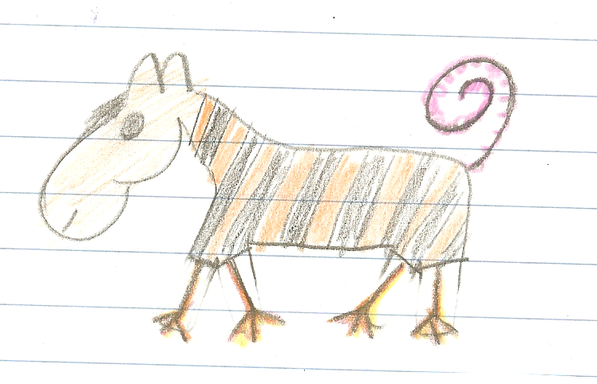
What they look like:
Horsotigopigchicks are really great pets.

These animals have the head of a horse, the body of a tiger, the tail of a pig and the legs of a chicken.
They have short hair and a short black mane. The tail of the horsotigopigchick is pink and very thin. It does not have any hair. Horsotigopigchicks are the size of a dog and they weigh about 15 to 20 kilograms.
How do they move?

Horsotigopigchicks can walk. They do not run very fast because their legs are short and weak. This is great because they do not need a big garden.

Home:
Hortotigopigchicks can live in your house or they can live outside in the garden. They need a doghouse to keep them warm and to spend the night.
In the winter, when it is very cold, you should keep them inside during the night.

.

What do they eat?
Horsotigopigchicks eat almost everything. Their favorite foods are spaghetti, pizza, bread and sweets. They also like fruits and they eat grass and leaves in the garden. The only thing these animals do not like is hot and spicy food like pepperoni or chili.

Other information:
Hortotigopigchicks are very shy animals. They get along well with children, but they are scared of loud noises and big dogs. You can take them for short walks, but you have to walk slowly and you must keep them on a leash. You should not take them to places with lots of people or cars.

Now it’s your turn to describe your animal in detail. Write a pet-info brochure like this one.
The words and ideas on the next page will help you.

page 22 – _ _ _ _ _ _ - _ _ _
Useful words and ideas to describe your animal:

The animal’s name
Make up a new name for your animal. For example:
a mousodogobird has the head of a mouse, the body of a dog and it has the wings of a bird.

What body parts does it have?
giraffes have long, thin legs, monkeys have strong arms, birds have wings, giraffes have very long necks, hippos have big heads, mice have small ears and eyes, squirrels have bushy tails, pigs have a fat bodies, monkeys have fingers and toes, cats have claws, fish have fins, male lions have manes, dogs have strong teeth.

What they look like - skin and hair
rabbit have soft, fluffy fur and smooth skin, dragons and fish have scales, an elephant’s skin has folds and wrinkles, some dogs have long hair, others have short hair, horses and lions have a mane

How does it move?
cats can walk and climb on trees, frogs jump, birds fly, mice run very fast, ants and caterpillars crawl, fish swim.

What does it eat?
horses eat grass, cats eat meat, some insects drink blood, pigs eat everything (they are omnivores – Allesfresser), sheep eat grass and leaves, (they are herbivores –Pflanzenfresser)

Home:
Does your animal need a cage? Does it live outside? Does it need a dog house or a big stable?
Can it live in your room?
Do you have to walk it on a leash?

Is it a good family pet?
Does it like children? Is it dangerous? Does it bite?
Do you need a leash to walk it outside? Does it sleep during the day or at night? Does it need any toys to be happy?
How does your animal get along with other animals? Does it fight? Does it like other animals?
What is it afraid of?

page 23 – _ _ _ _ _ _ - _ _ _ _ _
My Fantasy Animal
Create your own cool fantasy animal. Choose 3 animals and mix their body parts. You can create something like a catbirdfish, or a flying giraffocat or any other cool animal.

Step 1: Draw your animal here.
My fantasy animal
page 24 – _ _ _ _ _ _ - _ _ _ _
Now write an information brochure for your animal. Imagine you are selling these animals in a pet-shop and your customers want to know everything about these strange animals.
What do they look like?
How do they move?

What do they eat?

Home:
.

Other information:
.

.

page 25 – _ _ _ _ _ _ - _ _ _ _
page 10– _____________
My Time Capsule Written in the year ……..
Imagine yourself when you are all grown up. What will your life be like in the 2040 or 2050? Where will you be living? Who will be with you? What will you be doing? What will the world be like?
Tick all the things that you will do when you are grown up.
- I’ll stay up late at night.  - I’ll have a garden.  - I’ll have a big house with a pool.  - I’ll have a pet.  - I’ll be married.  - I’ll have children.  - I’ll work from 9 to 5 every day.  - I’ll go camping in the holidays.  - I’ll spend my holidays in a 5 star hotel.  - I’ll eat lots of sweets.  - I’ll watch every football game on TV. | - I’ll work for a large company.  - I’ll be my own boss.  - I’ll sing in a choir.  - I’ll play in a band.  - I’ll have my own car.  - I’ll have friends in other countries.  - I’ll speak at least three languages.  - I’ll live abroad (in another country).  - I’ll go to lots of concerts.

What will your daily routine be like when you are grown-up?
Describe your day in detail:
In the year 20.., when I am grown up, I will …
page 26 – _ _ _ _ _ _ - _ _ _
What will your home be like? Make a drawing:

Describe your future home in detail.
When I am grown up, I will live in…
What else will be different in the year 2050?
How will we travel? What will we eat? What will our planet be like?
page 27 – _ _ _ _ _ _ - _ _ _ _ _


Great Kids Contest

Your home city is looking for the greatest kids in town. If you have done some cool things and are highly creative, brave, intelligent, altruistic (you care for others more than for yourself) or cool in any other ways, apply for the prize.
Cool Kid
You can win 100 Euros for yourself + you can do whatever you want for one day (every activity is paid for)
Apply for the prize and say what makes you so special. Explain what you have done so far and why should you get the prize. (You can invent some things!)
BEFORE YOU START:

Make a list of 5 important things that you have done in your life. Then add some details to each one to show that these things area actually true.

Your experiences: 5 great things you have done in your life. | Details: (keywords)  when, where, what, why, how did you do these things?
I have … | It was in…
I have … | It was…

Now use these ideas in your letter to the jury of the Great Kids Contest.
page 28 – _ _ _ _ _ _ - _ _ _ _ _

Write your letter here.

Dear team of the Great Kids Contest,
I would like to apply for the Great Kids prize. I think I am a very ................. person, and I have done lots of things that show it.

I hope that I have convinced you that I am a very …………. person and that I should win the Great Kids prize of 2020.
Best regards,
____________________________
page 29 – _ _ _ _ _ _ - _ _ _ _
What’s your style?
Draw some cool clothes on this page or glue in pictures. Label all the items. Use as many different words as possible.
Add indoor and outdoor clothes, clothes you wear in your free-time and clothes you wear at school or on special occasions.

page 30 – _ _ _ _ _ _
My new cool clothes

Your aunt gave you a 50 pound voucher for the Depop online store. You did not know the store, but you had a look at the website (https://www.depop.com/) and bought some cool clothes there.
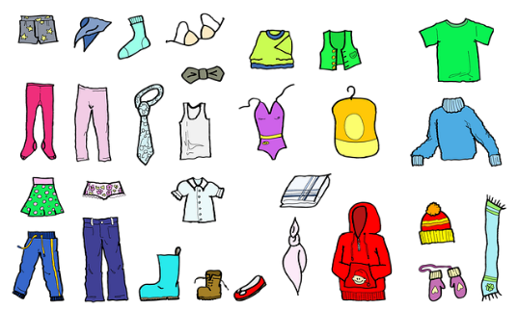
Write an email to a friend. Tell them what you think about the store and why you like it or don’t like it.
Imagine you have spent the 50 pounds. Describe your new clothes item in detail.
What did you buy? What does it look like? What is it made of? How much was it? What do you like about it? When/Where are you going to wear it?

Dear _____________,
page 31 – _ _ _ _ _ _ - _ _ _

English outside of school
If you want to learn English really well, use it as much as possible.
- Watch your favorite movies or series in English.
- Watch YouTube videos in English.
- Listen to English songs and try to understand the lyrics.
- Read English websites and books. Our library has really cool books for you.
- Play computer games in English and meet international gamers online.
- Use English in the holidays and with people from other countries e.g. classmates.

On this page, collect all these English outside of school experiences.

My favorite English songs
English movies that I have watched:



page 32 – _ _ _ _ _ _ - _ _ _
Cool English websites and Youtubers that I have found
People I talked to in the holidays or online.
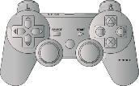
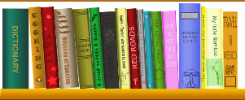
English books that I have read
Computer games that I have played in English

page 33 – _ _ _ _ _ _ - _ _ _ _ _

Any other things I do in English

Image sources:

Page 2: Scheere: https://pixabay.com/de/vectors/schere-werkzeug-zertrennen-337633/
Page 2: Kleber: https://pixabay.com/de/vectors/raupe-gras-kleber-fix-anf%c3%bcgen-1135242/
Page 6: Sieger: https://pixabay.com/de/illustrations/search/pokalsieger/
Page 14: floorplan: https://pixabay.com/de/photos/planen-wohnung-ferien-1974938/
Kinderzeichnung: C0: Elisabeth Pölzleitner
Page 18: https://pixabay.com/de/illustrations/fast-food-burger-pommes-frites-4683678/
Page 18: https://pixabay.com/de/illustrations/gekritzel-skizzieren-hand-gezeichnet-4861309/
Page 21: https://pixabay.com/de/vectors/bild-frame-digital-foto-rahmen-784578/
Page 22: C0: Elisabeth Pölzleitner
Page 24: https://pixabay.com/de/illustrations/rahmen-bilderrahmen-umrandung-gras-89485/
Page 28 : https://pixabay.com/de/illustrations/beeindruckend-botschaft-hinweis-1426595/
Page 28: https://pixabay.com/de/illustrations/vergeben-preis-briefmarke-gewinner-1714292/
Page 28: https://pixabay.com/de/vectors/zertifikat-zertifizierung-31872/
Page 31: https://pixabay.com/de/illustrations/kleidung-stiefel-schuhwerk-736033/
Page 32: globe: https://openclipart.org/detail/170988/travel-globe
Page 32. camera: https://pixabay.com/de/images/search/film/
Page 32: boy listening to music: https://pixabay.com/de/vectors/kerl-musik-h%c3%b6ren-klang-lied-1456576/
Page 30: website icon: https://pixabay.com/de/vectors/netz-die-anschrift-webpage-4746871/
Page 32: video conference: https://pixabay.com/de/illustrations/videokonferenz-zoomen-treffen-5964262/
Page 33: gaming controller: https://pixabay.com/de/vectors/konsole-spiele-hand-held-regler-309614/
Page 33: books: https://pixabay.com/de/vectors/regal-b%c3%bccher-bibliothek-lesen-159852/

