____________‘s
First
Reading Diary

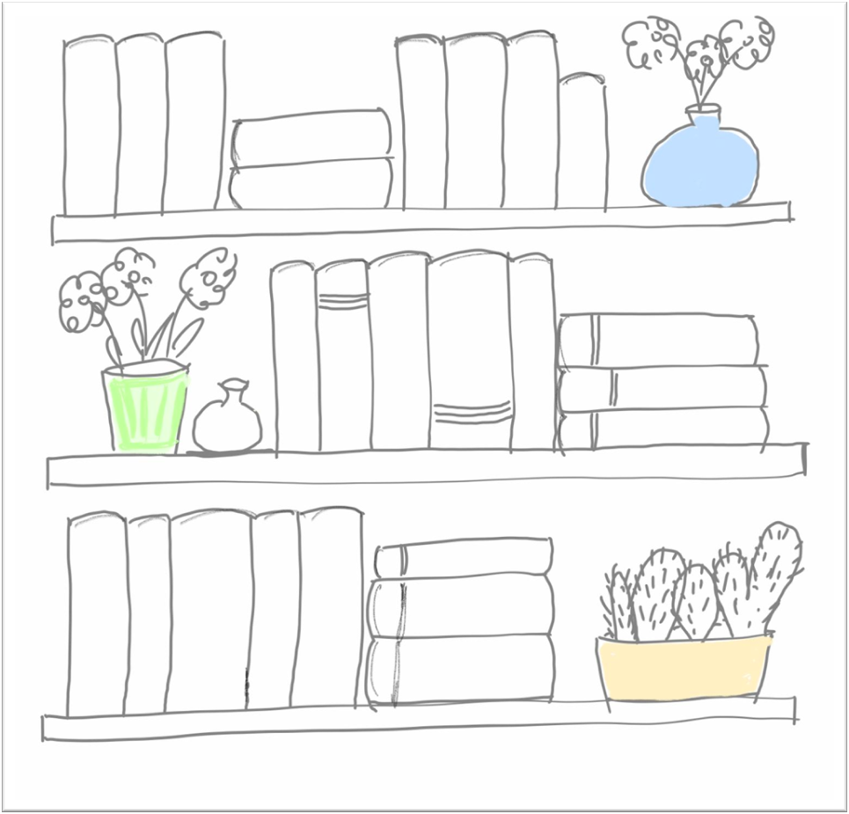
by Elisabeth Pölzleitner

Impressum:
Elisabeth Pölzleitner
Kontakt: creative.languageteachers@gmail.com
Elisabeth Pölzleitner
Kids who read succeed
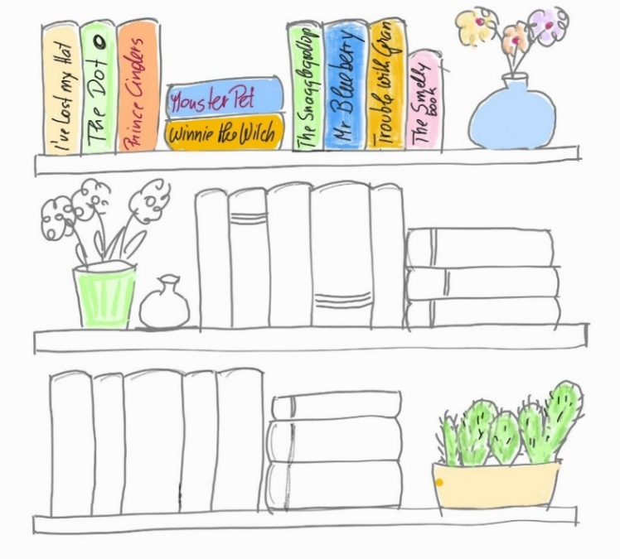
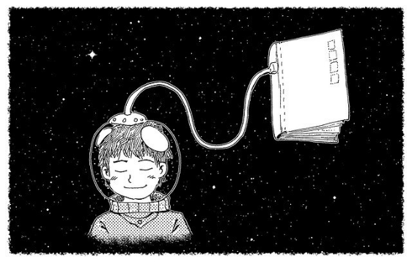
Die Forschung zeigt uns ganz klar, dass Lesen schlau macht. Unser Gehirn ist wie ein Muskel. Wenn wir es gut trainieren und gut füttern, wächst es und wir werden richtig schlau. Schon nach 2-3 Monaten Englischunterricht bist du auch in Englisch bereit Bücher zu lesen. Anfangs werden es Bilderbücher sein, später dann Kinder- und Jugendbücher auf Englisch. Du brauchst nicht jedes Wort verstehen – versuche aus den Bildern, dem Kontext und deinem Wissen von der Welt möglichst viel zu verstehen und unbekannte Wörter zu erraten.
Viel Spaß beim Lesen – und vergiss nicht: „Kids who read succeed“ – oder auf Deutsch „Lesen macht schlau und erfolgreich“

Copyright: Elisabeth Pölzleitner und Laura Bergmann, 2021

Tips for my book chats
Here are some phrases that can help you to talk about your book.
The main character (Hauptfigur) wants to…..
This book is about a …..

My favorite picture is on page …. . You can see….
My favorite part is when ….

The boy / the girl is happy / sad /angry / surprised, when….

I like the book because ….

I don’t like (this character) because…
I don’t like the book because ….
English books that I have read
Step 1: Color the plants and the 3 shelves.
Step 2: Each time you have read an English book, color one of the books in these shelves and write its title on the back of the book.
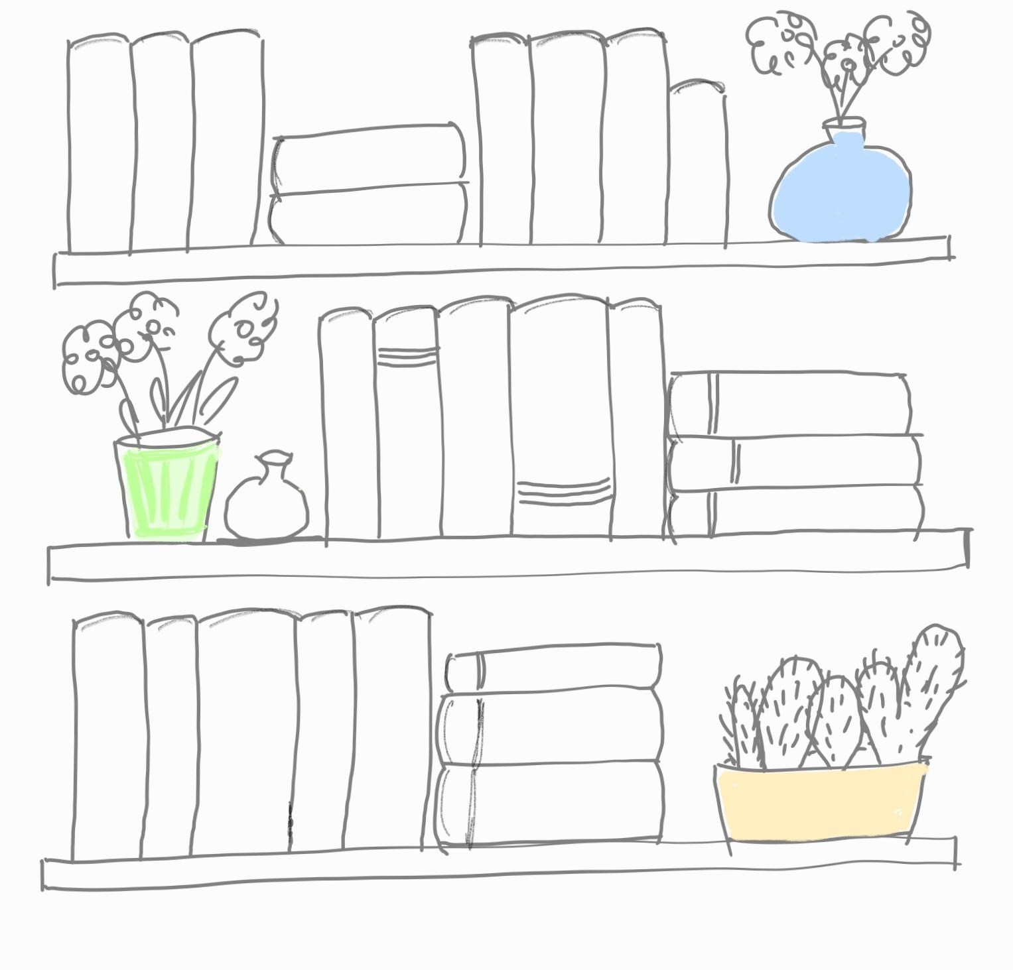
My first English Book
TITLE: ___________________________________
Author:_________________________________
Draw a picture about the story here.
Label the picture. Name as many things as possible.
Tip: You can find the words in your book.

My Opinion
Do you like the book? yes no

How many stars do you give the book (color the stars)

My favorite sentence from the book is

_______________________________________________________
_______________________________________________________

My favorite character (person or animal) in the book is

______________________________________________________

What can you say about this character?

_______________________________________________________
_______________________________________________________

My second book
TITLE:____________________________________
Author: _________________________________
Character Portrait:
Draw a picture of the main character (person or animal) in your book.


What do you know about this character?
Write as much as possible: (age, family, friends, likes, dislikes, hobbies, …)

Tip: Don’t forget the s (he likes, she doesn’t like, it lives in…
My Opinion
Do you like the book? yes no

How many stars do you give the book (color the stars)

My favourite sentence from the book is
_______________________________________________________
_______________________________________________________
My favorite character (person or animal) in the book is

______________________________________________________
What can you say about this character?
_______________________________________________________
_______________________________________________________
What happens in the book?
First __________________________________________________
Then __________________________________________________
After that _____________________________________________
In the end _____________________________________________

My third book
TITLE:____________________________________
Author: _________________________________
Word grid:
Choose 9 important words/phrases from your story and write them in the grid.
Then use two colors. Mark all the boxes with “happy words” in a light, friendly color. Mark the boxes with “sad or angry words” in a darker color. Explain to your teacher why you think these words are happy or sad for you.

What is the story about?
Tell the story in ten sentences.
How do they solve the problem?
What is the problem?
Who are the main characters?
Where does the story play?

My fourth book
TITLE: ____________________________________
Author: __________________________________
What are they doing?
What are the characters in your book doing? Draw 5 quick sketches into the photo frames. Then write a sentence for each photo.
Example: In picture 1 Alice is riding her bike to school.
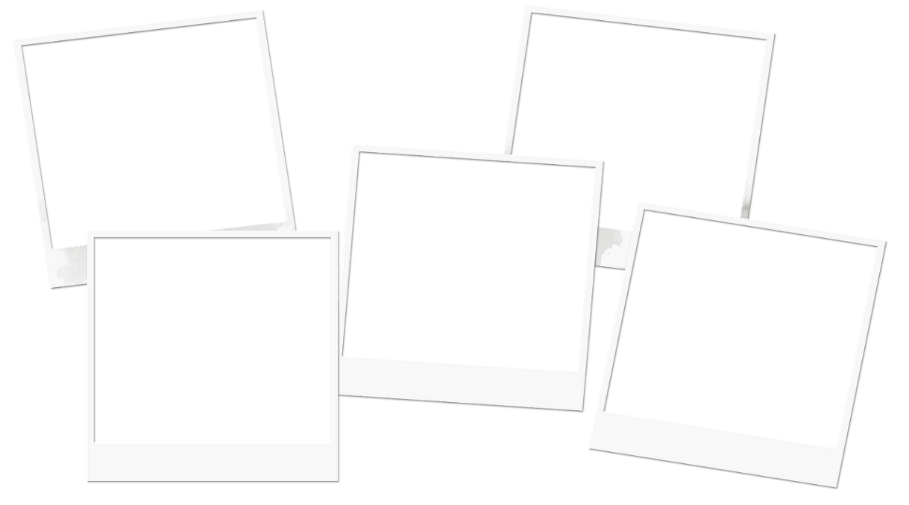

My opinion about this story and its characters

What do you think of the characters (people or animals) in this story. How do you like them?
My favorite character(s):

I like him / her/ them because…


These characters are ok:


My least favorite character(s):

I don’t like him/ her/ them because…

Making connections
Most good stories deal with real world problems.
What does this story remind you of?

My fifth book
TITLE:____________________________________
Author: __________________________________
My book on social media
Imagine the main character of your book was on social media. Draw 5 quick sketches of important events from your book that he/she would post online.

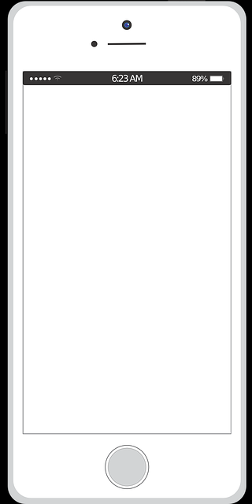

Then sum up the story in the past tense.
The following words will help you:
First..// Then // On the next day // Some time later// Finally..

A picture from my book
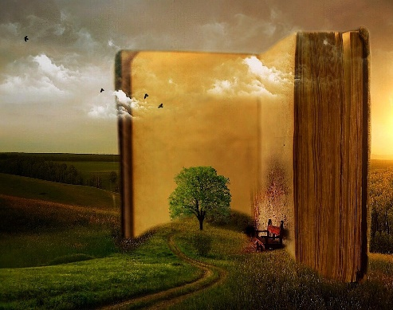
Where does the story play? Choose a page from the book where you can see the setting (place) very well. Describe the picture in detail.
What do you see? (on the right side, on the left side, in front of, behind, next to, above, under, in the foreground, in the background, in the sky, at the bottom…)
What are the characters doing in the picture. Are they sitting, running, jumping, flying, eating…?
In this picture I can see…

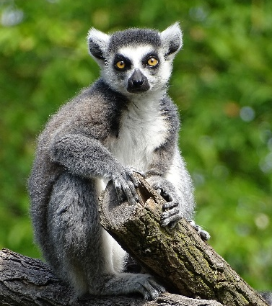
My sixth book
is a NON-fiction book about an animal

TITLE:____________________________________
Author: __________________________________
This time you have read a non-fiction book about interesting animals. Prepare a fact-sheet and write down the most interesting and the most astonishing facts that you have found out.
Interesting facts about …………………………..
Comparing Animals
Compare the animal from your book to another animal that you know well.
Which of the animals is bigger, heavier, faster, cuter,
more or less dangerous, more or less intelligent, more or less difficult to keep as a pet, more or less expensive, …

My seventh book
TITLE: _____________________________________
Author: __________________________________
 | Asking good questions  Write 10 intelligent questions about the story that you have read.  Be prepared to answer your questions in the book chat with your teacher. The first two questions have been done for you.
What is ………………..…’s main problem?
How did he/she solve it?
Who…
Who else…
Where…
Why…
…
…
…
…

Problems and Solutions

Learning to solve problems will make you successful in life. What can you learn from this story?

What was the problem?

How did they solve it?

What other ways of solving the problem can you think of?

Can you think of a similar problem that you have had or heard of?

My eighth book
TITLE: ___________________________________
Author: _________________________________
Have you ever…?
After reading your book ask yourself if you have ever been in any similar situations
or if you have ever been in a similar place
or if you know anybody who has been in a similar situation or place


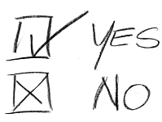  Example:  In my book the main  character had a fight  with his friend. I have also had a fight with my best friend. | It was last year, when we were…  Details
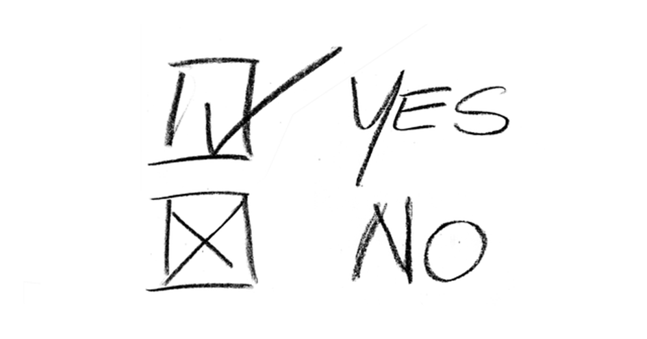 | It was…  What would you do in this case?
, I have never… | …but if I ……………………  (was, had, came, saw…) I would…

What if?
Picture these in your mind and describe what would happen if …
What would happen if your main character had a superpower?

What would happen if the main character of your story came to our school / our class?

What would happen if this story was set in another time (in the past or in the future)?

My ninth book

TITLE: ___________________________________
Author: _________________________________
The Lottery Winner
Imagine this: One of the characters in your book has just won a voucher of 1000 € in the lottery. The money cannot be cashed in – but your character can buy anything they want for himself/herself or for anyone else.
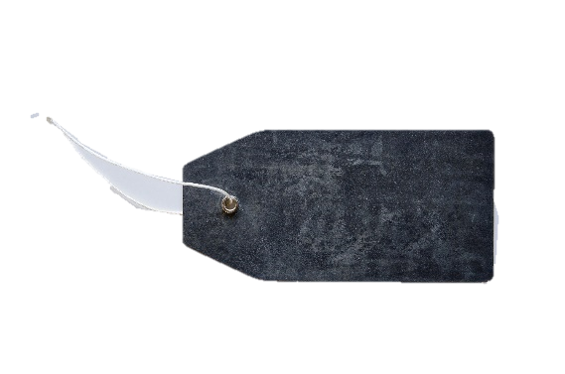
What would they buy?
Add simple drawings and price tags.
12 €

Letter to a friend
Imagine this: You are the main character in the story and you have not seen your best friend for a while. You want to inform your friend about the recent events in your life. Maybe you also want to ask for advice?
Write a nice, long letter. Don’t forget: Your friend has no clue about your situation and what has recently been going on in your life.
Write your letter on a separate sheet. Ask your teacher for an envelope and glue it in here.
Start like this:
Dear …………………,
I haven’t seen you for a long time and I have lots of news to tell you.



My tenth book
TITLE: ___________________________________
Author: _________________________________
Ups and downs in life
Choose five to seven important moments in your main character’s life. Write short notes about these events into the gray area of the table. Then decide how the character was feeling at these moments and draw appropriate smileys.
Draw a line through all these smileys to show the character’s emotional ups and downs in life.
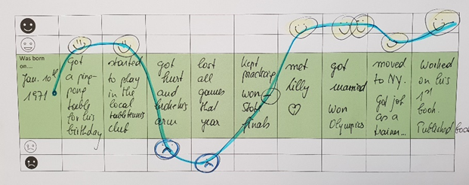






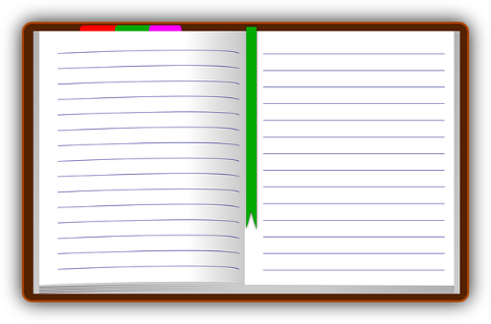
Diary
Choose one of the happiest or lowest moments in your character’s life and write your character’s diary entry for that day.
In the diary your character describes the situation he/she is in and his/her feelings about this situation. Maybe your character also writes about possible solutions to his/her problem.

Dear Diary,

My eleventh book
TITLE: ___________________________________
Author: _________________________________
Blog pictures
Choose three very important moments in the book. Imagine someone had taken photos at these moments and the main character writes about them in a blog. Draw these pictures and write down who is who and what happened.
 | In this photo …
 | Here you can see…
 | In this picture…

Agree or Disagree?

In your story the characters had to take several decisions.

Do you agree with them?
What would you have done in these situations?
Explain why.

My character decided to ……… | Yes, I would have done the same.  Yes, I would also have ……………….  because ……………………………………..  No, I would have …………… instead, because ……………………………………..

My twelfth book
TITLE:_____________________________________
Author: __________________________________
Same or different?
Your favorite character and YOU
What do you have in common?
What are the differences?

Draw a portrait of your character and of yourself.


My character: …………….. That’s me: …………..
What we have in common

My name: …………
My character’s name:
…………………


Giving good advice

It is always easier to see good solutions if you are not involved yourself.
Think of your main character’s situation and problems.
What advice could you give him/her?
What should he/she do?
What should he/she not do?
I think you should…

If I were you, I would….

I think you should not…

I think you …

Don’t ………….

My thirteenth book
TITLE: ____________________________________
Author: __________________________________
Good readers imagine how things look, sound, feel, smell and taste.
Choose one important thing from your story and draw it.
Then describe it as if you were selling it on Etsy.com (or any other online sales platform).

What is it?

What is it used for?
Who would like to have this item?
What is special about it?
What is it made of?
How did you feel about the events in the story?
Page:  What happened? | How I felt about it and why?

happy   | surprised   | bored  
satisfied   | puzzled   | worried  
sad   | shocked   | angry  

My fourteenth book
TITLE: ____________________________________
Author: __________________________________
Mindmap
What is this story about? Complete the mindmap. Add as many words as possible.

Title
Good
characters
Bad characters
Solutions
Problems
Places


Good guys and bad guys
Choose one of the good or bad characters from your story and write a WhatsApp message to one of them.
What do you want to tell them? Be specific. Do you want to help them and show your understanding.
Or do you want to criticize their behavior and tell them off?


My fifteenth book
TITLE: ____________________________________
Author: __________________________________

Your character’s secret thoughts
Put yourself in your main character’s shoes. What thoughts are going through his/her mind?


What’s next?
Your character’s life is not over. How will the story continue? What will your character experience next?
Write the next chapter in your character’s life.

My sixteenth book
TITLE: ____________________________________
Author: __________________________________
In the previous 15 entries you have tried lots of different tasks. Now you can choose your own. What would you like to do for this book? Be creative – show what you know and what you think about the book. If you need help, ask your teacher for some ideas.

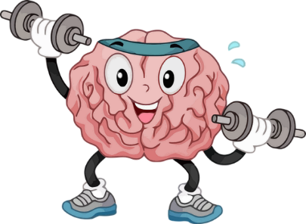
Congratulations!!! Smart kid !!!

You have read 16 English books. Your brain has grown super strong.

Keep reading even more cool books.

Abbildungsverzeichnis

Cover page: Illustration Elisabeth Pölzleitner
Page 0: https://pixabay.com/illustrations/fantasy-dream-astronaut-night-1077863/
und Illustration: Elisabeth Pölzleitner
Page 2: Illustration: Elisabeth Pölzleitner
Page3: I https://pixabay.com/vectors/label-tag-marker-tab-153963/ by openclipart-vectors-30363
Page 5 https://pixabay.com/de/vectors/foto-rahmen-unbekannt-person-37288/
Page 7 : https://pixabay.com/de/vectors/kegel-lebensmittel-eis-sommer-s%c3%bc%c3%9f-313944/
Page9: https://pixabay.com/de/illustrations/leere-bilderrahmen-2023679
Page10: https://pixabay.com/de/illustrations/mockup-digitalisierung-vernetzung-3758375/
Page11: https://pixabay.com/de/vectors/ich-telefoniere-smartphone-apfel-1228311/
Page12: https://pixabay.com/de/illustrations/rahmen-bilderrahmen-1712999/
Page13: https://pixabay.com/photos/lemur-animal-ape-wildlife-zoo-5161854/
Page 15: https://pixabay.com/de/photos/fragezeichen-symbol-charakter-2309040/
Page 16: https://pixabay.com/photos/question-mark-symbol-icon-character-2309040/ by Peggy-Marco
Page17: https://pixabay.com/photos/problem-solution-help-support-2731501/
Lupe : https://pixabay.com/de/vectors/lupe-lupe-glas-glas-vergr%c3%b6%c3%9fern-189254/
checkmarks : https://pixabay.com/illustrations/yes-no-opportunity-checklist-box-2167843/
Page 19: https://pixabay.com/de/illustrations/gewinner-beste-erfolg-preis-5257940/
Page 19: https://pixabay.com/de/photos/etikett-design-metall-seil-schnur-654697/
Page 20 : https://pixabay.com/de/illustrations/e-mail-botschaft-email-1454733/
Page 21 : Illustration : Elisabeth Pölzleitner
https://pixabay.com/de/photos/etikett-design-metall-seil-schnur-654697/
Page 22 : https://pixabay.com/de/vectors/veranstalter-tagebuch-buchen-155952/
Page23: https://pixabay.com/de/illustrations/rahmen-bilderrahmen-1712999/
Page 24 : https://pixabay.com/de/illustrations/entscheidung-frage-antwort-waage-1013752/
Page 24 : https://pixabay.com/de/illustrations/weg-kreuzung-richtung-abzweigung-1019745/
Page 26 : https://pixabay.com/de/vectors/dialog-trinkgeld-beratung-hinweis-148815/
Page 28 : all faces : https://pixabay.com/de/vectors/ver%C3%A4rgert-gesicht-emoticon-33059/
Page 30: https://pixabay.com/de/illustrations/whatsapp-plaudern-botschaft-handy-3012138/
Page 31 : https://pixabay.com/de/illustrations/fragezeichen-%c3%bcberlegen-denken-frage-2318030/
Page 35 : https://pixabay.com/de/vectors/gehirn-organ-muskel-karosserie-5532459/

