____________‘s
SpeakingBook

Flexi English
By
Elisabeth Pölzleitner

TABLE OF CONTENTS

All pictures: creative commons: pixabay or private pics.
*** = advanced task

Table of Contents
Table of Contents 1
Let’s learn to SPEAK English 3
3
My useful English Phrases 4
My useful English Phrases 5
1.That’s Me – who are you? 6
2. Find out about a new classmate 8
3. Present a new classmate 10
4. My friend and I *** 12
5. My Family 14
6. My Daily Routines 16
7. My fantasy dream-room 18
8. My Dream-house*** 20
9. Perfect food for my birthday party 22
10. A really fun, cool day in my life 24
11.Finding out about a friend’s holidays 26
12. My pet or the pet I would like to have 28
13. Our favourite outfits 30
14. My life in 15 years 32
15. Our plans for the next weekend 34
16. Truth or lie? 36
17. Let’s meet 38
18. The best place in our town 40
19. My topic 42
20. Show and tell 44

Let’s learn to SPEAK English
Let’s chat in English

How to prepare for the chats with your teacher
- Your teacher will tell you when you are ready to do a new speaking task from this book.
- Read the instructions and the help card carefully.
- Take notes (keywords). Do NOT write whole sentences. Your teacher wants to see that you can speak – do not read a prepared text.
- Practice what you want to say.
- Then tell your teacher that you are ready for the chat.
- Important: Mistakes and pauses are normal. Do not worry about them. Maybe you will even notice some mistakes in the sample videos. Just speak.

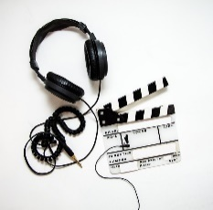
- To get a first idea, watch some of the sample videos of year 1 students.

So bereitest du dich für Sprechaufgaben mit deiner Lehrperson vor:
- Dein Lehrer/Deine Lehrerin sagt dir, wenn du bereit bist eine der Sprechaufgaben aus diesem Buch zu machen.
- Lies die Angaben und die Hilfekarte (help card) genau. Frage nach bevor du mit der Vorbereitung startest, wenn dir etwas unklar ist.
- Schreibe Stichwörter auf (keywords). Schreibe KEINE Sätze. Du sollst zeigen, dass du sprechen kannst – nicht, dass du vorbereitete Texte lesen kannst.
- Übe, was du sagen willst.
- Melde dich bei deiner Lehrperson, wenn du bereit bist die Sprechaufgabe zu machen.
- WICHTIG: Fehler und Pausen sind normal. Mach dir deswegen keine Sorgen. Vielleicht fallen dir auch in den Videos Fehler auf. Sprich einfach.

My useful English Phrases
Use the English words in everyday life. If you have used a phrase five times, you can color the shape.
Write your own English phrases in the empty shapes
Thanks
Come on –
let’s do it!
That’s so cool!

Hello! Let’s talk about ….

How do you say ………….. in English?

Can I help you?

Let’s go!
I love it!

Why not?
Bye, see you later!

page 2 – t _ _

My useful English Phrases
page 3 – t _ _ _ _
Keep collecting and using English phrases and write them into the shapes.

1.That’s Me – who are you?
Watch this example:
What can you say about yourself? Tell us lots of things about yourself. Tell us about
- your hobbies,
- your family,
- what languages you speak
- what you like,
- what you don’t like,
- your favorite food
- and other favorite things.

My cheat-sheet (Schwindelzettel):
Here you can write some important words that you want to use in your chat.

Practice your little presentation, then talk to your teacher. Remember: Do NOT read a prepared text.

Help card!
Tell us about
- Your name, age, where you are from
- Your family
- Hobbies and things you like doing
- Things you don’t like doing
- Food
- Animals and pets
- More ideas…


Language tips:
I am from / I live in
I like…/ I don’t like… /I love… /I hate…
My favorite … is/are
I have…/ I don’t have any…

How do you feel about your presentation?

What can you do to get even better next time?

FOR THE TEACHER This is what your teacher thinks about it:
 | not yet | poor | ok | good | excellent
Fluency
Range of vocab and structures
Accuracy
Comment

2. Find out about a new classmate

Preparation (Vorbereitung)
What will you ask (was wirst du fragen)?
What’s ___________________? | You want to know his / her name
How | You want to know how old he / she is
Where | You want to know where he / she comes from
 | You want to know what languages he / she speaks
 | You want to know if he / she has any brothers or sisters.
 | You want to know if he / she has any pets.
 | You want to know what his/her hobbies are.
 | You want to know what his/her favorite food is.
 |  | your own ideas…

Help card!
Tipp**
- Make this a real dialogue.
Listen to the answers and ask for more information
e.g.
- Why do you speak Turkish?
- What kind of dog do you have? (American)
- What kind of dog have you got? (British)
- How old are your brothers and sisters?
- How often do you play soccer?
- What’s your favourite computer game?

Language tips:
Look at the words in bold (fettgedruckt!)

Practice your dialog, then act it out for your teacher.

How do you feel about your presentation?
What can you do to get even better next time?

FOR THE TEACHER This is what your teacher thinks about it:
 | not yet | poor | ok | good | excellent
Fluency
Range of vocab and structures
Accuracy
Comment

3. Present a new classmate
Watch this example:
What can you say about your new classmate?
Tell us everything you know about your new classmate. Write your notes (keywords) in the boxes.
Country and Languages
Age
Name
Tip:
Use and and but (aber)
Pet(s)?
Brothers and sisters?

and
and
He/She likes…

He/She likes…

He/She doesn’t like…
but
Favorite food(s)
Hobbies

Favorite animal(s)

Practice what you are going to say about your classmate. Then ask your teacher to do the chat with you.

Help card!
Remember!
If you talk about another person you need to use the S

She likeS swimming but she doeSn’t like skiing.

How do you feel about your presentation?
What can you do to get even better next time?

FOR THE TEACHER This is what your teacher thinks about it:
 | not yet | poor | ok | good | excellent
Fluency
Range of vocab and structures
Accuracy
Comment

4. My friend and I ***
Tell your teacher about your friend and about yourself.
What do you have in common (gemeinsam)?
What is different (unterschiedlich)?
Preparation (Vorbereitung)
What will you talk about (worüber wirst du sprechen)?
Take notes – only keywords (Mache Notizen. Nur Stichwörter, keine Sätze)
our names
our age (how old)
home countries
languages
family (brothers/sisters)
Pets
Hobbies
favorite food(s)
things we don’t like
Your ideas…

Help card!
Remember!

If you talk about another person you need to use the S

Talking about yourself
I like swimming but I don’t like skiing.

She likeS swimming but she doeSn’t like skiing.

How do you feel about your presentation?
What can you do to get even better next time?

FOR THE TEACHER This is what your teacher thinks about it:
 | not yet | poor | ok | good | excellent
Fluency
Range of vocab and structures
Accuracy
Comment

5. My Family
Tell us about your family. Give us lots of details about two or three people in your family.
Important members of my family are:

Age (how old)
name

He/She speaks …. because…
In his/her free time …

He/She loves… but doesn’t like…
He/She likes… but doesn’t like…

He/She has …

He/She hates…because

He/She doesn’t have…

His/her favorite … is/are…

page 10– _____________
Help card!
Remember!
If you talk about one other person you need to use the S.

If you talk about more than one person you do not need an S.

If you talk about another person you need to use the S

She likeS swimming but she doeSn’t like skiing.

My parents like swimming but they don’t like skiing.

How do you feel about your presentation?
What can you do to get even better next time?

FOR THE TEACHER This is what your teacher thinks about it:
 | not yet | poor | ok | good | excellent
Fluency
Range of vocab and structures
Accuracy
Comment

6. My Daily Routines

Tell us about your typical schoolday. Tell us lots of details from getting up to going to bed.
Breakfast?
When? What?
Who makes it?
When do you get up?
When do you go to sleep?
When do you go to bed?
TV? Reading?
When do you go to your room? What do you do there?
Brothers? Sisters? Friends?
Hobbies?
Clubs?

Evening?
After dinner?
Dinner? Who? When? What?
Afternoon?
School? Homework?
After lunch?
Lunch? Where? When?
When does school start / end?
What time is recess?
How do you get to school? What time?
Shower? Teeth? Get dressed?

Help card!

first,
then.
after that
after breakfast/lunch/ dinner
5 minutes/an hour later
always
usually
often
sometimes
never

Make it interesting !
and
but (aber)
because (weil)

I usually don’t have breakfast because I like to sleep late but on Tuesdays I have breakfast because I stay at my dad’s place and he makes pancakes for me.

How do you feel about your presentation?
What can you do to get even better next time?
FOR THE TEACHER This is what your teacher thinks about it:
 | not yet | poor | ok | good | excellent
Fluency
Range of vocab and structures
Accuracy
Comment

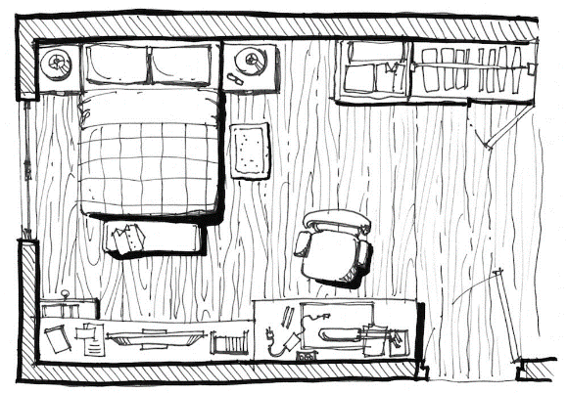
7. My fantasy dream-room
Cool loft bed with sofa underneath
Shelf with books, TV and gaming station
Slide from bed to pool
My private garden with monkey cage

Swimming pool

Draw a quick plan of your dream-room on a piece of paper.
Be creative – you can have anything you want!
Plan your little presentation:
General impression of your room (light, dark, cosy, big, small…)

When you enter the room you see….

Describe all the pieces of furniture in detail and tell us where they are. Beschreibe alle Möbelstücke und erkläre wo sie sind.
Tell us what they look like, whether you like them, what you use them for… Erkläre wie sie aussehen, ob du sie magst, wofür du sie benützt.
Make a list of the furniture here and add a few keywords. Do NOT write whole sentences. Mache eine Liste der Möbelstücke und schreibe ein paar Stichwörter auf – keine ganzen Sätze!

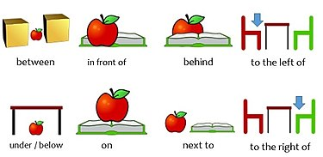

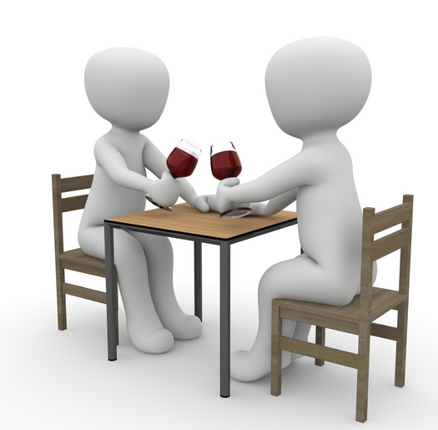


Tip: Your teacher should be able to draw your room from your description. Make sure they know where everything ist. Dein Lehrer/Deine Lehrerin sollte den Raum nach deiner Beschreibung richtig zeichnen können. Stelle sicher, dass sie wissen, wo was ist.
above
opposite
Helpcard

How do you feel about your presentation?
What can you do to get even better next time?
FOR THE TEACHER This is what your teacher thinks about it:
 | not yet | poor | ok | good | excellent
Fluency
Range of vocab and structures
Accuracy
Comment

8. My Dream-house***
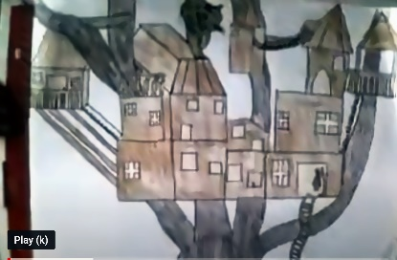
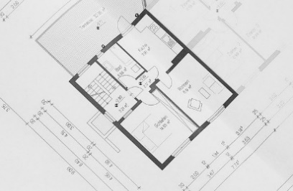

Be creative. Describe your dream-house in detail. Start from the outside – what kind of house is it. Then walk us through the house. What rooms do you have?
Describe your favorite room in detail. Make a good plan and describe the house so well that your teacher can draw it while you are talking.
Use this table to plan your presentation
My dream house: general idea
place / where?

outside:

rooms on the ground floor:

rooms on the first floor

other details: what is so special about this house?

My favorite room in this house is:
where is it?

general impression (allgemeiner Eindruck): bright, cosy, colorful…

pieces of furniture and where they are

Tell us lots of details (colors, what it is used for, your favourite place… )

above
opposite
Help card

How do you feel about your presentation?
What can you do to get even better next time?

FOR THE TEACHER This is what your teacher thinks about it:
 | not yet | poor | ok | good | excellent
Fluency
Range of vocab and structures
Accuracy
Comment

9. Perfect food for my birthday party
Design an ideal buffet for a birthday party. You have invited 15 friends, including these three:
I love sweet things.

I love all kinds of junk food.


I am vegetarian and I love fruits and vegetables.

Tell your teacher what you are going to buy and serve.


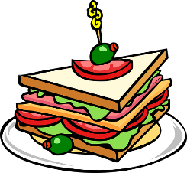

Don’t forget drinks. Write some ideas (keywords!) in the box below.
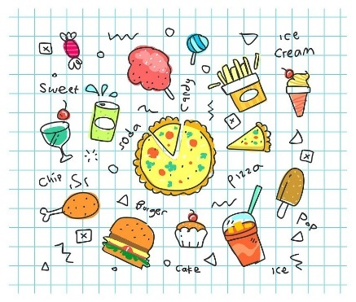
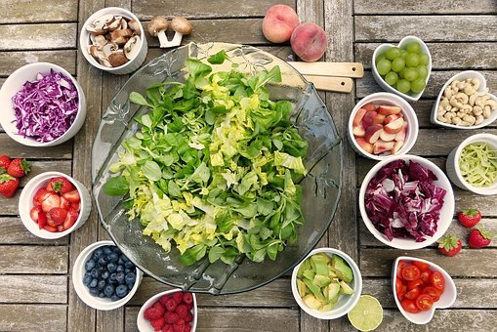
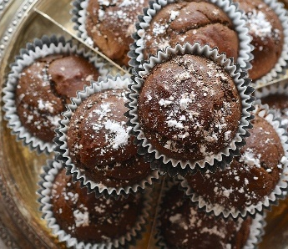


Help card:
I’m going to buy…. because ….
….most people like…
I’m going to make…. because ….
… some people (don’t) want…
I’m (not) going to serve…
…most of my friends (don’t) like …
My mother/grandmother/friend can help me to make ….

How do you feel about your presentation?
What can you do to get even better next time?
FOR THE TEACHER This is what your teacher thinks about it:
 | not yet | poor | ok | good | excellent
Fluency
Range of vocab and structures
Accuracy
Comment

10. A really fun, cool day in my life
Tell us about a cool day in your life. Tell us lots of details from getting up to going to bed.
Where were you?
When was that?
Why was the day special?
What did other people think about it?
What did you do first?
Would you like to do it again? Why (not)?
What was the best thing about the day?
…
…
…
Why?
What did you do in the evening?
What happened after that?
What did you do next?
How did you feel?
Who was with you?
Why?
What happened then?
Help card!
Always give extra information to make it more interesting
I walked to the beach but I did not go into the water, because it was too cold.
Remember!
If you talk about a day in the past, use the past tense

Some words have irregular past tense forms.

If you talk about another person you need to use the S

was / had / went / ran / said / thought / met / ate / bought / ….

How do you feel about your presentation?
What can you do to get even better next time?
FOR THE TEACHER This is what your teacher thinks about it:
 | not yet | poor | ok | good | excellent
Fluency
Range of vocab and structures
Accuracy
Comment

11.Finding out about a friend’s holidays
Your friend was on holiday. Ask him/her lots of questions to find out as much as possible about the holidays. Then tell your teacher about it.
Write down a few questions here to get started. When you talk, ask more questions to find out about details.
Where did ________________? | You want to know where he/she went-
When did _________________?  How long did _____________? | You want to when he/she went there and for how long.
Who went ________________? | You want to know who went with him / her
What _____________________? | You want what they did there
 | You want to know what was the best thing they did? Why?
 | You want to know how your friend felt..
 | You want to know what they did first?
 | You want to know what they did then?
 |  | your own ideas…

Help card!
Remember!
When you talk about a day in the past, use the past tense

Some words have irregular past tense forms.

If you talk about another person you need to use the S

was / had / went / ran / said / thought / met / ate / bought / ….
I went to
Slovenia to visit
my grandparents.
Where did you go in the holidays?
Always give extra information to make it more interesting
How do you feel about your dialogue?
What can you do to get even better next time?
FOR THE TEACHER This is what your teacher thinks about it:
 | not yet | poor | ok | Good | excellent
Fluency
Range of vocab and structures
Accuracy
Comment

12. My pet or the pet I would like to have
Tell us everything we need to know about your pet /or the pet you would like to have. Explain why it is a good pet.
Plan what you want to say about your animal. Write keywords into the table.
What kind of animal is it?

What does it look like?

What does it eat?

What should it not eat?

Home: indoor / outdoor / stable/ cage/ basket…

Other important information about this pet:

Why is it a good / the best pet:

Help card:
You shouldn’t feed it sweets but you can give it fresh fruit as a treat.
You should feed it vegetables and corn. It also likes….
You have to clean its cage every week
It needs fresh water every day
You mustn’t let it run outside because it will run away.
Remember: Animals are “it”. My favourite animal is a chameleon. It lives in a terrarium. You have to clean its terrarium once a month.

How do you feel about your presentation?
What can you do to get even better next time?

FOR THE TEACHER This is what your teacher thinks about it:
 | not yet | poor | ok | good | excellent
Fluency
Range of vocab and structures
Accuracy
Comment

13. Our favourite outfits
Think of all the clothes that you have. What would you wear if you wanted to look really nice or cool?
Discuss your favorite outfit with your friend. Explain in detail what it looks like and why you like it so much. Ask your friend about his/her favorite outfit and tell him/her what you think about it. Give your friend some tips how to improve the outfit (=make it even better).
Make a quick sketch of your favorite outfit here. Label the pieces of clothing and write some keywords (e.g. baggy / cropped / soft / warm / ….)

Help card!

Which of these items are you going to talk about?
- clothing items: jeans, shorts, T-shirts, sweaters, cardigans, hoodies, pullovers, skirts, blouses, dresses, jackets, coats,
- accessories: belts, scarves, jewelry, earrings, rings, bracelets,
- materials: cotton, wool, nylon…
- designs: striped, checkered, with a flower pattern, with polka dots,
You could add….
It looks really nice. I think it would look even better if you……
My favourtie outfit is a …. with …because….

How do you feel about your dialogue?
What can you do to get even better next time?
FOR THE TEACHER This is what your teacher thinks about it:
 | not yet | poor | ok | good | excellent
Fluency
Range of vocab and structures
Accuracy
Comment

14. My life in 15 years
Monologue
Imagine yourself in 15 years. What will your life be like? Where will you be living? Who will be with you? What will you be doing? Will you be studying or working? Will you have a partner or even children? What will the world be like?
Think about different aspects of your daily life in the future. Write down some keywords. Then tell your teacher about your future.
Think about:
Your daily routines
Your hobbies

Your family
Cool things you own
Your job or studies
Your home:
…
Maybe everybody will have flying cars, or at least hoverboards.
I hope I will have my own flat and I will own a big dog.
I think I will live in a big city, maybe in Vienna or in London.
Remember!
If you talk about the future and predict things (vorhersagen), you use the will future.

How do you feel about your presentation?
What can you do to get even better next time?
FOR THE TEACHER This is what your teacher thinks about it:
 | not yet | poor | ok | good | excellent
Fluency
Range of vocab and structures
Accuracy
Comment

15. Our plans for the next weekend
Write down your plans for the next weekend. If you don’t have any plans yet, make them now. You don’t have to do cool things, you can also plan to stay at home, help your mum, study for school …..
Find out what your partner is going to do next weekend. Ask for lots of details.
Then tell your partner about your plans for the weekend.
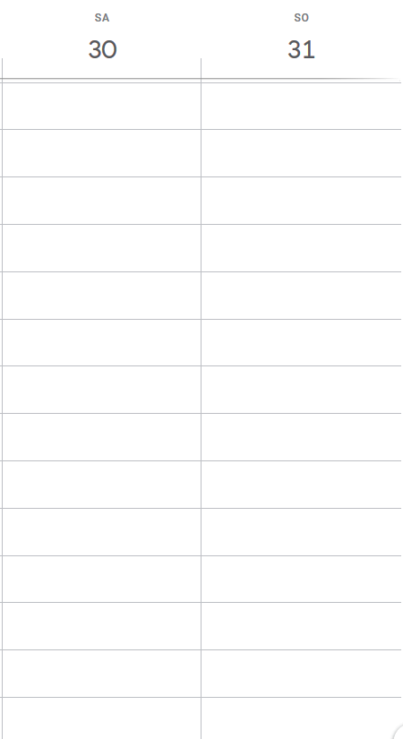
Sunday
Saturday

Remember!
If you talk about your future plans, you use the going to future.

Next Saturday I am going to sleep in and then have a big breakfast. Then I am going to meet some friends and go to the shopping centre.
What are you going to do next Saturday?
How do you feel about your dialogue?
What can you do to get even better next time?
FOR THE TEACHER This is what your teacher thinks about it:
 | not yet | poor | ok | good | excellent
Fluency
Range of vocab and structures
Accuracy
Comment

16. Truth or lie?
Write down 3 sentences about interesting things that you have done in your life. Two are true and one is a lie. Your partner does the same thing. Now ask your partner lots of questions about these events. Find out which one is not true.
Answer your partner’s questions. Be creative and convincing. Can you deceive (täuschen) your partner?

Write down your three things here:
EXPERIENCES

- I have ….
- I have…..
- I have….

Tip: Ask lots of questions to find out if your partner is lying or telling the truth. Ask for details.
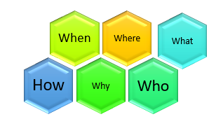
did you ….

Help card!
That was when I was six years old. We were in Kitzbühl and I took part in a skiing race for kids. I won the first prize.
I have eaten insects.
I have touched a shark.
I have won a competition.
Remember
When you talk about experiences (about what you have done in your life), you use the present perfect tense.

When you talk about specific events in the past (and about all the details), you use the past tense.

How do you feel about your dialogue?
What can you do to get even better next time?
FOR THE TEACHER This is what your teacher thinks about it:
 | not yet | poor | ok | good | excellent
Fluency
Range of vocab and structures
Accuracy
Comment

17. Let’s meet
Roleplay
Person A
You want to go to the cinema with your friend. You suggest different films and try to find a date when you are both free.

Your notes:

Person B
Your friend wants to go to the cinema with you, but you do not have enough money this month. You need to wait for next month’s pocket money, so you invent lots of things why you cannot go on the dates that your partner is proposing. (vorschlagen) Make this a long dialogue!
Your notes:

Help card!
I have to walk the dog, and…
I am going to go shopping with my mom.

.

Why not?
I’m sorry. I can’t.
0
Are you free on …..?
Sounds great. When would you like to go?
How about ……?
I’m not a big fan of … movies
Would you like to watch…..?

How do you feel about your dialogue?
What can you do to get even better next time?
FOR THE TEACHER This is what your teacher thinks about it:
 | not yet | poor | ok | good | excellent
Fluency
Range of vocab and structures
Accuracy
Comment

18. The best place in our town
What is the best place in our town. What makes it so special? What can you do there? How do you get there from school?
Take some notes:
What is it?
Where is it?
What can you do there?
What is special about the place?
Why is it your favorite place in town?
How can you get there?

Draw a small map here to illustrate the way from your school to the place:

Help card!
My favorite place is …because

Useful phrases:
- You must take the bus / tram …
- Take the number ….. bus and change at ….
- Get off at …..
- You can go there by bike…
- You can walk to this place…
- Turn right – left – at ….
- Cross the street ….

How do you feel about your dialogue?
What can you do to get even better next time?
FOR THE TEACHER This is what your teacher thinks about it:
 | not yet | poor | ok | good | excellent
Fluency
Range of vocab and structures
Accuracy
Comment

19. My topic
Talk about a topic that you are really interested in. Give lots of details.
Take some notes here:
Why is the topic important for you?

What do you know about the topic?

How did you learn about it?

What would you like to do about it?

What should everybody know about it?

Help card!
If I could change one thing, it would be…
This is important to me because…..
Remember
- Explain the most important points first

- Give examples to explain your point of view

I want people to know that…..

How do you feel about your presentation?
What can you do to get even better next time?
FOR THE TEACHER This is what your teacher thinks about it:
 | not yet | poor | ok | good | excellent
Fluency
Range of vocab and structures
Accuracy
Comment

20. Show and tell
Bring an interesting object from home and tell us why this item is important to you? Give lots of details.
Take some notes here:
Why is the item important or interesting for you?

What do you use it for?

How do you feel about it?

When did you get it? Who gave it to you?

What else do you want to tell us about this item?



Help card!
It makes me feel ….
This is important to me because…..
It reminds me of…
Remember
Need some help? Watch some of the examples here :

I got it from my ….

How do you feel about your presentation?
What can you do to get even better next time?
FOR THE TEACHER This is what your teacher thinks about it:
 | not yet | poor | ok | good | excellent
Fluency
Range of vocab and structures
Accuracy
Comment

