In 2011, the Educational Endowment Foundation conducted a meta-study that looked at the wide range of interventions that schools in Great Britain used to improve the academic performance of five to 16 year olds.
“Teaching & Learning Toolkit,” Education Endowment Foundation, https://educationendowmentfoundation.org.uk/evidence/teaching-learning-toolkit/ (accessed June 25, 2016).

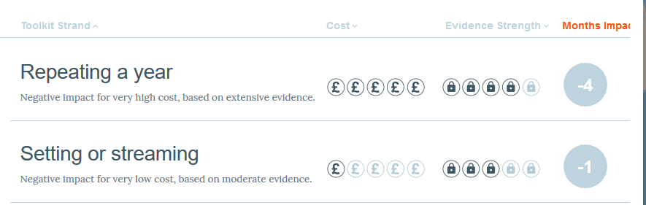

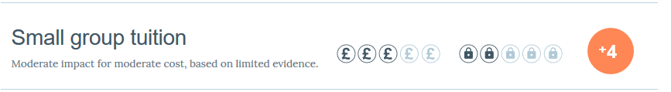
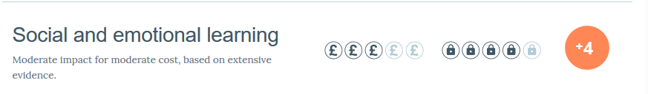
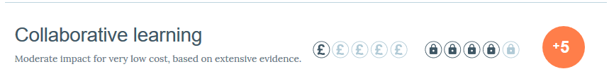

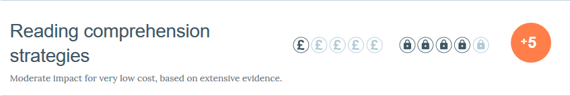
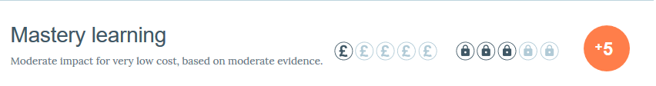


Info on mastery learning: https://educationendowmentfoundation.org.uk/resources/teaching-learning-toolkit/mastery-learning/

MOVE #1: TEACH MINDSETS
Develop the mindsets of agency, creativity, growth mindset, and passion for learning

The GO researchers found that the leading organizations in their review cite five mindsets as a top priority for new recruits:

Agency - the initiative and capacity to act in a desired direction or
toward desired goals7
Creativity - defining problems, arriving at solutions8
Growth mindset - belief that abilities can be developed through effort and
persistence9
Passion - genuine interest in learning10
Teaming - flexible teamwork to tackle problems and identify emerging
opportunities

MOVE #2: RELEASE CONTROL
The second move is to release control to students so that they can make progress without waiting for the class or teacher and practice the mindset of agency. To do this, a teacher must free students from teacher- delivered instruction and give them content and lessons that they can learn independently.

(necessary: Blended learning)

MOVE #3: ENCOURAGE TEAMING

MOVE #4: GIVE FEEDBACK
Create a culture of feedback so that students receive personal, frequent, and actionable feedback in the moment, in small groups, and in one-on-ones.

MOVE #5: BUILD RELATIONSHIPS OF TRUST
Show interest and concern in students as individuals and trust in their ability to drive their own learning, given the right structures are in place.

MOVE #6: HELP STUDENTS HOLD
THEMSELVES ACCOUNTABLE

MOVE #7: HOLD YOURSELF ACCOUNTABLE
Give them tools to set goals, track their progress, and follow through.

