Back from the holidays!
Task 1: Find out how many of your classmates…..

 | Question | Names and notes
…went abroad  (Find out details: where to? Why? How long did they stay there?) | Did you go abroad?
…visited their families?  (Find out details: Who? Where?) | Did you visit your family?
…got stuck in traffic jam.  (Find out details: Where? For how long?) | Did you get stuck in a traffic jam?
….tried out a new sport?  (Find out details: Which sport? Did they like it?) | Did you try out a new sport?
…went on a bike tour  (Find out details!) | Did you….
…got a sunburn  (Find out details!) | Did you….
…met nice people  (Find out details!) | Did you….
…read a book.  (Find out details!) | Did you….
… discovered a new tv series (which one? what is it about?)

…had Corona

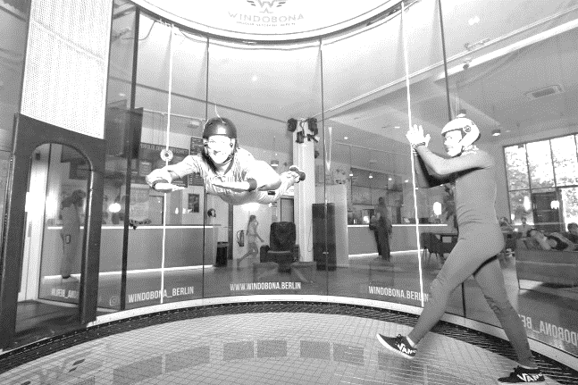
That was really cool! Have you ever tried that??
Last summer I did something really cool. I went flying in a wind tunnel.
It was very exciting. I flew twice, for one minute each time.
Unfortunately it was quite expensive.
Have you ever flown
in a wind tunnel?

Now write 3 sentences about something exciting that you did this summer. Use the past tense. (e.g. went / stayed / saw / visited / met /had …)

Guess: How many of your classmates have done that (in their lives)? Write down the number:

Write down the Question:

Have you ever….

Ask you classmates. Were you right?

