Target group: Year 3, Mittelschule
Topic: Fake News
Lesson count: Max. 16

Long-term goals:
- Developing media and news literacy
- Students can critically and reasonably engage with (social) media, the internet and news
- Students know what fake news are, where to find them, how to identify them and how to deal with them
- Students can discuss and justify their own opinion on current topics

Objectives:
After the sessions, students…
- can understand the overall meaning of a text and a video and summarize the main points
- can report what someone said (language objective – reporting)
- can talk/write about news and events of the past
- can communicate their own opinion
- can give advice to others on how to deal with fake news

Products:
- Speaking Evidence: Students can give advice to a classmate on how to deal with fake news.
- Writing Evidence: Students can write a fake news story.

Getting started

Survey about social media and news

WHAT? | Students will fill out a survey about their habits regarding (social) media and news. Survey will be anonymous
WHY? | introducing the topic and relating it to students’ lives and personal experience
HOW? | E.g. with Feedback function on Moodle

Sample questions:
- What kind of media do you use regularly?
- Which platforms do you use regularly? (e.g. Facebook, Instagram, Twitter)
- How often do you inform yourself about the news and current events (i.e. read, watch, listen etc.)?
- Where do you get your news from? (e.g. newspaper in print/online, social media, radio, TV)
- How important do you think it is to pay attention to the news?
- Do you trust what you read on (social) media?
- Have you ever heard the term fake news?
- Do you know what fake news are? / What do you think fake news are?

Impulse on fake news

WHAT? | Students will be provided with news headlines. They have to vote whether they think the headline is true or fake.
WHY? | Introducing the topic; raising awareness on difficulty to distinguish between real and fake news
HOW? | This can be done with a digital tool such as https://www.mentimeter.com or in via the survey tool in Moodle. All students should see the results of the polls. In a synchronous session, students could be asked why they think the headline is true/fake.  This activity can then be followed with short input/activities on the definition of fake news

Example input:
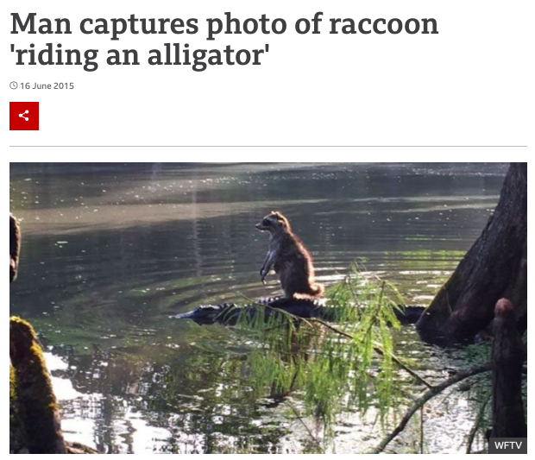
Source: https://www.bbc.com/news/world-us-canada-33143367

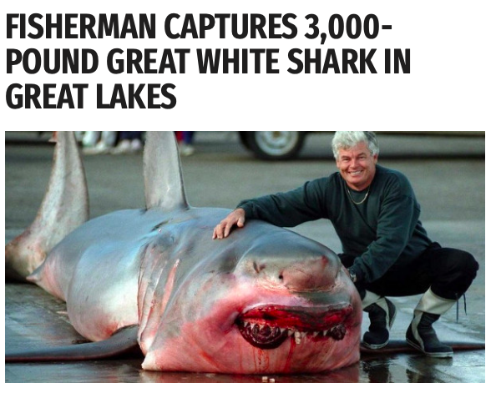
Source: https://worldnewsdailyreport.com/fisherman-captures-3000-pound-great-white-shark-in-great-lakes/

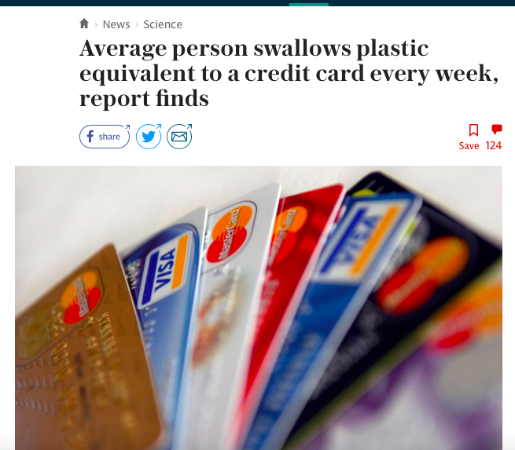

Source: https://www.telegraph.co.uk/science/2019/06/11/average-person-swallows-plastic-equivalent-credit-card-every/

Content input

How to evaluate news and recognize fake news

WHAT? | Students will play a game and learn how to evaluate news and recognize fake news on the internet. The game includes a “practice part” at first for students to try out what they already know, then input in between (3 short videos), then another practice part where student can apply the input from the videos. The game guides the students through the second practice part.
WHY? | To create a basic understanding on fake news and how to spot them. This will also prepare the learners for their final product/speaking evidence. Samples are real-life examples of news and fake news of online websites.
HOW? | Students will complete the game and watch the input via this link: https://newsliteracy.ca/fakeout/  Activity will most likely take one lesson  Students work alone, procedure is fairly self-explanatory  Videos in the game can also be re-watched on YouTube:  https://www.youtube.com/watch?v=NzhiKo2QlrU  https://www.youtube.com/watch?v=E1zgz2nBNQo  https://www.youtube.com/watch?v=UNxCmQolkZ0  Wrap-up task?

Exploring other resources on fake news

WHAT? | Students will be provided with a choiceboard on different materials on fake news.
WHY? | To deepen the understanding of what fake news are. This will also create the basis of information for the final speaking task.
HOW? | Students will be given a choiceboard and have to choose one website, images and video per row to explore. Students have to note down 6 pieces of advice from these sources (what you should do and what you shouldn’t do). These can be collected for the whole class as a common resource, e.g. in a Padlet.  Students could also create a meme out of this on https://imgflip.com/memegenerator

Activities

Reading & Speaking: Mary Glasgow Magazine

WHAT? | Students will read an article on conspiracy theories, summarize the main points and then answer the discussion questions in pairs.
WHY? | To practice reading; to get further input on the topic; to discuss about recent topics; to practice giving one’s own opinion
HOW? | At first, students will read the article “Conspiracy Theories” from the March 2021 issue pp. 4-5 https://www6.scholastic.co.uk/3dissue/mgm/2020-21/Issue4/Team/ on their own. Then, they should find out and summarize the main points of the text – these will be collected in plenary. Then, they should discuss the questions on the bottom of p.5. For the last question, students could do a discussion competition where they have to state and explain their own opinion – “Do you think conspiracy theories and fake news are fun or dangerous? Why?”

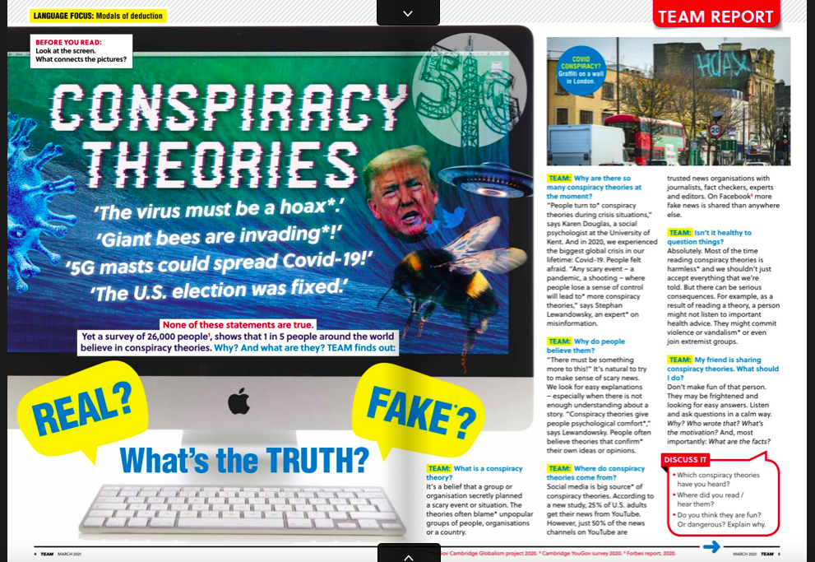

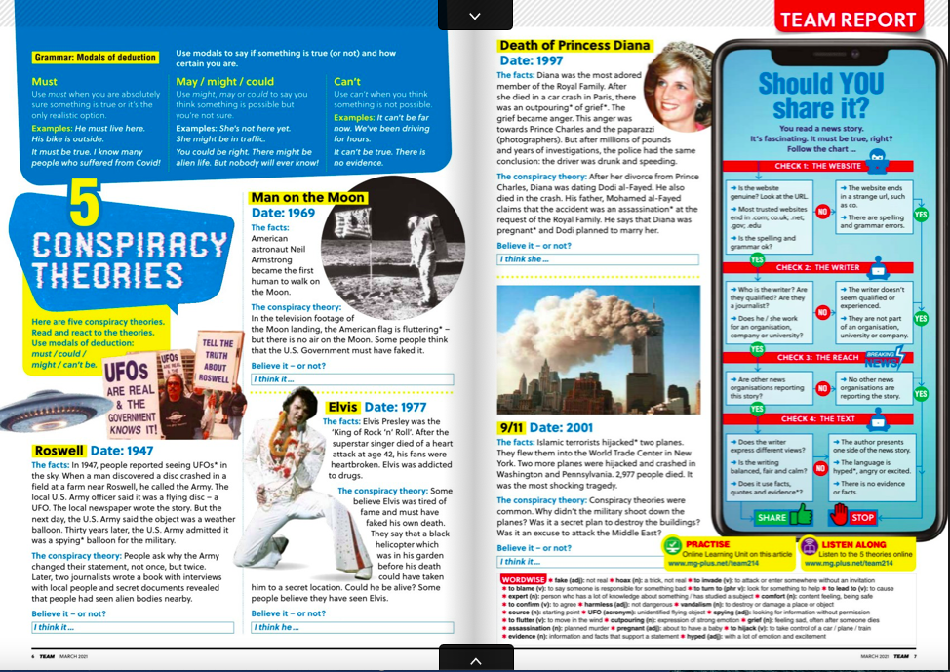

Listening & dictogloss

WHAT? | Students will listen to a news report and have to reconstruct the text.
WHY? | To practice listening for important content; to practice writing and using the past tense, which will help to prepare for final writing task; speaking and negotiating
HOW? | Students listen to a news recording at full speed. They have to note down the most important key words and then try to reconstruct the story as best as possible with a partner. The reconstructed texts will be presented to the others and then compared to the original recording.  Listening here: https://breakingnewsenglish.com  E.g. https://breakingnewsenglish.com/2102/210209-reptile-2l.html  https://breakingnewsenglish.com/2102/210213-online-lecture-2l.html

Rewriting news headlines and reports

WHAT? | Students will browse through news reports online and will rewrite these into fake news stories.
WHY? | Practice for final writing task; exposing students to models texts
HOW? | - At first, a few sample headlines will be provided to the students and rewritten together. Then, a short paragraph of a news report will be rewritten together with the whole class and ideas collected of what a good fake news story needs (e.g. catchy headline, still believable, a few key information altered, sensational words etc.)  - Students can choose from a pre-selected list of news reports, they rewrite the headline and a small paragraph.  - Ideally, this should be done in pairs or small groups, then they swap their stories with another group to peer-correct; they especially have to check whether the criteria identified earlier are met. If this activity is done on their own, they swap their stories with a partner to peer-correct,  Examples for news websites:  https://teachingkidsnews.com/category/news  https://maryglasgowplus.com/students/features  https://listenwise.com/current_events  https://breakingnewsenglish.com

Language focus: reporting

Activity in plenary: watching an Interview (e.g. with a celebrity, in present tense mostly?); giving examples of the statement in the interview and reporting what has been said in the interview; asking students what they notice; then students have to report what else they have heard in the interview

Haven’t found a proper video yet. Alternatively, they could come up with interview questions for a partner / for a teacher, interview him/her and then follow the procedure as presented above.

Could also be practiced then with worksheets, e.g. on https://www.liveworksheets.com

Reading comprehension & listening comprehension

Reading comprehension and listening comprehension task with MC/SG/True or False statements could be used as quick fillers during the sessions, e.g. from https://breakingnewsenglish.com. Can then also be paired with a short speaking activity where they have to give their opinion on the topic/discussion competition

Vocabulary work

Vocab cards? Walk and Talk?

OR writing down important and recurring words related to (fake) news and media, looking their meaning up in the dictionary, writing 2 own and true sentence with the new word.

Lernvideo?

End product & evidence

Writing evidence: Students can write a fake news story.

WHAT? | Students will write their own fake news story.
WHY? | To show that they can write about news and events of the past.  Uploading the products to Padlet for their peers to see and finding out which story is the most convincing will be likely to encourage the effort put into the assignment by the students.
HOW? | - Students will be given an impulse topic (e.g. a video). They will then have the choice whether they want to rewrite the story they have heard in the video OR whether they want to come up with their own fake news story. The goal is to make the fake news story as convincing as possible.  - Students will have time to think about what they want to write about at home, then they will also have time to work on the text in school.  - Students upload their text to Moodle to an assignment activity which will then be graded.  - Students can use one of these links to generate a “news article” of their text in pdf file:  https://www.fodey.com/generators/newspaper/snippet.asp  https://www.homemade-gifts-made-easy.com/newspaper-generator.html  - The students anonymously upload the pdf file to https://de.padlet.com/. Each of the students then has to like their top 3 most convincing fake news story to find out which is the most convincing one.

(Preliminary) Task design according to GRASPS framework

Goal: | The goal (within the scenario) is to create a fake news story that is as interesting and convincing as possible.
Role: | You are a reporter and you want your fake news story to be published in next week’s newspaper.
Audience: | The target audience are readers of a local newspaper.
Situation: | You need to write a convincing fake news story on an interesting topic.
Product/Performance and Purpose: | You need to write a convincing fake news story on an interesting topic that will then be published in the local newspaper.
Standards & Criteria for Success: | Your story needs to have fake elements in it but it has to be convincing. It needs to have a catchy title, an interesting topic for your peers and good language.

Assessment tbc

Speaking evidence: Students can give advice to a classmate on how to deal with fake news

WHAT? | Students will act out a dialogue. One student gives advice to a classmate on how to deal with a fake news / an issue on (fake) news.
WHY? | To show that they can give advice to others; to show that they have understood the input on how to deal with fake news
HOW? | - Students will have time to prepare and work on this task in class as well.  - Students work in pairs. They record two videos (e.g. via Zoom) and take turn so that each student takes the role as an advice giver and as an advice seeker once.  - They think of a situation for which Student B asks for advice. Student A gives advice and includes at least 3 pieces of advice that he/she elaborates. Talking time should be around 2 mins.  - Sentence starters or helping cards will be provided to the students if they need help.  - The video will be uploaded to Moodle for assessment.  Uneven number of students?

(Preliminary) Task design according to GRASPS framework

Student A: Advice giver

Goal: | The goal (within the scenario) is to give advice to a classmate on a (fake) news issue.
Role: | You are yourself.
Audience: | The target audience is a classmate of yours from class.
Situation: | You need to offer advice to a classmate who asked for your help.
Product/Performance and Purpose: | You need to film your conversation on video. You need to think about tips, ideas and advice that could help your classmate.
Standards & Criteria for Success: | Your video is around 2 mins long. You have given at least 3 good pieces of advice on (fake) news that fit the needs of your classmate’s situation. You have explained your tips in an understandable way. You have spoken freely without reading from a script.

Student B: Advice seeker

Goal: | The goal (within the scenario) is to give seek advice from a classmate in our class on (fake) news.
Role: | You are yourself.
Audience: | The target audience is a classmate of yours from class.
Situation: | You need to ask for advice.
Product/Performance and Purpose: | You need to film your conversation on video. You need to ask for advice; you need to tell your classmate what the issue is, what kind of advice you need and why.
Standards & Criteria for Success: | Your video is around 2 mins long. You have explained your situation, why you need advice and what you need advice on. You have explained your situation in an understandable way. You have spoken freely without reading from a script.

Assessment tbc

Further resources on news and fake news

Resources on fake news, what they are and how to spot them:

Videos:
https://ed.ted.com/lessons/how-to-choose-your-news-damon-brown
https://ed.ted.com/lessons/how-false-news-can-spread-noah-tavlin
https://www.youtube.com/watch?v=H3P73NqR7s0
https://www.commonsensemedia.org/blog/how-to-spot-fake-news-and-teach-kids-to-be-media-savvy
https://www.youtube.com/watch?v=icCdAl6TvNM

Websites:
https://www.factcheck.org/2016/11/how-to-spot-fake-news/
https://www.theglobeandmail.com/community/digital-lab/fake-news-quiz-how-to-spot/article33821986/
https://30secondes.org/en/module/what-is-fake-news/
https://www.teachingenglish.org.uk/sites/teacheng/files/Fake_news_student_worksheet.pdf

Images:
https://www.lib.sfu.ca/help/research-assistance/fake-news
https://www.commonsense.org/education/sites/default/files/tlr-asset/hs-legitposter_8.5x11.pdf

PowerPoint:
https://www.bbc.co.uk/teach/young-reporter/lesson-1-real-news-vs-fake-news/z899vwx/

Examples of real news:
https://teachingkidsnews.com/category/news
https://maryglasgowplus.com/students/features
https://listenwise.com/current_events
https://breakingnewsenglish.com – also listening!

“Breaking news” generator:
https://breakyourownnews.com

