Writing activity: Students can write a convincing fake new story

- Students will be given pictures as an impulse. They can choose whether they want to write a fake news story based on a picture or whether they want to choose their own topic.
- Students work on their own.
- Fake news story has to include the criteria from the checklist.
- Time: 1 hour max.
- Students upload their text to Moodle to the assignment activity which will then be graded.

- Optional: Students can use this link afterwards to generate a “news article” of their text in pdf file: https://www.homemade-gifts-made-easy.com/newspaper-generator.html. The students can anonymously upload the pdf file to Padlet and students can like their top 3 fake news story to find out which is the most convincing one.

Task design according to GRASPS framework

Goal: | The goal (within the scenario) is to make the readers believe your fake news story is true. You want a lot of people to read and share your story.
Role: | You are a reporter for a famous online news website.
Audience: | The target audience are the readers of a famous online news website.
Situation: | You want to write a fake news story for a famous news website. Design your fake news story so that it is both convincing and interesting for the readers to get a lot of clicks and shares.
Product/Performance and Purpose: | You need to write a convincing fake news story. You should write about a topic that is interesting and that makes the readers want to read and share the story. Include all the important criteria a fake news story should contain. Make sure you include good and correct language.
Standards & Criteria for Success: | your topic is interesting and makes the readers want to read the story  your story contains the necessary elements (headline, name of the author, date and place)  your text contains good and true information  your text contains fake information  you have used good language and vocabulary  your story is understandable

Input: (pictures from Pixabay)

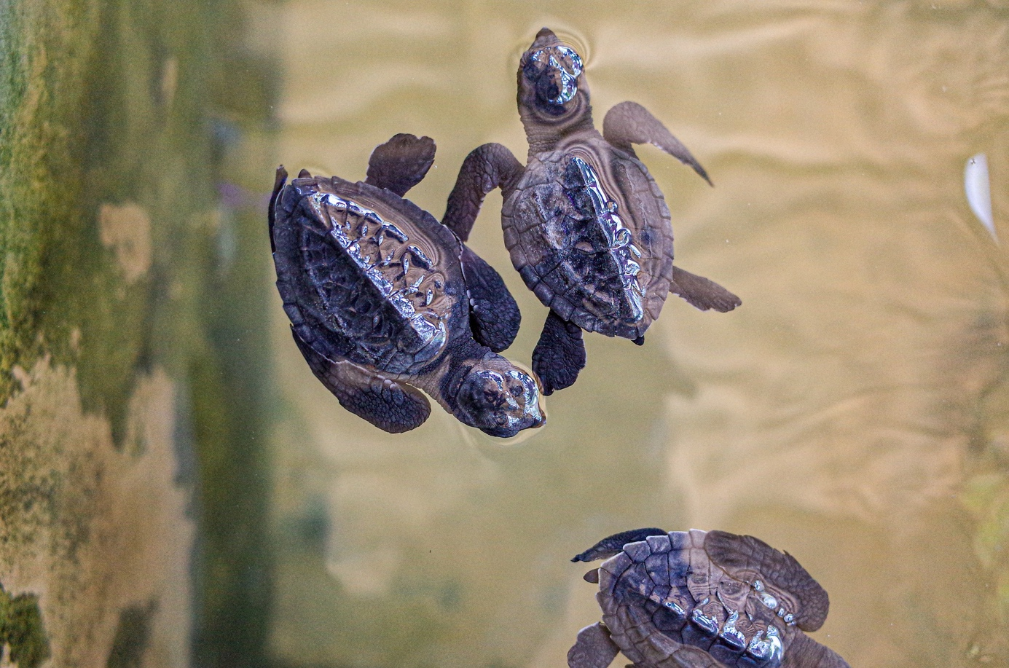

Expert: “The islands are famous for their turtles.”
Expert: “This is a special species of turtles that need to be protected.”

Input: (pictures from Pixabay)

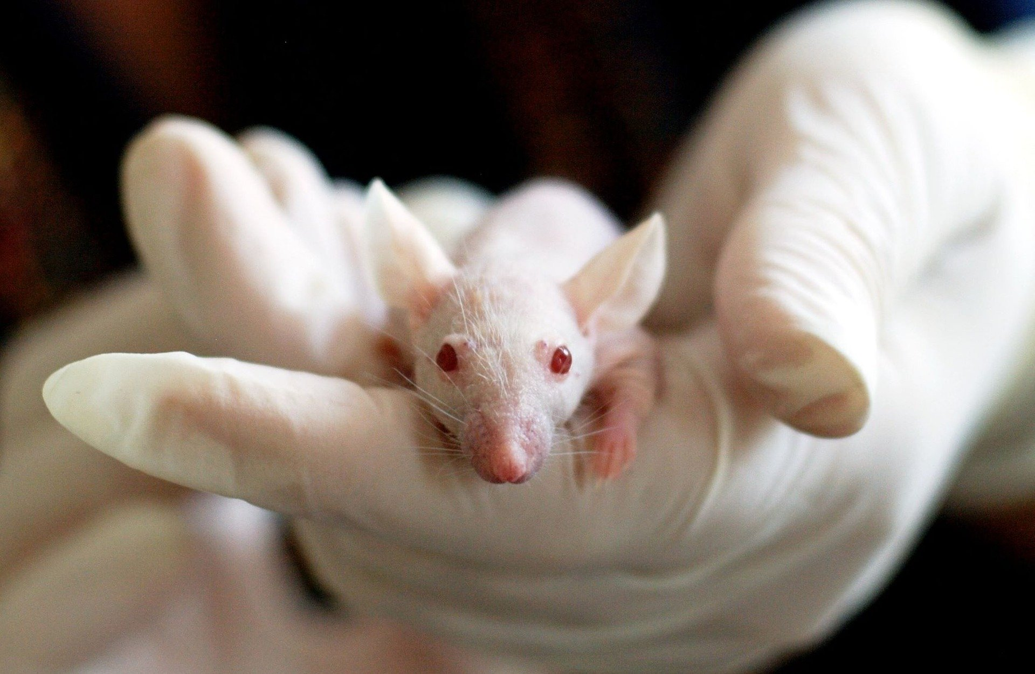

Scientists: “This mouse is unlike any other.”
Scientists: “It has a very special talent. It can do something that no other mouse can.”

