
I survived….

Choose a book:
Choose one of these riveting stories about kids who have survived life-threatening situations. Start reading…


Task 1: Finding dramatic moments
While reading your book, use a few sticky notes to mark the most dramatic scenes.

Task 2: Dramatic reading:
Step 1: Choose one of the dramatic scenes that you have marked in task 1. Your selection should be about 2-3 paragraphs long – not more than half a page.
Practice reading this selection in an interesting way. Use your voice to show the character’s feelings. Read slowly to show sadness or a heavy mood, read faster to show the character’s excitement.

Step 2: Meet with two classmates who are reading a different book. Read your chosen passages to your classmates.
Ask each other questions to find out more about these scenes and the story as a whole.



Task 3: A voice message from hell
Imagine you are the main character in your "I survived" book.
You are experiencing the scene that you have picked in the last task. You take out your phone and try to call your best friend. He/She does not pick up the phone and you leave a message.
In your message you
describe the scene in detail. Tell your friend what is happening around you. Use the present continous (is/are + -ing) to describe what is happening this very moment.
- give lots of details. Make it interesting and exciting to listen to.
- Tell your friend how you are feeling
- Say that you are going to call again, later.
- Record you voice message and upload it to ...............................................
Listen to a short example produced by a native speaker student.


Task 4: I am safe!
Imagine you are the main character in your "I survived" book. Luckily, you have survived and are now safe. You phone your friend again that evening. He/She is still not picking up, so you leave a second voice message.
Tell your friend what happened that day.
- Describe the scenes in a lot of detail. Tell your friend what was happening around you. Use the past continous (was/were + -ing) to describe what was happening at that time.
- Make it interesting and exciting to listen to.
- Tell your friend how you were feeling and how you are feeling now.
- Record you voice message on flip.com


Task 5: Blog writing

Imagine this:
You are the main character of your book. You have just barely survived this really dangerous and dramatic situation and you want to share this experience with the world.
You have found the blog "I survived" and feel that this is the right place to post your personal experiences.
Write a blog entry about the most dramatic moments that you have recently experienced. Tell your readers lots of details. Describe the scene -- make sure we can see it in front of our eyes. What was going on around you? What did you do? How did you feel about it?

After getting feedback from your teacher, revise your text carefully. Use your teacher's comments and tips to make your text perfect.
Then paste your text into SWAY and add a fitting picture. To do that just type in a keyword and use one of the free pictures that SWAY suggests.

Publishing your blog:
Have a look at our blog on SWAY: ……………………………………………………………………….

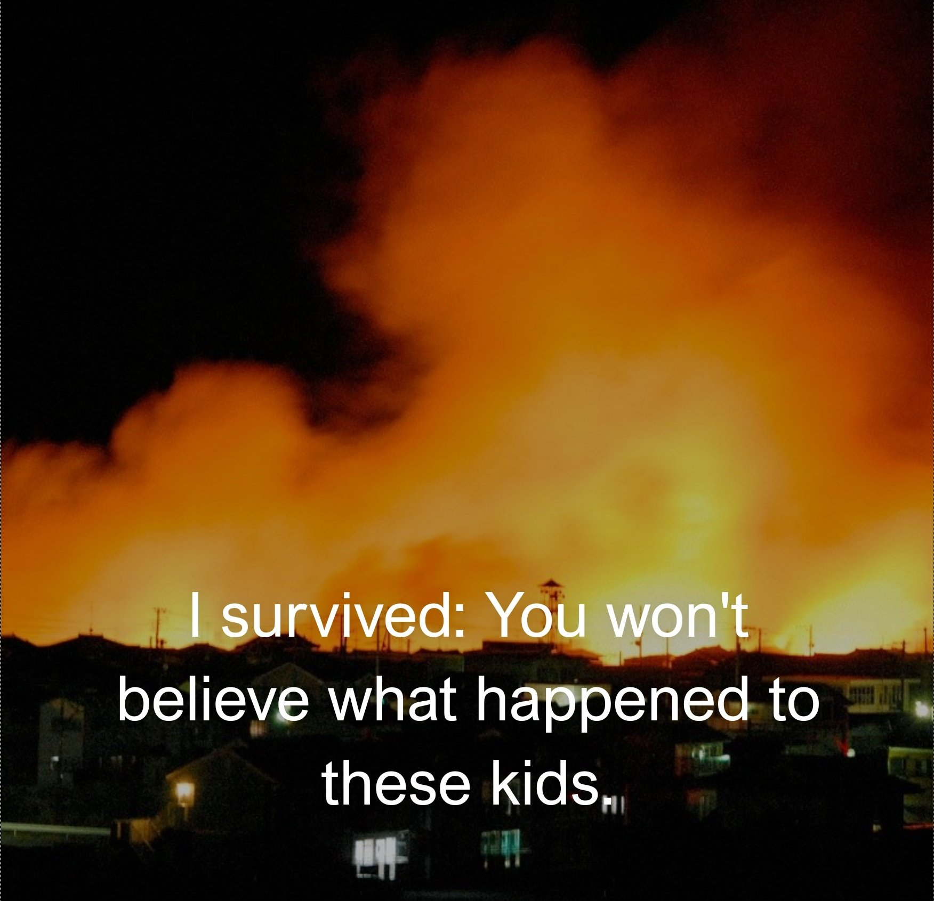

For the teacher
Tips for audio files
The audio files that your students create for tasks 3 and 4 can be stored on different platforms. Depending on your school’s IT environment you might use: Moodle, Google Classroom, Teams or Padlets. Make sure the students can listen to each other’s recordings. This will make the task a lot more interesting and the students will learn from each other.

Tips for creating a blog on SWAY
Here you will find an example of such a blog on SWAY. Unfortunately, all my SWAYs containing very nice student work were deleted when I left my school. I have rebuilt a sample SWAY for this project.


Follow the link to read the SWAY blog
https://sway.cloud.microsoft/EW7zvhDHqFTEDPtj?ref=Link

How to set up your own SWAY
Go to the Microsoft SWAY app by using your Microsoft account.
Create a SWAY and add a title and an example text and picture to get it started and show the learners what you expect them to do.
Share the SWAY with your students and tell them to work on one block only. Their block consists of a heading card (with a picture) and a text card. To organize this very efficiently, I usually create such an empty block (Heading and Textfield) for each of the students in the class. I write their names into the heading boxes. That way every student can quickly find their space and start working. You can change the order of the entries later.
Warning: You’ll need to share two different links to the SWAY
- the viewing link (it says …”play” at the end)
- and the editing link
You can create these links by opening the SHARE menu: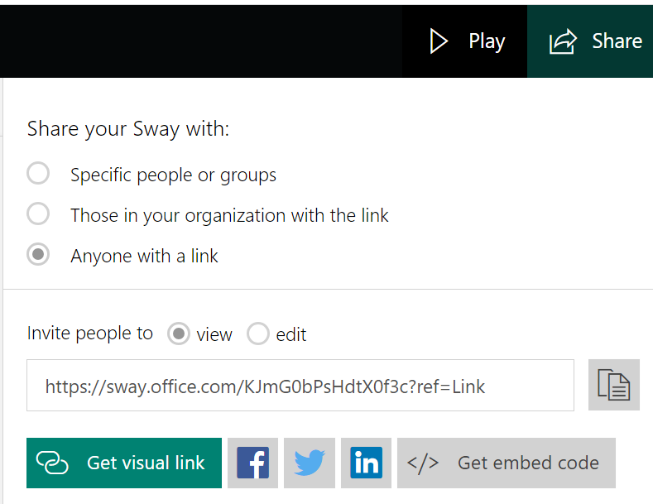
That’s it – you are ready to go.
All pictures: pixabay and creative commons on bing

