I survived / Nightmare Club
Your name:

While you are reading the book
Task 1: Character silhouette
What do you know about the main character of your book? Fill the character’s head with all the details that you know about him/her. Keep adding details while you are reading and add the book pages where you found the details.
Ideas: Name, age, appearance (what does the person look like), family, friends, hobbies, likes, dislikes, fears, things that are important for this character …
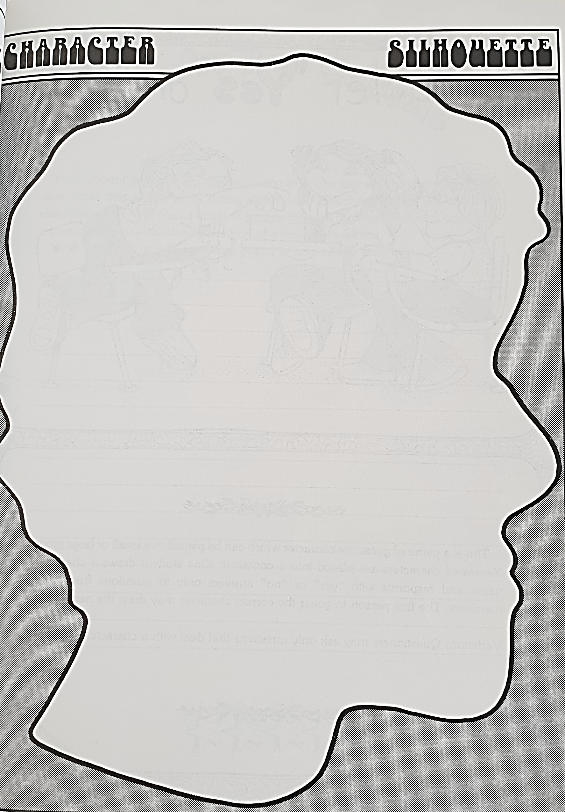
image from: Janice Szabos, Reading- A Novel Approach, Good Apple, Inc. Carthage, IL, p. 49
Task 2: Flapbook
Find an exciting scene in your book and use a flapbook to describe it in detail.

Write 5-6 sentences that describe the setting and atmosphere and 5-6 sentences showing what happens in the story.
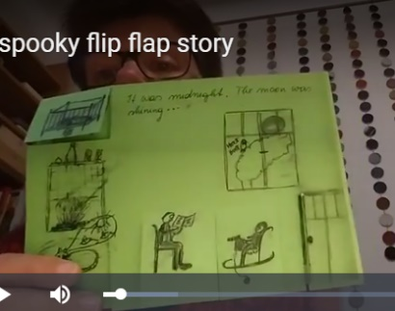
Ask your teacher to check your sentences. Then make a nice Flapbook that you can present when you present the book.

Use this page to make a cheat sheet

The situation / the setting | What happened then?
Form: was / were + ….-ing | Form: past simple (e.g. went, had, …)
Task 3: Cool new words and phrases
While you are reading the book, collect at least 5 cool words or phrases that you would like to remember.
Step 1: find an interesting word in your story. Look at the pictures on the page and try to guess the word’s meaning.
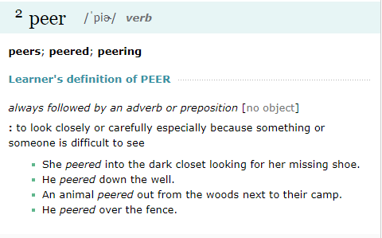
Example: 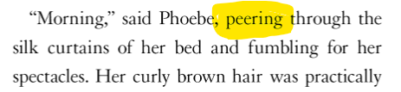
Step 2: Now check if you were right. Look the word up in the Merriam-Webster Learner’s Dictionary online: www.learnersdictionary.com.
Look at the examples there and listen to the word. If you need help understanding the word, ask your teacher.
Step 3: Write your favorite example sentence for the new word on this page. Show your page to your teacher.
Step 4: Then copy the checked phrases on blank vocabulary cards and practice them with your other vocabulary.
Cool phases from your book | Page number
Sentence in the book:

Example sentence:

Sentence in the book:

Example sentence:

Sentence in the book:

Example sentence:

Sentence in the book:

Example sentence:

Sentence in the book:

Example sentence:

Task 4: Solve a Problem
Be proactive: Learning to solve problems is an important skill. If you can solve the book characters’ problems, you can also solve your own problems in life.
What was the main problem in your story?

How was the problem solved in the story?

What other ideas would you have for solving this problem?


Task 5: What if…
These stories are full of dangerous things that happen to the main character. What if some of these happened to you?
Think of ONE situation in the story and see how it would affect YOUR life.
Example: What if you were on a ship that was sinking?
If I was on a ship that was sinking, I would try to call for help on my phone.
If I lived near a volcano that erupted, I would not go back to my house but try to find my family and get away as quickly as possible by car or even by bike.
Now it’s your turn:
If you could change the story, what would you change?

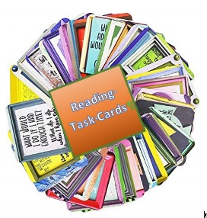
Task 6: Choose a Task from the Reading task cards folder

Task 7: A novel Museum
Have you ever been to a museum? How do they present artefacts (things) there?
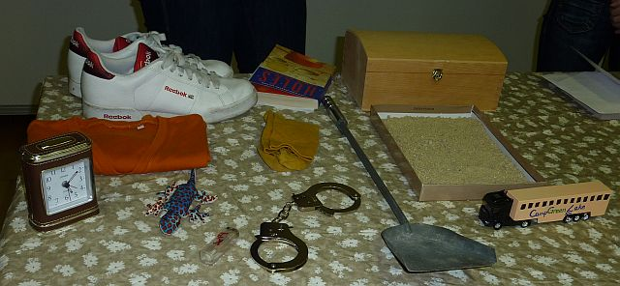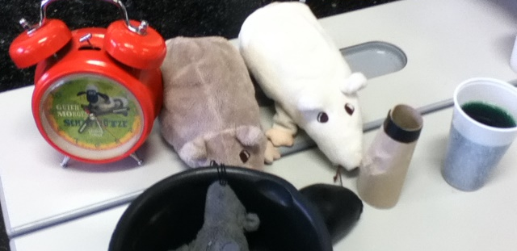
Let’s do the same for some important artefacts from our stories.
Each book group will present a collection of important artefacts from the story on a table.
What could you bring? Think of objects that play a role in your book, photos, drawings, written notes, diary pages…
Make a list of all the things you and your partner will bring for the museum
- My flapbook (so that I can present one exciting scene)

Date of the museum display shows: ……………………………..

On this day you will present your book museum and you will have a chance to visit all the other displays and find out more about the other books in this project.
For your museum visits, use the sheet on the next page.
Task 8: Finding out about the other stories
Talk to your classmates and find out more about the stories so you can decide which book to read next.
Rules of the activity:
Talk to 1 person at a time. No groups!
Speak only English

