Key page 40 / ex 2

- The Tower of Londo
- Camden Town
- Tate Modern
- Big Ben (Queen Elisabeth Tower)
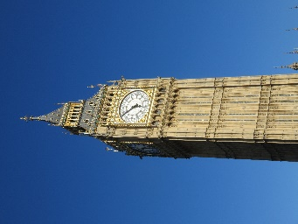
- The Making of Harry Potter
- Westminster Abbey

Exercise 2c
2. 17 royal weddings
3. six
4. 5 million people

