Dear David,

My name is Chris and I’m your exchange partner. I’ll come to visit you in June and you’ll come to my place in September.
Let me tell you a bit about me and my family. My family that’s me, my mother and my two sisters, Mary and Angie. They are twins and they are 9 years old.
We live in Brighton in a small house with a garden. We also have two cats. The cats live in the garden and cellar but they mustn’t come into the house because Angie is allergic to them. However, I love them and they are my cats, so I have to feed them every day before school and I have to empty the cat toilet.
Rules in my family are not very strict. I have to come home straight after school and I have to ask my mother if I want to visit a friend or go out. I mustn’t hang out at the pier alone because it can be dangerous. (That’s Brighton Pier on the foto – there’s a fun park on the pier!)
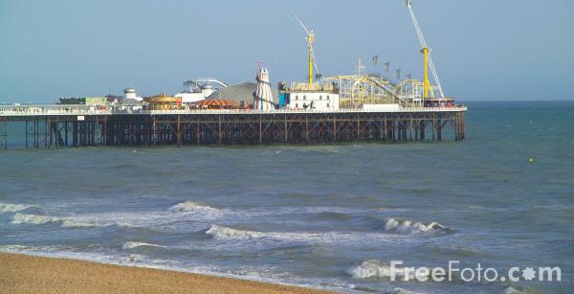
We all have to be at home for dinner, that’s very important to my mum. And we mustn’t eat sweets before dinner – she always finds out!
I like sports a lot. I like surfing and diving in the sea. I also like skateboarding – we’ve got a big skate park next to our school. You must wear a helmet but you can even use it during the lunch break.
I also love reading – you’ll find lots of books in my room – and playing computer games. I have to turn off my computer at 9 pm but I can play after lunch if I have finished my homework.
I don’t like playing with my sisters – they always want to play boring games – but I like playing tricks on them .
What about you and your family? What do you like doing? Is your family very strict?
Write back soon,
Chris

Answer Chris’ email.
Tell him
- About your family
- About the rules in your family (what you have to do/mustn’t do)
- About your hobbies (what you like doing and what you don’t like doing)
Write about 100 words.

Nutcracker
You exchange partner asked you about your school. Write to Chris (your exchange partner) and tell him
- Where you go to school
- About the rules in your school
- What you like doing and what you don’t like doing)
Write about 100 words.

