Everything’s different now – relative pronouns GR-2-p16

A lot of things have changed in Corona times. Many things are more difficult, but some things are quite nice. This is what students and teachers have said:
The subject that is most difficult right now is ………………………..
The thing that I like most about home-schooling, is sleeping in in the morning.

The video conferences that our teachers organize for us are very helpful.
The thing that I like least about home-schooling, is that I cannot see my friends.

The program that we use for our video meetings is called Zoom.
The thing that I miss most during the Corona crisis is………………………………….

The children who do not have a computer at home can borrow a tablet from school.
The students who work hard even during the crisis, will get really good grades at the end of the year.

The person who worries most about Corona is ……………………….. because…………

The people who have to work most during this crisis are doctors, nurses and people who work in supermarkets.

Challenge: Find the rule
We use who, when we talk about _______________________
We use that when we talk about _______________________

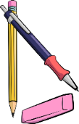
Your Turn:
Write true and meaningful sentences about yourself, your family and your friends.
Use WHO (5x) and THAT (5x)
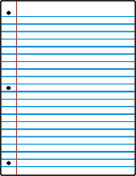

New rules – modal verbs GR-2-p17
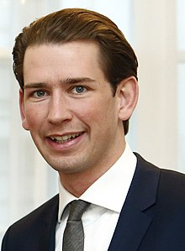
A lot of things have changed because of Covid-19.
We must try to stop the virus because it is very dangerous. So people should stay at home as much as possible. You are not allowed to leave you house unless you have to work or need to go shopping. If you go shopping, you have to wear a mask. It doesn’t have to be a clinical mask, you can make one yourself. You don’t have to wear gloves, but it is a good idea.
You are allowed to go for a walk but you are not allowed to go to a playground.
You must keep your distance from people who do not live in your house and you mustn’t invite people to visit you. I know that this is hard. I had to spend Easter without my parents, too and if someone of my staff gets ill, I will have to stay in quarantine in the ministry.
You can come to school, but you shouldn’t. You have to take part in the online lessons.
I hope we will soon be able to go back to our normal lives and you will be allowed to meet your friends.

Challenge: Find the correct meaning
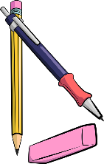
Read Kurz’s statement and find out what the words in bold mean. Write them into the correct box.
wir müssen (weil wir das wollen):  ___________________________ | du darfst nicht (2x)  __________________________  __________________________ | Leute sollen:  _________________________
du musst (weil es ein Gesetz ist):  __________________________ | du musst nicht (es ist kein Gesetz)  __________________________ | du solltest nicht:  __________________________
es muss nicht ...sein  __________________________ | ich musste:  ___________________________ | du kannst / du darfst:  __________________________
du musst/es ist notwendig, dass du:  _________________________ | ich werde ... müssen:  _________________________ | du wirst dürfen:  __________________________

Your turn:
Use these words to write sentences about the rules at home and in school.
Write 10 sentences – use a different verb in each sentence.
(I always have to …/ I don’t have… / Last week I had to… to count as three different verbs)

If things had been normal GR-2-p18

In March 2020 schools closed due to the Corona crisis. During the Easter break visits to friends and family were not allowed, all hotels were closed, and you could not go to another country. All shops – except for food stores – were closed as well.
When the teachers meet after Easter, they talk about their holidays. Guess who is talking and write the names next to speech bubble.
I spent the holidays with my kids and my husband. If there had not been a Corona outbreak, the whole family would have met in the garden for a huge Easter celebration.

I spent the holidays with my wife and my daughter’s family. It was my granddaughter’s first Easter. If we had not had a Corona crisis, I would have gone to Italy in my camper.

I spent the holidays at home with my husband. It was not a lot of fun because there was a building site next to our house. If we had been allowed to travel, I would have flown to Greece.

I spent the holidays with my husband and my son Jakob. We stayed in our flat all the time. If we had not been afraid to get ill, we would have gone to the playground with Jakob!

My rule:
Look at the words in bold letters. If you talk about how things in the past
could have been different (but you cannot change them any more) you use:
If I _had + __________________, I would + _________+___________

Your turn:
What would you have done in the Easter holidays if there had not been a Corona outbreak?
What would your friends and family have done?
Write 5 sentences.

If they had given up easily, they wouldn’t be as famous today. GR-2-p19
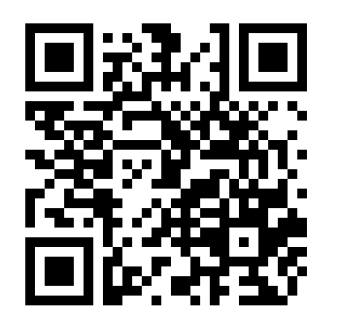
Who are these famous people who all failed miserably, but did not give up?
Match the life stories with the names.
Steve Jobs, Steven Spielberg, The tower of Pisa, Henry Ford, Thomas Edison, The Beatles, Walt Disney, Bill Gates, Michael Jordan, J K Rowling, Albert Einstein, Charly Chaplin
Then watch the video and check your answers. Be careful. Not all examples in the video have been used.
If he had given up after being fired from his basketball team, he would not have become the most famous basketball player of all times.
If they had stopped playing music with their band after several record labels told them that guitar music was not cool, they would not have become the most famous band of all times.
If he had given up drawing cartoons because nobody wanted to hire him as an artist, he would not have created the most famous cartoon figure in the world.
If he had given up his dream of building computers after dropping out of university, he would not have become one of the richest men on Earth.
If she had stopped writing because several publishers rejected (=did not want) her first book, she would not have become one of the most famous authors of children’s books and the second-richest female entertainer.
If he had listened to his teachers who told him that he “would never amount to much”, he would not have won the Nobel prize in physics.
If he had given up after being fired from three computer companies, he would not have become one of the richest men and the owner of one of the most famous industrial designers in the world.
If he had given up his dream after going bankrupt five times, he would not have become one of the most successful car producers of the USA.
If he had given up when his teachers told him that he was “too stupid to learn anything”, he would not have invented the light bulb.
If he had listened to the Hollywood studio chiefs, who said that his acts were too stupid and nonsensical, he would not have become one of the most famous English comic actors of all times.
If he had given up after being rejected from film-school, he would not have become one of the most famous film directors of our times.
If this tower wasn’t leaning to the side, it would certainly not be as famous.
https://www.youtube.com/watch?v=5cZh6tYVM2w

