New rules – modal verbs GR-2-p17

A lot of things have changed because of Covid-19.
We must try to stop the virus because it is very dangerous. So people should stay at home as much as possible. You are not allowed to leave you house unless you have to work or need to go shopping. If you go shopping, you have to wear a mask. It doesn’t have to be a clinical mask, you can make one yourself. You don’t have to wear gloves, but it is a good idea.
You are allowed to go for a walk but you are not allowed to go to a playground.
You must keep your distance from people who do not live in your house and you mustn’t invite people to visit you. I know that this is hard. I had to spend Easter without my parents, too and if someone of my staff gets ill, I will have to stay in quarantine in the ministry.
You can come to school, but you shouldn’t. You have to take part in the online lessons.
I hope we will soon be able to go back to our normal lives and you will be allowed to meet your friends.

Challenge: Find the correct meaning
Read Kurz’s statement and find out what the words in bold mean. Write them into the correct box.
wir müssen (weil wir das wollen):  ___________________________ | du darfst nicht (2x)  __________________________  __________________________ | Leute sollen:  _________________________
du musst (weil es ein Gesetz ist):  __________________________ | du musst nicht (es ist kein Gesetz)  __________________________ | du solltest nicht:  __________________________
es muss nicht ...sein  __________________________ | ich musste:  ___________________________ | du kannst / du darfst:  __________________________
du musst/es ist notwendig, dass du:  _________________________ | ich werde ... müssen:  _________________________ | du wirst dürfen:  __________________________
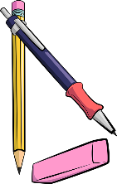
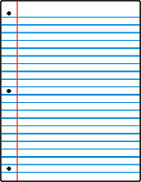
Your turn:
Use these words to write sentences about the rules at home and in school.
Write 10 sentences – use a different verb in each sentence.
(I always have to …/ I don’t have… / Last week I had to… to count as three different verbs)

