Step 1:
Go to https://maryglasgowplus.com/customer/login
Create an account with your school email address. Your student code is ruler30

Step 2.
Go to the Language Lab section: 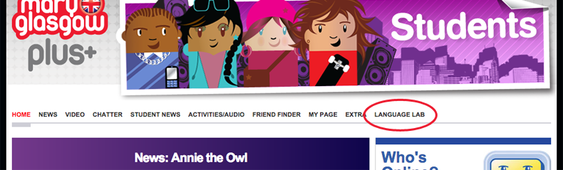
Step 3.
And join the class: 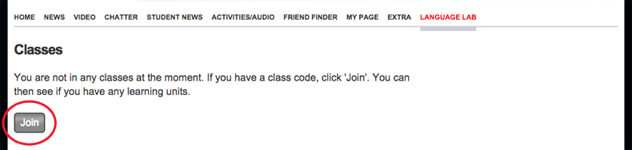
Step 5.
Enter the class code, and your real name.
Our code is: gvb723

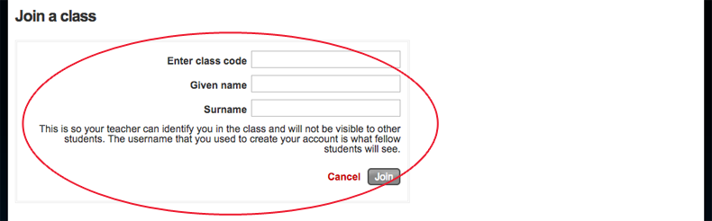
Start working….

