- Write the descriptions under the pictures
messy | lazy | clumsy | shy | cheerful | grumpy | absent-minded | loud | rude | hardworking | touchy | selfish | talkative | friendly | easy-going | quiet
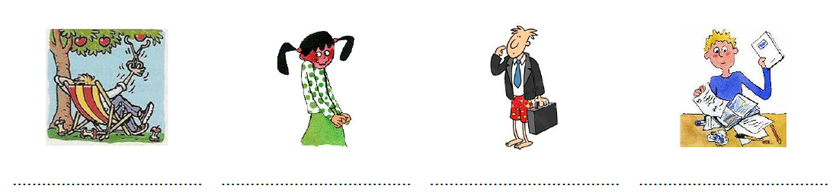
lazy shy absent-minded messy
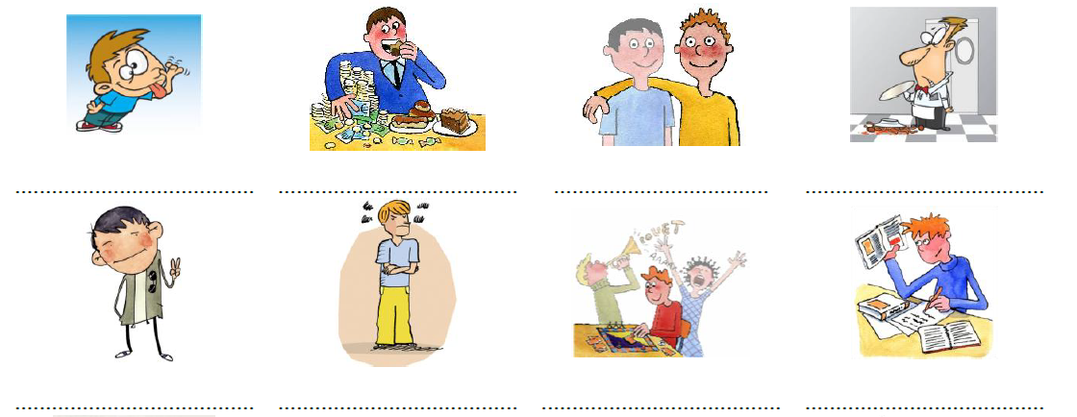
easy-going grumpy quiet / loud hard-working
rude selfish friendly clumsy
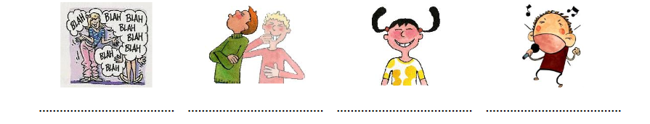
talkative touchy cheerful loud

2. Find and write the opposites (use both posters!) 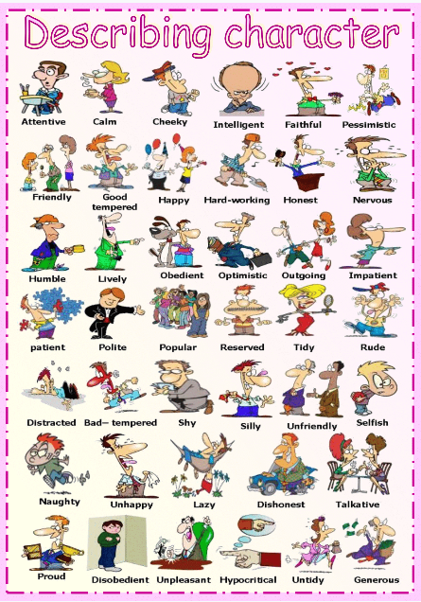 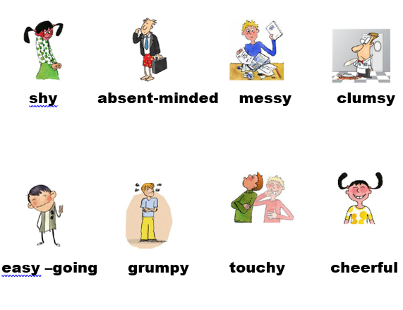
(if you need help, do the online exercise – moodle / Focus on Form – Worksheet opposites -first
lazy ≠ hard-working
generous ≠ selfish
tidy ≠ untidy
polite ≠ impolite
quiet ≠ loud
honest ≠ dishonest
optimistic ≠ pessimistic
naughty ≠ good/nice/attentive
proud ≠ humble

3. Use adjectives from both posters to fill in the gaps
1. Julia is constantly chatting on the phone. She's so___________talkative____________
2. It’s 12 o’clock and you are still in bed! Come on! Get up! You _____lazy_______________boy.
3. Don't forget your laptop! You're so ______absent-minded / forgetful_____________________.
4. Don't just think of yourself, that's so____selfish____________________________.
5. I love our new classmate Debbie! She makes friends very easily, she's very____easy-going/friendly______.
6. Mike is very nice but he doesn't speak much, he's rather____shy_________________.
7. She bought the tickets for everybody. She’s very _____generous_______________________.
8. He can’t speak to girls, he’s really _______shy_____________________________.
9. He never does what the teachers tell him to do. He’s a ____naughty____________________ student!
10. She never says please or thank you. She’s ____rude________________ to everybody.

