Describing people
- Write the descriptions under the pictures
messy | lazy | clumsy | shy | cheerful | grumpy | absent-minded | loud | rude | hardworking | touchy | selfish | talkative | friendly | easy-going | quiet
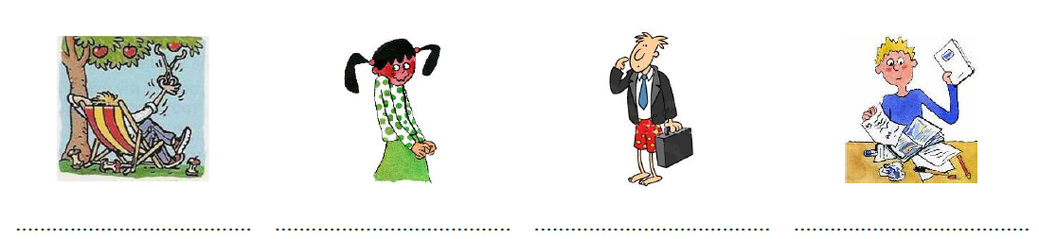
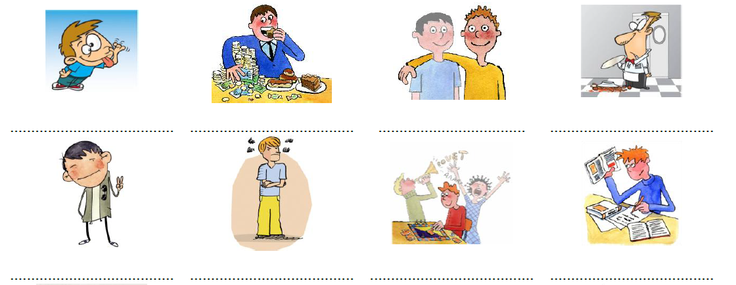
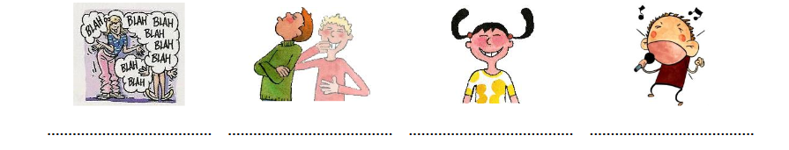

2. Find and write the opposites (use both posters!) 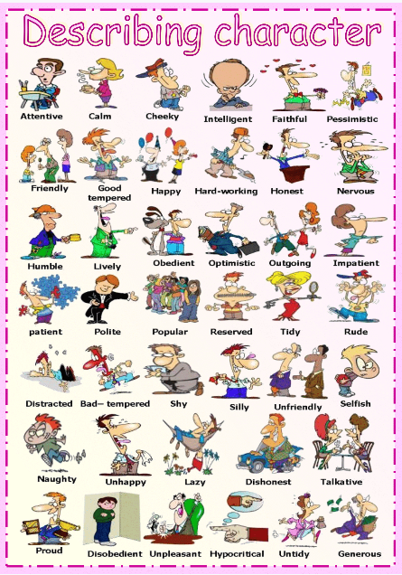 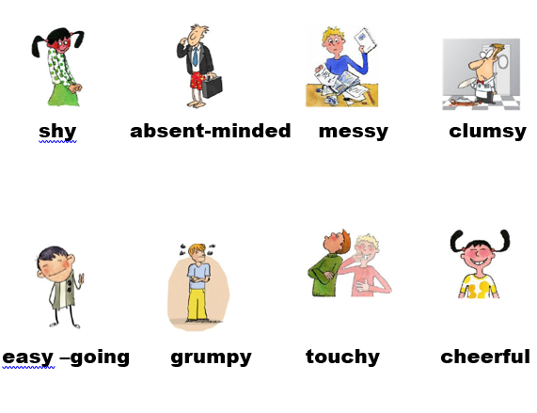
(if you need help, do the online exercise – moodle / Focus on Form – Worksheet opposites -first
lazy ≠
generous ≠
tidy ≠
polite ≠
quiet ≠
honest ≠
optimistic ≠
naughty ≠
proud ≠

3. Use adjectives from both posters to fill in the gaps
1. Julia is constantly chatting on the phone. She's so_______________________
2. It’s 12 o’clock and you are still in bed! Come on! Get up! You ____________________boy.
3. Don't forget your laptop! You're so ___________________________.
4. Don't just think of yourself, that's so________________________________.
5. I love our new classmate Debbie! She makes friends very easily, she's very________________________.
6. Mike is very nice but he doesn't speak much, he's rather_____________________.
7. She bought the tickets for everybody. She’s very ____________________________.
8. He can’t speak to girls, he’s really ____________________________________.
9. He never does what the teachers tell him to do. He’s a ________________________ student!
10. She never says please or thank you. She’s ____________________ to everybody.

4. Choose 5 friends in the class and write sentences such as:
Tom is extremely talkative. If you start to talk with him, he will never stop.

5. What are you like? Complete the sentences. Do not show this to your classmates!
I am extremely____________________
I am very____________________
I am quite ____________________
I am a little ____________________
I am not very ____________________
I am not____________________at all.

6. Fill in the gaps to describe the classmate next to you.
Use extremely | very | quite | a little | not very | not…at all .
Then swap your worksheets. Read your partner’s description of yourself and tick the box and say whether the description is true or false

I think you are _________________________absent-minded. TRUE FALSE
I think you are _________________________outgoing. TRUE FALSE
I think you are _________________________shy. TRUE FALSE
I think you are _________________________polite. TRUE FALSE
I think you are _________________________tidy. TRUE FALSE
I think you are _________________________proud . TRUE FALSE
I think you are _________________________talkative. TRUE FALSE
I think you are _________________________patient. TRUE FALSE
I think you are _________________________generous. TRUE FALSE
I think you are _________________________hard-working. TRUE FALSE
TRUE = 1 point My score: ________/ 10P

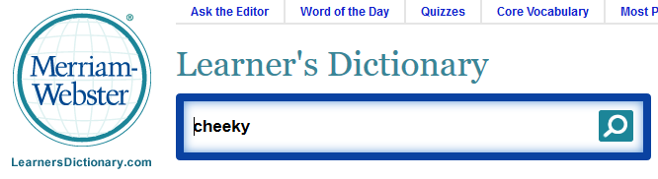
7. In pairs, explain 5 of the words that you want to remember and use in the future.
Use an online dictionary (link on moodle)

A cheeky person is someone who says funny things when a teacher tells him / her to do something.  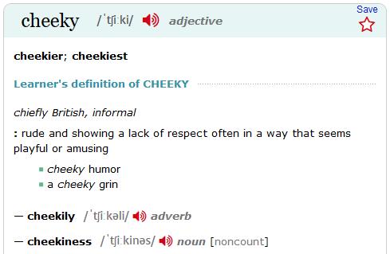  It is naughty, but in a funny way. | A _____________ person is someone who ... | A _______________ person is someone who ...
A _____________ person is someone w _ _ ... | A ________________ person is someone _ _ _ ... | A _______________ person is someone _ _ _ ...

8. Writing (~ 120 words): Write description of yourself / Use at least 5 new words
  - What are you like?
- Give examples of what you do, to explain your definition
e.g. I’m a lazy person. I don’t like doing my homework, so I often just lie in bed in the afternoon and watch TV. If I have to study, I get tired really quickly and take a lot of breaks.
- What is your best character trait?
- What would you like to change about your character?
If you need practice before you write this, you find example texts in the stretch your memory 1 section online

