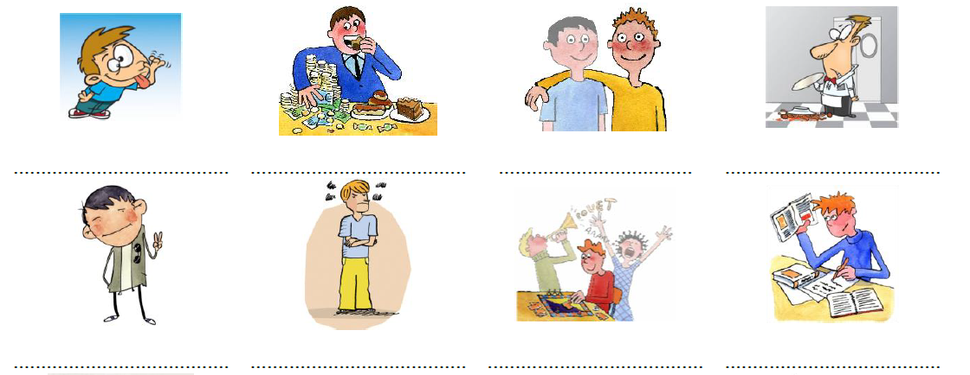
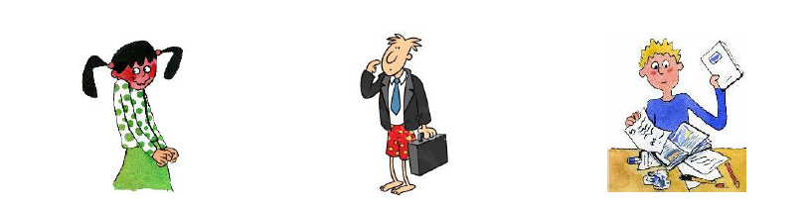
shy absent-minded messy clumsy

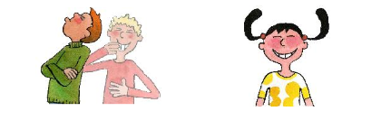
easy –going grumpy touchy cheerful

shy absent-minded messy clumsy

easy –going grumpy touchy cheerful

