Personality Adjectives
I’M NOT NOSY AT ALL .
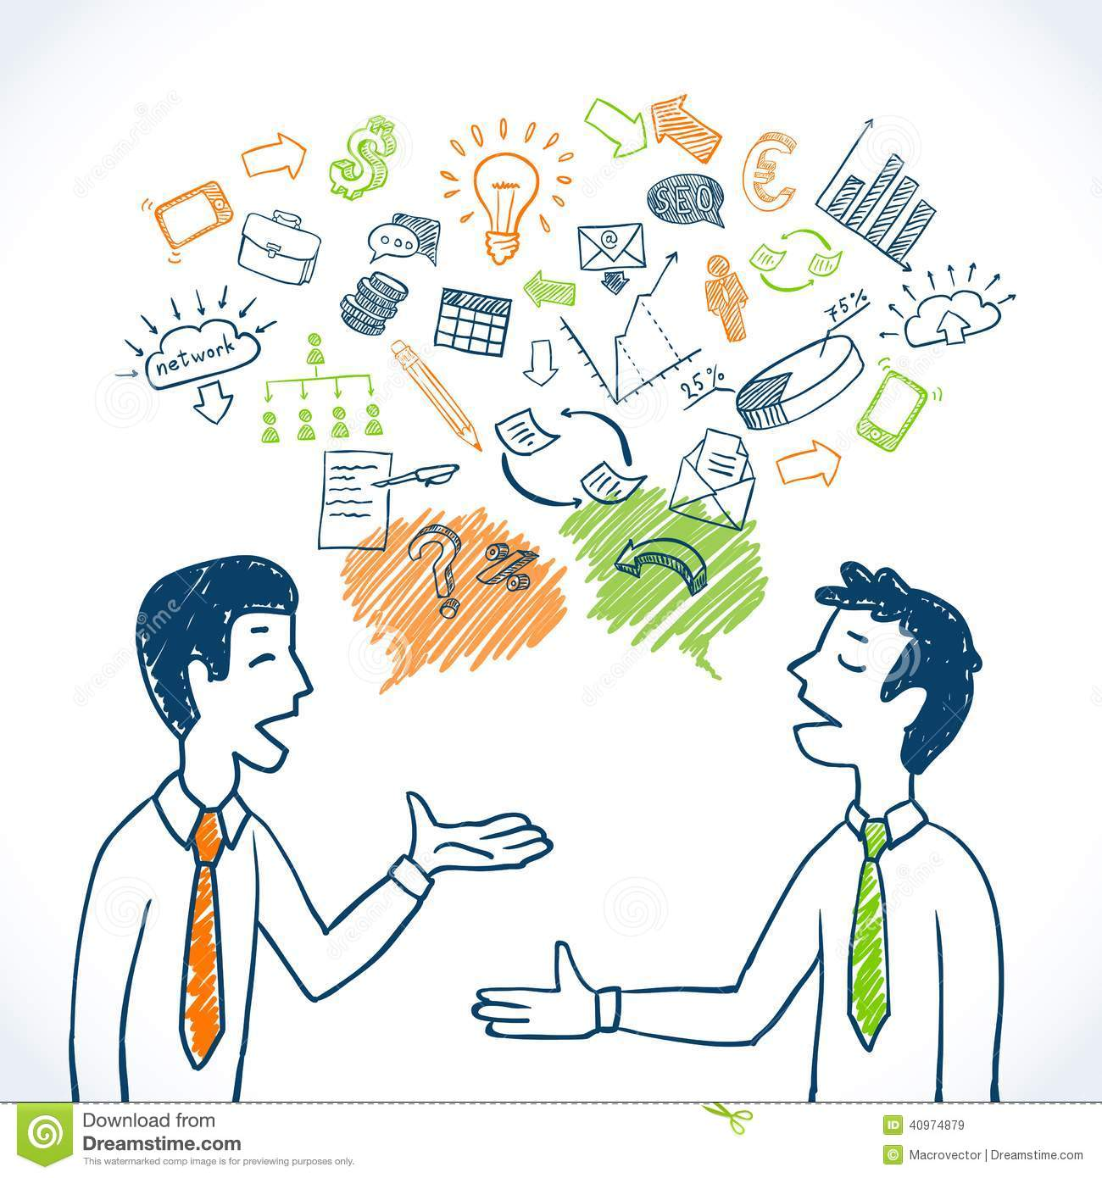
NOT AT ALL A BIT QUITE RATHER VERY EXTREMELY
WHAT ARE YOU LIKE?

I’M QUITE SHY.

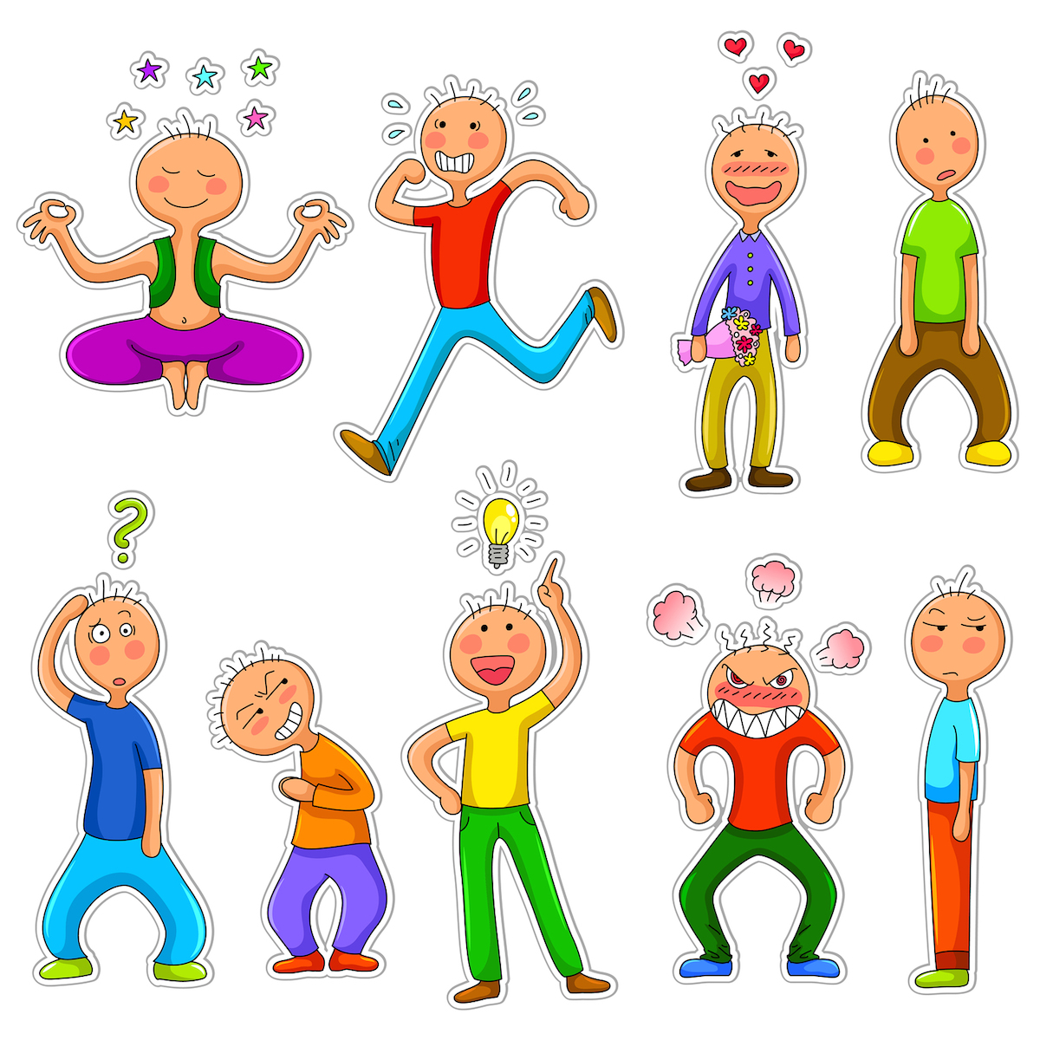  CALM /EASY GOING/ RELAXED |   SERIOUS | 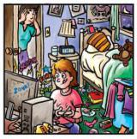  DISORGANISED/ UNTIDY/ MESSY |   BOSSY
  CONFIDENT / BRAVE/ ADVENTUROUS | 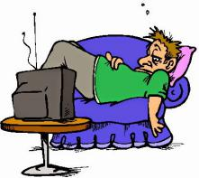  LAZY | 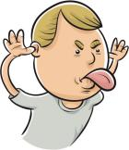  RUDE / IMPOLITE/ BAD MANNERED | 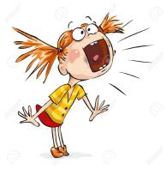  NOISY
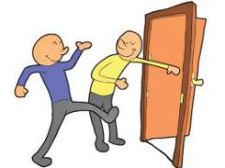  POLITE /  WELL MANNERED | 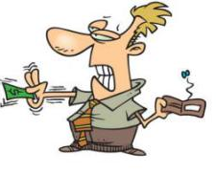  STINGY / MEAN /SELFISH | CLEVER/ SMART/ INTELLIGENT / WISE | 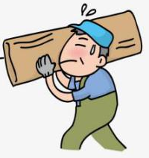  HARDWORKING
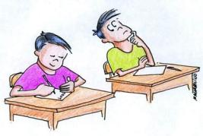  DISHONEST | SPORTY/ ACTIVE/LIVELY | 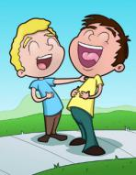  FUNNY | 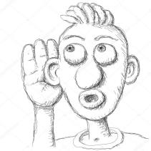  NOSY
  BORING | 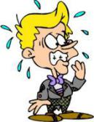  NERVOUS | 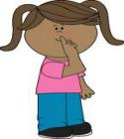  QUIET | IMPATIENT/  BAD TEMPERED
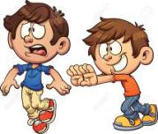  MEAN/CRUEL | 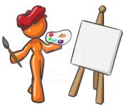  CREATIVE/ ARTISTIC | 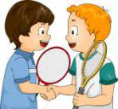  NICE/ FRIENDLY |   HONEST/ TRUSTWORTHYY
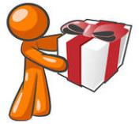  GENEROUS | SILLY / FOOLISH/ DAFT | 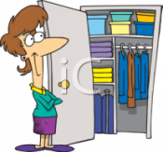  ORGANZED/ TIDY | 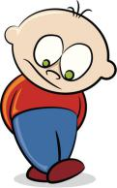  SHY/ TIMID/  CAUTIOUS
CAN YOU THINK OF ANY MORE ADJECTIVES TO DESCRIBE SOMEONE’S PERSONALITY?

isl-collective: https://en.islcollective.com/download/english-esl-worksheets/grammar/adjectives-opposites/personality-adjectives-first-day-activity/109738

Personality Adjectives
Write the opposites:

- confident _______________
- lazy _______________
- polite _______________
- cruel _______________
- tidy _______________
- silly _______________
- quiet _______________
- nervous _______________
- honest _______________
- selfish _______________
Getting to Know You

What are you like?
__________________________________________________________________________

What do you like doing in your free time?
___________________________________________________________________________

What are you good at?
__________________________________________________________________________

What are you bad at?
___________________________________________________________________________

What are you frightened of?
___________________________________________________________________________

What can you do better this year?
___________________________________________________________________________

What’s your favourite class at school? Why?
___________________________________________________________________________

What type of music are you into? Why?
___________________________________________________________________________

Which famous person do you like? Why?
___________________________________________________________________________

What do you like and dislike about autumn?
___________________________________________________________________________

What are you really looking forward to this year?
___________________________________________________________________________

What do you hope to do this year?
___________________________________________________________________________

