Somebody is watching you…

Peter and the spider

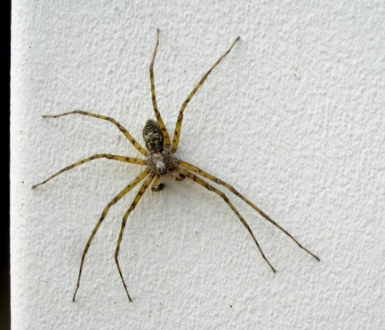
Peter is in 5th grade. He is eleven years old and has just arrived at school. It is 7.30 and lots of children are running around in the hallways. A big spider is watching the kids from its nest on top of the blackboard.
Peter enters his classroom and quickly goes to his desk. He takes out his math books and his pencil case and puts them carefully on his desk. Suddenly another boy runs into the classroom. He is shouting loudly, and he pushes Peter into the corner aggressively. Peter’s math books fall to the floor. Peter seems to know this boy, it’s not the first time that he is behaving like this. Peter picks up his books quietly and just walks away from the boy.
That’s when the teacher comes in. ..

Now it’s your turn:
An interesting lesson in your class
Imagine an interesting lesson in your class. The big spider is still sitting on the wall near the blackboard. It is watching you. What does it see? What is going on in the classroom? How do you and your classmates behave? Write about 100 words.
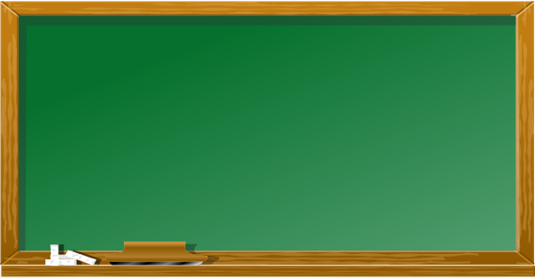
Physics
…
English
German
Arts
Biology
Maths
Egon is watching you..
Today’s lesson…
Maths Test

