Somebody is watching you…

Sarah and the Fly
Sarah is in 5th grade. She is eleven years old and she is working on a story for a writing contest in school. A fly on the wall is watching Sarah in her room. She is working on her story. Here is what the fly sees:
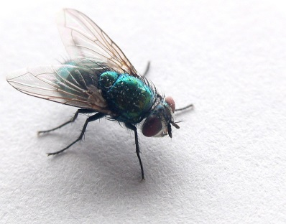
Sarah is sitting at her desk quietly. She is writing slowly.
She stops and looks up. She is chewing her pencil thoughtfully. Then she starts writing again. She angrily erases something. She is frustrated. She gets up and turns off the radio. Suddenly, she hears a bird. She listens carefully. Then she goes back to her desk and starts writing again.
She is writing quickly now. She finishes the story and happily closes her notebook.
Her story is finally finished!

Now it’s your turn:

Breaktime in our school
It is 9.20 and the students at PraxisNMS are having their break. A big bird is sitting on the tree near the basketball hoop in our schoolyard. It is watching you. What does it see? What is going on in the schoolyard? How do you and your classmates behave? Write about 100 words.

Today’s lesson…
Maths Test

This exercise is based on Westfall,Weber: English to go 2. Coursebook. p. 61.

