Somebody is watching you…

Sarah and the Fly
Sarah is in 5th grade. She is eleven years old and she is working on a story for a writing contest in school. A fly on the wall is watching Sarah in her room. She is working on her story. Here is what the fly sees:
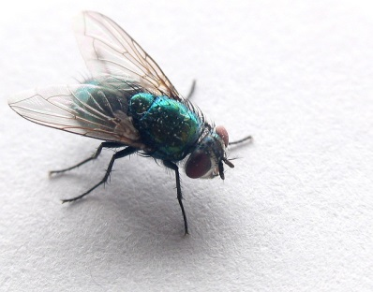
Sarah is sitting at her desk quietly. She is writing slowly.
She stops and looks up. She is chewing her pencil thoughtfully. Then she starts writing again. She angrily erases something. She is frustrated. She gets up and turns off the radio. Suddenly, she hears a bird. She listens carefully. Then she goes back to her desk and starts writing again.
She is writing quickly now. She finishes the story and happily closes her notebook.
Her story is finally finished!

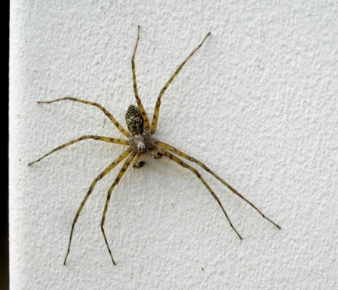
Now it’s your turn: Egon, the spider
An interesting lesson in your class
Imagine an interesting lesson in your class. Egon, the spider is sitting on the wall near the blackboard. He is watching you. What does he see? What is going on in the classroom? How do you and your classmates behave? Write about 100 words.

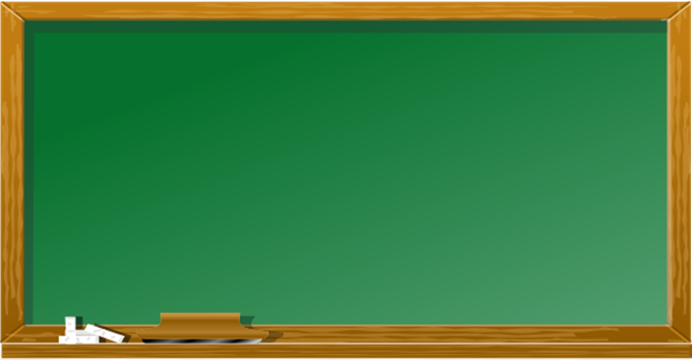
Start like this:
Physics
…
English
German
Arts
Biology
Maths
Egon is watching you..
Today’s lesson…
Maths Test
Hello,
I am Egon the spider and I live in 3F. I really like the kids in this class. I have built my net above the blackboard and I can watch the kids all day. Today is a typical day in 3F. Some kids are happy, some are sad, and some are angry. Let me give you some examples of what they are doing and how they are behaving today.

This exercise is based on Westfall,Weber: English to go 2. Coursebook. p. 61.

