Somebody is watching you…

Egon, the spider: A day in your class
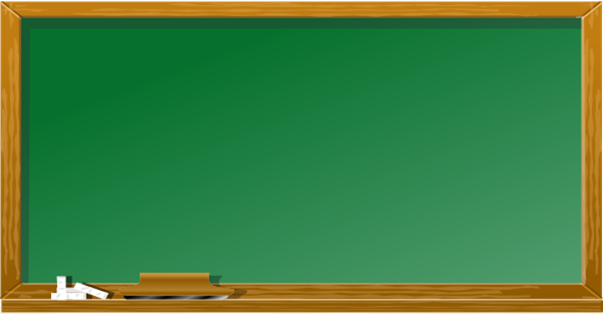
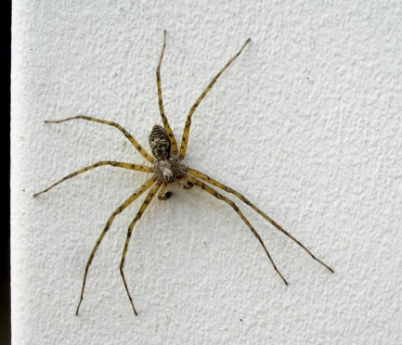
Arts
Egon is watching you..
German
Math
English
Physics
…
Biology

Hello,
Today’s lesson…
Maths Test
I am Egon the spider and I live in 3F. I really like the kids in this class, and I am glad that they have all come back after the holidays. I have built my net above the blackboard so I can watch the kids all day. Let me tell you what I saw yesterday:
In the morning 3F had Math. Most of the kids worked really hard and tried to solve the problems quickly. Some of the kids talked quietly with their partners. The teachers were very happy with the class.
Then 3F had ….
Continue Egon’s description. Tell us what Egon the spider saw.
- What did you all do? How did you do it? (quietly, quickly…)
- What was it like? (difficult, beautiful…)
Give lots of details and use different adverbs and adjectives.
Write about 100 words.

