The Nightmare Club
Your name:

Our first reading project
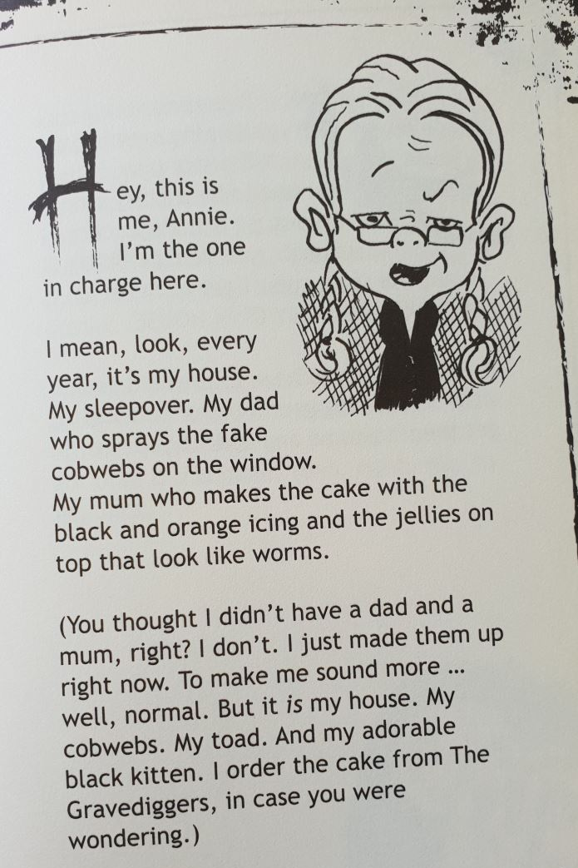

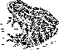
Annie Graves is twelve years old, and she is not interested in growing up. She is an orphan (that means her parents died) and she lives in a secret place in Dublin with her pet toad and a small black kitten . She doesn't go to school, but she loves writing and she writes all the Nightmare Club titles HERSELF, but some authors (people who write books) CLAIM to have helped her: Deirdre Sullivan, Alice Stevens, Katherine Farmar, Oisín McGann, David Maybury, Sarah Purcell, Dave Rudden. Publisher’s note: We did try to take a picture of Annie, but her face just kept fading away.
Annie organizes cool sleepovers for her friends and every time one of them has to tell a really scary, spooky, creepy story.
You are now going to read one of these spooky, creepy, scary stories.
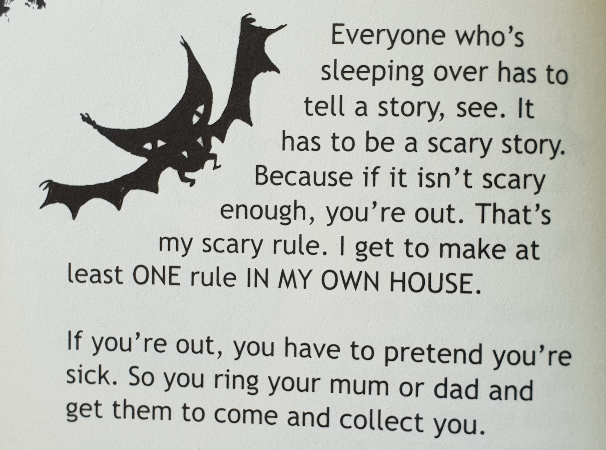Let’s get started: Write the title of your book here:

Task 1: Prereading Organizer
a: Before you start reading, take a good look at your book. Look at the title, the cover and at the pictures inside. Guess what the story might be about.
b: Then talk to a classmate who is reading the same book and compare your ideas. Speak ENGLISH ONLY!!!
Picture Clues: What I see in the pictures.
There is a ….There are some…

My predictions: I think the story might be about….
I think there will be….
Maybe…
Perhaps…

Task 2: Ten Questions
One more task BEFORE you are allowed to start reading your spooky story.
Look through the book again. You will certainly have lots of questions about the places, the characters (the people in the story), the pictures or about unknown words.
What does ‘dilute’ mean?
Write down 8 questions that you hope the book will answer.
After reading the book, come back to this page and see if you can answer your own questions.
Who? When? Where? Why? How? What?
How did he open the door? How did she escape?
Who is Abbey? Who is the woman on page 23?
Where is the funfair? Where did they find the egg?
When did she find out that he was a zombie?
What happened, when she touched the mirror?
Why did he hide? Why did she take a photo?

My questions about the story. | My answers (after reading the book).
ask your teacher to check your questions

While you are reading the book
Task 3: Character silhouette
What do you know about the main character of your book? Fill the character’s head with all the details that you know about him/her. Keep adding details while you are reading.
Ideas: Name, age, appearance (what does the person look like), family, friends, hobbies, likes, dislikes, fears, things that are important for this character …
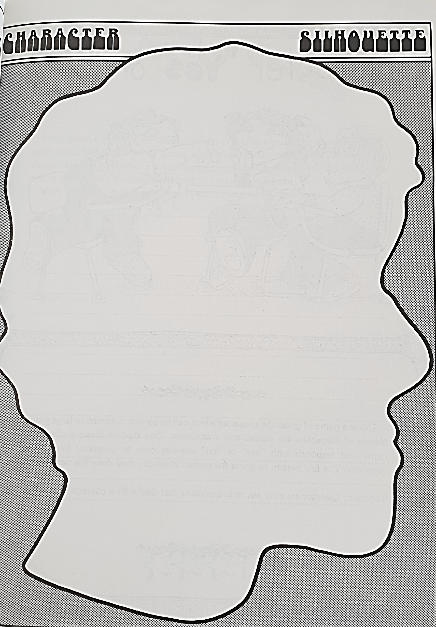
image from: Janice Szabos, Reading- A Novel Approach, Good Apple, Inc. Carthage, IL, p. 49
Task 4: Cool new words and phrases
While you are reading the book, collect at least 5 cool words or phrases that you would like to remember.
Step 1: find an interesting word in your story. Look at the pictures on the page and try to guess the word’s meaning.
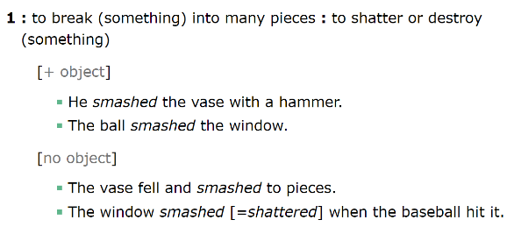
Example: 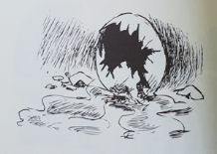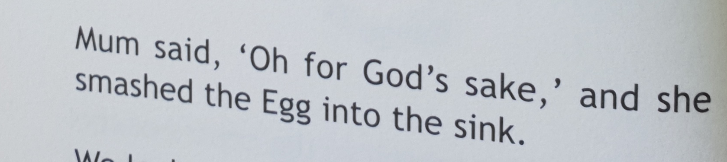
Step 2: Now check if you were right. Look the word up in the Merriam-Webster Learner’s Dictionary online: www.learnersdictionary.com.
Look at the examples there and listen to the word. If you need help understanding the word, ask your teacher.
Step 3: Write your favorite example sentence for the new word on this page. Show your page to your teacher.
Step 4: Then copy the checked phrases on blank vocabulary cards and practice them with your other vocabulary.
Cool phases from your book | Page number
Sentence in the book:

Example sentence:

Sentence in the book:

Example sentence:

Sentence in the book:

Example sentence:

Sentence in the book:

Example sentence:

Sentence in the book:

Example sentence:

Task 5: Solve a Problem
Be proactive: Learning to solve problems is an important skill. If you can solve the book characters’ problems, you can also solve your own problems in life.
What was the main problem in your story?

How was the problem solved in the story?

What other ideas would you have for solving this problem?


Task 6: What if…
These stories are full of strange and weird things that happen to the main character. What if some of these happened to you?
Think of ONE situation in the story and see how it would affect YOUR life.
Example: What if your brother was a zombie?
If my brother was a zombie I would warn my friends.
If my brother was a zombie I would feed him rats, not my neighbors’ cats and dogs. …
Now it’s your turn:
If you could change the story, what would you change?

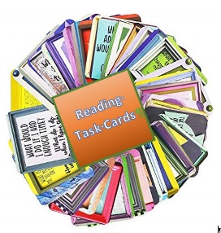
Task 7: Choose a Task from the Reading task cards folder

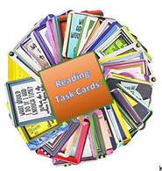
Task 8: Choose a Task from the Reading task cards folder

Task 9: A novel Museum
Have you ever been to a museum? How do they present artefacts (things) there?
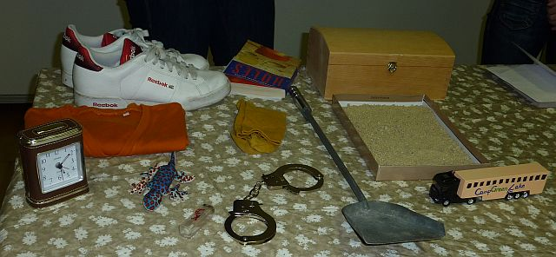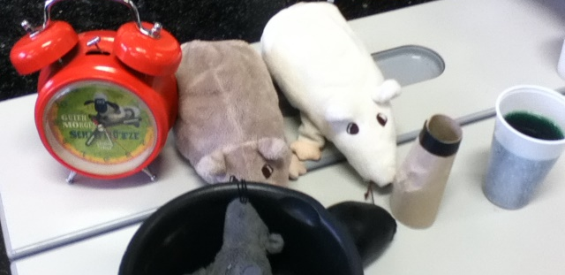
Let’s do the same for some important artefacts from our stories.
Each book group will present a collection of important artefacts from the story on a table.
What could you bring? Think of objects that play a role in your book, photos, drawings, written notes, diary pages…
Make a list of all the things you and your partner will bring for the museum

Date of the museum display shows: ……………………………..

On this day you will present your book museum and you will have a chance to visit all the other displays and find out more about the other books in this project.
For your museum visits, use the sheet on the next page.
Task 10: Finding out about the other stories
On this page you find a collection of sentences from all the different books in this project. Visit all the museum displays and look at the artefacts. Talk to your classmates and find out more about the stories.
Find out
- which story the following sentences belong to and
- what they mean in the story. (Who, Where, What, When, Why…)
Rules of the activity:
Talk to 1 person at a time. No groups!
Speak only English

Sentence | From the book: | Who told you:
Cats and dogs started to disappear in our neighborhood.
He complained about everything and he lied a lot.
Mom spent nine months getting big and waddly, and then one day she went to the hospital and when she came back she had a baby with her.
Abbey and Bee agreed to swap roles.
As soon as I touched the Egg, I felt a shiver run up the bones of my wrist.
Whenever Dervla told me to do something, I did the exact opposite.
I read these warnings but well … you know … it was the internet. I didn’t take it too seriously.
You didn’t know I had a sister, did you?
Well, I have.
Eh… had.
Or …no, … have.
Let me explain.
I had to investigate what was happening at the blood bank. I needed a bulb of garlic , a torch and my phone.
Dad killed the rabbit with a hatchet.
Which of the books looks most interesting to you? Which book are you going to read next?
Task 11: How to recognize demons, witches, vampires and zombies
Collect lots of info from all the books on this page.
Demons
Witches

Zombies
Vampires

