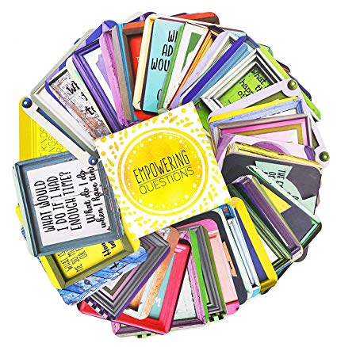
Reading Task Cards

Reading Task Cards

