- Listening - on moodle 33%
- Reading – on moodle 33%
- Focus on Form / Writing 33% - 50P

- Look at the pictures. Tell us if you have done the things or not. 12P
Choose 6 pictures. Write one sentence per picture – 6 sentences

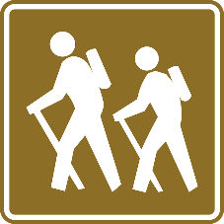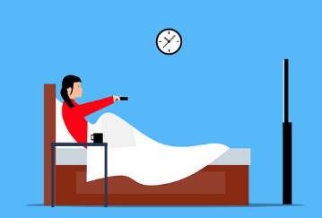

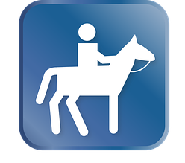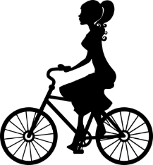

- Choose 3 things that you have done. Write about them in more detail. Tell us some interesting facts about that event. Write 3-4 sentences about each event.
18P

- What if … 20P

Write a short text (4-5 sentences) about two of these ideas.
