- Listen and answer the questions link

- What was special about the final scene? (2)
_________________________ and __________________________________________
- How does the woman feel about the series. Why? Give on example. (4)
She thinks ______________________________________________________________
because ________________________________________________________________
- What does “predictable”mean? (2)
________________________________________________________________________
- What happened to Jamie? (give at least 2 details) (4)
________________________________________________________________________
- Did any of the main characters die in the series? (2)
________________________________________________________________________
- What is the man’s criticism about the series (2)
________________________________________________________________________
- What could be the reason that there were only seven episodes? (2)
________________________________________________________________________
- Does character Cersei become a good person in the end? (2)
________________________________________________________________________
- Does the woman like Cersei’s character?
Explain and give at least two pieces information about Cercei’s character (5)
Yes, she likes the character No, she doesn't like the character
________________________________________________________________________
- What are the two people talking about? (2)
a book a TV series a hollywood film an episode in a TV series

___________/ 27P
Writing
Opinion Writing: Write a text for the OPINION PAGE in a student magazine.
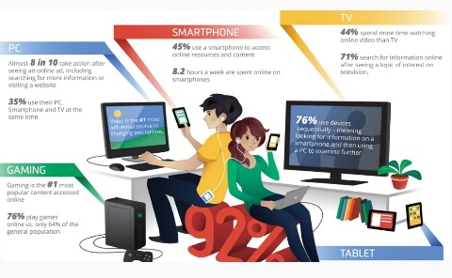
Write about:
- media use of teenagers in your class
- your personal media consumption (compared to others)
- Discuss whether these viewing and gaming habits are healthy for the development of young people.
Describe all these in detail and use specific vocabulary from our recent unit. Use at least 3 quantifiers and underline them.

Assessment:

Listening |  |  | Writing
Listening | / 26P  % |  | Writing | %
Schularbeitennote Einstufung  AHS  STANDARD |  | ____________%

Notenschlüssel
100 – 90% | Sehr gut AHS
89 – 80% | Gut AHS
79 – 70% | Befriedigend AHS | Sehr gut Standard
69 – 60% | Genügend AHS | Gut Standard
59 – 50% | Nicht genügend AHS | Befriedigend Standard
49 – 40% |  | Genügend Standard
39 – 00% |  | Nicht genügend Standard

- KEY
https://learnenglish.britishcouncil.org/skills/listening/b1-listening/chatting-about-series
- What was special about the final scene? (2)
_____there is a dragon_______ and _____special effects_________________________
- How does the woman feel about it? Why? Give on example. (4)
She likes it but she thinks it’s not as good as the ones before _______________________
because ______you know what is going to happen/nobody died___________________
- What does “predictable”mean? (2)
______you know what is going to happen ________________________________________________
- What happened to Jamie? (give at least 2 details) (4)
_____a dragon attacked him / he fell into the water / he was saved ____________________
- Did any of the main characters die in the series? (2)
______no____________________________________________________
- What is the man’s criticism about the series (2)
______it was shorter than the others only 7 not 10 episodes
- What could be the reason that there were only seven episodes? (2)
_______they are not using the story in the book /they might be out of ideas
- Does character Cersei become a good person in the end?
_______no. _________________________________________________________________
- Does the woman like Cersei’s character?
Explain and give at least two pieces information about Cercei’s character (5)
X Yes, she likes the character No, she doesn't like the character
She likes Cercei’s character (her favourite),
She does not really like her as a person. She likes her because she is interesting. She surprises her but she is not a nice character. she wants revenge / she is not happy / she never sees her mistakes / she is unpredictable / we can’t believe anyone would be like her
- What are the two people talking about? (2)
a TV series

