Extraordinary People
Who was …………………………………………………….? (Write the name of your chosen person here.)
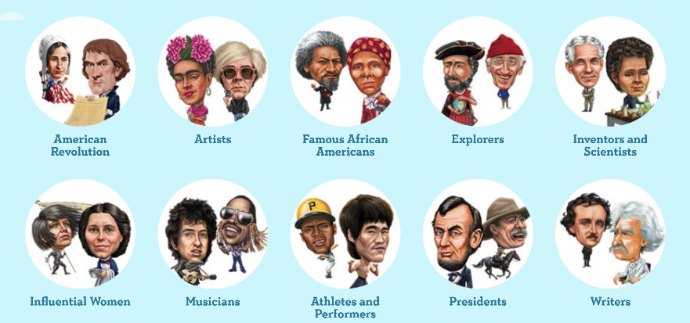
In this reading project you will choose an interesting personality and read their biography.
Find out lots of interesting things about the person of your choice.

Before you start reading, look at the tasks for this little project.
While reading the book, collect information and take notes in this booklet. This will make it very easy for you to write your text for the end of this project.

1. Before you start reading
Look at the book cover, the blurb (the back of the book) and the pictures inside the book. What do the pictures tell you about this extraordinary person?
Guess and take notes. Fill this box with LOTS of ideas – not just 5 words! After reading your book, you can come back here and check if you were right.

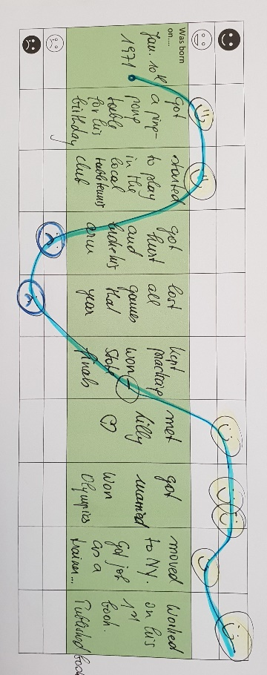
2. Timeline of good and bad times
Use the table below as a timeline of your personality’s life. Mark about 10 important events in this person’s life. In your presentation you will then talk about these events and explain to your classmates why these events are important.
For each event in the timeline, mark whether this was a happy moment or a sad and difficult moment in the person’s life. Choose a fitting smiley and add it to the timeline. Then draw a line through all your smileys. This will show you the ups and downs in this person’s life. Look at the example on the right.


Was born on….




Task 3: Character silhouette
What do you know about the main character of your book? Fill the character’s head with all the details that you know about him/her. Keep adding details while you are reading.

Ideas:
Name,
age,
appearance
(what
does the person look like),

family,
friends,
hobbies,
likes,
dislikes,
fears,

things that are important for this character …

4. Childhood and Youth
While reading, collect information about your extraordinary person’s childhood and original family. Collect lots of interesting facts and ideas.
What was that person’s childhood like?
Where did the person grow up? What was this place like?
Did he/she have any brothers and sisters? Who else was important to the person?
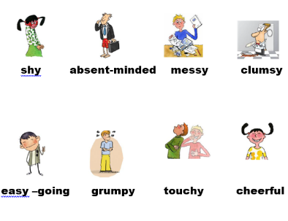
What did the person like/dislike in their childhood?
What kind of personality traits did the person have? You can choose from the words below or find adjectives in the book. Give an example from the book that shows this character trait.
Example: Jane Goodall was quiet – page 15 - As a child she spent five hours watching chicken and they did not notice her.

messy | lazy | clumsy | shy | cheerful | grumpy | absent-minded | loud | rude | hardworking | touchy | selfish | talkative | friendly | easy-going | quiet
What obstacles or challenges did this person experience as a child? How did the person overcome them?

Any other interesting information about the person’s childhood

5. Adult life:
What job(s) did the person have? What did they do in these jobs?
What were the person’s goals and dreams in life? What was important to him/her?
What obstacles or challenges did the person experience in adult life?
How did he/she overcome them? What did the person do to succeed?
6. Any other interesting things that you have found out about this extraordinary person.

7. Sum it up:
What made this person famous?
Why do you admire this person?

