Lesson plan

Prodinger & Rieder 16. April 2020
Praxisschule – Neue Mittelschule der PHSt

- Unit Topic:
3rd conditional (coronavirus outbreak & Easter break)

- Teaching objectives:
- Ss can talk about the imagined past (what they would have done if conditions had allowed it)- Ss know how to structure the 3rd conditional
- SS can use the 3rd conditional when talking about their own experiences (Easter break)
- Lesson Plan

Phase | Activities | Materials/Resources | Time
Warm-Up | - “Chit-Chat”  - Wait until everybody entered the Zoom meeting  - Get to know students  - Create a welcoming atmosphere  - Introduce myself |  | 3-5 min.
Lead-in | - Talk about Easter break  - What did you do? | PowerPoint (screenshare) | 3 min.
Consciousness raising | - How do you express the activities that you would have done without the corona virus? | I don’t think this will happen, because the kids will only talk about what they did (simple past).  They won’t be able to express “imagined past” yet.  We could discuss this among the teachers – this would work as input. | 3 min.
Grammar | - Introduction of 3rd conditional  - When to use it?  - Explain the structure with example sentences  - Answer students’ questions | PowerPoint (screenshare) | 5-10min.
Practice | - Question students:  What would you have done if corona virus wasn’t around? | Substitution table for students who need it | 5 min.

=> suggestion: last activity: Packing your suitcase

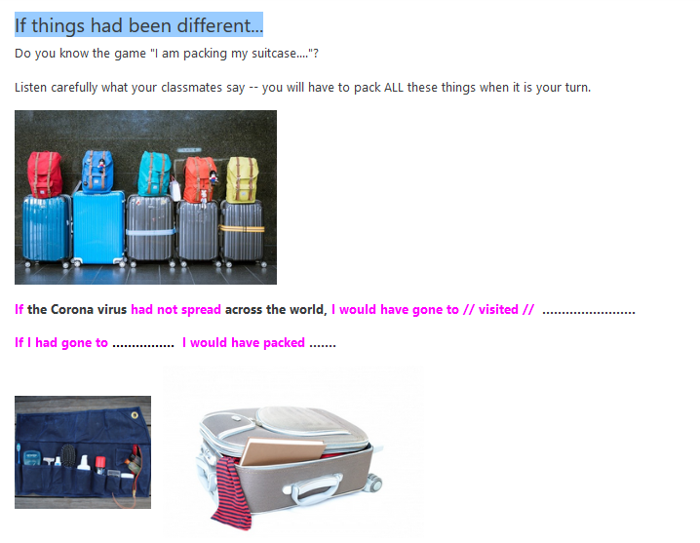
- Attachments and materials

