Lesson plan
New Rules in our Lives

Prodinger & Rieder 23. April 2020
Praxisschule – Neue Mittelschule der PHSt

- Unit Topic:
Modal verbs and new rules due to the current situation

- Teaching objectives:
basic goal: S can name modal verbs
target goal: S are able to use modal verbs in the correct context
more complex goal: S can form sentences using the right modal verb and based on their own experiences
- Lesson Plan

Phase | Activities | Materials/  Resources | Time
Warm-Up | Get students talking  - Wait until everybody entered the Zoom meeting  - Create a welcoming atmosphere  - Chat a little with the students |  | 11:30- 11:33  3 min.
Context-ualisation | Question Time  - A lot of things have changed because of the Coronavirus. Can you name something that has changed for you?  - Students should try to form sentences using the sentence frames/substitution table provided on PPP  (We are not allowed to…/ We are allowed to…, We have to… and so on) | PowerPoint (screenshare) | 11:33-11:36  3 min.
Focussing | Short reading activity  - Students read the text by Sebastian Kurz.  - Question: What rules are mentioned in the text?  Draw your own rule  - All students pick one rule from the text and draw it as good as they can. Then the others have to guess which rule it could be. The student then explains the real meaning to the others, using modal verbs.  Upload your drawings+ description on moodle. | Screenshare text  Paper, pens | 11:36-  11:41  5min  11:41-  11:50  9min
Practice | Past and Present:  - There are also other rules in our lives. What rules do we have in our society? What rules did we have before the Coronavirus has changed our lives?  Future:  - Imagine, what rules could be in the future? | Examples on PPP | 11:50- 11:55  5 min.
Use | Question- Answer  - Ss are asked to question their classmates by using the sentence frames/ examples (activity 1).  - Questions should be answered with YES or NO  Examples:  - Are we allowed to do something dangerous, where we can get hurt badly?  - Do we have to wear socks to cover mouth and nose when we go shopping?  - Should we go to school?  - Are we allowed to drive our car as fast as we can?  Task: write two of your questions on moodle. | Power Point  Screenshare | 11:55-  12:05  10 min
Ending the session | Farewell and task explanation on moodle | Screenshare | 2min

- Attachments and materials
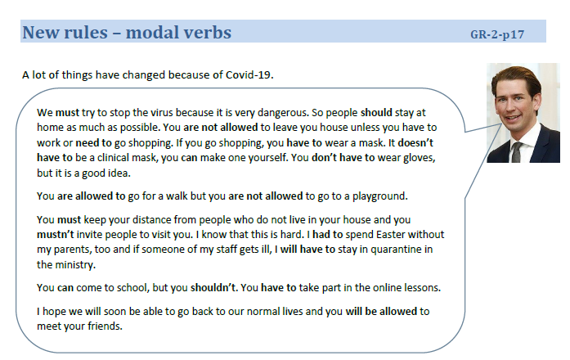
- Reflection
What went good? Is there anything we would like to change? Was there a problem? Did the students know what to do?

