Second Test : 3F

Listening comprehension:
https://www.youtube.com/watch?v=4FXZp35bLFs&ab_channel=WhatLurksBelow

Listen to the 3 short encounters with dolphins and answer the questions in complete sentences. (17)

12
- What was Mr Grant Dickson doing out in the middle of the ocean with his boat ? (1)

- What happened to his boat? (1)

- What did he do after that? (1)

- What happened to the other people? (1)

- Why did the sharks get interested in him? (1)

- What did the dolphins do? (write down at least 2 actions) (2)

11
- What was the young woman and a group of lifeguards doing in the ocean? (1)

- What happened when the great white shark appeared in front of them? (1)

- Did they attack the swimmers? (1)

- What did the dolphins do? (write down at least 2 actions) (2)

10
- What was Maddalene Bearzi doing out there in the ocean? (1)

- One of the dolphins surprised them? What did it do to surprise them? (1)

- How did the other dolphins react? (1)

- What / Who did the researchers find when they followed the dolphins (1)

- What would have happened if the researchers had not followed the dolphins? (1)

Writing: Write two short texts

Text 1:
You have seen a short encounter with an elephant.
https://www.youtube.com/watch?v=0nUeIjPrsCM&ab_channel=FailArmy
Imagine you were present as well. Write a message to a friend and tell them what you saw. Describe the scene in detail: Where were you? Who else was there? What were people doing? How were they all feeling when it happened? What do you think about the situation now?
Tip: Use the correct tenses to describe the main events and what was going on around you.
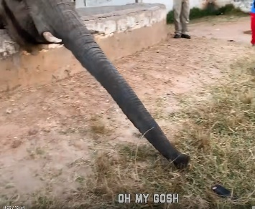
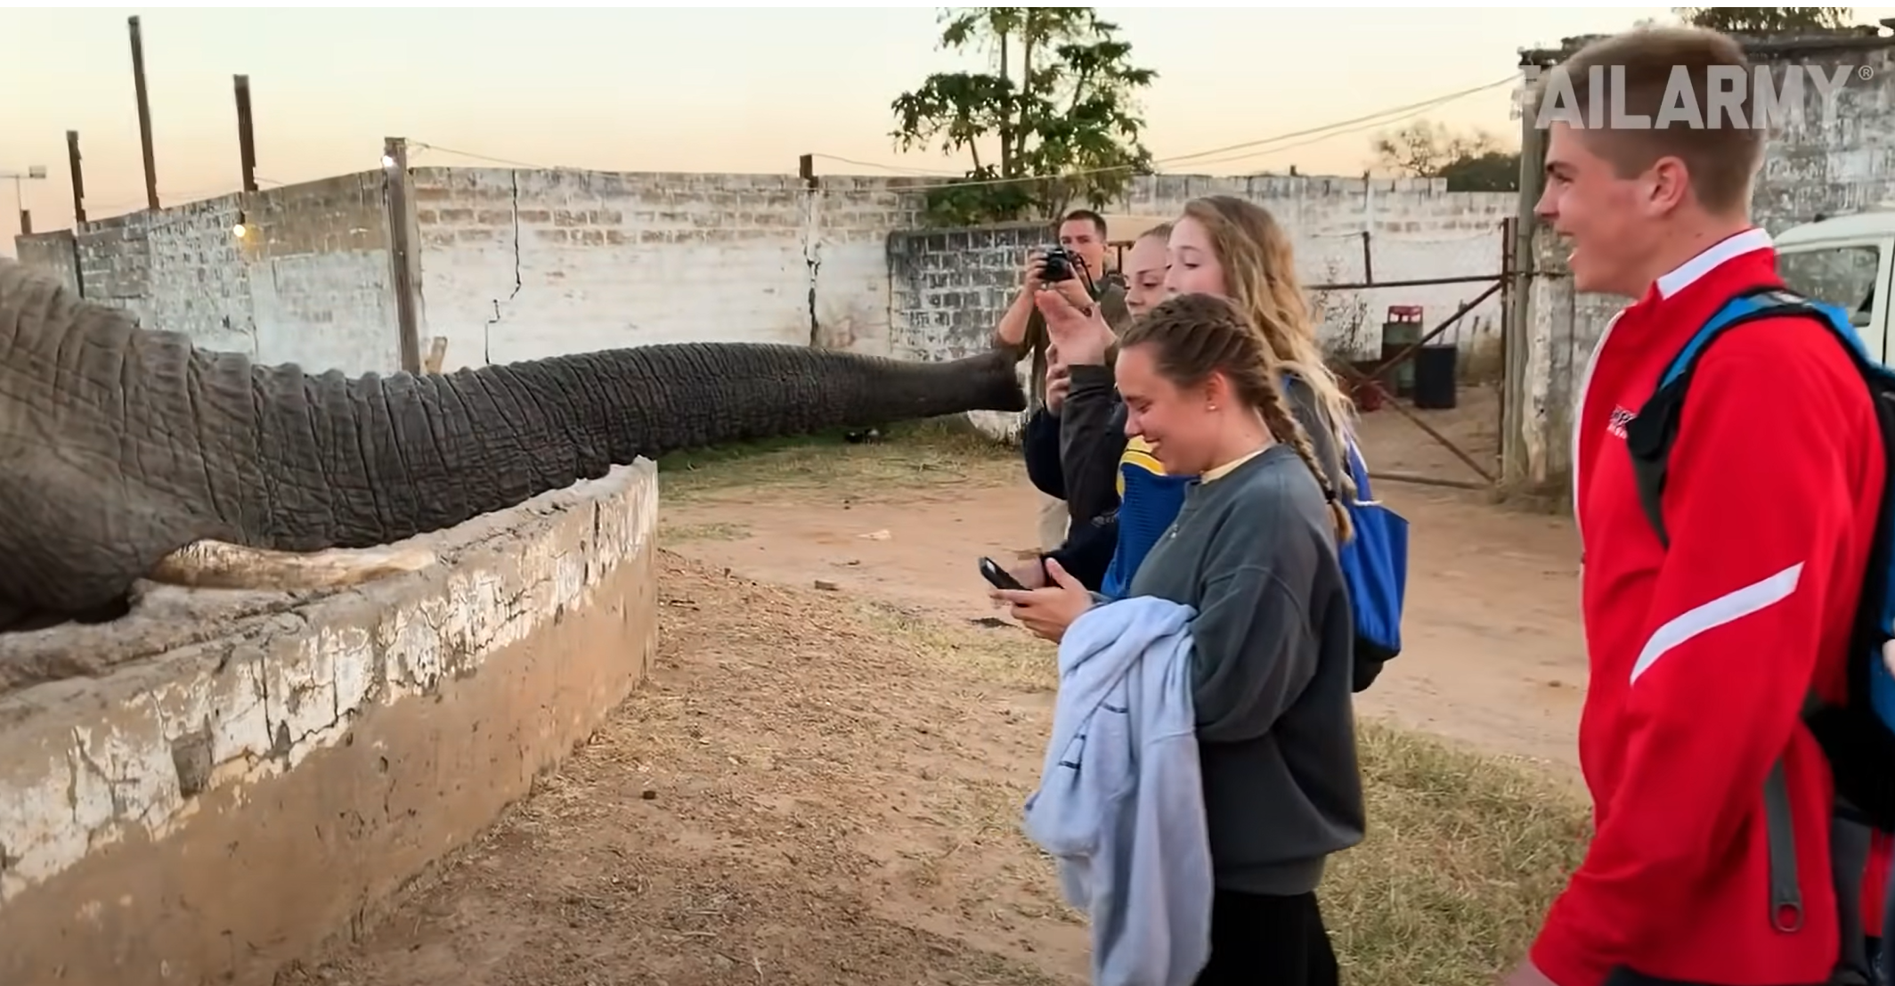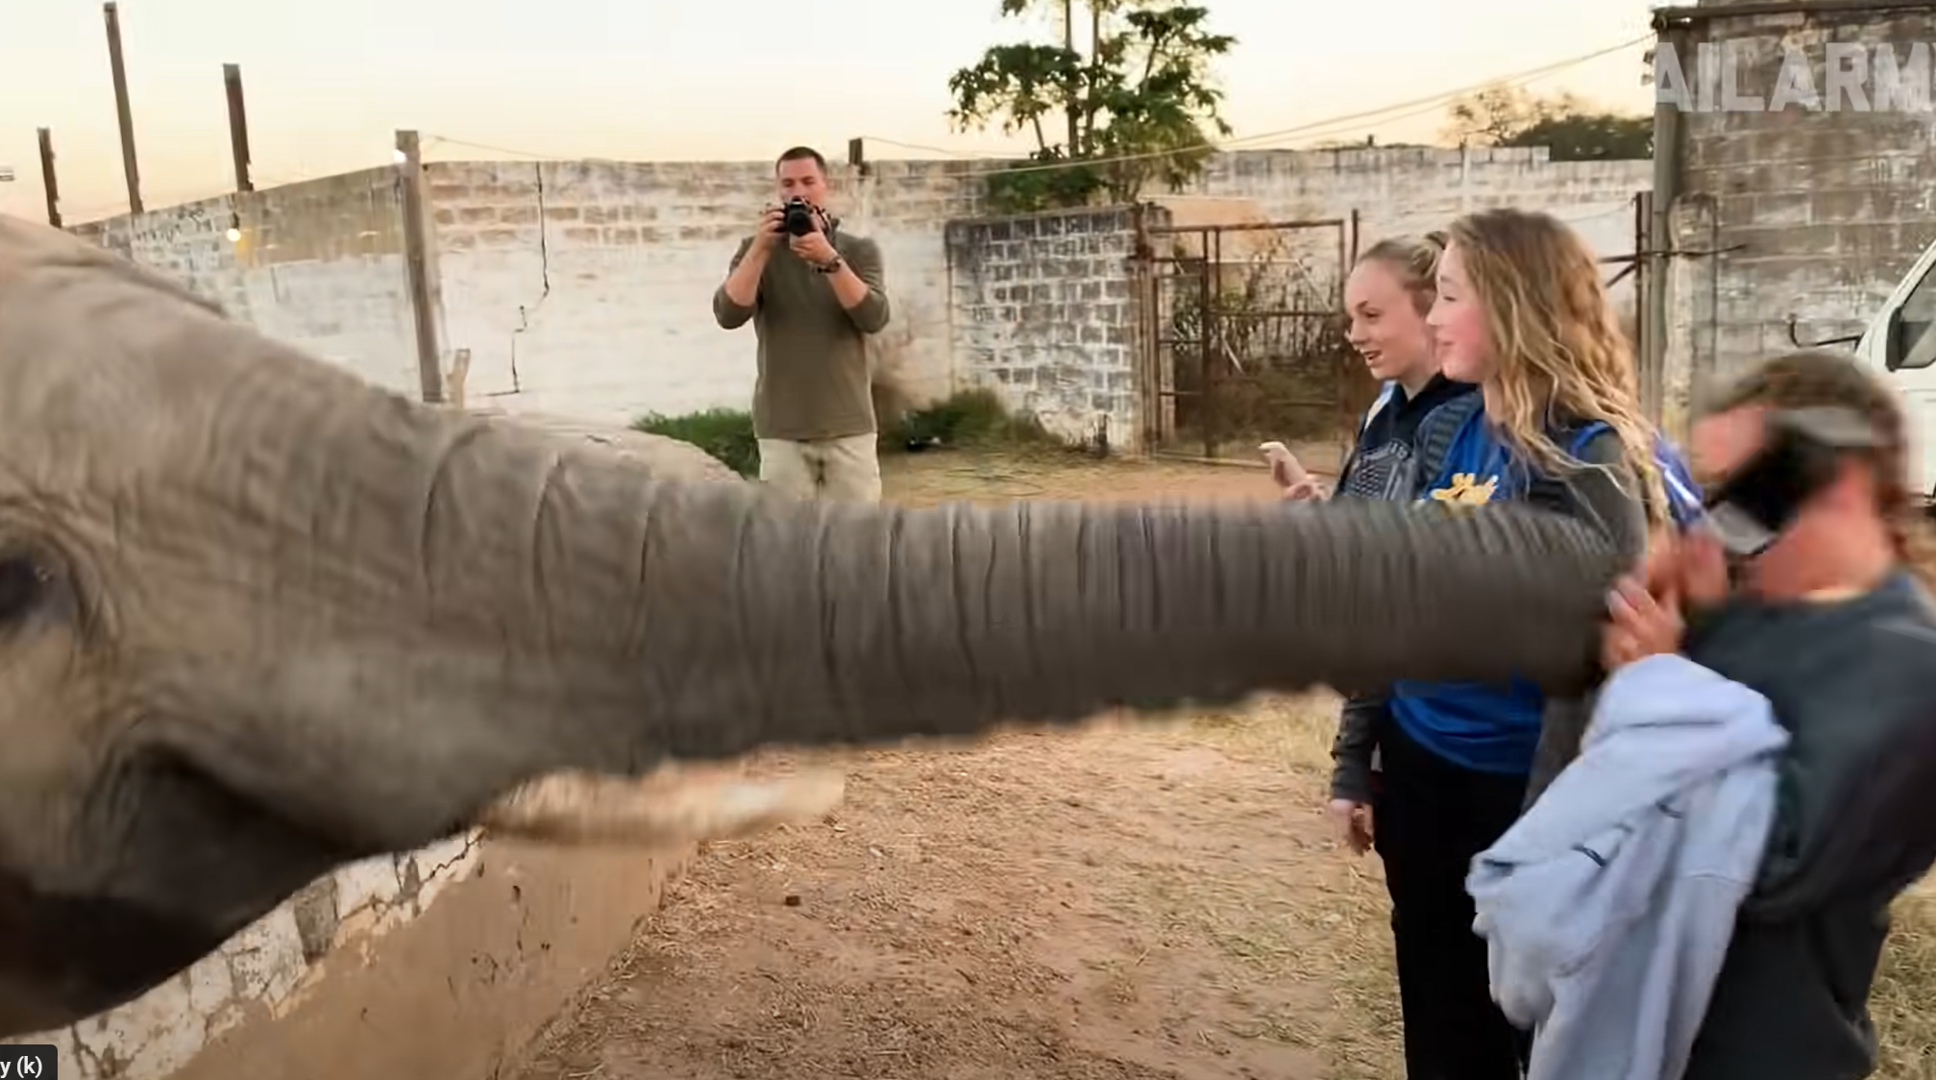

Text 2:
You have just read Malala’s book. A student from year 2 has seen all the Malala books in our library and asked you who this woman is and why she is so famous.
Write a short text (70-80 words) and tell the student
- what happened to Malala
- why it happened to her
- Also tell them one thing she has done that really impressed you.
- Would you recommend the book to student? Why / Why not?

Listening:
Writing 1: Elephant
Writing 2: Malala
Total:
AHS  Sehr gut: 90 – 100%  Gut: 80-89%  Befriedigend: 70 – 79%  Genügend: 60 – 69%  Nicht genügend <60% | STANDARD  Sehr gut: 70 – 100%  Gut: 60-69%  Befriedigend: 50 – 59%  Genügend: 40 – 49%  Nicht genügend <40%

Script:

#12. Grant Dickson protected from sharks
0:05
Grant Dickson, a 36-year-old Australian man, was fishing in northern Queensland along with
0:11
many other people back in 2002. During his journey, the fishing boat was destroyed in
0:17
the water and the man found himself holding on to the remains of the boat, all alone in
0:22
the middle of the ocean. His profusely bleeding wounds attracted several sharks. As he watched
0:28
them grow closer, something exciting happened. A pod of dolphins began to circle him and
0:33
eventually scared away the sharks. After a while, Grant Dickson was safely rescued
0:39
#11. Lifeguard and woman saved from sharks In 2004, a young woman from New Zealand along
0:48
with a group of lifeguards was training at sea when a great white shark about 3 meters
0:53
long suddenly emerged in front of them. They slowly moved close to them ready to attack!
0:56
Unfortunately for those sharks, a small pod of dolphins appeared and surrounded the group
1:01
and the woman. They also proceeded to wave their tails and create a lot of noise which
1:06
discouraged the shark from attacking them and swimming away.
1:10
#10. Dolphins lead researchers to a girl in the water
1:14
Maddalena Bearzi a National Geographic researcher reported that one time she was studying bottlenose
1:21
dolphins along with her team. The team observed that suddenly one dolphin broke away from
1:27
their feeding circle and started swimming in a different direction. The other dolphins
1:32
also turned around and followed, and so did the surprised researchers. The dolphins eventually
1:37
led them to a drowning girl in the middle of the ocean. The 18-year-old girl was rescued
1:43
by researchers and they found out that she had been suffering from hypothermia. Had the
1:48
dolphins not led them to her, she would have died.

Solutions:
Listening comprehension: 15 pts
https://www.youtube.com/watch?v=4FXZp35bLFs&ab_channel=WhatLurksBelow

Listen to the 3 short encounters with dolphins and answer the questions in complete sentences.

12
What was Mr Grant Dickson doing out in the middle of the ocean with his boat ?
He was fishing (along with many other people). 1
What happened to his boat?
It was destroyed. 1
What happened to him
He fell out of the boat 1 and held on the remains of the boat. 1
What happened to the other people in his boat?
We do not know anything about the other people 1, they must have drowned. 1
Why did the sharks get interested in him?
Because his wounds were bleeding profusely. Sharks smelled the blood. 1
What did the dolphins do?
They circled him 1
and scared away the sharks. 1
They saved his life. 1

11
What was the young woman and a group of lifeguards doing in the ocean?
She was training (at sea.) 1
What happened when the great white shark appeared in front of them? Did they attack the swimmers?
They moved closer and closer, but they did not attack the swimmers. 1
What did the dolphins do?
They circled / surrounded the group, waved their tails and created a lot of noise. 2

10
What was Maddalene Bearzi doing out there in the ocean?
She was studying dolphins with her team. 1
One of the dolphins surprised them? What did it do to surprise them?
It turned away and started to swim in a different direction. 1
How did the other dolphins react?
They followed the dolphin. 1
What / Who did the researchers find when they followed the dolphins
A girl 1

What would have happened if the researchers had not followed the dolphins?
The 18-year-old girl would have died. 1

