2nd test
Datum | 26/11/21 | Klasse | 4F

Name
Part 1 Reading
14P
Part 2
Read the text below. Imagine what happened that day. Choose 3 or 4 pictures and write a DIARY ENTRY. Amy, Dan and you are being chased again – and this time you are helping them to get to the next clue. Write about
- the day’s events and
- your feelings.
You were sitting on the train and reading the 39 Clues books when you realized that a boy and a girl were looking at you very curiously. You tried to look away, but you felt uncomfortable. Suddenly the girl started talking, “I’m sorry, we don’t want to bother you… But we are surprised someone is ACTUALLY reading our books!” You couldn’t believe your ears- they were Dan and Amy from the 39 clues and they were on their way to their next adventure! You were really engaged in a conversation when suddenly…..

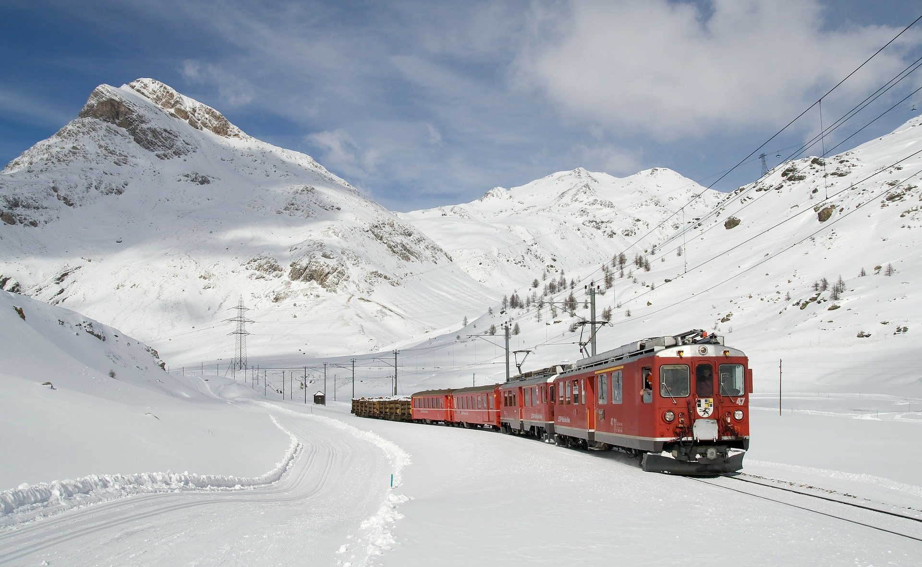

(story, plot)



The 39 clues - Vesper’s rising
p.113/114
1. Put the events in the correct order. Write the numbers into the boxes 7P
Winthrop saw two men
Winthrop said “Father”
Winthrop saw his father crouching on the ground.
Winthrop called “Help!”
Winthrop went closer to his father.
Winthorp’s father ran ahead.
A carriage almost killed Winthorp and his father.
2. What is the father’s name? 2P
_________________________________________________
3. How many people were originally tied to the tree? 2P
_________________________________________________
3. Does he know the people who are tied to the tree? 2P
yes no some of them
4. How does Winthorp feel? Give 2 pieces of evidence from the text. 6P
I know he feels ______________________ because ________________________________
And because ________________________________________________________________
5. How does his father react, when he asks him if the people are alive? 2P
____________________________________________________________________________

The 39 clues - Vesper’s rising
p.115/116 – never the same

- Label the picture with words from the text 6P

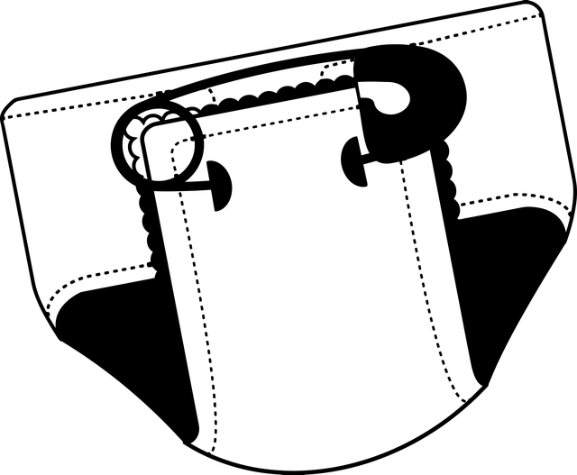
or
- Complete the family tree. Use NAMES. 6P
Grace’s Mother
Grace’s Father
________________

Grace

- Where is Grace in 1942? 2P
__________________________________________________
- What do we learn about Fiske. Give 2 facts that you learned from the text 4P
__________________________________________________
- What happened to Grace’s mother? 2P
___________________________________________________

Reading |  |  | Writing
Reading 1 | / 19P |  | Writing |  | %
Reading 2 | / 20P
Grade Reading | % |  | Grade Writing |  | %  according to assessment scale – see online (eduvidual)
Schularbeitennote Einstufung  AHS  STANDARD |  | %

Notenschlüssel

AHS
Sehr gut: 90 – 100%
Gut: 80-89%
Befriedigend: 70 – 79%
Genügend: 60 – 69%
Nicht genügend <60%

STANDARD
Sehr gut: 70 – 100%
Gut: 60-69%
Befriedigend: 50 – 59%
Genügend: 40 – 49%
Nicht genügend <40%

