2nd test
Datum | 26/11/21 | Klasse | 4F

Name
Part 2
Read the text below. Imagine what happened that day. Choose 3 or 4 pictures and write a DIARY ENTRY. Amy, Dan and you are chased again – and this time you are helping them to get to the next clue. Write about
- the day’s events and
- your feelings.
You were sitting on the train and reading the 39 Clues books when you realized that a boy and a girl were looking at you very curiously. You tried to look away, but you felt uncomfortable. Suddenly the girl started talking, “I’m sorry, we don’t want to bother you… But we are surprised someone is ACTUALLY reading our books!” You couldn’t believe your ears- they were Dan and Amy from the 39 clues and they were on their way to their next adventure! You were really engaged in a conversation when suddenly…..
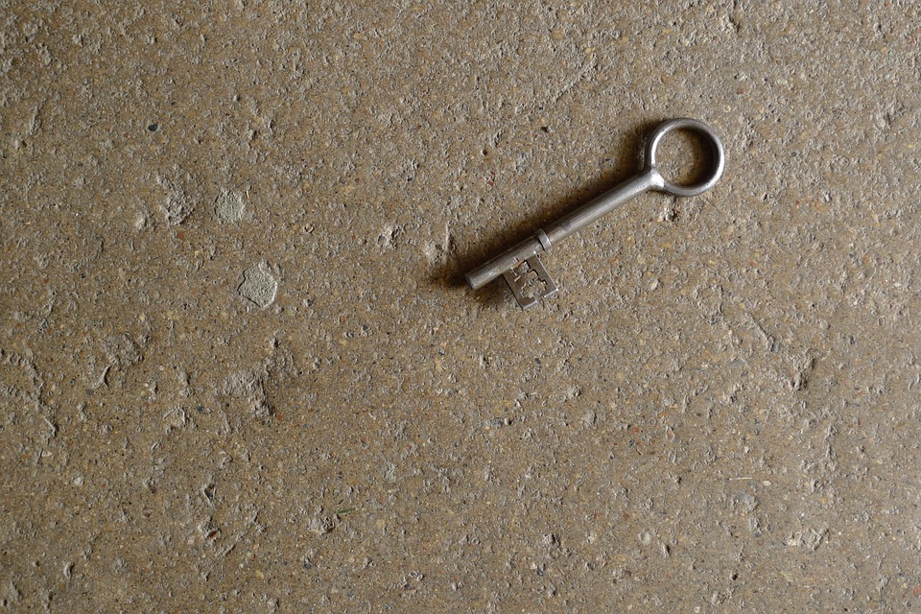
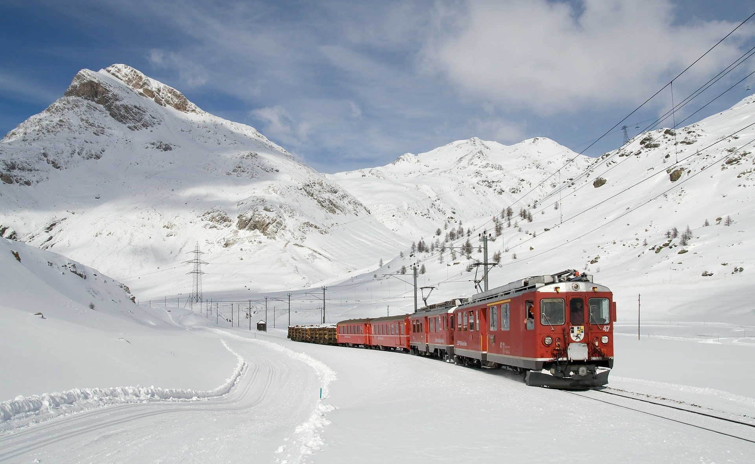

(story, plot)

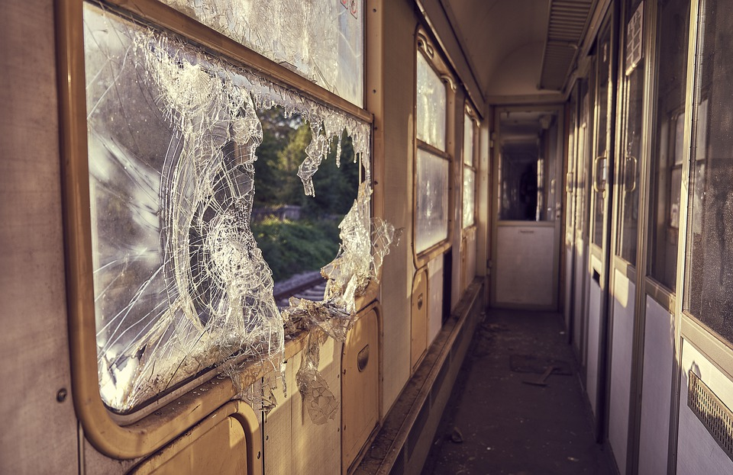

Dear Diary
Today I sitting in the train and read the 39 clues because I love the books so much but then I saw that a boy and a girl curiosly looked on me. I tried to looked away but I can’t because it was so strange that they looked on me. Then the girl started talking “I’m sorry, we don’t wanted to bother you but we are surprised someone is Actually reading our books.” I can’t believed that they are Dan and Amy from the book. I asked a lot of thinks like what Amy and Dan felled in this situation and we toked a lot and then I now thets are the real Amy and Dan. Suddenly the train had a chrech with an other train but we are saved- We went out of our little rom. I’m so angsty because I don’t know what hapened but I’m happy that I was safe by the chresh. We saw a lot of people but they all deaht but on the end of the flor stand a man whit a mask. We now he was not in the train by the chresh. He started to ran tho us. Whe all so angsty in this situation but I found a rock on the window. I hold the rock in front of us and the man ran in the rock and felled down, on the left side of his head was a key. I know that thets are the start for a new adventure and Dan asked me “Do you want ed to have a coll adventure and with my and Amy? “I sad yes and we go out of the train. That’s a relly strange day but also a interested day. Whish me look for the future.

