

Read another book from the 39 Clues series

Swap books with your classmates and read another one of the 39 Clues adventures.
Have a look at the next task before you start reading.
10. Famous historical figures
We know that the Cahill family is related to many famous historical characters. Therefore, these characters play an important role in the clue hunt.
In each of the 39 Clues books, Amy and Dan find out interesting facts about a famous character from history. Some are very old -- others more recent, but all of them are world-famous and have contributed important things to our society.

Step 1: While reading your second book, collect bits and pieces of information about the historic character that plays a role in the book. Print out the "who-was" fact sheet and collect your notes there.


Famous Cahill Characters from History
Who was………………………………… (name)?
Collect your notes here.

11. More Research
After reading the book, go to SIMPLE WIKIPEDIA and do some research on your character. Add more notes here.
ATTENTION: write keywords or short phrases – not whole sentences. Do NOT plagiarize – (copy other people’s texts). Just take notes notes here.

12: Write an info page about the famous character for your classmates.
Write a first draft and upload it to Moodle. Then correct your text and write your second draft on this page.
Famous Cahill Characters from History
Who was…………………………………(name)?

13. A Diary entry from another point of view
Read at least 50 pages of the new book. Choose an interesting character (not Amy or Dan) and an interesting scene form the book.
Write a diary entry from this person's point of view. Upload your first draft to Moodle. Then copy your revised diary on this page.
Remember: In a good diary entry the character describes
- the events of the day
- how they felt about these events
- their plans for the next steps
Write a long and detailed diary --not just a few lines.
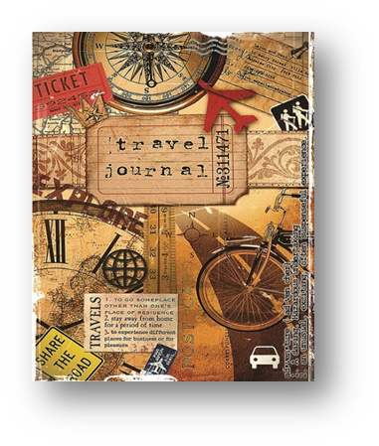

14. Speaking Activity: Teaming up against Amy and Dan

We now know that all the other branches of the Cahills are also hunting the clues. Some of them are building teams and alliances in order to fight against Amy and Dan. In this task choose one character from your book who is from another branch of the family. Meet with a partner and act out a (telephone-)conversation where you ask each other what you know about Amy and Dan and how you could pair up in order to get to the next clue before them.
- Discuss what Amy and Dan have recently done ...
- what clues or parts of clues they have found...
- where you have met them...
- what you and your own branch have recently done to find the next clue ...
- what you are planning to do next in order to get to the next clue before Amy and Dan can find it
Practice your conversation, then act it out for your teacher.

